Network Defense Analysis Workbench Application Guide
Windows use and validation
By Jason Stys Version 1.1.0 11 November 2026
Inspect authorized offline captures through the real Rust packet decoder and existing detection engine. Keep full-snapshot hypotheses, filtered evidence pages and unfiltered capture limitations distinct while recording reasoned review decisions and exact private exports.
The independently downloaded and installed application passed its real user workflows. Current main checks and processed CodeQL passed before publication. Icon targets were verified; normal default-profile shortcut activation is separately untested.

Capabilities and previous improvements
The native workbench adds editable capture/policy workflows, policy-aware findings, exact source/decoder provenance, cursor/filter context, reasoned saved reviews, bounded history and restart-persistent evidence. No live capture or enforcement is introduced.
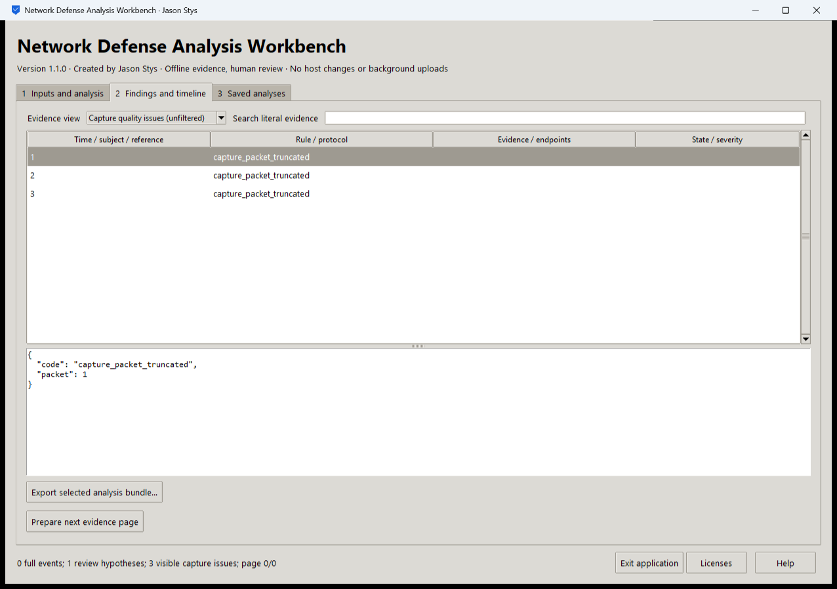
Figure 1 The installed workbench displays a source-bound synthetic evidence review with its original findings and visibility caveats retained.

A worked application journey
A network analyst reviews fictional capture traffic, inspects original hypotheses and capture gaps, pages through exact filtered evidence and saves a reasoned disposition before exporting the complete selected bundle.
1. Select a supported authorized capture and policy or prepare a fictional scenario. Review parameters and acknowledge permission before running.
2. Inspect original full-snapshot hypotheses separately from Selected evidence page and capture-issue views.
3. Use the exact saved cursor/filter context for the next page; record a reasoned local disposition without clearing original findings.
4. Export the selected complete bundle, then reopen Saved analyses after normal exit to verify persistence. Keep private capture evidence and originals under your own access controls.
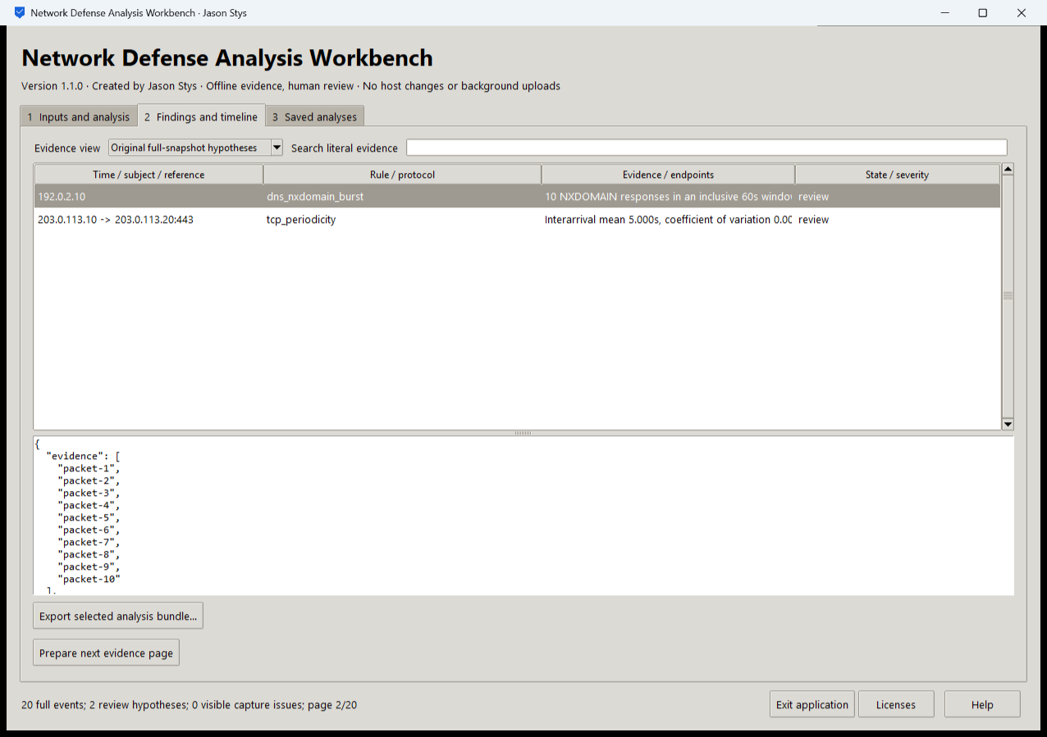
Figure 2 The installed workbench shows Original full-snapshot hypotheses, including DNS NXDOMAIN-burst and TCP-periodicity review prompts. These whole-capture findings remain separate from bounded evidence pages and their filters.

Important implementation details

Carry the exact saved snapshot and filters into the next page
The page transition restores the original saved context and its next cursor. It rejects an exhausted page rather than guessing a new snapshot or silently changing filters.
ndal/desktop_project.py lines 311 to 318
311 def next_page(files: dict[str, bytes]) -> dict[str, str]:
312 """Prepare the next real cursor with the saved exact filters; do not silently change the selected snapshot."""
313 page = json_value(files["query.json"])
314 if page["next_cursor"] is None:
315 raise Rejected("no_next_evidence_page")
316 result = json_value(files["page-context.json"])
317 result.update(mode=MODES[1], cursor=page["next_cursor"])
318 return dict(result)
Source file SHA256 2d42c99b08a0c6051af0bdf7001266cf3fd7a77bf0e38248fed03c5975647b31

Validation results and operating limits
Runtime source 725be04258204035927cb5aa38c92a7c95bcfded
Check | Observed evidence | Result
Installed native workflows | Two real installed EXE launches passed all eight original native workflows, exact exports and byte-identical saved bundle retention, with normal owned exits. | Passed
Original engines | 153 Python tests passed with 96.57% coverage and three explicit platform skips. Rust passed 15 debug and 15 release cases; the actual tcpdump differential remained required. | Passed
Source and security | All exact-main CI and processed CodeQL passed with zero open main alerts. Stable ordinary-file/FIFO/link/growth controls and cursor/filter regressions passed. | Passed
Downloaded installation | Five downloaded assets matched provider SHA-256. The actual Python 3.14.10 DLL and bundled Rust decoder were bound to installed proof; individual icon targets passed read-back. | Passed

Installation and private data
Download the Windows EXE, its checksum and notices from official Releases. Verify the hash and launch the EXE; retain old versions and stopped-profile backups. No Python setup or Docker is required.
Open the individual Desktop icon, read Help and runtime notices, and use the application's own Quit controls. Prepared examples are inputs inside the actual app, never separate demo applications.

Limits and help
Offline hypotheses are review prompts, not proof of compromise or a substitute for missing capture visibility. The GUI does not capture live traffic, scan hosts, deploy rules or change a network.
Unsigned Windows portable EXE. Owner-local saved evidence is plaintext, without multiuser authentication or protection from that OS user. No ordinary profile or Docker setting was changed, and default-profile shortcut activation was not independently exercised.
Release and checksums | Runtime source | Usage and limits

