Node RED Metadata Workbench Application Guide
Windows use and validation
By Jason Stys Version 1.1.0 12 November 2026
Author metadata messages and provider records, run the original nodes in genuine Node-RED, and inspect real retry, failure and cancellation evidence in a local Windows application.
Five independently downloaded assets supplied the installed application. All ten original workflow groups passed through two normal exits, with all 10,162 program files unchanged. Two further actual scenarios provide the original illustrations in this guide.

Capabilities and previous improvements
The original credential-aware metadata nodes, contract checks, bounded queue and structured completion remain. The graphical workbench adds editable policies and closed-schema projects, an owned provider, exact project/run history, explicit replacement choices, practical exports and completion-aware Exit.
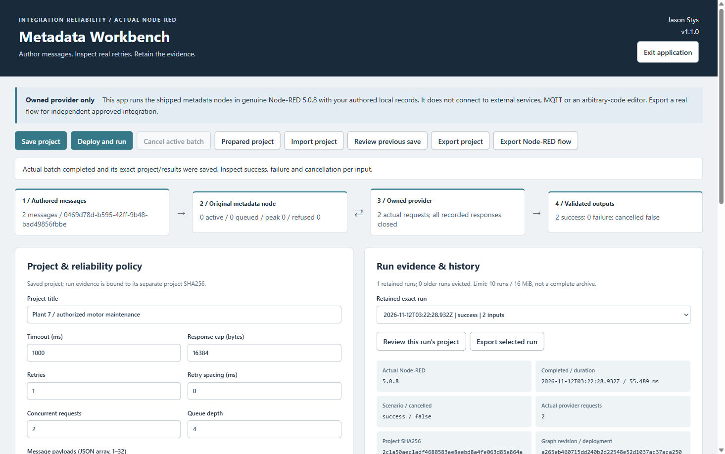
Figure 1 The actual flow shows two successful authored inputs and the saved project's policy and history controls. The capture driver separately inspected the drive-200 result at 460 V.

A worked application journey
A maintenance developer authors two equipment metadata lookups and a bounded retry policy, inspects their actual outputs, then contrasts a held-request cancellation with successful completion before exporting evidence.
1. Open NodeRedMetadata.exe or its verified icon. The owner-local workspace opens automatically. Choose Prepared project or Import project for supported JSON. Keep editing preserves an unsaved draft; Replace draft explicitly changes it. There is no separate workspace chooser or New dialog.
2. Edit the title, message payloads, authorized provider records and timeout, queue or retry policy. Use Save project before Deploy and run. Duplicate or unsupported records fail validation. Metadata values keep their authored meaning and units; the app does not calibrate them.
3. Inspect each input's output, original completion, requests and queue evidence. Change a fault scenario, save and run again. Cancel active batch redeploys the actual flow; cancelled or not-started input remains distinct from success.
4. Select an exact retained run to inspect or review its project. Export project, selected run or a credential-free ordinary Node-RED flow to a new file. Configure external integration separately. Use Exit application and wait for accepted exports, the actual runtime child and owned provider.
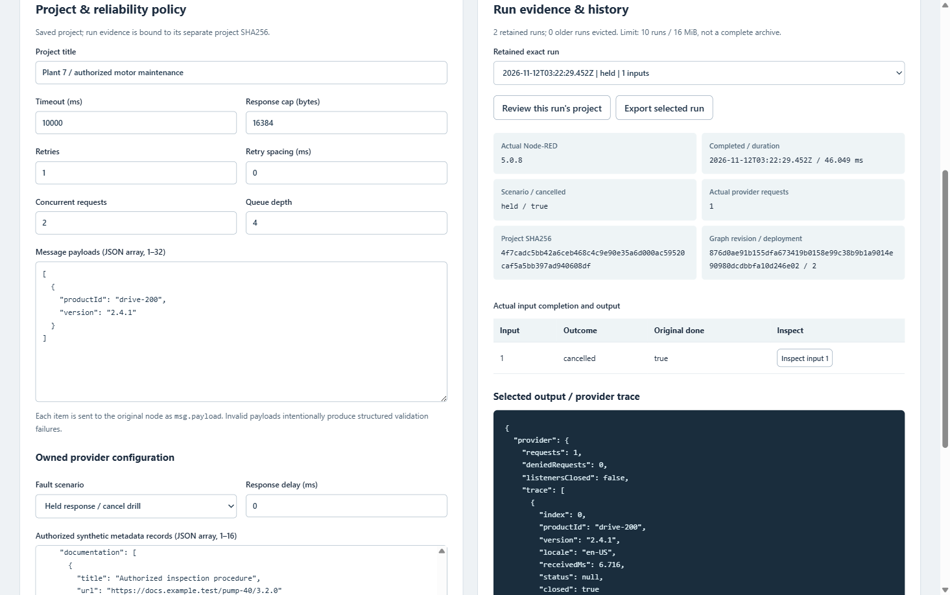
Figure 2 Run evidence retains cancelled=true, the input's cancelled outcome and original done=true. The owned provider listener remains available for another scenario; Exit drains it separately.

Important implementation details

Deploy the actual metadata nodes
The fixed flow builder creates the supported graph, supplies its owned ephemeral provider credential and awaits genuine deployment. A non-cancelled graph must expose the actual lookup node and service client before it is counted.
desktop/flow-engine.cjs lines 305 to 320
305 async function deploy(project) {
306 const nodes = projectApi
307 .runtimeFlow(project, baseUrl)
308 .map((node) => (node.type === 'metadata-service' ? node : { ...node, z: 'native-tab' }));
309 const revision = await setFlowsAndWait({
310 flows: [{ id: 'native-tab', type: 'tab', label: project.title }, ...nodes],
311 credentials: { service: { apiToken: token } },
312 });
313 if (
314 !active?.cancelled &&
315 (!RED.nodes.getNode('lookup') || !RED.nodes.getNode('service')?.client)
316 )
317 throw new Error('Actual shipped Node-RED nodes did not deploy.');
318 deployment++;
319 return revision;
320 }
Source file SHA256 b79529901e419b6024ddcfd16952472f47a8c54ea30d04677b04e405470ef172

Validation results and operating limits
Runtime source fa088a1eff06d910b2cd3bc99a7106929667317b
Check | Observed evidence | Result
Installed workflows | Five assets matched provider identities and checksums. All ten original workflow groups passed through two normal exits. All 10,162 program files stayed unchanged. | Passed
Source and updater | All three main workflows and three processed CodeQL categories passed, with zero raw findings/open alerts. Both fresh Dependabot jobs executed real PNPM updates and submitted their PR changes. | Passed
Capture and icons | The separate two-scenario illustration capture passed with one normal exit. Both known Desktop and Start-menu targets were read back. Ordinary default-profile icon activation was not independently tested. | Passed

Installation and private data
Download NodeRedMetadata-1.1.0-windows-x64.zip and its matching SHA256 sidecar from Releases. Verify the checksum, extract the complete folder and launch NodeRedMetadata.exe. Keep its runtime, resources and notices together. No Node.js, Python or IDE setup is required.
Use the individual desktop icon, Help and Exit application. The workspace is created outside the program folder. Protect plaintext projects, records, history and backups; do not remove a retained owner lock to force startup.

Limits and help
Windows x64 portable and unsigned; no signed installer, automatic updater or clean-machine/cross-platform certification. One trusted OS owner and static filesystem admission are the boundary, not authenticated reviewers, encryption or protection from a hostile concurrent same-account writer.
Only closed supported nodes and an owned loopback provider are exposed. Imported data cannot select arbitrary nodes, endpoints or credentials. There is no external AI or live-machine connection. Cancellation does not undo a remote side effect. The checks opened no ordinary profiles and did not change Docker.
Release | Exact source | Usage and limits

