FieldOps Offline Application Guide
Windows use and validation
By Jason Stys Version 1.1.0 11 November 2026
Create, edit and review inspection records without a network connection, then synchronize through an explicitly owned local companion. The real Windows MAUI application retains accepted versions, pending outbox commands and exact conflict evidence across restarts.
The independently downloaded and installed application passed its real user workflows. Current main checks and processed CodeQL passed before publication. Icon targets were verified; normal default-profile shortcut activation is separately untested.

Capabilities and previous improvements
The complete native UI adds explicit row editing, bounded literal search, exports matching the exact visible filtered rows, per-profile companion authority/checkpoint pairing and shutdown that retains ownership until pending work finishes. Android release source remains validated separately.
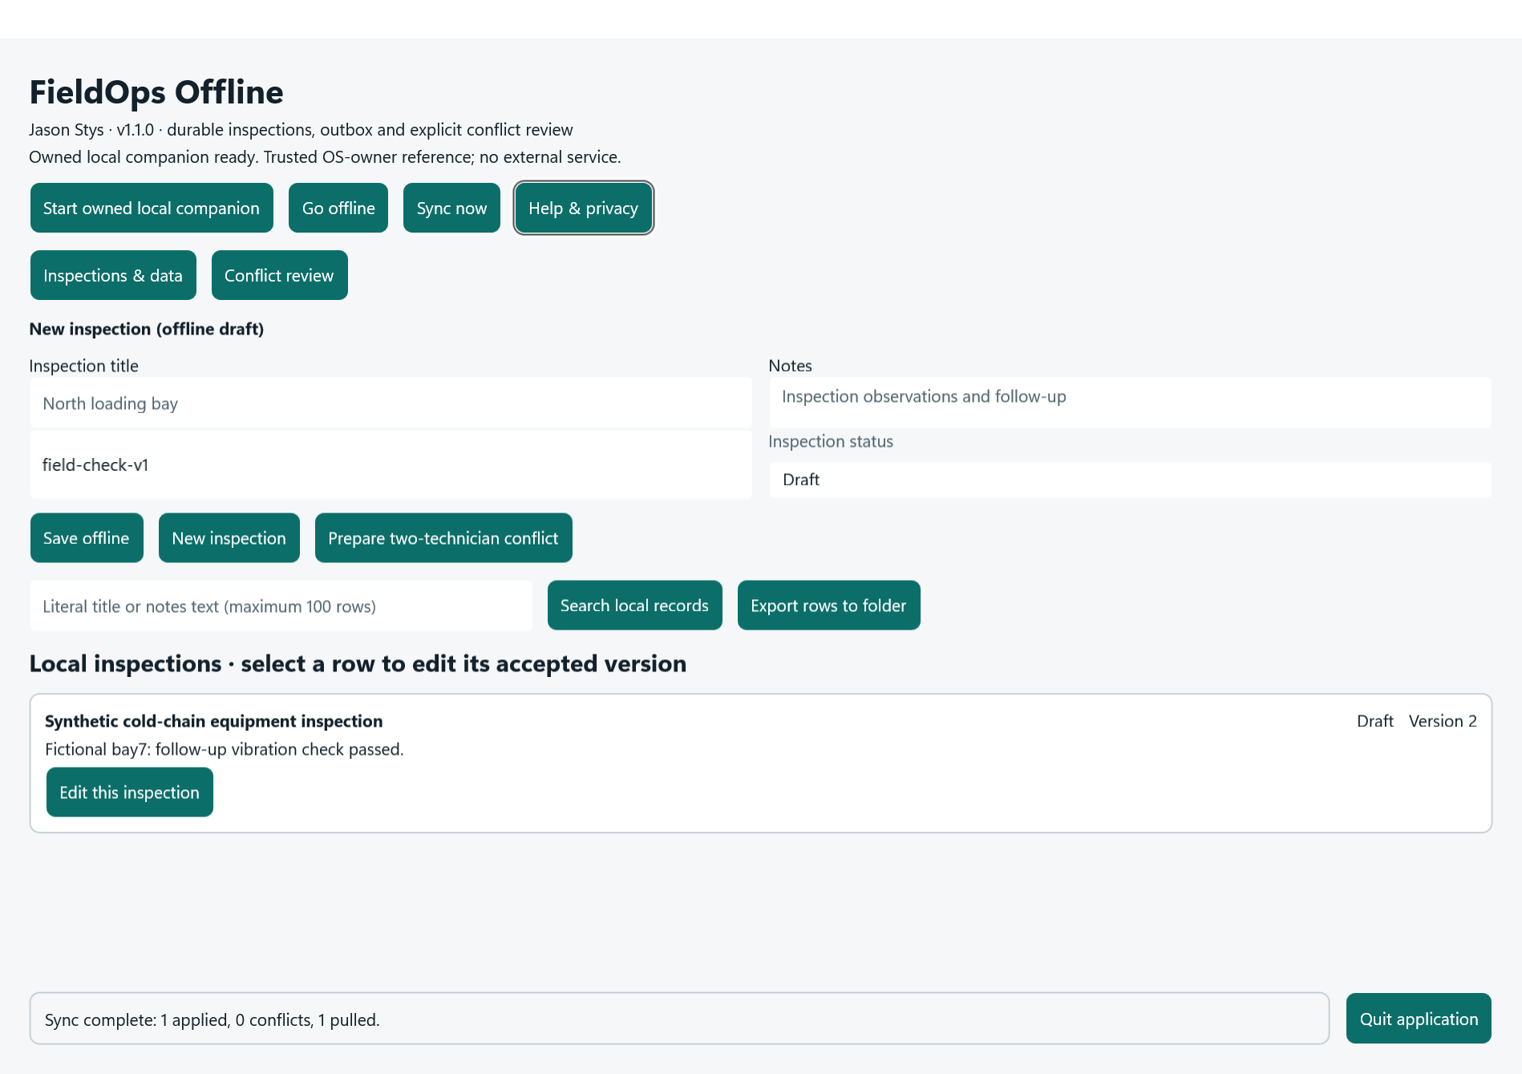
Figure 1 The installed MAUI app displays the retained synthetic inspection at accepted version 2 after synchronization: one applied command, zero conflicts and one pulled record.

A worked application journey
A fictional cold-chain technician edits an inspection offline, synchronizes its accepted version, then compares a second technician's competing change before choosing an explicit conflict resolution.
1. Open Inspections & data, enter a title and notes, then Save offline. Select an existing row to edit its accepted version.
2. Start the owned local companion and choose Sync now. Keep outbox and accepted-version status visible when interpreting results.
3. Use Conflict review to inspect both versions and resolve deliberately. Search and export operate on the exact bounded visible set.
4. Quit application waits for pending I/O and ownership cleanup. Back up the stopped external profile; do not pair it with an empty or rolled-back companion silently.
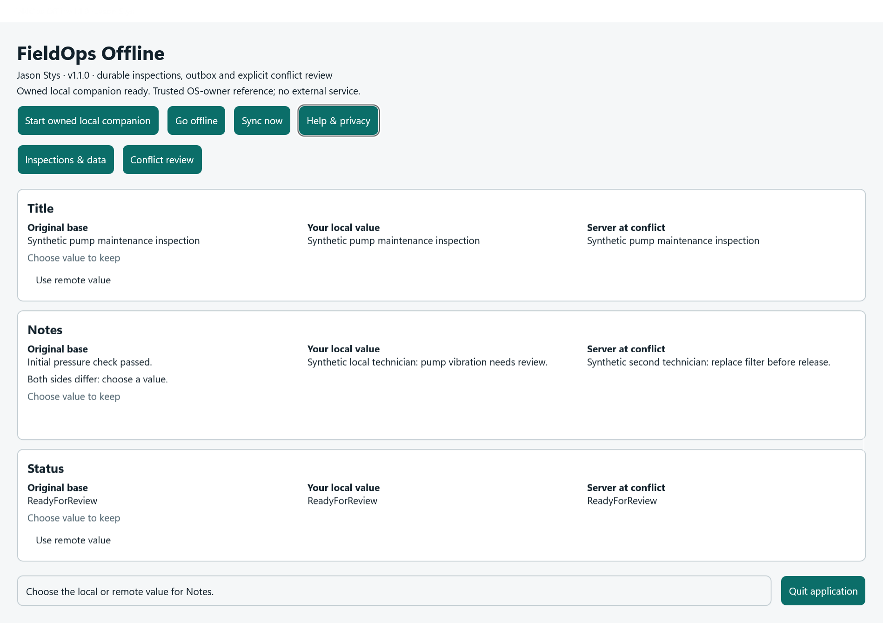
Figure 2 The same installed application exposes its explicit conflict-review workflow; competing versions remain evidence for the technician rather than being silently overwritten.

Important implementation details

Finish owned work before closing the native window
The Windows close handler ignores repeated close requests while awaiting MainPage.CloseAsync. It closes the actual native window only after completion; handled I/O failures retain the window and allow a safe retry.
src/FieldOps.App/App.xaml.cs lines 37 to 54
37 var native = (Microsoft.UI.Xaml.Window)window.Handler!.PlatformView!;
38 async Task CloseOwnedAsync()
39 {
40 if (waiting) return;
41 waiting = true;
42 try
43 {
44 await mainPage.CloseAsync();
45 completed = true;
46 native.Close();
47 }
48 catch (Exception error) when (error is IOException or InvalidOperationException or UnauthorizedAccessException)
49 {
50 waiting = false;
51 await mainPage.DisplayAlertAsync("Still closing safely",
52 "Local work could not finish. Keep this window open and try Quit again; ownership and saved data were retained.", "Keep open");
53 }
54 }
Source file SHA256 4aa763d6fb3f9ae0b78b708f6148aa089d1867f542e5ae2829a36bc383d621bc

Validation results and operating limits
Runtime source 514913be78a45876ad90a8ced6d9cbeaecbb4b37
Check | Observed evidence | Result
Actual installed MAUI | Two real installed native launches passed editing, synchronization, explicit conflicts, exact retained records and normal exit codes 0/0. | Passed
Domain and boundaries | The source suite passed 90 tests with 94% line coverage. Fourteen real Windows profile controls and 105-row/53-filtered exact-export regressions passed. | Passed
Build and security | Current main CI, actual Windows native acceptance, Android release build and processed C# analysis of both core/API and MAUI source passed. | Passed
Portable distribution | Five independently downloaded assets matched provider hashes. Installed application and .NET 10.0.15 payload hashes matched; individual icon targets passed read-back. | Passed

Installation and private data
Download the Windows ZIP and its checksum from official Releases. Extract into a fresh folder and launch FieldOps.App.exe; retain old versions and stopped-profile backups. The self-contained app needs no system .NET setup.
Open the individual Desktop icon, read Help and runtime notices, and use the application's own Quit controls. Prepared examples are inputs inside the actual app, never separate demo applications.

Limits and help
This Windows portable app is unsigned; it is not an MSI or Store package, and no clean-machine or mobile installation test is claimed. Local and hosted SDK patch versions differ; the installed self-contained runtime is verified as 10.0.15.
The companion is a trusted-OS-owner reference, not a production multiuser identity service or cryptographic remote attestation. Profiles are plaintext local data. Normal profiles, system SDKs and Docker were unchanged.
Release and checksums | Runtime source | Usage and limits

