Offline Incident Timeline Application Guide
Windows use and validation
By Jason Stys Version 1.1.0 11 November 2026
Investigate approved incident JSON and CSV locally, filter a persistent event snapshot by exact UTC time and indexed fields, inspect selected records and export the complete filtered evidence through a usable offline desktop application.
The published Windows app passed all original installed native journeys after independent download. Prepared data, custom inputs, exact exports, malformed-input preservation and restart passed with two normal exits and all 89 installed files unchanged.

Capabilities and previous improvements
The original browser PWA, Worker parser, IndexedDB indexes, chart, keyboard list and equivalent table remain. The native app adds its own durable origin and profile, verified bundled assets, explicit new-file exports and completion-aware shutdown. UTC labels and actual Worker failure cleanup were corrected with independent regressions.
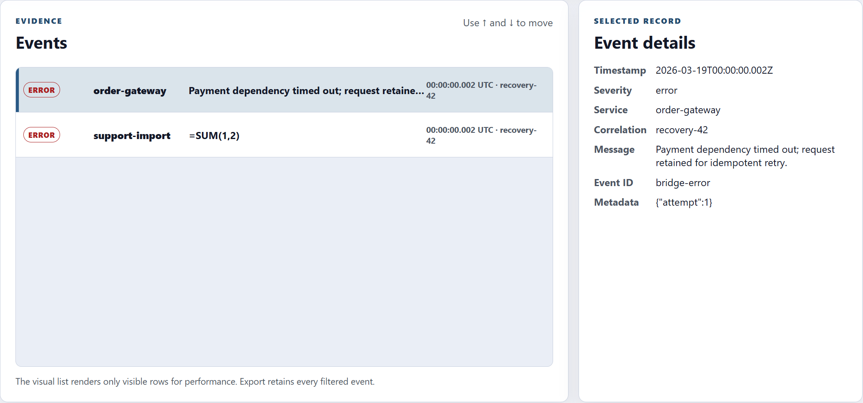
Figure 1 Two custom error events share the exact UTC millisecond. The selected record retains the original message, correlation and metadata; formula-like imported text stays literal.

A worked application journey
An incident analyst imports four synthetic recovery events across UTC midnight, selects a single millisecond, compares two coincident error records and exports their exact JSON and formula-safe CSV before reopening the saved snapshot.
1. Load the prepared Service outage or UTC midnight recovery case, or import approved JSON or CSV. A successful import replaces the current snapshot; malformed or wholly invalid input preserves prior evidence.
2. Combine message tokens, severity, service and correlation with inclusive UTC bounds. Equal bounds select an exact millisecond. Invalid or reversed bounds disable exports.
3. Inspect events with the keyboard list and selected record. Use the equivalent table for counts when chart points overlap; exports retain filtered events beyond the visible virtualized rows.
4. Export JSON or CSV to a new file, or cancel the save choice. Close normally and wait for accepted work and real worker and database teardown; reopen the app to restore its event snapshot.
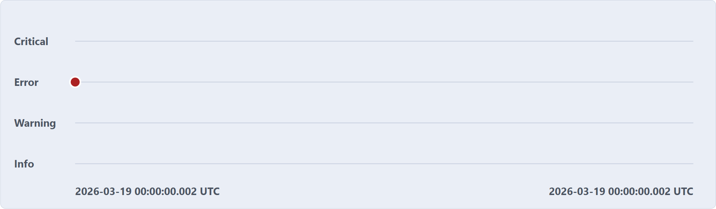
Figure 2 Equal inclusive boundaries select the exact millisecond. Coincident error marks overlap visually; the equivalent table, record list and exact exports retain the separate events.

Important implementation details

Use explicit UTC for evidence labels
Both helpers derive labels from the normalized ISO instant. Full timestamps retain the date and milliseconds, while compact rows retain millisecond clocks with an explicit UTC suffix. This matches the filter and export time scale regardless of the computer time zone.
src/ui/utc-time.js lines 8 to 16
8 /** @param {string} timestamp Valid timestamp with an explicit offset. @returns {string} UTC date and clock. */
9 export function utcTimestamp(timestamp) {
10 return new Date(timestamp).toISOString().replace("T", " ").replace("Z", " UTC");
11 }
12
13 /** @param {string} timestamp Valid timestamp with an explicit offset. @returns {string} Millisecond UTC clock for a compact row. */
14 export function utcClock(timestamp) {
15 return new Date(timestamp).toISOString().slice(11, -1) + " UTC";
16 }
Source file SHA256 402badc8ffbbcc652431f800e4689766a238852cda4c5a4db59f9817a4d07801

Validation results and operating limits
Runtime source 832e11e43942f937aa855525e3c278be037c8c27
Check | Observed evidence | Result
Actual installed app | Two visible launches passed original 15-event and custom four-event flows, exact UTC windows, rejected-import preservation, retained IndexedDB, JSON and CSV, cancel and no-overwrite, closed bridge refusals and a real export through repeated Quit. Both processes exited zero without renderer errors. | Passed
Original source and browser gates | 100 scoped source tests passed at 97.90% coverage; 26 native helper cases passed at 99.27% lines and 95.97% branches over five helpers. Six ZIP controls and original three-engine browser and Lighthouse gates passed; six existing browser-specific skips remain explicit. | Passed
Distribution and security | Five independently downloaded release files matched provider hashes. All 89 installed files stayed unchanged. All three exact-source main workflows and three actual raw CodeQL categories passed with no findings or open alerts before publication. | Passed

Installation and private data
Verify the SHA256 and extract the complete Windows x64 ZIP. Retain every Electron and Chromium notice, then launch IncidentTimeline.exe or the individual Desktop icon. Electron 44.11.1 and Node 24.22.2 are bundled; no Node setup, local HTTP service, IDE or Docker change is required.
The native profile uses owner-local plaintext Chromium and IndexedDB storage outside the installation. Browser PWA data is a separate origin and moves only by explicit import and export. Protect approved inputs and exports. Validation used fresh synthetic profiles; normal data was not opened.

Limits and help
This is an offline event investigation tool, not a live feed, forensic signature, authenticated chain of custody, encrypted vault, shared account service or backup system. Coincident chart points can overlap; inspect the equivalent table and individual records.
Static profile admission trusts the OS owner and does not defeat a malicious same-account writer. Interrupted-owner locks are retained for review. The application is unsigned; package hashes and installed tests are distinct from signed-installer or clean-machine certification.
Release and checksums | Exact runtime source | Usage and profile limits

