Orbital Safety Workbench Project Guide
  - By Jason Stys
Public source revision 89278b3a1997
This edition documents the cited source. Validation observations below identify their own tested revision and time; they are not a promise that an unrun later revision passed.
Civilian orbit replay, transparent multi-object screening and reproducible scientific evidence. Created by Jason Stys.
The released 1.1.0 portable workbench includes illustrative distance-window review: inspect exact sampled-history interval bounds, boundary censoring and replay positions while retaining archived ISS/SGP4 evidence and downloadable reports.
The existing civilian historical replay and fictional multi-object tracks remain the purpose. The actual extracted UI is checked against an analytic relative-distance oracle and exact JSON export, with collision probabilities explicitly absent. POSIX-safe archives and newly complete CPython/PyInstaller notices improve distribution without adding operational prediction or guidance.

Purpose operation and implementation
Inspect illustrative threshold windows, including exact piecewise-linear entry/exit times, duration, tangencies and window-edge censoring. Replay buttons inspect the nearest second. These teaching thresholds add no collision probability, safety radius or maneuver/interception advice.
> Educational replay only—not navigation, flight software, collision-risk assessment or an operational safety tool. No targeting, intercept solver, destruction/fragmentation model or maneuver advice.
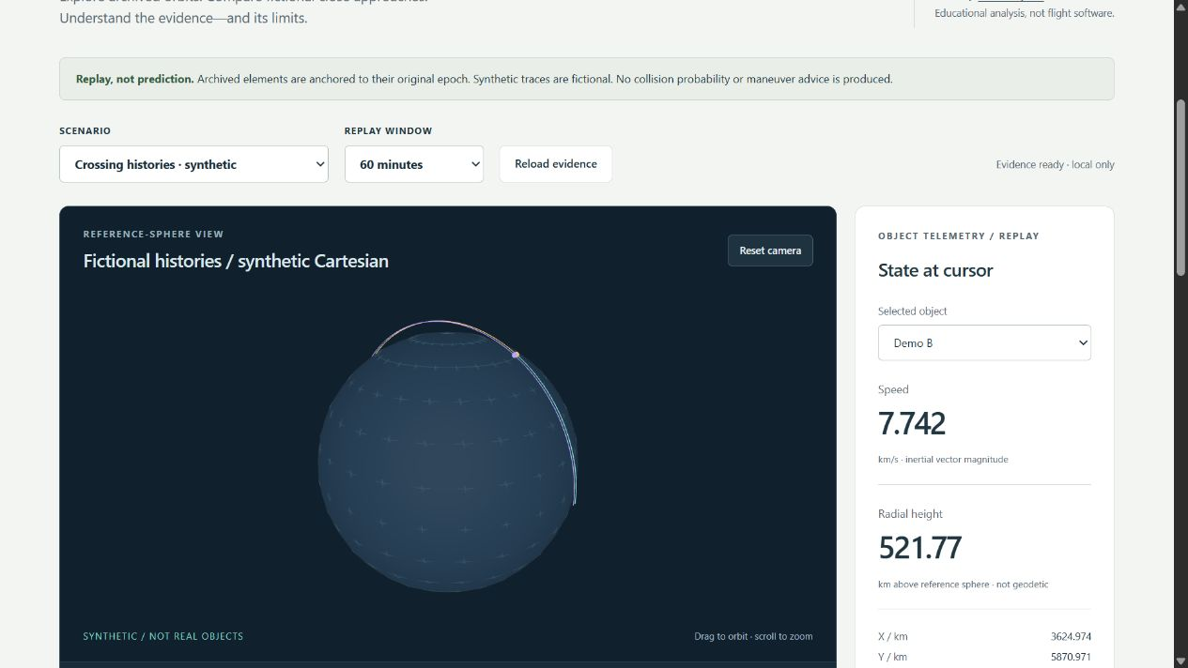
Tested local workbench showing a fictional multi-object replay

What you can do
- Replay archived ISS mean elements at their May 2024 epoch with SGP4; never silently propagate stale elements to today.
- Explore two fictional three-object histories, including a closest approach between displayed sample timestamps.
- Orbit/zoom a 3D reference sphere, inspect an equal-scale XY projection, scrub/play time and select objects to inspect positions, speed and radial height.
- Search every piecewise-linear segment for each pair's minimum distance. Collision probability is unavailable because covariance and physical sizes are absent.
- Export JSON, unit-labeled CSV and inert HTML, including content-addressed run IDs and provenance. Optionally save immutable run evidence to a local SQLite history through the CLI.
- Run locally without accounts, API keys, external fonts, analytics, CDNs or remote data fetches.

Quick start
Requires Python 3.12–3.14 and Node.js 24 for development. Run commands from the repository root. On Windows use .venv/Scripts/python.exe; on macOS/Linux use .venv/bin/python after creating the environment.
python -m venv .venv
# Activate using the standard command for your shell, or use the venv's Python path.
python -m pip install --require-hashes -r requirements.lock
npm ci
npm run build
python -m orbital serve
The service binds only 127.0.0.1 on an available port and opens your default browser. Keep its terminal open; Ctrl+C stops it. The browser view is responsive on small screens, but the local server runs on a desktop computer. It is not a public hosted website or a mobile-native installer.
The v1.1.0 portable release provides Windows x64 ZIP and Linux x64/macOS ARM64 .tar.gz archives with matching .sha256 files. Verify the digest, extract the entire archive with its _internal folder and licenses, preserve POSIX links/permissions, then launch OrbitalSafetyWorkbench (.exe on Windows). No Node/Python installation is needed for a bundle. These are unsigned portable applications, not notarized installers; do not bypass OS security warnings. See installation and verification.

Evidence without the UI
python -m orbital export --scenario synthetic-crossing --minutes 60 --format json --output evidence.json --history evidence.sqlite3
python -m orbital export --scenario iss-archive --minutes 30 --format html --output archived-iss.html
Existing export files are never silently overwritten. Only the CLI can write a history database; HTTP is read-only. Reports are deterministic across repeat runs with identical source/model/software inputs. Hashes identify content; they are not cryptographic signatures or proof of physical truth.

Why these languages
Component | Choice | Responsibility
Scientific service and CLI | Python + the vetted SGP4 implementation | Epoch-safe propagation, numeric validation, exports and packaging
Browser application | Strict TypeScript + Three.js | Typed view state, rendering, accessible controls and bounded playback
Evidence persistence | SQL / SQLite | Atomic, parameterized, idempotent immutable history
Presentation | HTML / CSS | Semantic help, responsive layout and restrictive same-origin assets

There is no unneeded language wrapper around the science engine. This is an engineering demonstrator, not a claim to implement a mission-qualified propagator.

Repository map
File / folder | Summary
orbital/model.py | Immutable sample/track contracts, bounded interpolation and continuous minima over sampled line segments
orbital/scenarios.py | Reviewed catalog, ISS OMM propagation, synthetic fixtures, provenance and finite serialized cache
orbital/reports.py | JSON/CSV/HTML export and transactional SQLite history
orbital/server.py | Loopback-only API, allowlisted assets, origin/Host checks and security headers
orbital/__main__.py, launcher.py | Source CLI, local website launcher and native application entry
orbital/resources/ | Public historical scientific fixture and history SQL schema
web/ | Semantic shell, styles, pure display utilities, typed state orchestration and disposable 3D renderer
tests/ | Numeric/reference/property, HTTP/security, CLI/history, TypeScript and cross-browser end-user tests
tools/ | Documentation inventory verification, native packaging and frozen-app smoke checks
.github/ | Least-privilege pinned CI, CodeQL and manual draft-release automation
docs/ | Architecture, scientific method, user help, threat model, testing, validation, file/line catalogs

Every file is summarized in FILE_CATALOG. Source headers link to a generated exact-line function/class/variable index, so line references are checked instead of copied into comments that become stale.

Documentation and contact
- User guide · Science and data · Architecture
- Security/threat model · Testing · Release runbook
- Author/contact: Jason Stys, project issues. Please do not post private security information in public issues; use GitHub private vulnerability reporting when available.
MIT-licensed source; see third-party notices. No affiliation with a space agency or government organization is implied.

Current portable release
Version 1.1.0 includes the current practical workflow in Windows ZIP and Linux/macOS tar.gz portable folders, with OS/CPU/version labels and source-bound release metadata. Historical 1.0.0 downloads predate these improvements. These are unsigned portable applications, not installers; preserve the entire extracted folder and POSIX links. See release notes, local validation and release procedure for exact acceptance and publication boundaries.

Current scope and practical limits
- Historical ISS data and fictional sampled tracks; no live catalog, covariance, collision probability, targeting or maneuver guidance.
- Distances are illustrative display thresholds rather than operational safety radii.
- Unsigned desktop portable folders, not system installers or clean-machine proof. Three-OS extracted-native checks drive an owned URL; default OS browser opening remains manual.
The accompanying Validation Review records the exact tested baseline, workflow evidence, test scope and known gaps. The Excel workbook provides filterable workflow and test-source inventories; neither substitutes for the actual execution logs.

Source references and maintenance
Maintain the editable Markdown and this Word edition together. Preserve dated execution reports and re-run the documented checks before release.
README.md · SECURITY.md · docs/ARCHITECTURE.md · docs/TESTING.md · docs/reports/PORTABLE_REFRESH_20261109.md
Project source and current Actions · Contact Jason Stys

