Orbital Safety Workbench Application Guide
Windows use and validation
By Jason Stys Version 1.1.0 10 November 2026
Review synthetic sampled proximity windows with explicit censoring and replay focus. Prepared scenarios use the full Windows application and its existing model and report exports.
The published Windows portable application was installed and tested using isolated synthetic inputs. Provider and sidecar digests, release metadata and installed resource identities were checked. The installed file set remained unchanged after testing.

Capabilities and previous improvements
Inspect illustrative threshold windows, tangencies and sample/window censoring around civilian close approaches. Makes screening results interpretable while keeping sampled geometry separate from collision probability or guidance.
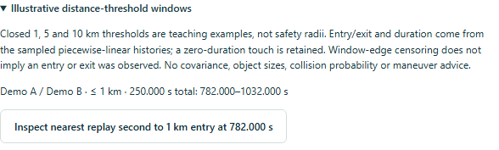
Figure 1 Visible portion of the selected 1 km teaching window: Demo A/B, 782–1032 seconds, 250 seconds total. The full nine-window contract was validated separately; these are illustrative distances, not safety radii or collision probabilities.

A worked application journey
The worked example compares fictional crossing screening windows with frozen historical iss frame. Interpret the results using the model assumptions and limits on the final page.
1. Open the application shortcut to start its local web interface and console. Select a prepared scenario or your own supported input; the examples require no external account or live hardware.
2. Choose synthetic-crossing with a 30-minute window. Expand the screening windows, focus one in the replay and export it. Compare the frozen historical ISS view.
3. Review the main case alongside the boundary case shown in Figure 2. Nine sampled screening windows were retained; the narrow example spans 782 to 1032 seconds. The frozen historical view retained its TEME frame and no invented windows.
4. Download the supported evidence report and retain the input/configuration with it. Recompute after an input change; do not reuse a result under a different configuration.
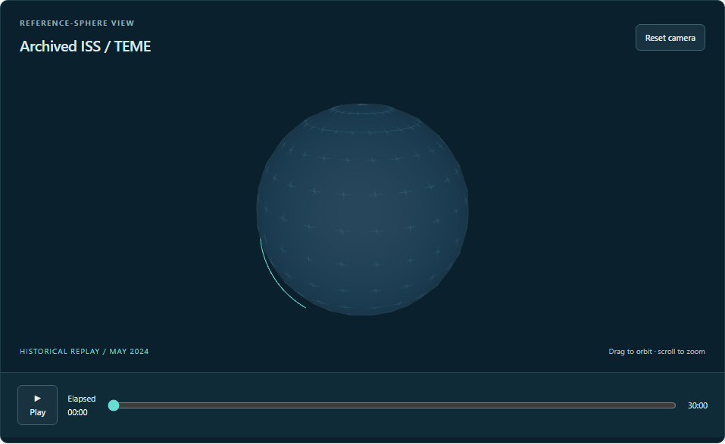
Figure 2 Actual installed application showing frozen historical iss frame. Captured during the accepted native user journey with prepared synthetic inputs.

Important implementation details

Screening windows
Stationary and moving relative segments use separate threshold-window calculations; endpoints are clipped to each sampled interval and touching windows merge only within numerical tolerance. This is geometric teaching evidence, not collision probability.
orbital/screening.py lines 41 to 62
41 speed2 = sum(x * x for x in delta)
42 if speed2 == 0:
43 if sum(x * x for x in relative) > radius_km**2:
44 continue
45 entry, exit_ = 0.0, 1.0
46 else:
47 center = -sum(x * y for x, y in zip(relative, delta, strict=True)) / speed2
48 perpendicular2 = sum(
49 (x + center * y) ** 2 for x, y in zip(relative, delta, strict=True)
50 )
51 if perpendicular2 > radius_km**2:
52 continue
53 half = math.sqrt(max(0, (radius_km**2 - perpendicular2) / speed2))
54 entry, exit_ = max(0.0, center - half), min(1.0, center + half)
55 if entry > exit_:
56 continue
57 start = a.t + entry * (b.t - a.t)
58 end = a.t + exit_ * (b.t - a.t)
59 if windows and start <= windows[-1]["end_s"] + 1e-9:
60 windows[-1]["end_s"] = max(end, windows[-1]["end_s"])
61 else:
62 windows.append({"start_s": start, "end_s": end})
Source file SHA256 4ff01acd36818ec1c41422ab12989324c4d0e6f90a6e9e5d56a8895e62467cb4

Validation results and operating limits
Runtime source 89278b3a1997c3b4ab3f4b7acc81672a87a5f22e
Check | Observed evidence | Result
Published package | Exact public release, provider/sidecar hashes and installed resources verified; installed bytes unchanged. | Passed
Actual native core | The existing packaged CLI/API and native feature acceptance helper passed on the installed executable. | Passed
Scenario evidence | Nine sampled screening windows were retained; the narrow example spans 782 to 1032 seconds. The frozen historical view retained its TEME frame and no invented windows. | Passed
UI and cleanup | Actual compiled-application browser journey passed. Both images were individually inspected; cleanup left no owned child process. | Passed

Installation and private data
Use the complete matching Windows portable folder from Releases, including all companion files; verify the SHA256 sidecar before extracting it. Keep application files separate from your inputs, downloaded reports and optional CLI history.
Return to this app's own console and press Ctrl+C. Closing its browser tab alone does not stop the service.

Limits and help
Frozen/synthetic educational propagation only; no live catalogs, maneuver generation, interception, targeting or weapons guidance.
These Windows portable checks used isolated synthetic inputs. System-wide installation, default-browser opening, desktop shortcuts and mobile installation were outside this test. Additional shortcut checks are recorded separately. No user data or Docker configuration changed.
Release and checksums | Runtime source | Project usage and limits

