OT Security Monitor Workbench Application Guide
Windows use and validation
By Jason Stys Version 1.1.0 11 November 2026
Review authorized offline industrial-network captures, TCP/Modbus observations, configured-register coverage and reasoned analyst dispositions. Keep absent observation distinct from a verified safe device.
The independently downloaded and installed application passed its real user workflows. Current main checks and processed CodeQL passed before publication. Icon targets were verified; normal default-profile shortcut activation is separately untested.

Capabilities and previous improvements
Adds editable capture/policy inputs, explicit bounded policy overrides, source-bound reviews, literal evidence search, exact bundle export and persistent saved analyses. The original conservative passive protocol engine remains authoritative.
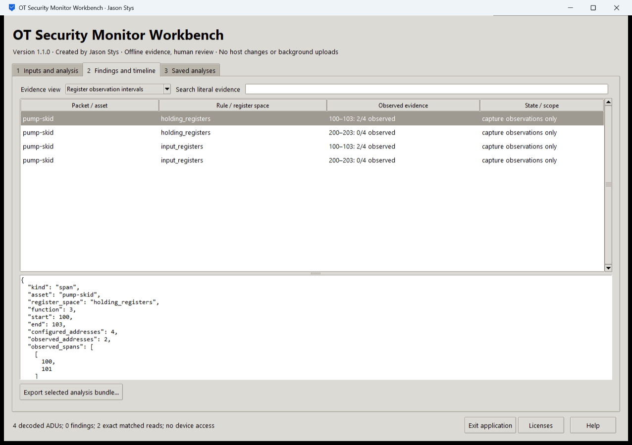
Figure 1 The installed app shows explicit register observation intervals: two of four addresses observed in one span and zero of four in another. These are capture observations, not verified device state.

A worked application journey
An industrial-network analyst reviews a fictional pump-skid capture. Two addresses in one four-address span were observed; another span had no observations. They inspect coverage before interpreting the absence of findings.
1. Choose an authorized capture and original policy, or load a prepared fictional scenario inside the real app. Review optional bounded overrides and acknowledge permission.
2. Run the original passive analysis. Inspect protocol findings separately from register observation intervals and unresolved capture limitations.
3. Use literal evidence search and row details. Record the reason for a local review without changing original source evidence or treating unseen addresses as safe.
4. Export the selected complete analysis bundle, quit normally and reopen Saved analyses to inspect the same persisted evidence.
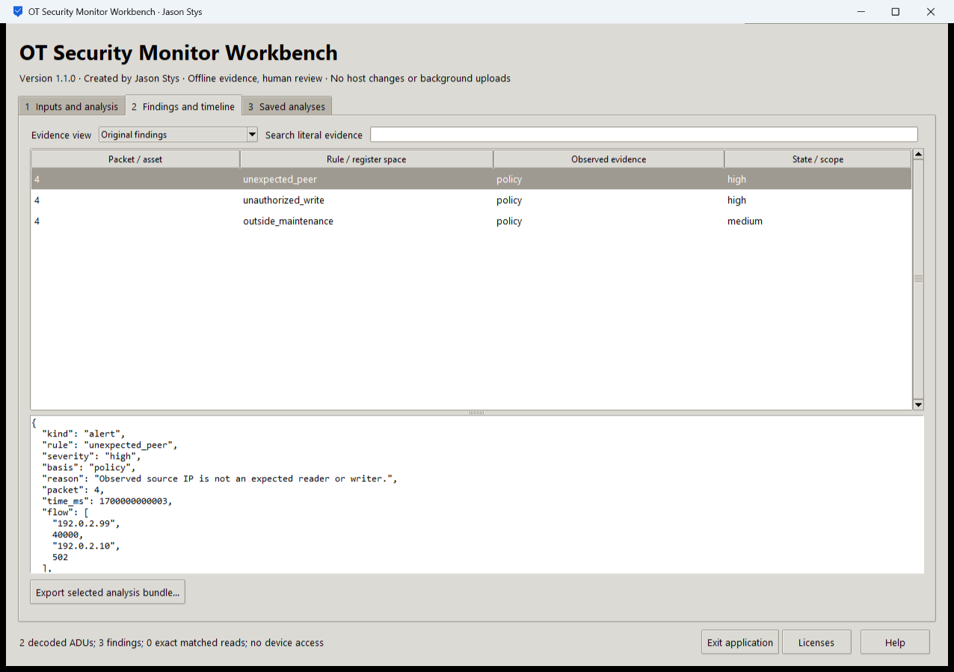
Figure 2 The installed evidence view retains source-bound details, original protocol scope and human review context; search changes presentation rather than underlying capture evidence.

Important implementation details

Preserve policy bytes unless the user explicitly overrides a bounded field
Overrides accept only explicit bounded decimal values. The original policy is retained when no override is provided, and the resulting policy is validated before analysis.
otmon/desktop_project.py lines 163 to 186
163 def effective_policy(raw: bytes, parameters: dict[str, str]) -> tuple[bytes, list[str]]:
164 """Preserve the original policy exactly unless explicit bounded scalar overrides are supplied."""
165 config = json_value(raw)
166 if not isinstance(config, dict):
167 raise Rejected("policy object required")
168 changed = []
169 for name, maximum in (
170 ("response_timeout_ms", 60000),
171 ("rate_window_ms", 60000),
172 ("rate_limit", 10000),
173 ):
174 value = parameters.get(name, "").strip()
175 if value:
176 if (
177 not value.isascii()
178 or not value.isdecimal()
179 or not 1 <= int(value) <= maximum
180 ):
181 raise Rejected("invalid policy override")
182 config[name] = int(value)
183 changed.append(name)
184 result = canonical(config) if changed else raw
185 policy(result)
186 return result, changed
Source file SHA256 b0d4d1d45884439dbb5a8f47492a06645e4f9d5725cae3bda23e96221e34f86a

Validation results and operating limits
Runtime source b9ec245296cb5900e98d490ca52641b02522dee8
Check | Observed evidence | Result
Actual installed native journeys | Two installed launches passed nine workflows, nine exact saved bundles, invalid-input preservation and normal exits. | Passed
Original engines and security | Original TCP/Modbus parsing and coverage tests, source/privacy checks, actual TShark interoperability where configured and processed CodeQL passed on exact main. | Passed
Package and runtime identity | Five independently downloaded assets matched provider SHA-256. Actual installed bytes and source/runtime identities matched the reviewed clean-main proof. | Passed
Launch and privacy boundary | Individual Desktop and Start-menu link targets passed read-back. Installed EXEs were exercised separately with synthetic profiles; normal default-profile shortcut activation was not independently exercised. | Passed

Installation and private data
Download the Windows EXE, checksum sidecar and notices. Verify the hash and launch the EXE. Retain old versions and stopped-profile backups; no Python setup or Docker is required.
Open the individual Desktop icon and read Help/notices. Quit through the app; prepared examples are inputs in the real application, never separate demo apps.

Limits and help
Passive offline observations cannot establish current device safety or completeness. The app sends no packets, reads no real device, changes no controller and performs no enforcement.
Unsigned Windows portable EXE. Saved evidence is plaintext owner-local data. Static alias guards do not isolate a malicious same-OS-user process. No ordinary profile or Docker setting was changed.
Release and checksums | Runtime source | Usage and limits

