Personal Image Model Studio Application Guide
Windows use and validation
By Jason Stys Version 0.3.1 11 November 2026
Review approved image-and-caption data, train a compact native diffusion model, generate and compare images, and retain the datasets, learned weights, reports and human feedback in a private local account.
The independently downloaded Windows app passed all original installed CPU and browser workflows. An actual published 0.3.0 to installed 0.3.1 encrypted-account upgrade preserved old evidence, reused its learned model, reopened again and closed normally three times. Ordinary account data was not opened.

Capabilities and previous improvements
The preserved dataset, glossary, rights declarations, bounded quality review, real CPU training, learned generation, history and feedback now run from a portable application with a native owner window. Open, Help, runtime notices and completion-aware Quit remain available without an IDE or Python setup.
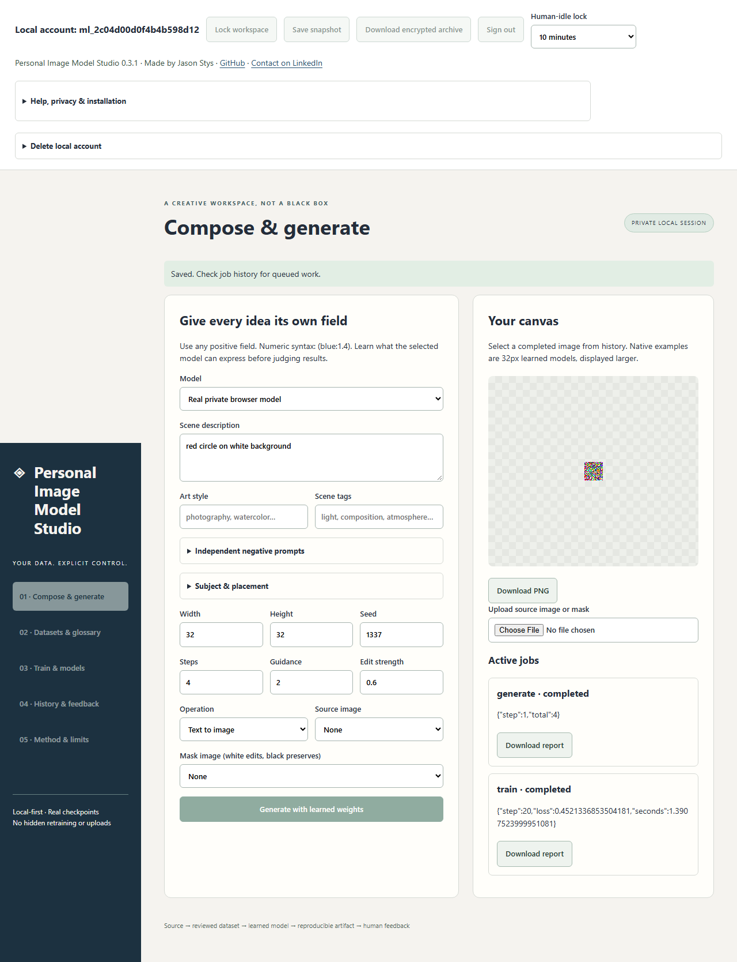
Figure 1 A fresh synthetic account completed 20 CPU optimizer steps and generated a 32-pixel PNG using its learned weights. The noisy enlarged result proves execution; this short regression does not demonstrate useful image quality.

A worked application journey
A local model developer reviews owned synthetic captions and images, performs a small CPU training run, generates a PNG, records feedback, seals the workspace and reopens its model and evidence after upgrading the application.
1. Launch the native owner window, open the local interface, create an alias and unique login password, save the one-time recovery code privately, and choose a separate vault phrase. Login recovery cannot recover a lost vault phrase.
2. Use Datasets to create owned synthetic inputs or explicitly import approved images and captions. Review origin declarations, eligibility, file integrity and cross-split similarity; inspect candidates before training.
3. Select the dataset in Train, choose native CPU mode and a bounded step budget. Inspect the completed report, then choose the learned model in Compose, generate and download a PNG, and use History for feedback.
4. Save or lock, wait for completion, and use Quit application to stop the owned service. Preserve the complete protected account directory and previous app for recovery; upgrading the executable does not require recreating an account.
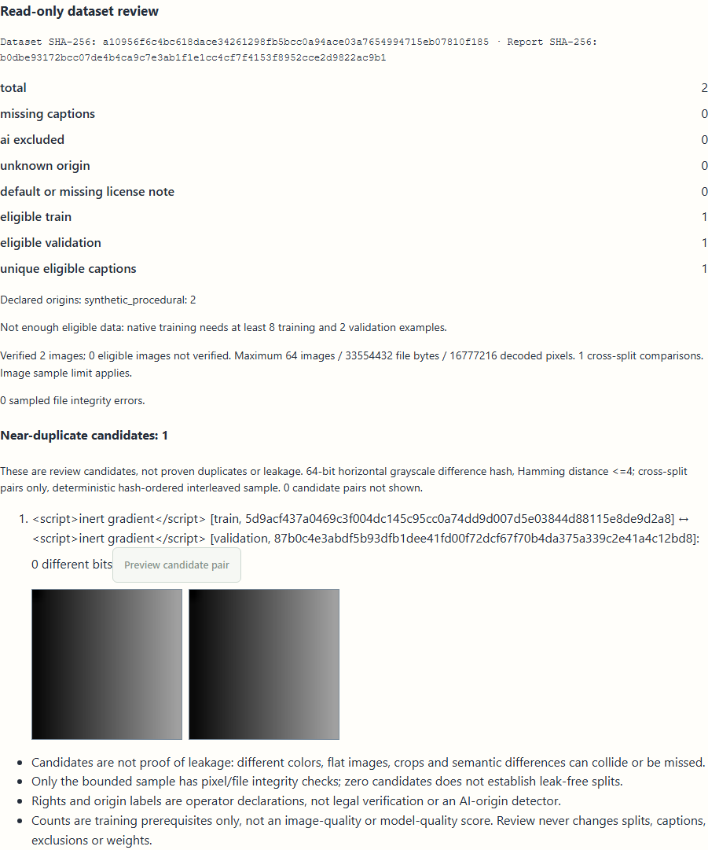
Figure 2 Two synthetic gradients have one near-duplicate candidate and insufficient training counts. Caption markup remains literal. Review neither changes splits nor establishes legal rights or model quality.

Important implementation details

Authenticate before parsing a restored workspace
The bounded archive reader validates the format and streams AES-GCM ciphertext into a private temporary file. finalize authenticates the complete stream before the next ZIP-parsing step. Later entry checks reject traversal, aliases, duplicates and excessive sizes; a wrong key cannot expose an extracted workspace.
studio/vault.py lines 157 to 180
157 def decrypt_workspace(source: Path, root: Path, key: bytes) -> str:
158 """Authenticate the entire archive before opening ZIP or exposing extracted files to the ML engine."""
159 if source.stat().st_size < 36 or source.stat().st_size > MAX_BYTES + 32 * CHUNK:
160 raise ValueError("Invalid encrypted workspace size")
161 descriptor, temporary = tempfile.mkstemp(prefix=".verified-", dir=root.parent)
162 try:
163 with source.open("rb") as stream, os.fdopen(descriptor, "wb") as plain:
164 if stream.read(8) != MAGIC:
165 raise ValueError("Unsupported encrypted workspace version")
166 nonce = stream.read(12)
167 stream.seek(-16, os.SEEK_END)
168 tag = stream.read(16)
169 stream.seek(20)
170 remaining = source.stat().st_size - 36
171 decryptor = Cipher(algorithms.AES(key), modes.GCM(nonce, tag)).decryptor()
172 decryptor.authenticate_additional_data(AAD)
173 while remaining:
174 chunk = stream.read(min(CHUNK, remaining))
175 if not chunk:
176 raise ValueError("Truncated encrypted workspace")
177 remaining -= len(chunk)
178 plain.write(decryptor.update(chunk))
179 plain.write(decryptor.finalize())
180 with zipfile.ZipFile(temporary) as archive:
Source file SHA256 644a665474879e4a480a09980a7c77447db9fe4518a5a7c158df17e36741fe66

Validation results and operating limits
Runtime source fb62b95a291ed2370d639e958d6f3039a7cdf0b6
Check | Observed evidence | Result
Actual installed application | All 12 original CPU checks and six private-account/real-model browser journeys passed. Both owned processes exited zero and listeners closed. All five installed files remained unchanged. | Passed
Real 0.3.0 to 0.3.1 upgrade | Existing credentials, datasets, learned model, images, reports, glossary and feedback were retained. Wrong password/key refused; old model generated a new image; second new process restored exact history. Three normal zero exits. | Passed
Source, security and distribution | All 25 PR checks and fresh source/native/security workflows passed, including real extracted workflows on three platforms. Three actual raw CodeQL categories had no findings. All six downloaded assets matched provider hashes, sidecars and embedded clean-source identity. | Passed

Installation and private data
Verify the matching SHA256 and extract the complete Windows x64 archive. Retain all five files and dependency notices. Launch PersonalImageModelStudio.exe or its individual Desktop icon; use the native owner window to open the local browser and quit. CPython 3.14.10 and actual native CPU ML are bundled.
Existing accounts stay outside the installation at %LOCALAPPDATA%\PersonalImageModelStudioAccounts. Passwords are hashed; locked workspace archives are authenticated and encrypted. Actual ML needs temporary plaintext and a key in the trusted local service. Ordinary profiles and Docker were not changed by validation.

Limits and help
This is a local loopback application, not public account hosting or a native mobile app. OS administrators, same-user malware, extensions and crash recovery remain outside its privacy guarantee. Keep a complete stopped-profile backup and the vault phrase; there is no developer recovery backdoor.
The unsigned portable package is not publisher-certified. Compact models and short synthetic runs do not promise photorealism or useful accuracy. Optional classic SD/LoRA needs the preserved full source environment and an explicitly trusted runtime; no pretrained weights or automatic provider imports ship.
Release and checksums | Exact runtime source | Account and recovery limits

