Player Telemetry Analytics Application Guide
Windows use and validation
By Jason Stys Version 1.1.0 10–11 November 2026
Import supported event batches, inspect actual DuckDB cohort/session/player analyses, retain durable accepted batches, and export Parquet verified by an independent reader.
The downloaded Windows app passed its full workflow with synthetic data. Required main-branch checks and security scans passed for this source revision. Desktop and Start-menu shortcut targets were verified; the installed app was tested separately.

Capabilities and previous improvements
Acquisition-cohort review includes receipt-time cutoffs, later activity across platforms, and mature versus censored D0/D1/D7 denominators. This prevents late arrivals and immature cohorts from producing misleading retention comparisons.
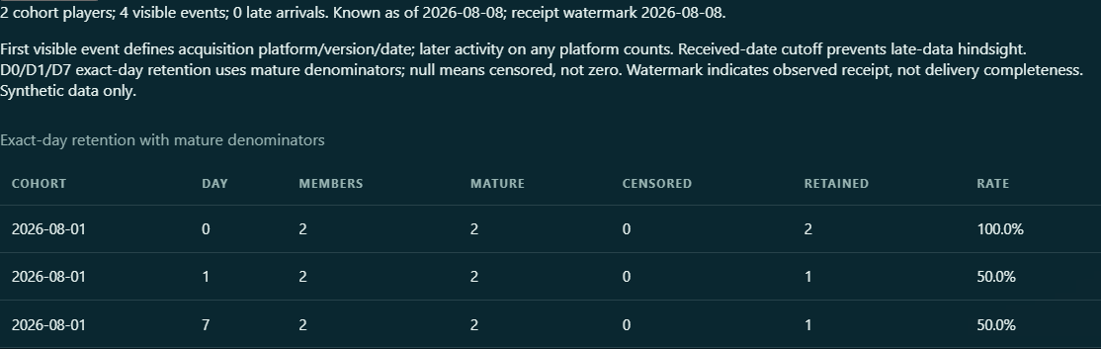
Figure 1 The installed analytics application displays the selected cohort and original warehouse results after the imported event workflow.

A worked application journey
A fictional game analytics team imports event batches, reviews cohorts and sessions, exports actual Parquet and reopens the retained accepted batches.
1. Open the app and select supported synthetic or deidentified event files in the import controls.
2. Import the batch and inspect accepted, quarantined and duplicate/replay outcomes before using its metrics.
3. Review cohorts, sessions and players with the actual warehouse queries; keep the selected filters visible.
4. Export Parquet and evidence, close normally, and reopen to verify the retained batches and player results.
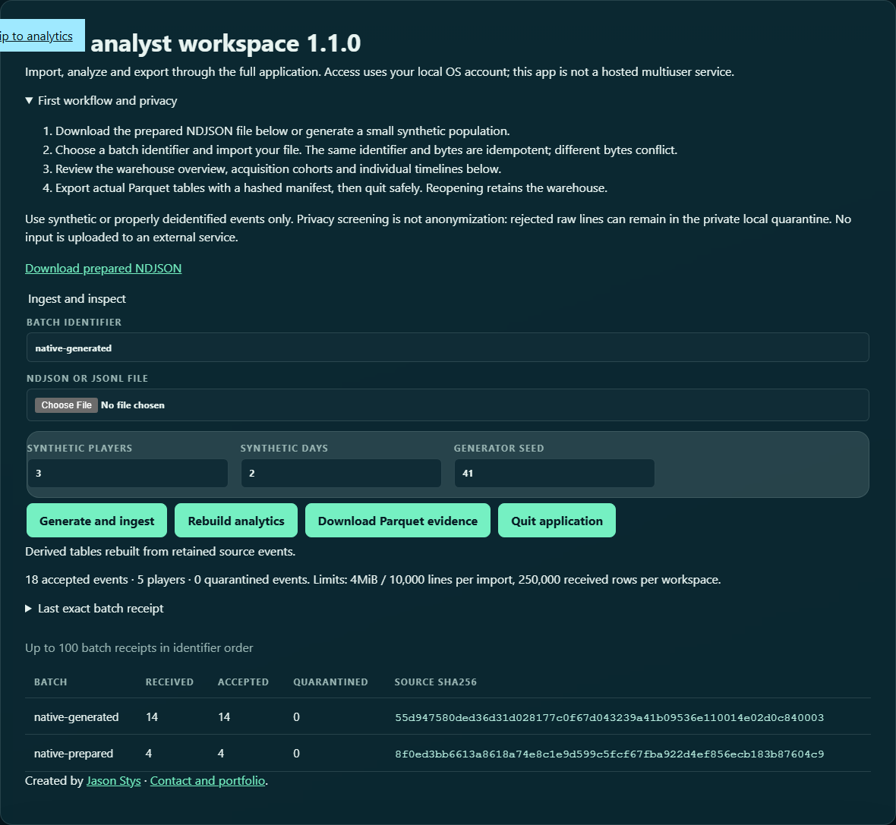
Figure 2 The installed application displays the accepted workspace and its original project results using synthetic data.

Important implementation details

Retained database operations remain serialized through repeated HTTP cancellation
The warehouse lock stays held while the owned task completes. Repeated HTTP cancellation is recorded without abandoning the database operation; the pending set is cleared only after completion. Shutdown drains retained tasks before releasing the profile.
desktop/service.py lines 47 to 69
47 async with self.lock:
48 task = asyncio.create_task(asyncio.to_thread(complete))
49 self.pending.add(task)
50 cancelled = False
51 try:
52 while True:
53 try:
54 value, error = await asyncio.shield(task)
55 break
56 except asyncio.CancelledError:
57 if task.cancelled():
58 raise RuntimeError(
59 "Owned operation was unexpectedly cancelled"
60 ) from None
61 cancelled = True
62 if cancelled:
63 raise asyncio.CancelledError from error
64 if error is not None:
65 raise error
66 return value
67 finally:
68 if task.done():
69 self.pending.discard(task)
Source file SHA256 c4366eafe9458df478c8ce97b51663c732535cf337b377aab7980d2b03e674c1

Validation results and operating limits
Runtime source 9307b4aee75c7304ac9971dd502f5191d7fefe07
Check | Observed evidence | Result
Real native workflows | Two installed launches retained two batches/five players; independent Parquet reading and original DuckDB cohort/session results passed. | Passed
Source and security | All required main workflows for the runtime revision passed; processed CodeQL analyses reported zero open main alerts before release. | Passed
Distribution identity | All 2 assets matched provider/checksum identities; all 121 installed files remained unchanged during acceptance. | Verified
PC scope | New per-user version folder and individual links verified. Synthetic profiles only; existing data and Docker were not used or changed. | Verified

Installation and private data
Keep the complete extracted ZIP together and launch PlayerTelemetryAnalytics.exe. No system runtime or terminal setup is needed.
Open the verified Desktop icon. Help describes supported inputs and workflow limits; close through the app's owner controls and back up its external data directory after a normal exit.

Limits and help
Unsigned Windows portable app; no signed installer or clean-machine certification. The reference API remains unauthenticated; the native per-launch local session is not a hosted multiuser identity service.
Prepared inputs and acceptance used synthetic data only; normal profiles were not opened and Docker was unchanged. Local plaintext is trusted-OS-owner data, not protection against that OS user or administrator.
Release and checksums | Runtime source | Usage and limits

