Jason Stys Portfolio Application Guide
Windows use and validation
By Jason Stys Version 1.1.0 12 November 2026
Explore the actual portfolio offline, search projects, read case studies, and inspect source-bound current application downloads and illustrated guides in one native Windows application.
Five independently downloaded assets supplied the installed application. The complete original two-launch consumer passed with two normal exits, no renderer errors or outside responses, and all 196 program files unchanged. These are screenshots of that installed application.

Capabilities and previous improvements
The searchable 67-project site, strongest-project case studies and earlier validation history remain. The current catalog separately identifies released runtime source, later repository checks and current Windows guides. The native edition bundles that same site with Back, Forward, Overview, Help, exact source identity and completion-aware Exit.
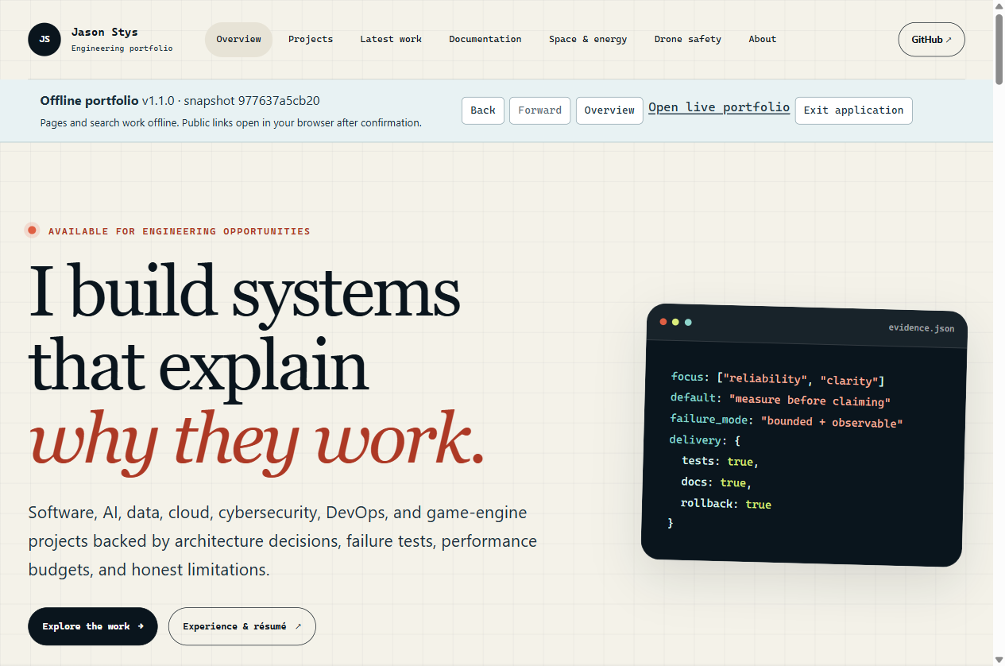
Figure 1 The installed application displays the real portfolio homepage, native navigation and immutable snapshot identity. Its bundled catalog includes 67 project pages and 66 other current application records.

A worked application journey
A reviewer searches for a project, narrows the catalog by language, opens a case study and reviews current download evidence, then returns through native history and reads the author's background without requiring a local web server.
1. Launch JasonStysPortfolio.exe or its verified individual icon. The bundled homepage opens offline. Use Help for operating limits; the visible native strip identifies version and source. No account or IDE is required.
2. Open Projects, enter a search or use the Role, Language, Domain and Maturity filters. Open a project for its purpose, practical improvements, rationale, limitations and links. Back and Forward preserve document, query and fragment navigation.
3. Use Downloads for current packages, checksums, prerequisites and immutable Word guides. All current entries have static paginated navigation and a complete JSON index. Earlier release evidence has a separately labeled history view; another platform's published asset is not a test result on this PC.
4. Choose a public link and review its Cancel-default confirmation. Cancel stays in the app; Open uses your external browser and network. The app does not fetch linked programs. Use Overview, About or Exit; accepted confirmations finish before normal shutdown.
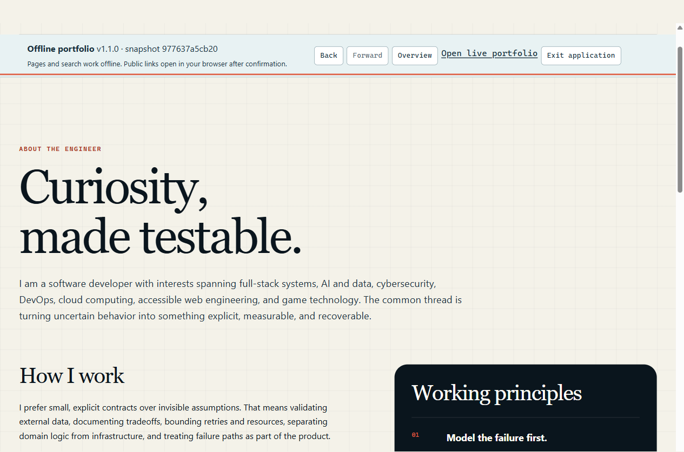
Figure 2 Keyboard and native navigation reach the actual About page. Public reference and contact links require a separate confirmation before opening an external browser.

Important implementation details

Retain accepted work through Exit
Only one public-link operation is admitted at a time. The finally block releases it after actual completion; shutdown closes admission and awaits every already accepted operation before the owner exits.
desktop/operations.cjs lines 16 to 32
16 async run(work) {
17 if (closing || pending.size) throw new Error("Finish the current public-link request first.");
18 const task = Promise.resolve().then(work);
19 pending.add(task);
20 try {
21 return await task;
22 } finally {
23 pending.delete(task);
24 }
25 },
26 stopAdmission() {
27 closing = true;
28 },
29 async finish() {
30 closing = true;
31 await Promise.allSettled([...pending]);
32 },
Source file SHA256 48fdfe8484bccb378286a849494015414cf587266b3096961dd2266c2722488d

Validation results and operating limits
Runtime source 977637a5cb208ab0181c6d56f960efbcb6adab22
Check | Observed evidence | Result
Installed consumer | Original complete journey: two normal exits, source identity, responsive layouts, project search/history, all current download pages and JSON. All 196 program files unchanged. | Passed
Isolation and closure | Native isolation and permission/network/popup refusal passed, as did Cancel/Open, durable restart and held confirmation through Quit/Close. Only the OS dialog and external opener were substituted. | Passed
Delivery and source | Five provider downloads matched identities. Desktop and Start-menu targets read back. All three main workflows and two processed CodeQL categories passed. Ordinary default-profile icon activation was not performed. | Passed

Installation and private data
Download the Windows x64 ZIP, matching SHA256 sidecar and package-integrity.json from Releases. Verify them and extract the complete folder. Retain every runtime file, resource and license notice; launch JasonStysPortfolio.exe. No system Node.js, Python, Docker or local HTTP service is required.
Use the individual Desktop icon and native Help/Exit. Browser state is stored outside installation under the trusted OS owner. The portable program folder is not an account backup. Do not remove an owner lock to force a second instance.

Limits and help
Unsigned Windows x64 portable software; no signed installer, automatic updater or clean-machine/cross-platform certification. Local plaintext browser state and static filesystem admission do not protect against a hostile process with the same OS account.
The native snapshot is immutable at its stated runtime source. Later website and guide metadata can describe newer publication facts. Public links need your confirmation and an external browser/network. The app does not launch other portfolio programs; existing accounts/data and Docker were unchanged.
Release | Exact runtime source | Usage and limits

