Reactor Systems Simulator Project Guide
  - By Jason Stys
Public source revision a6d4fc55f126
This edition documents the cited source. Validation observations below identify their own tested revision and time; they are not a promise that an unrun later revision passed.
A local, interactive fictional thermal-system learning workbench by Jason Stys. C++ computes an energy-conserving two-node analogy; TypeScript visualizes it; Python serves the app and produces auditable reports. SQL supports optional local immutable experiment history.
Explore fictional dimensionless thermal lessons, compare forcing with matched baselines and export sampled differences through 1.1 portable apps.
Packages the numerical kernel and explanatory interface so a reviewer can distinguish changed forcing from changed assumptions and inspect the same evidence after extraction.

Purpose operation and implementation
The matched forcing comparison now isolates scenario changes against a constant-forcing control at identical settings, with sampled signed/absolute deviations and explicit model-time witnesses. It remains a dimensionless teaching analogy and adds no reactor physics or operating guidance.
Despite its nuclear-energy learning context and name, this is not reactor physics. It cannot design, predict, monitor, control or assess the safety of any real reactor. All coefficients, inputs, time and outputs are invented and dimensionless. It has no fuel/rod selection, neutron kinetics, criticality, radiation/dose, decay heat or real telemetry. Source-off is not a nuclear shutdown/SCRAM model. See model boundary.
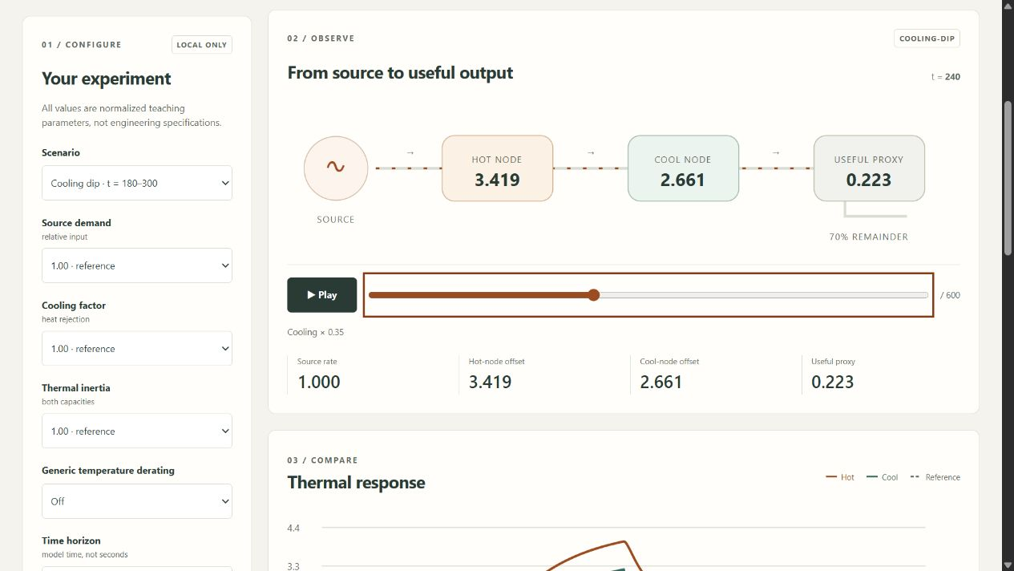
The local thermal experiment workbench

Explore
- Four synthetic experiments: constant source, demand step, temporary cooling dip, and source input removed.
- Bounded source demand, cooling factor, thermal inertia and generic temperature derating—not nuclear reactivity feedback.
- An animated energy network, experiment/reference temperature curves, keyboard timeline, playback, readable data table and energy ledger.
- JSON, CSV and inert HTML reports containing full samples, assumptions, numeric residuals, settings and a SHA-256 identity.
- Optional CLI-only SQLite history: parameterized inserts, content verification, no updates/deletes, 100-run cap.
- Loopback-only service; no accounts, uploads, cloud APIs, analytics or external assets. Mobile-responsive browser UI.

Run the app
Download the matching versioned portable archive (Windows ZIP; Linux/macOS .tar.gz) and its SHA-256 file from Releases. Verify the checksum, extract the entire archive, then launch ReactorSystemsSimulator.exe (Windows) or ReactorSystemsSimulator (Linux/macOS). A local browser window opens; closing its console stops the service. No compiler, Node, Python setup, admin rights or real reactor data is needed for packaged apps.
The bundles are unsigned, not notarized or store-certified. Do not disable OS protections or bypass warnings; build reviewed source if your OS blocks the bundle. Builds target the architecture listed on each asset, not every architecture. Mobile uses a compatible browser connected to its own local runtime; no native Android/iOS package or public hosting is provided. The server deliberately does not expose a LAN/public address.

Build reviewed source
Requires Python 3.12–3.14, Node 24 and a C++20 toolchain (Visual Studio 2022/2026 C++ tools on Windows, GCC/Clang on Linux, Xcode command-line tools on macOS). Commands run from this repository root:
python -m venv .venv
# Activate .venv with your platform's standard command.
python -m pip install --require-hashes -r requirements-dev.lock
python tools/build_native.py
npm ci
npm run build
python -m simulator serve
The service prints an ephemeral http://127.0.0.1:<port>/ URL. For a fixed local port: python -m simulator serve --port 8775 --no-browser. The bundled application is a local web application, not an embedded webview with extra native privileges.
python -m simulator export --scenario cooling-dip --cooling 0.5 --duration 300 --output evidence.json
python -m simulator export --scenario source-off --format csv --output samples.csv --history history.sqlite3
Exports refuse to overwrite existing files. History and file export are separate transactions. Paths and database files are never accepted through HTTP.

Verify
python tools/build_native.py
python -m pytest --cov=simulator --cov-report=term-missing
python -m ruff check simulator tests tools launcher.py
python -m ruff format --check simulator tests tools launcher.py
python -m mypy simulator
python tools/verify_repo.py
npm run format:check
npm test
npm run build
npx playwright install chromium firefox webkit
npm run test:e2e
python -m pip_audit --disable-pip --no-deps -r requirements-dev.lock
npm run audit
python tools/package_app.py
Linux also runs Clang AddressSanitizer/UndefinedBehaviorSanitizer and GCC coverage. Validation evidence distinguishes numerical verification from physical validation. CI gates Python branch/line coverage at 90% and production C++ line coverage at 90%; it does not hide exclusions. Actions uploads no run artifacts or caches. Release archives go directly to draft GitHub Releases after successful exact-commit checks.

Project map
Area | Responsibility
native/model.hpp, model.cpp | Fictional coefficients/contracts, bounded inputs, source relaxation and conservative heat balance
native/cli.cpp, tests.cpp | Fixed numeric JSON worker and Release-active native regression tests
simulator/engine.py | Reviewed settings, worker isolation/validation, detached cache, provenance and content IDs
simulator/server.py | Read-only loopback HTTP, origin/Host checks, asset confinement and restrictive headers
simulator/reports.py, resources/history.sql | JSON/CSV/HTML evidence and explicit local immutable history
simulator/__main__.py, launcher.py | Source/portable startup and no-overwrite CLI exports
web/ | Responsive accessible interface, SVG plots/network, finite preferences and stale-request protection
tests/ | Independent reference, property, security, integration, display and cross-engine browser tests
tools/ | Native build, generated exact-line inventories, packaging, frozen-app smoke and gated release tools
.github/workflows/ | Cross-platform tests/packages, native sanitizers/coverage, CodeQL and manual draft releases

Every file is summarized in FILE_CATALOG. Code headers describe file responsibilities; function/class contracts explain inputs and state. CODE_INDEX is the CI-checked exact line map for functions, parameters, variables and structural identifiers, avoiding stale duplicated line numbers in headers.

Documentation and contact
User guide · Model & assumptions · Architecture / ADR · API · Security · Validation · Release guide · Dependencies
Created by Jason Stys. Portfolio/contact profile · Issues. MIT licensed; no certification, regulatory approval or suitability for nuclear operations is implied.

Portable release identity
The 1.1 release contract keeps the software version consistent across Python, npm, the running service and the UI. Versioned archives include RELEASE.json with source commit, platform and clean/dirty build status. Packaging tests the freshly extracted application, including its new practical workflow, from an unrelated temporary working directory. Windows uses ZIP; Linux/macOS use .tar.gz to preserve required native links and permissions. Published 1.0 assets remain unchanged. Check the selected release's source and version rather than assuming an older download contains current source improvements. See the portable operation and release guide.
Observed local packaging checks and boundaries: portable 1.1 validation.
Draft discovery uses a bounded complete authenticated release listing and numeric-ID verification; a published-only tag lookup cannot prove that an untagged draft is absent. The release guide documents fail-closed ambiguity/history limits and the no-overwrite policy.

Current scope and practical limits
- A fictional thermal analogy, with no nuclear physics, fuel, neutron, criticality, radiation or real-plant monitoring/control.
- Sampled extrema and numerical tolerances are not physical measurements, safety limits or operating recommendations.
- Unsigned educational desktop portable packages; no system installer, native mobile app, plant connection or safety certification.
The accompanying Validation Review records the exact tested baseline, workflow evidence, test scope and known gaps. The Excel workbook provides filterable workflow and test-source inventories; neither substitutes for the actual execution logs.

Source references and maintenance
Maintain the editable Markdown and this Word edition together. Preserve dated execution reports and re-run the documented checks before release.
README.md · docs/ARCHITECTURE.md · docs/reports/PORTABLE_RELEASE_20261109.md
Project source and current Actions · Contact Jason Stys

