Reactor Systems Simulator Application Guide
Windows use and validation
By Jason Stys Version 1.1.0 10 November 2026
Compare fictional dimensionless thermal forcing against a matched baseline. Prepared scenarios use the full Windows application and its existing model and report exports.
The published Windows portable application was installed and tested using isolated synthetic inputs. Provider and sidecar digests, release metadata and installed resource identities were checked. The installed file set remained unchanged after testing.

Capabilities and previous improvements
Compare matched dimensionless thermal lessons with forcing controls, sampled peaks and scenario differences. Improves educational cause-and-effect review within the documented non-operational model.
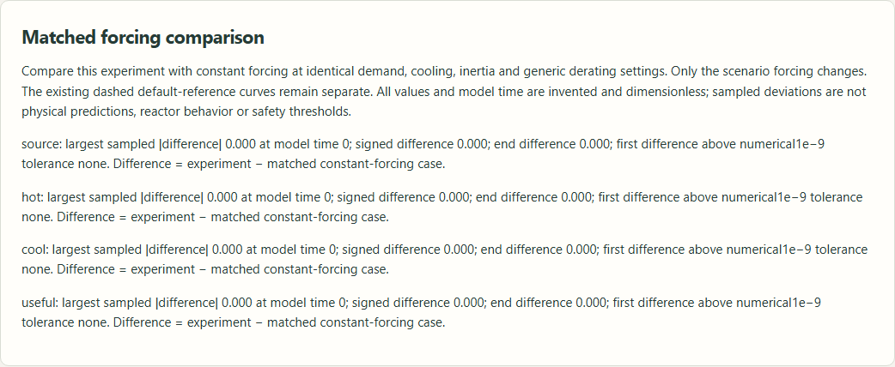
Figure 1 Actual installed application showing fictional matched baseline. Captured during the accepted native user journey with prepared synthetic inputs.

A worked application journey
The worked example compares fictional matched baseline with fictional cooling-dip forcing comparison. Interpret the results using the model assumptions and limits on the final page.
1. Open the application shortcut to start its local web interface and console. Select a prepared scenario or your own supported input; the examples require no external account or live hardware.
2. Run nominal and cooling-dip cases. Inspect the four field differences and extrema against their matched baselines; repeat with a supported nondefault setting and export the comparison.
3. Review the main case alongside the boundary case shown in Figure 2. Four dimensionless comparison series matched sample-by-sample differences and extrema. A nominal experiment had zero differences against its matched baseline.
4. Download the supported evidence report and retain the input/configuration with it. Recompute after an input change; do not reuse a result under a different configuration.
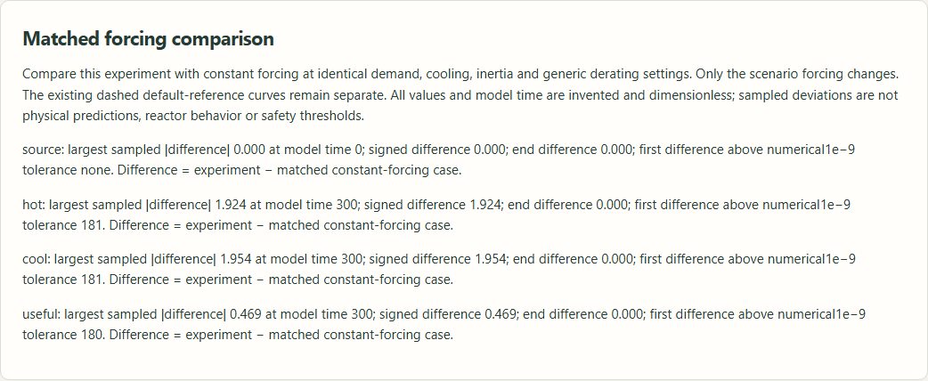
Figure 2 Actual installed application showing fictional cooling-dip forcing comparison. Captured during the accepted native user journey with prepared synthetic inputs.

Important implementation details

Forcing comparison
Strictly paired samples compare each dimensionless state against matched constant forcing. Sampled extrema and first numerical difference remain separate from endpoint difference; none is a physical reactor safety threshold.
simulator/comparison.py lines 17 to 32
17 for field in ("source", "hot", "cool", "useful"):
18 differences = [
19 (a["time"], a[field] - b[field])
20 for a, b in zip(experiment["samples"], matched["samples"], strict=True)
21 ]
22 time, peak = max(differences, key=lambda item: abs(item[1]))
23 rows.append(
24 {
25 "field": field,
26 "peak_absolute_difference": abs(peak),
27 "peak_signed_difference": peak,
28 "peak_sample_time": time,
29 "end_difference": differences[-1][1],
30 "first_difference_time": next(
31 (t for t, value in differences if abs(value) > 1e-9), None
32 ),
Source file SHA256 95a1c212af245ad7605f318eb8d5eab2b9aaa6ff694dba26cea818b3efd3c1ed

Validation results and operating limits
Runtime source a6d4fc55f12681c5b5bdec1dcd09ddb801d94683
Check | Observed evidence | Result
Published package | Exact public release, provider/sidecar hashes and installed resources verified; installed bytes unchanged. | Passed
Actual native core | The existing packaged CLI/API and native feature acceptance helper passed on the installed executable. | Passed
Scenario evidence | Four dimensionless comparison series matched sample-by-sample differences and extrema. A nominal experiment had zero differences against its matched baseline. | Passed
UI and cleanup | Actual compiled-application browser journey passed. Both images were individually inspected; cleanup left no owned child process. | Passed

Installation and private data
Use the complete matching Windows portable folder from Releases, including all companion files; verify the SHA256 sidecar before extracting it. Keep application files separate from your inputs, downloaded reports and optional CLI history.
Return to this app's own console and press Ctrl+C. Closing its browser tab alone does not stop the service.

Limits and help
Fictional thermal analogy only: no fuel, neutron/criticality, nuclear-reaction/radiation model, real reactor monitoring/control or design optimization.
These Windows portable checks used isolated synthetic inputs. System-wide installation, default-browser opening, desktop shortcuts and mobile installation were outside this test. Additional shortcut checks are recorded separately. No user data or Docker configuration changed.
Release and checksums | Runtime source | Project usage and limits

