Resilient Energy Microgrid Lab FIELDGRID Project Guide
  - By Jason Stys
Public source revision 39a16658fbb6
This edition documents the cited source. Validation observations below identify their own tested revision and time; they are not a promise that an unrun later revision passed.
The full-window feeder-loss stress workflow reevaluates both policies with feeder availability removed, preserving all other supplied assumptions. Compare service/storage effects and download the exact derived replay input; every stressed trace retains rational-reference and energy-audit gates.
Rehearse full-window feeder loss, compare two dispatch policies and download the derived replay input through 1.1 portable apps.
Lets a reviewer investigate service/storage tradeoffs with the same original assumptions and independently checked energy accounting, using an extracted package rather than a development environment.

Purpose operation and implementation
An offline energy-accounting workbench by Jason Stys. Explore how renewable output, battery limits, feeder interruptions and critical/flexible loads interact at a fictional remote research station. Compare two transparent dispatch policies from the same starting state, inspect hourly flows, and export reproducible evidence.
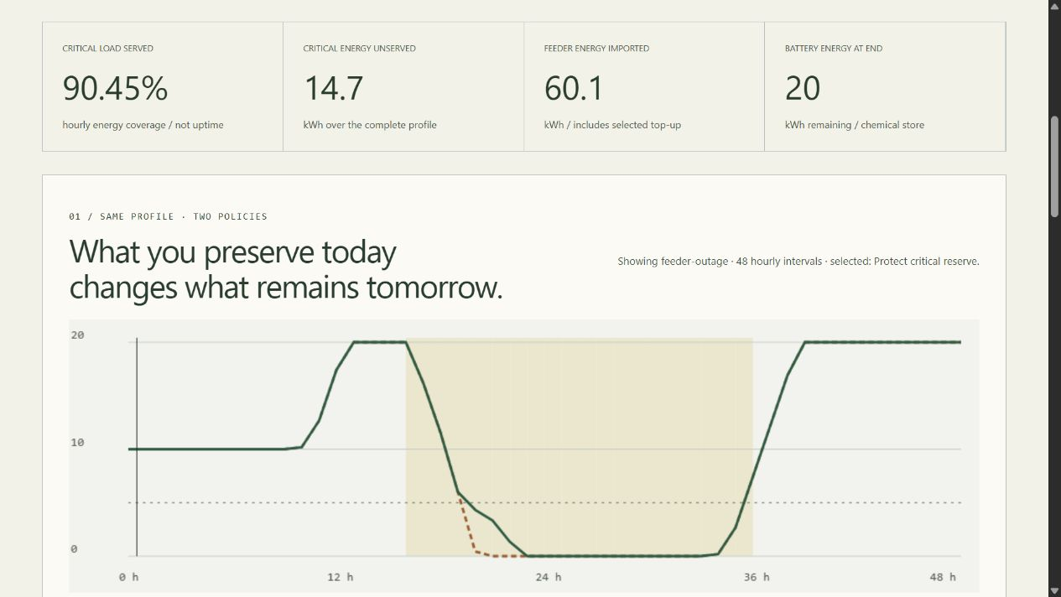
FIELDGRID browser interface

Use it
Download the Windows ZIP or Linux/macOS .tar.gz for your OS from Releases, verify its adjacent SHA-256 file, and extract the entire archive. Launch ResilientEnergyMicrogridLab (Windows: .exe) to open the local browser UI. No Python/Node installation, admin rights, account, cloud service or Docker is required for the portable app. Quit with Ctrl+C in its console. Unsigned software may trigger OS warnings; verify the source/checksum and do not bypass your organization's controls. Desktop Windows x64, Linux x64 and macOS arm64 are the release targets, not universal binaries or mobile installers.
Source setup with Python 3.12–3.14 and Node 24:
python -m venv .venv
# Activate the environment using the command for your shell.
python -m pip install --require-hashes -r requirements-dev.lock
npm ci
npm run build
python -m gridlab serve

What it demonstrates
- Python production dispatch and a separately implemented exact-rational reference, checked on every run.
- Capacity, initial energy, charge/discharge rates, efficiency losses, feeder caps, unavailable batteries and protected flexible-load reserves.
- Six fictional scenarios; 648 finite control combinations. Both heuristics prioritize critical load; only one restricts flexible battery service to preserve reserve.
- TypeScript/HTML/CSS UI with real Canvas energy traces, hourly inspector, policy comparison, keyboard/mobile layouts and help.
- Full JSON evidence, both-policy CSV, inert HTML, editable input JSON, and optional immutable SQLite history.
- Bounded local inputs, read-only loopback HTTP, pinned tooling, cross-platform CI, CodeQL and draft-gated portable releases without Actions artifact/cache uploads.

Example and interpretation
With default settings, protected-reserve dispatch supplies 90.454545% of critical energy versus 88.181818% for serve-all dispatch over the 48-hour feeder-outage profile. It leaves 14.7 kWh versus 18.2 kWh critical energy unserved, while shedding more flexible demand. The first critical-shortfall slot is hour 22 versus 20. Neither policy is universally best, and a single profile is not a reliability probability or optimization proof. Full regression summaries are in benchmark evidence.
python -m gridlab export --format input --output editable.json
python -m gridlab export --input editable.json --output evidence.json --history private.sqlite3
python -m gridlab export --scenario winter-drought --format csv --output drought.csv
Outputs are create-only; SQLite is explicit, unencrypted and local, with no automatic pruning. Do not submit sensitive infrastructure data.

Verify and navigate
python -m ruff check gridlab tests tools launcher.py
python -m ruff format --check gridlab tests tools launcher.py
python -m mypy gridlab
python tools/verify_repo.py
python -m pytest --cov=gridlab --cov-report=term-missing
python -m tools.benchmark
npm run format:check
npm test
npm run build
npx playwright install chromium firefox webkit
npm run test:e2e
npm run audit
python -m pip_audit --disable-pip --no-deps -r requirements-dev.lock
python tools/package_app.py
Main files: gridlab/model.py validates and builds profiles; dispatch.py allocates source-first flows; reference.py independently allocates load-first rational flows; engine.py checks ledgers, compares policies and summarizes; reports.py exports/stores evidence; server.py confines local HTTP; __main__.py provides CLI; web/main.ts renders the workbench; web/contracts.ts guards responses; tools/ validates inventories, benchmarks, packaging and release gates. Every file and exact function/variable location is indexed below.
User guide · Model/units · Architecture · API/input schema · Validation results · Release procedure · File catalog · Exact code index · Security · Third-party notices

Boundaries and contact
Synthetic civilian education only: no real telemetry, electrical control, power-flow solver, protection model, forecasts, battery certification, site calibration, reliability guarantee or optimal scheduling. Hourly energy adequacy does not establish electrical safety. Not affiliated with or endorsed by a government agency, employer, laboratory or equipment vendor.
Created by Jason Stys. Questions/issues · LinkedIn. MIT license; retain bundled runtime notices.

Portable release identity
The 1.1 release contract keeps the software version consistent across Python, npm, the running service and the UI. Versioned archives include RELEASE.json with source commit, platform and clean/dirty build status. Packaging tests the freshly extracted application, including its new practical workflow, from an unrelated temporary working directory. Windows uses ZIP; Linux/macOS use .tar.gz to preserve required native links and permissions. Published 1.0 assets remain unchanged. Check the selected release's source and version rather than assuming an older download contains current source improvements. See the portable operation and release guide.
Observed local packaging checks and boundaries: portable 1.1 validation.
Draft discovery uses a bounded complete authenticated release listing and numeric-ID verification; a published-only tag lookup cannot prove that an untagged draft is absent. The release guide documents fail-closed ambiguity/history limits and the no-overwrite policy.

Current scope and practical limits
- Synthetic hourly adequacy is not power flow, protection/transient behavior, a forecast or electrical safety.
- Stress removes supplied feeder availability across the whole window; it does not guarantee outage survival or optimize a real facility.
- Unsigned local portable desktop packages; no system installer, native mobile application or real infrastructure controls.
The accompanying Validation Review records the exact tested baseline, workflow evidence, test scope and known gaps. The Excel workbook provides filterable workflow and test-source inventories; neither substitutes for the actual execution logs.

Source references and maintenance
Maintain the editable Markdown and this Word edition together. Preserve dated execution reports and re-run the documented checks before release.
README.md · SECURITY.md · docs/ARCHITECTURE.md · docs/reports/PORTABLE_RELEASE_20261109.md
Project source and current Actions · Contact Jason Stys

