Resilient Energy Microgrid Lab Application Guide
Windows use and validation
By Jason Stys Version 1.1.0 10 November 2026
Compare two dispatch policies under full-window feeder loss using the same assumptions. Prepared scenarios use the full Windows application and its existing model and report exports.
The published Windows portable application was installed and tested using isolated synthetic inputs. Provider and sidecar digests, release metadata and installed resource identities were checked. The installed file set remained unchanged after testing.

Capabilities and previous improvements
Compare full-window feeder-loss contingencies under both policies with exact replay inputs and critical/flexible unmet-demand deltas. Supports transparent resilience planning with independently checked energy accounting.
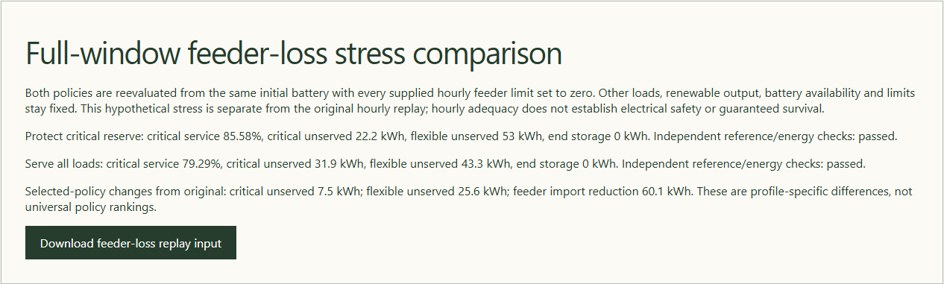
Figure 1 Actual installed application showing full-window feeder loss. Captured during the accepted native user journey with prepared synthetic inputs.

A worked application journey
The worked example compares full-window feeder loss with alternate dispatch policy under same loss. Interpret the results using the model assumptions and limits on the final page.
1. Open the application shortcut to start its local web interface and console. Select a prepared scenario or your own supported input; the examples require no external account or live hardware.
2. Compare the original profile with a full-window feeder loss. Review service and storage tradeoffs, download the derived replay input, and load that experiment under both dispatch policies.
3. Review the main case alongside the boundary case shown in Figure 2. The 48-row derived feeder-loss input retained its original configuration. Both policies imported zero grid energy, and independent energy ledgers agreed.
4. Download the supported evidence report and retain the input/configuration with it. Recompute after an input change; do not reuse a result under a different configuration.
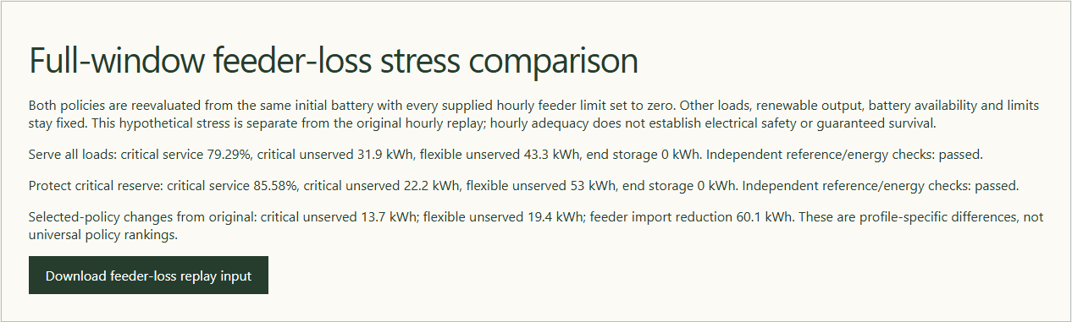
Figure 2 Actual installed application showing alternate dispatch policy under same loss. Captured during the accepted native user journey with prepared synthetic inputs.

Important implementation details

Analyze
Deep copies preserve the original hourly input and initial state while the derived stress case sets only feeder limits to zero. Both policies use the same evaluator, preventing an unequal or mutated baseline comparison.
gridlab/engine.py lines 205 to 221
205 validate(data)
206 selected = evaluate(data)
207 other = copy.deepcopy(data)
208 other["config"]["policy"] = 1 - data["config"]["policy"]
209 comparison = evaluate(other)
210 disrupted = copy.deepcopy(data)
211 disrupted["name"] = "full-feeder-loss"
212 disrupted["provenance"] = (
213 "Derived synthetic full-window feeder loss; original assumptions retained except grid_limit_w=0. Not measured."
214 )
215 for slot in disrupted["profile"]:
216 slot["grid_limit_w"] = 0
217 validate(disrupted)
218 stressed = evaluate(disrupted)
219 disrupted_other = copy.deepcopy(disrupted)
220 disrupted_other["config"]["policy"] = 1 - data["config"]["policy"]
221 stressed_other = evaluate(disrupted_other)
Source file SHA256 42e2c531f776061228c5fa87560faedcd3ef53c417d3df8682ce8926867305f0

Validation results and operating limits
Runtime source 39a16658fbb68bc2558aea4bf60ab74253ef2aba
Check | Observed evidence | Result
Published package | Exact public release, provider/sidecar hashes and installed resources verified; installed bytes unchanged. | Passed
Actual native core | The existing packaged CLI/API and native feature acceptance helper passed on the installed executable. | Passed
Scenario evidence | The 48-row derived feeder-loss input retained its original configuration. Both policies imported zero grid energy, and independent energy ledgers agreed. | Passed
UI and cleanup | Actual compiled-application browser journey passed. Both images were individually inspected; cleanup left no owned child process. | Passed

Installation and private data
Use the complete matching Windows portable folder from Releases, including all companion files; verify the SHA256 sidecar before extracting it. Keep application files separate from your inputs, downloaded reports and optional CLI history.
Return to this app's own console and press Ctrl+C. Closing its browser tab alone does not stop the service.

Limits and help
Synthetic hourly adequacy only; no electrical power flow, protection/control, real infrastructure command or electrical safety assertion.
These Windows portable checks used isolated synthetic inputs. System-wide installation, default-browser opening, desktop shortcuts and mobile installation were outside this test. Additional shortcut checks are recorded separately. No user data or Docker configuration changed.
Release and checksums | Runtime source | Project usage and limits

