RMF Evidence Workbench Application Guide
Windows use and validation
By Jason Stys Version 1.1.1 11 November 2026
Assess authorized evidence workspaces, validate six OSCAL model exports, compare revisions and inspect owner-calendar and ledger evidence. The workbench preserves source identities and uncertainty; an assessment does not grant authorization.
The installed 1.1.1 app passed its full native workflows and reopened the same synthetic profile created by 1.1.0 with exact saved evidence. Existing links were backed up and retargeted with read-back verification; default-profile shortcut activation was not independently exercised.

Capabilities and previous improvements
Build owner monitoring calendars and exact component-scoped freshness, integrity, risk and milestone work queues. Helps maintain evidence continuously without claiming that a dashboard grants authorization.
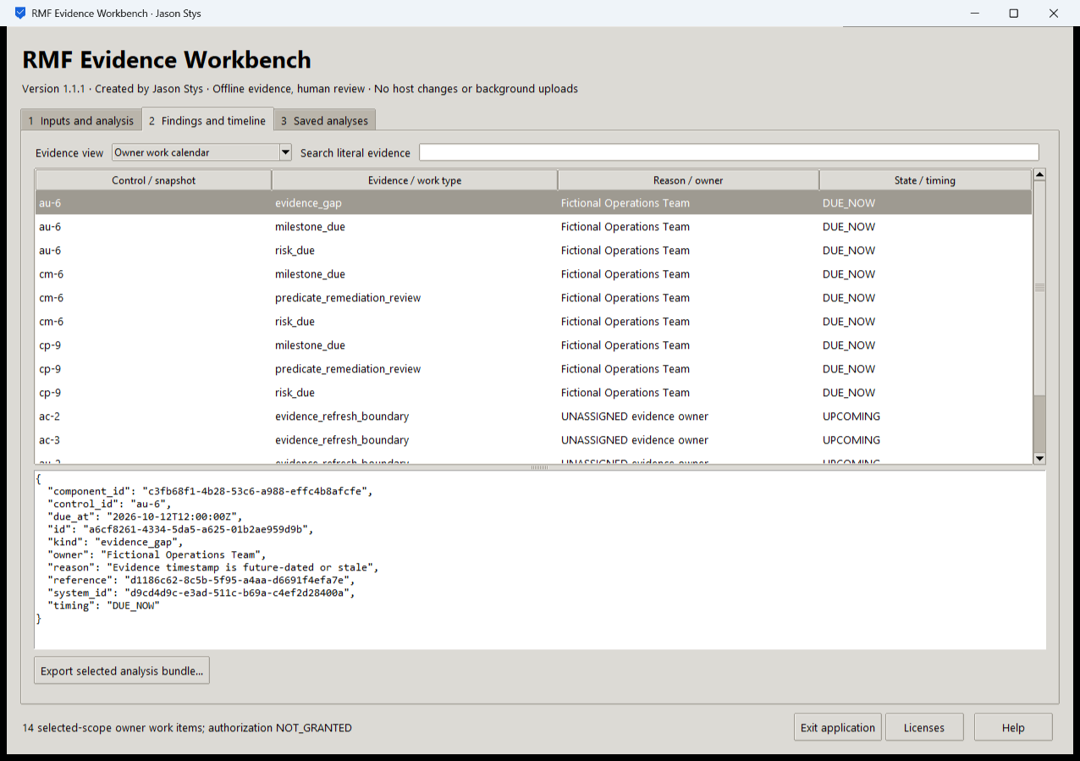
Figure 1 A separate workflow in the same installed workbench preserves its original review state and evidence rather than replacing it with a generic success message.

A worked application journey
An assessor opens a fictional evidence workspace, compares revisions, reviews owner-calendar findings and inspects an imported closed ledger without claiming an authorization decision.
1. Open the app and choose your supported authorized files or a prepared fictional scenario in Inputs and analysis.
2. Choose the required operation, inspect its actual parameters, acknowledge permission and Run selected analysis.
3. Inspect the original results in Findings and timeline, change evidence views and search literal records; retain unknown/inconclusive outcomes for review.
4. Export the selected bundle and reopen Saved analyses after a normal exit. Keep private evidence separate from any minimized handoff.
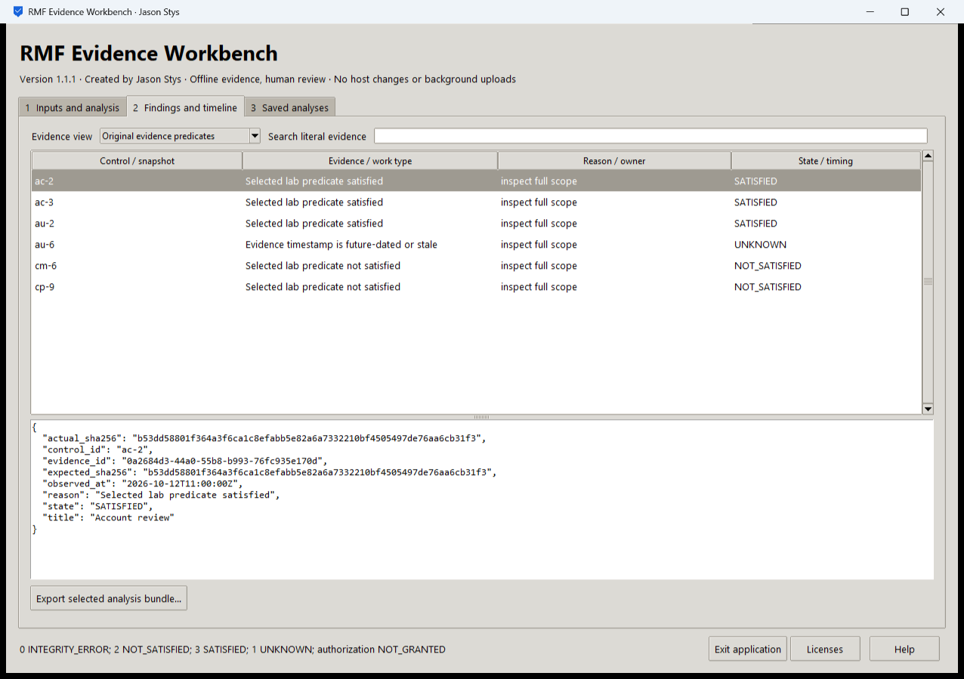
Figure 2 The installed workbench displays its accepted analysis and selected original evidence. These are fictional test inputs, not collected production records.

Important implementation details

Check fixed state before a write can follow an alias
This pre-initialization check requires any existing fixed state member to be an ordinary single-link file without a Windows reparse attribute. Startup and connection admission apply it to the known marker/lock/SQLite recovery paths; ordinary recovery files are retained.
rmf/desktop_state.py lines 213 to 225
213 def admit_existing(path: Path) -> None:
214 """Refuse pre-existing linked/nonregular fixed state before initialization can write through an alias."""
215 try:
216 info = path.lstat()
217 except FileNotFoundError:
218 return
219 if (
220 not stat.S_ISREG(info.st_mode)
221 or info.st_nlink != 1
222 or getattr(info, "st_file_attributes", 0)
223 & getattr(stat, "FILE_ATTRIBUTE_REPARSE_POINT", 0)
224 ):
225 raise Rejected("fixed workspace state must be unlinked one-link regular files")
Source file SHA256 0d56b4eb2129ba1b9e3b9bd0344c80e709f594b4d9dc99b6b32b860a3c208294

Validation results and operating limits
Runtime source b7e373ee01aea9cc4f29c6417936682cc59b8a0c
Check | Observed evidence | Result
Actual installed workflows | Full original domain, review and export controls passed two normal native launches; all 6 saved bundles retained exact original bytes. | Passed
Old-to-new profile | The actual installed 1.1.0 app created a synthetic profile; installed 1.1.1 reopened it and retained all 6 exact bundles without reset. | Passed
Source and distribution | Exact-main workflows and processed CodeQL passed with zero open main alerts. Five downloaded assets and installed files matched their verified SHA-256 identities. | Verified
PC and links | Existing links were backed up and retargeted with settings retained. Normal profiles and Docker were unchanged; default-profile shortcut activation remains separately untested. | Verified

Installation and private data
Use the matching Windows EXE, checksum and notices from Releases; no system Python or terminal setup is needed.
Open the verified Desktop icon. Help describes supported inputs and workflow limits; close through the app's owner controls and back up its external data directory after a normal exit.

Limits and help
Six educational predicates; no authorization to operate, risk acceptance, full NIST assessment or proof of collector authenticity. A blank ledger tip is unanchored. Even an independently retained matching tip is not a signed or timestamped authority.
Prepared inputs and acceptance used synthetic data only; normal profiles were not opened and Docker was unchanged. Local plaintext is trusted-OS-owner data, not protection against that OS user or administrator.
Release and checksums | Runtime source | Usage and limits

