Scientific Sensor Calibration Lab · DATUM Project Guide
  - By Jason Stys
Public source revision 1bdb2244451a
This edition documents the cited source. Validation observations below identify their own tested revision and time; they are not a promise that an unrun later revision passed.
Inspect each estimate's modeled uncertainty budget: response noise, fitted-parameter covariance, variance shares and dominant modeled source. Withheld estimates retain null contributions; the signed covariance cross term is explained without double counting.
Review per-estimate variance budgets, missing samples and expired-calibration withholding in the 1.1 portable calibration workflow.
Bundles the native fit/runtime with a practical uncertainty review and export path, tested against actual compiled execution and independent arithmetic after extraction.

Purpose operation and implementation
An offline calibration workbench by Jason Stys. Fit a fictional instrument's response, propagate uncertainty, validate on separate check records, inspect changing offsets and keep missing/saturated data explicit. A C# weighted-fit kernel is checked against a separately implemented exact-rational Python reference on every report.
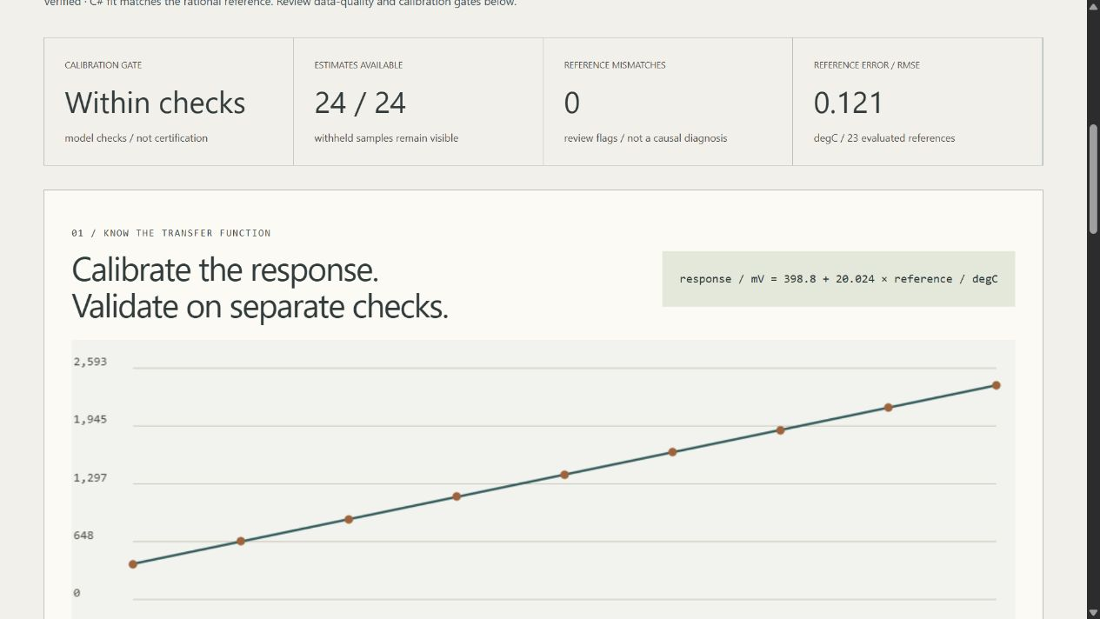
DATUM calibration workbench

Run it
Download a portable release, verify its adjacent SHA-256 checksum, and extract the whole archive. Launch ScientificSensorCalibrationLab (Windows: .exe) to open the local browser UI. Keep _internal with the executable; Ctrl+C in its console stops it. Portable apps include Python and the C# runtime: no developer setup, account, Docker, elevation or public hosting is required. Releases target desktop Windows x64, Linux x64 and macOS arm64—not every OS/version or native mobile installation. Builds are unsigned: follow OS/organization policy and do not disable security protections.
Source setup requires Python 3.12–3.14, Node 24 and the stable .NET SDK in global.json:
python -m venv .venv
# Activate the environment using the command for your shell.
python -m pip install --require-hashes -r requirements-dev.lock
dotnet restore calibration-core --locked-mode
dotnet build calibration-core -c Release --no-restore
npm ci
npm run build
python -m sensorlab serve

Features and engineering evidence
- Known-response-variance linear calibration: coefficients, covariance, residuals and reduced chi-square, without silently rescaling uncertainties to hide misfit.
- Six synthetic scenarios: stable response, unequal uncertainty, changing offset, electronics clipping/range, missing data and unsupported nonlinearity. 162 finite control combinations.
- Separate fit/check/monitoring records. Checks and monitoring references never influence fit coefficients. Reference-mismatch flags are evidence for human review, not a causal fault diagnosis.
- Explicit withheld estimates for missing/saturated signals, insufficient calibration/span, near-zero sensitivity, inconsistent fit, failed checks, expired calibration and extrapolation.
- Combined standard uncertainty from first-order inverse propagation, with assumptions and omitted sources visible—not a certified confidence interval.
- TypeScript/HTML/CSS/Canvas browser UI, keyboard/mobile layout, hourly inspection, help and creator contact links.
- Full JSON evidence, inert HTML, sample CSV, replayable strict input and opt-in immutable SQLite history.
- Cross-platform tests, pinned tools/Actions, three-language CodeQL, independently verified native fit and portable app acceptance. No Actions artifact/cache uploads.
The default synthetic case fits response/mV = 398.8 + 20.024 × reference/degC; all 24 samples receive estimates, 23 have supplied evaluation references, and their corrected RMSE is approximately 0.12142 degC. These are invented demonstration results, not an instrument specification. The nonlinear case deliberately fails fit adequacy; rejected estimates do not become a misleading zero RMSE. See case contracts.
python -m sensorlab export --format input --output editable.json
python -m sensorlab export --input editable.json --output evidence.json --history private.sqlite3
python -m sensorlab export --scenario sensor-drift --format csv --output samples.csv
Outputs are create-only. SQL history is explicit, local and unencrypted; it caps unique reports at 100 and never prunes automatically. Do not use confidential instrument/facility data in this educational project.

Verify
dotnet build calibration-core -c Release --no-restore
dotnet format whitespace calibration-core --no-restore --verify-no-changes
dotnet calibration-core/bin/Release/net10.0/CalibrationCore.dll --self-test
python -m ruff check sensorlab tests tools launcher.py
python -m ruff format --check sensorlab tests tools launcher.py
python -m mypy sensorlab
python tools/verify_repo.py
python -m pytest --cov=sensorlab --cov-report=term-missing
python -m tools.benchmark
npm run format:check
npm test
npm run build
npx playwright install chromium firefox webkit
npm run test:e2e
npm run audit
python -m pip_audit --disable-pip --no-deps -r requirements-dev.lock
python tools/package_app.py
Main files: calibration-core/Program.cs provides the bounded native fit/parser/self-tests; sensorlab/model.py builds and validates inputs; reference.py solves exact rational normal equations; engine.py compares fits, propagates uncertainty and gates samples; reports.py exports/stores evidence; server.py confines read-only HTTP; __main__.py provides CLI. web/main.ts renders charts/inspection, contracts.ts validates display data, and tools/ provides measured regression, inventory and portable-release gates. Every file and exact function/variable location is described in the generated indexes.
User guide · Model and primary research · Architecture · API/schema · Validation results · Release/rollback · File catalog · Code index · Security · Notices

Boundaries and contact
Synthetic scientific education only. No real hardware collection/control, accredited calibration, physical traceability, certified coverage interval, arbitrary nonlinear curves, reference-input uncertainty, correlated noise, automatic causal drift diagnosis or safety-critical use. An internally verified computation can still describe the wrong real-world model. Do not calibrate/qualify real equipment from these invented examples.
Created by Jason Stys. Questions/issues · LinkedIn. No government, employer, laboratory or equipment-vendor endorsement. MIT source; retain bundled runtime notices.

Portable release identity
The 1.1 release contract keeps the software version consistent across Python, npm, the running service and the UI. Versioned archives include RELEASE.json with source commit, platform and clean/dirty build status. Packaging tests the freshly extracted application, including its new practical workflow, from an unrelated temporary working directory. Windows uses ZIP; Linux/macOS use .tar.gz to preserve required native links and permissions. Published 1.0 assets remain unchanged. Check the selected release's source and version rather than assuming an older download contains current source improvements. See the portable operation and release guide.
Observed local packaging checks and boundaries: portable 1.1 validation.
Draft discovery uses a bounded complete authenticated release listing and numeric-ID verification; a published-only tag lookup cannot prove that an untagged draft is absent. The release guide documents fail-closed ambiguity/history limits and the no-overwrite policy.

Current scope and practical limits
- Modeled standard uncertainty excludes physical reference uncertainty, unmodeled correlations and certification.
- The signed covariance cross term is already inside fit variance; withheld estimates have no invented uncertainty budget.
- Synthetic local instrument examples and unsigned desktop portable packages; no system installer, real instrument connection or certified measurement service.
The accompanying Validation Review records the exact tested baseline, workflow evidence, test scope and known gaps. The Excel workbook provides filterable workflow and test-source inventories; neither substitutes for the actual execution logs.

Source references and maintenance
Maintain the editable Markdown and this Word edition together. Preserve dated execution reports and re-run the documented checks before release.
README.md · SECURITY.md · docs/ARCHITECTURE.md · docs/reports/PORTABLE_RELEASE_20261109.md
Project source and current Actions · Contact Jason Stys

