Scientific Sensor Calibration Lab Application Guide
Windows use and validation
By Jason Stys Version 1.1.0 10 November 2026
Explain per-estimate uncertainty contributions and withhold expired/missing estimates. Prepared scenarios use the full Windows application and its existing model and report exports.
The published Windows portable application was installed and tested using isolated synthetic inputs. Provider and sidecar digests, release metadata and installed resource identities were checked. The installed file set remained unchanged after testing.

Capabilities and previous improvements
Explain response-versus-fit covariance contributions, signed cross terms and explicitly withheld uncertainty components. Makes calibration uncertainty traceable rather than presenting one unexplained error bar.
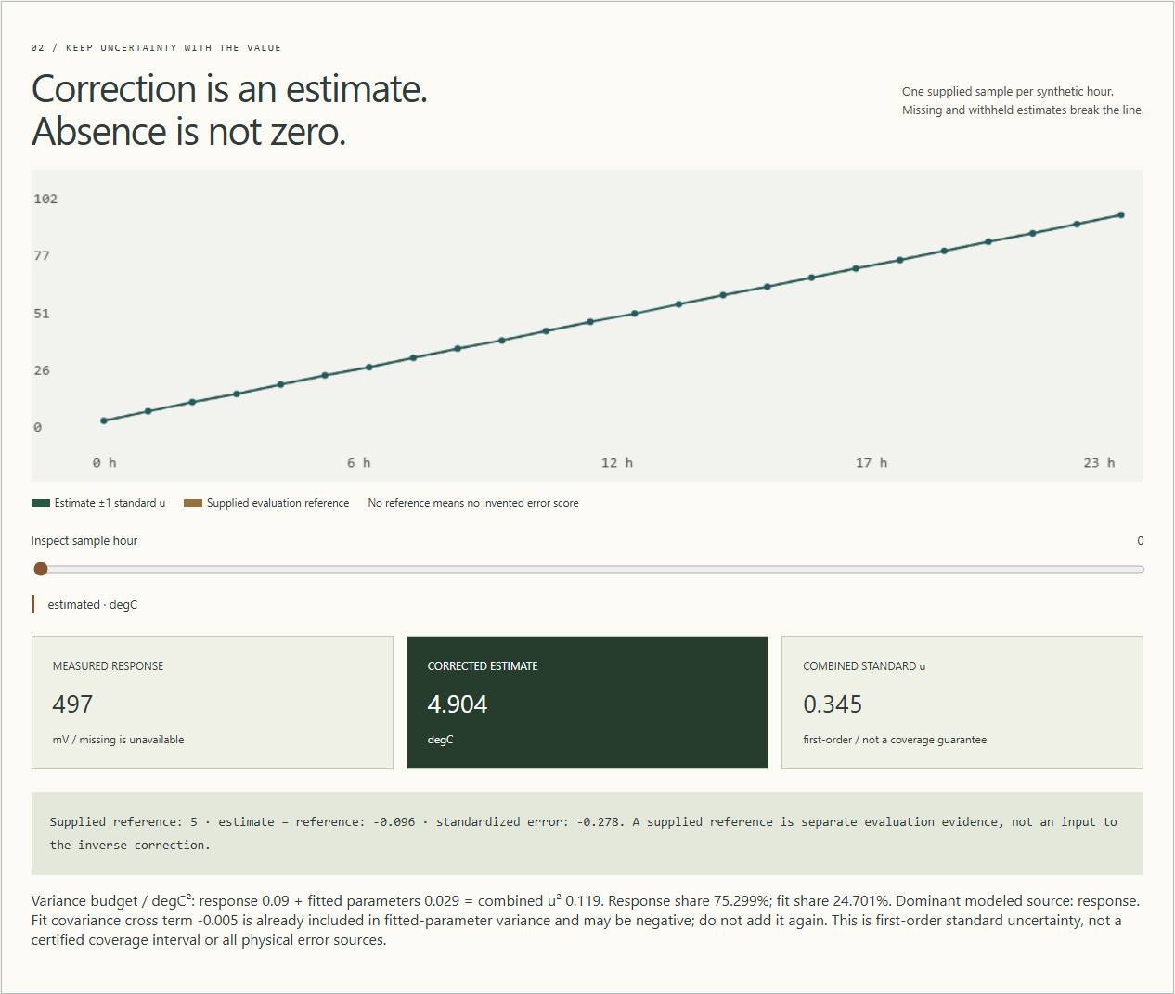
Figure 1 Actual installed application showing response/fit variance contribution. Captured during the accepted native user journey with prepared synthetic inputs.

A worked application journey
The worked example compares response/fit variance contribution with expired calibration with withheld estimates. Interpret the results using the model assumptions and limits on the final page.
1. Open the application shortcut to start its local web interface and console. Select a prepared scenario or your own supported input; the examples require no external account or live hardware.
2. Inspect the nominal variance budget and compare response and fit contributions with JSON. Set calibration age to 120, reanalyze, and review the withheld estimates.
3. Review the main case alongside the boundary case shown in Figure 2. Twenty-four rows matched the native reference and response-plus-fit variance accounting. At calibration age 120 all 24 estimates and budgets were withheld.
4. Download the supported evidence report and retain the input/configuration with it. Recompute after an input change; do not reuse a result under a different configuration.
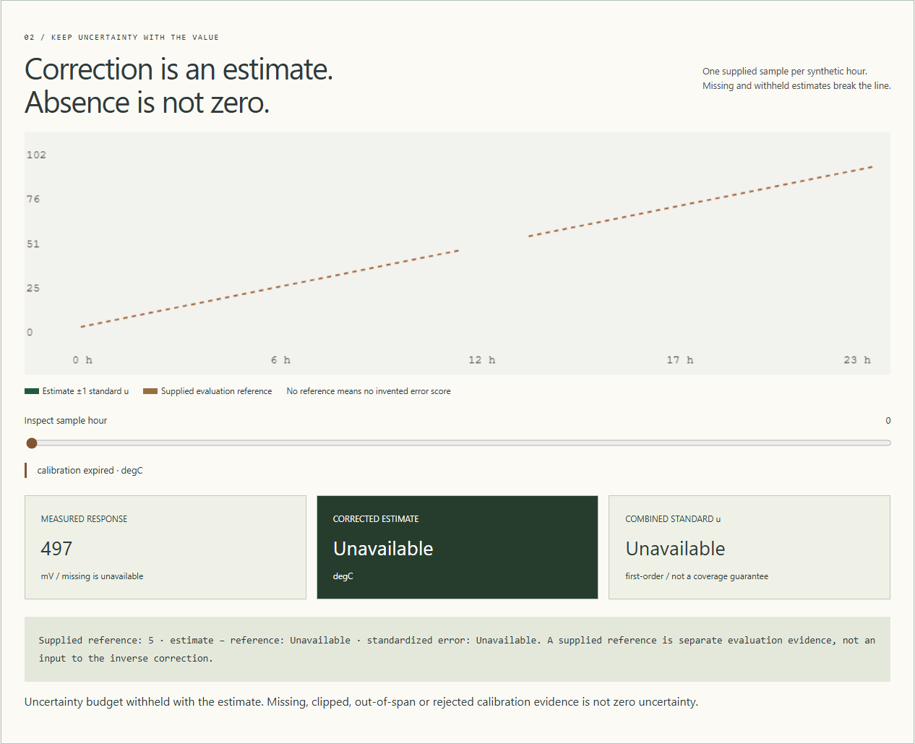
Figure 2 Actual installed application showing expired calibration with withheld estimates. Captured during the accepted native user journey with prepared synthetic inputs.

Important implementation details

Fit variance
The fitted-parameter variance includes the covariance cross term, rejects materially negative or nonfinite propagation and clamps only tiny roundoff below zero. This keeps uncertainty accounting explicit rather than treating it as a certified interval.
sensorlab/engine.py lines 99 to 104
99 def fit_variance(fit: dict[str, Any], x: float) -> float:
100 """Evaluate known-variance covariance propagation for the fitted mean response at x."""
101 value = fit["var_a"] + 2 * x * fit["cov_ab"] + x * x * fit["var_b"]
102 if value < -ABS_TOL or not math.isfinite(value):
103 raise RuntimeError("Invalid covariance propagation")
104 return max(0.0, float(value))
Source file SHA256 6c62de468e2eee591d0fb2c6d9393461aca2dcb87f3dc72686ce2bcb5d7d6142

Validation results and operating limits
Runtime source 1bdb2244451af67d90600e60c566435b66ea2bd0
Check | Observed evidence | Result
Published package | Exact public release, provider/sidecar hashes and installed resources verified; installed bytes unchanged. | Passed
Actual native core | The existing packaged CLI/API and native feature acceptance helper passed on the installed executable. | Passed
Scenario evidence | Twenty-four rows matched the native reference and response-plus-fit variance accounting. At calibration age 120 all 24 estimates and budgets were withheld. | Passed
UI and cleanup | Actual compiled-application browser journey passed. Both images were individually inspected; cleanup left no owned child process. | Passed

Installation and private data
Use the complete matching Windows portable folder from Releases, including all companion files; verify the SHA256 sidecar before extracting it. Keep application files separate from your inputs, downloaded reports and optional CLI history.
Return to this app's own console and press Ctrl+C. Closing its browser tab alone does not stop the service.

Limits and help
Synthetic measurement model, not physical reference certification, real instrument connection or complete correlated uncertainty budget.
These Windows portable checks used isolated synthetic inputs. System-wide installation, default-browser opening, desktop shortcuts and mobile installation were outside this test. Additional shortcut checks are recorded separately. No user data or Docker configuration changed.
Release and checksums | Runtime source | Project usage and limits

