Secret Rotation Reliability Lab Application Guide
Windows use and validation
By Jason Stys Version 1.1.0 11 November 2026
Rehearse credential handoff and lease expiry with the original Broker and Coordinator using a closed event script and virtual time. Inspect which consumers still need a current generation before treating a rotation as complete.
The published Windows application passed its unchanged full consumer after independent download and installation. Exact source workflows and processed security analyses passed before publication. Individual shortcut targets were read back separately.

Capabilities and previous improvements
The original broker, policy, concurrency tests and separate real TLS OpenBao and PostgreSQL drill remain available. The desktop app adds authorized secret-free scripts, explicit policy controls, per-event outcomes and pending-consumer review, durable history and exact export. Prepared scenarios are editable inputs in this same application.
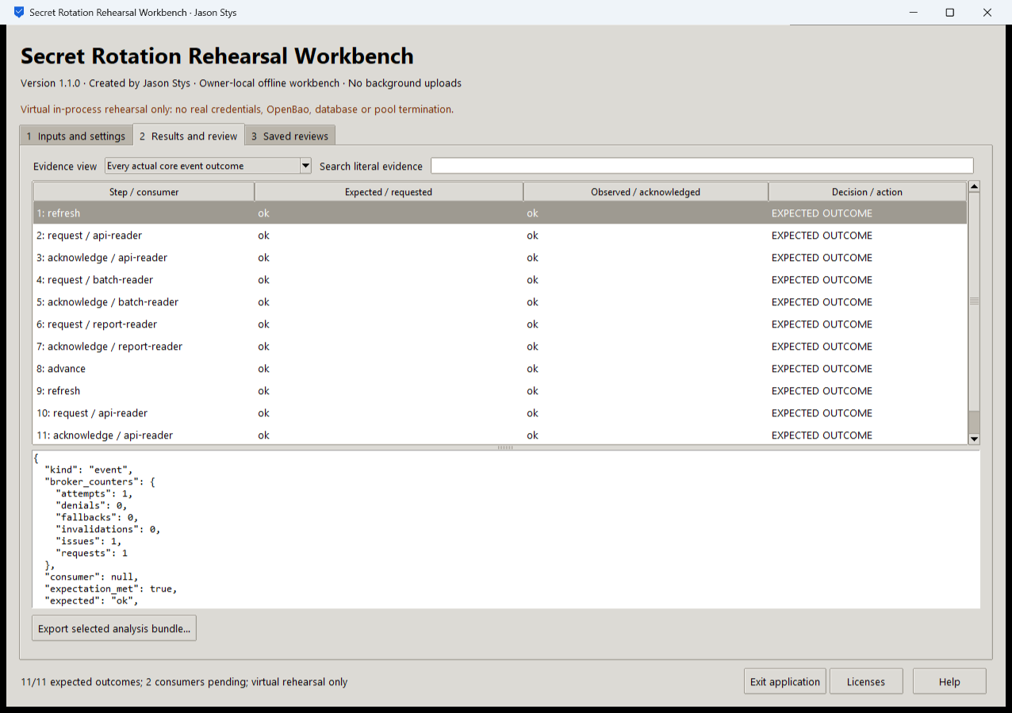
Figure 1 All eleven displayed events match their expected outcomes, yet two consumers still need handoff. Matching event expectations does not mean every consumer switched.

A worked application journey
A service operator rehearses a rotation for three fictional consumers. Only one acknowledges the new generation, so two remain pending. The operator also inspects a deliberately wrong expected outcome rather than hiding the mismatch.
1. Choose an authorized rehearsal JSON file or a prepared case. Use nonidentifying consumer and slot codes; the schema has no real token, password, provider URL or arbitrary program field.
2. Review the original script and policy, then set any optional TTL, expiry-guard or retry controls. Run the rehearsal through the actual in-process core.
3. Inspect expected versus observed events, exact generation references and Pending consumers. A matching expected rejection is a successful test of refusal, not successful authentication.
4. Search the full retained evidence, export to a new destination and reopen Saved reviews to compare exact history. Exit waits for the owned worker and durable save.
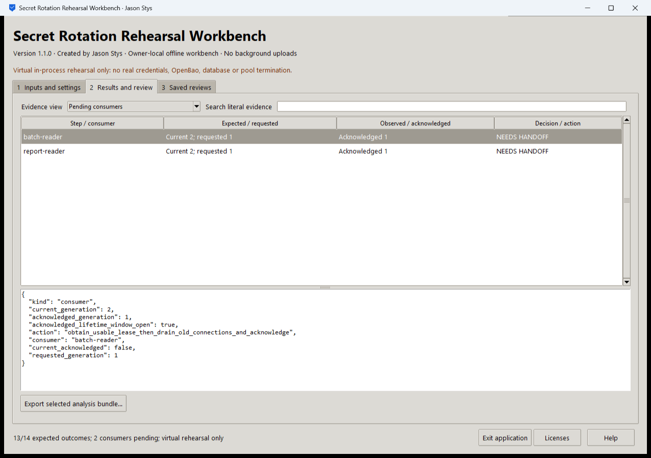
Figure 2 Two consumers still acknowledge generation 1 while generation 2 is current. This prepared mismatch case also retains thirteen of fourteen matching outcomes; it does not relabel the wrong expectation as a pass.

Important implementation details

Bind acknowledgements to actual requested lease objects
The rehearsal retains each actual request result, then passes that generation and lease object to the original Coordinator. The supplied drain flag remains an in-process assertion; the GUI does not terminate real database connections.
rotation/desktop_project.py lines 478 to 492
478 elif op == "refresh":
479 coordinator.refresh()
480 elif op == "request":
481 refs[event["slot"]] = coordinator.request(event["consumer"])
482 else:
483 if event["slot"] not in refs:
484 raise ValueError("no successful request for reference")
485 generation, lease = refs[event["slot"]]
486 if op == "acknowledge":
487 coordinator.acknowledge(
488 event["consumer"],
489 generation,
490 lease,
491 old_connections_drained=event["drained"],
492 )
Source file SHA256 701225b1fa18704b4c4f4ef95a6d6fafb85ae6b46401dc5583e2001cf207f31d

Validation results and operating limits
Runtime source 1d2ea4edd286aac5418a913bf45082998b17d503
Check | Observed evidence | Result
Independent distribution | All five downloaded release files matched provider hashes. The executable also matched its checksum sidecar. Installed resources remained byte-identical after actual use. | Passed
Actual use and restart | All 12 installed workflows and 12 exact evidence bundles passed the original full assertions. Both launches exited normally; reopening retained every saved bundle. | Passed
Source and security | All exact-source main workflows passed before publication. Configured processed CodeQL analysis had zero raw findings and zero open main alerts. | Passed
Individual shortcut | Desktop and Start-menu targets were read back. Full installed executable acceptance is distinct from activating a normal default-profile shortcut. | Verified

Installation and private data
Download SecretRotationReliabilityLab-1.1.0-windows-x64.exe and its checksum from Releases. This unsigned portable Windows x64 executable bundles Python 3.14.10 and Tcl and Tk 9.0.4; no Python setup or Docker change is required.
Use the individual Desktop icon and in-app Help. The owner profile stores selected paths and evidence as plaintext outside the installation. Protect exports and use nonidentifying inputs. Tests used separate synthetic profiles; normal user data was not opened.

Limits and help
The provider and credentials are fictional and time is virtual. A drain flag is a supplied assertion; this GUI measures neither live TLS nor automatic refresh scheduling or database-pool termination.
No real credential or service is contacted. Code syntax is not a universal secret detector: choose nonidentifying inputs. The plaintext profile trusts the OS owner; the separate live drill retains its documented lab limits.
Release and checksums | Exact runtime source | Usage and limits

