Secure Delivery Pipeline Lab Application Guide
Windows use and validation
By Jason Stys Version 1.2.0 11 November 2026
Inspect source-bound delivery evidence and perform an offline integrity preflight of an exact four-asset release set against an independently selected repository, commit, tag and workflow tuple. Keep checksum integrity distinct from authenticated publisher trust.
The independently downloaded installed application passed its original full native acceptance and retained-file checks. Current main source workflows and processed security analyses passed before publication; shortcut targets were verified separately.

Capabilities and previous improvements
The original signed-delivery CLI retains authenticated verification, promotion and rollback gates. The new desktop app adds actual source inventory calculations, exact offline release-file inspection, explicit original/effective inputs and durable evidence review without executing a downloaded payload.
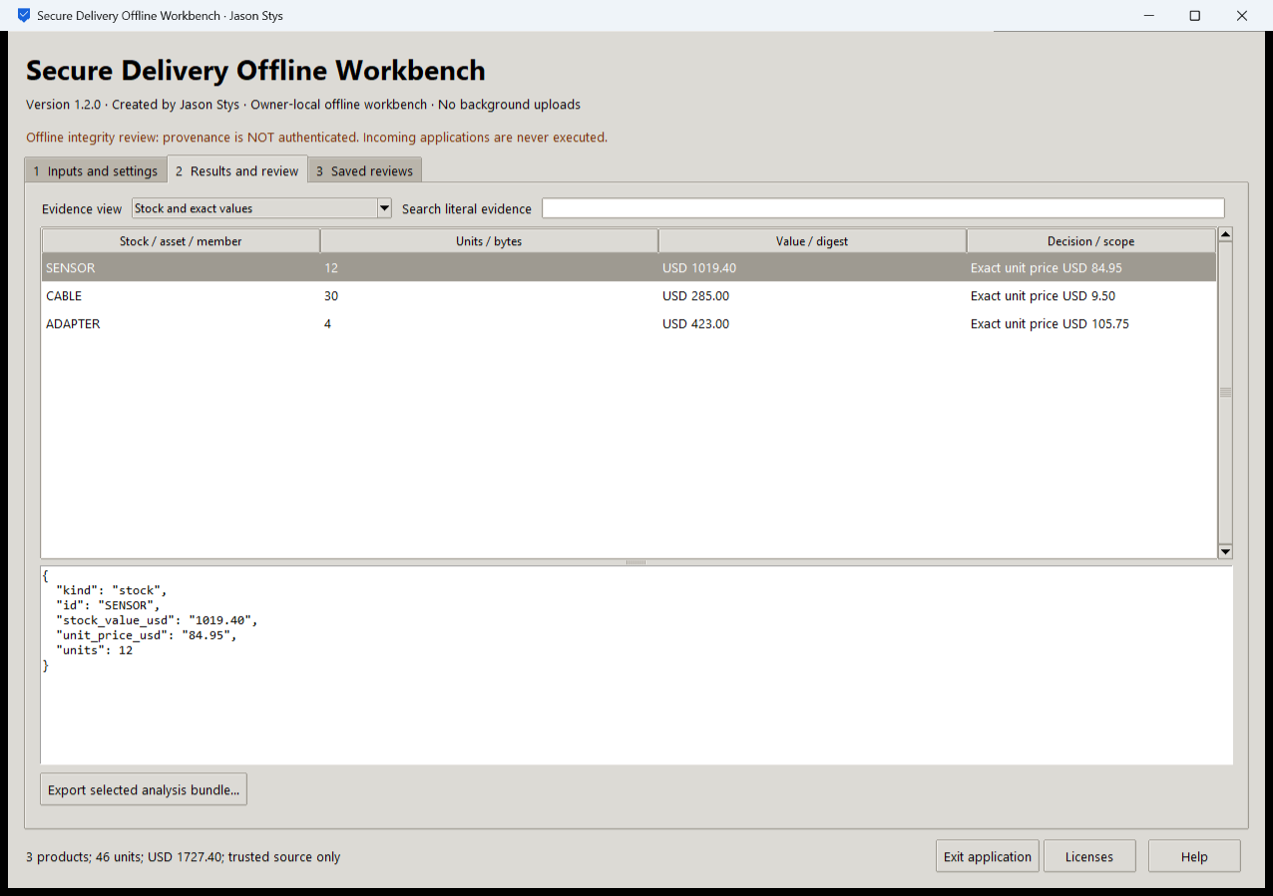
Figure 1 The installed inventory operation calculates actual supplied stock totals; inventory arithmetic is distinct from release authentication.

A worked application journey
A release engineer first checks supplied product inventory totals, then reviews a received release set against an independently entered expected source tuple. The engineer inspects mismatches and exports the full preflight evidence.
1. Select a supported inventory file or the exact offline release-set operation. Prepared exercises are inputs in this same app.
2. Enter independently established repository, commit, tag and workflow expectations for a release review. Keep its four required assets together.
3. Run the analysis, inspect every mismatch and the persistent integrity-only warning, then search the selected evidence without dropping original rows.
4. Export to a new destination and reopen the same profile to compare exact retained bundle identities. Close with the native owner control.
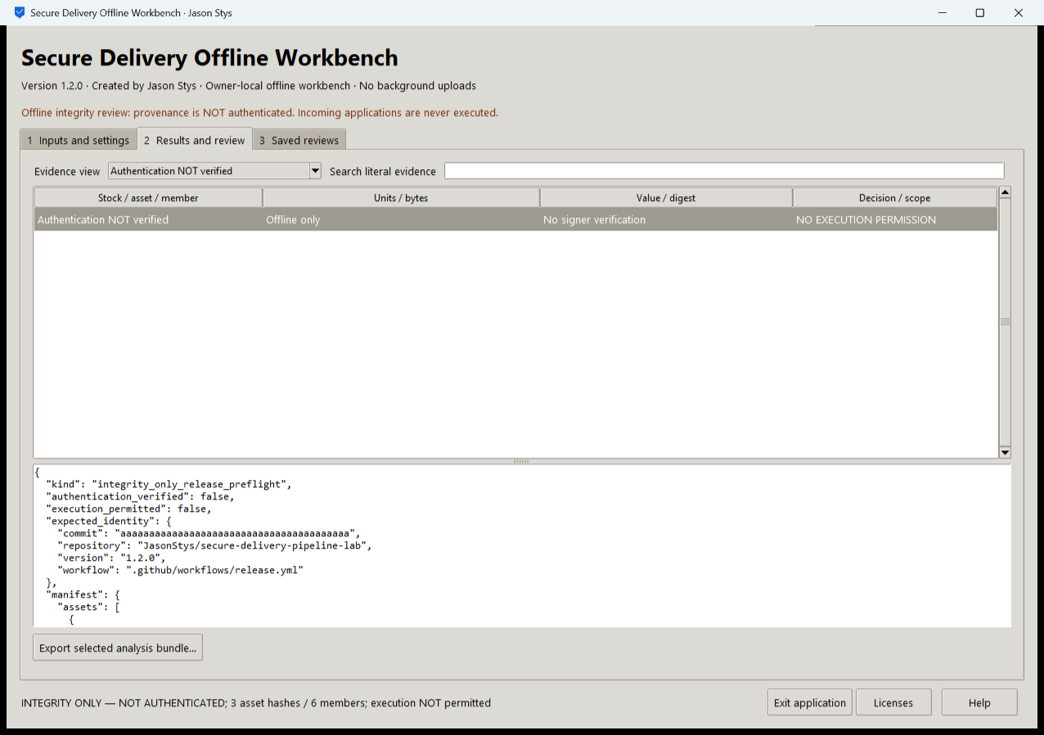
Figure 2 The installed release review explicitly states that authentication is not verified. It preserves the expected tuple and integrity findings.

Important implementation details

Use closed offline operations over stable data
The desktop adapter admits supported operations and prepared cases, then passes bounded selected bytes to the original summarizer. It contains no deployment, executable or signer call.
delivery/desktop_project.py lines 240 to 258
240 def analyze(
241 state: Workspace, parameters: dict[str, str], stage: Path
242 ) -> tuple[str, str, dict[str, bytes]]:
243 """Use actual trusted core calculations/preflight on stable data copies; no executable, signer or deployment call."""
244 mode = parameters.get("mode")
245 if mode not in MODES:
246 raise Rejected("choose a supported offline operation")
247 exercise = parameters.get("exercise", "")
248 if mode == MODES[2] and exercise not in CHOICES["exercise"]:
249 raise Rejected("choose a supported prepared exercise")
250 inventory = mode == MODES[0] or mode == MODES[2] and not exercise.startswith("unsigned-")
251 if inventory:
252 raw = (
253 read_source(Path(parameters["inventory"]), MAX_INPUT)
254 if mode == MODES[0]
255 else canonical(inventory_example(exercise))
256 )
257 rows = json_value(raw)
258 totals = summarize(rows)
Source file SHA256 69be0062bd64db8b4518530186d155b7264b3dd5013e3b18af6d371b8d2aa3cc

Validation results and operating limits
Runtime source 83df1d81fb48f29256efab51b742a96a5776cc50
Check | Observed evidence | Result
Independent distribution | Downloaded provider assets, sidecar and installed file identities matched. The complete installed app was used; installation resources remained byte-identical. | Passed
Actual app use and restart | Eight real installed workflows and eight evidence bundles passed unchanged full consumer assertions. Two normal launches retained history and exact exported bytes. | Passed
Source and security | All current main workflows passed before publication. All configured exact-source processed CodeQL categories had zero raw findings and zero open alerts. | Passed
Individual shortcut | Desktop and Start-menu targets were read back against the installed version. Normal default-profile shortcut activation is separate from full installed executable acceptance. | Verified

Installation and private data
Download the matching version and checksum from Releases. This is an unsigned per-user portable Windows x64 app; keep its complete accompanying files together. No system Python installation or Docker change is needed.
Use the individual Desktop icon and in-app help. Inputs, saved evidence and exports stay outside the installation. Preserve older versions and your own profiles; tests used only separate synthetic inputs.

Limits and help
Offline GUI preflight is INTEGRITY_ONLY_NOT_AUTHENTICATED. Checksum agreement and a matching expected tuple are not an authenticated signature, provenance or payload safety verdict.
The GUI never executes a payload or promotes or rolls back a release. Use the separately documented authenticated CLI when those original functions are required.
Release and checksums | Exact runtime source | Usage and limits

