Secure Service Desk Application Guide
Windows use and validation
By Jason Stys Version 1.1.0 10–11 November 2026
Use the complete bundled PHP/Laravel ticket workflow with selectable fictional requester/staff actors, version-safe assignment and status, comments, search, audit exports and durable local profiles. Actor selection is a teaching/review mechanism, not a sign-in or multi-user authorization system. Only the trusted OS owner should use this local application.
The downloaded Windows app passed its full workflow with synthetic data. Required main-branch checks and security scans passed for this source revision. Desktop and Start-menu shortcut targets were verified; the installed app was tested separately.

Capabilities and previous improvements
Assign and unassign tenant agents with shared version checks, atomic audit/outbox writes and bounded ticket history; filter owner/SLA queues and recheck stale authorization and SLA candidates. Turns a ticket list into an auditable support workflow that resists lost updates, partial commits and cross-tenant mistakes.
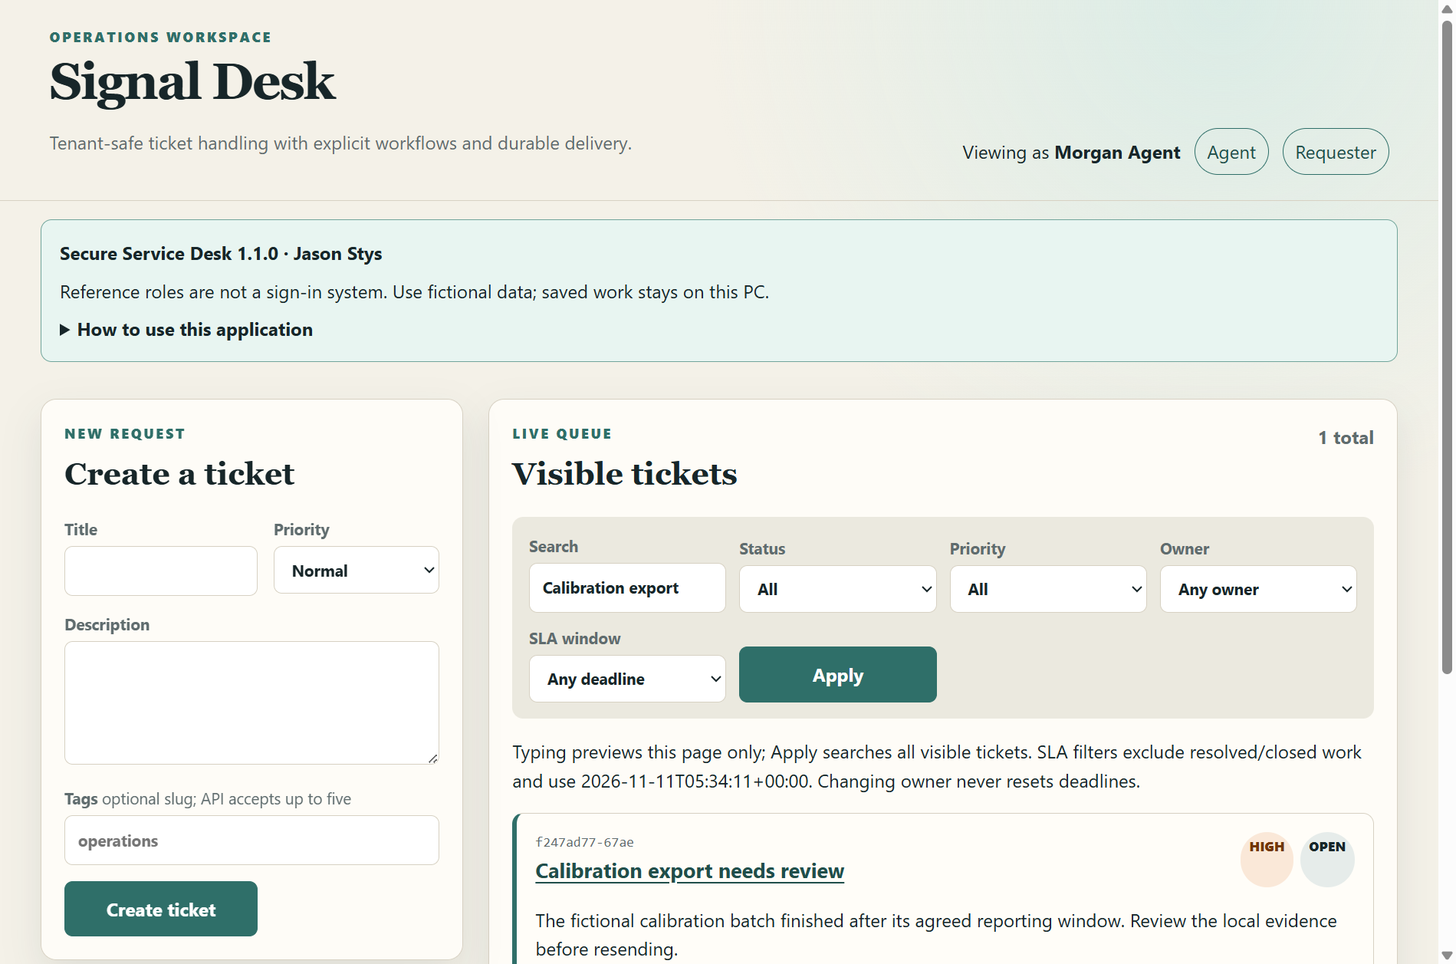
Figure 1 The real installed ticket queue shows the saved synthetic ticket and search results for the selected fictional actor.

A worked application journey
A trusted local reviewer uses fictional requester/staff actors to create a ticket, change assignment/status, retain a comment and inspect the queue. Actor selection is not sign-in.
1. Launch the app and read its local-actor notice. Choose a fictional actor; this is a trusted-owner teaching/review workspace.
2. Create a ticket with the real form, then inspect its explicit version and permitted controls for the selected actor.
3. Change assignment/status and add a comment. Stale versions and missing CSRF values must be refused without overwriting accepted work.
4. Search the queue, close normally and reopen the saved ticket/comment/version. Do not expose this actor-selection app as a public service.
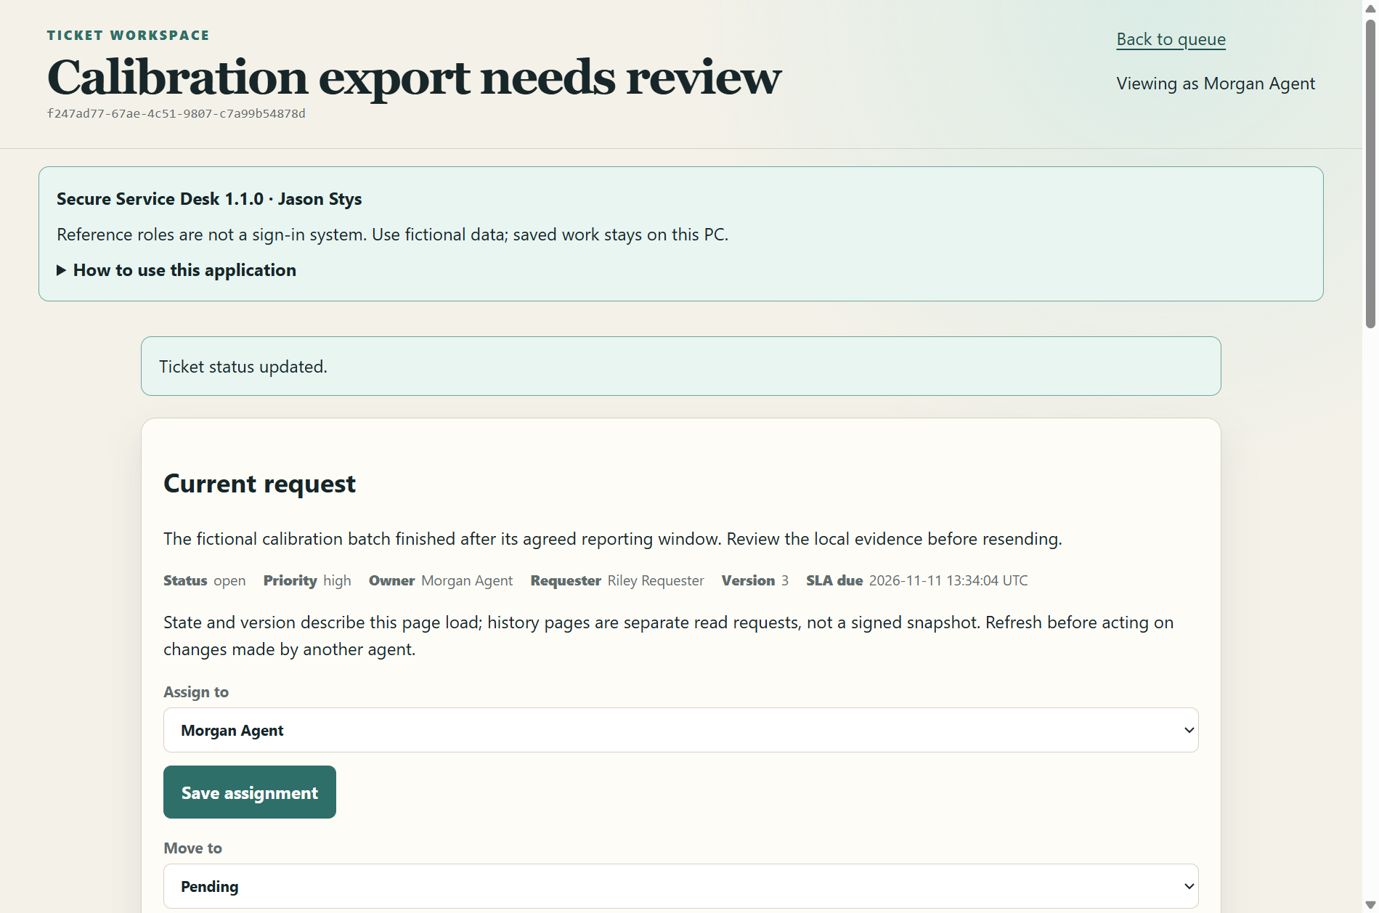
Figure 2 The installed Laravel ticket form displays retained assignment, status and comment evidence. Fictional actor selection is not sign-in.

Important implementation details

Keep the private profile outside bundled application files
The actual gateway refuses profile paths inside either the application or PHP runtime directory before initialization. Its existing initialization marker is checked before mutable setup, so an unknown marker is preserved rather than reset.
desktop/runtime.mjs lines 248 to 268
248 export async function createNativeService({ root, phpDirectory, profile }) {
249 root = resolve(root);
250 phpDirectory = resolve(phpDirectory);
251 profile = resolve(profile);
252 if (
253 profile === root ||
254 profile.startsWith(root + sep) ||
255 profile === phpDirectory ||
256 profile.startsWith(phpDirectory + sep)
257 ) {
258 throw new Error('The native profile must remain outside application/runtime files.');
259 }
260 const { absolute, identity, fresh } = await profileIdentity(profile);
261 const initializedPath = join(absolute, 'initialization.json');
262 const initializedBytes = '{"schema":1,"product":"secure-service-desk","initialized":true}\n';
263 let initialized = false;
264 try {
265 initialized =
266 (await readBounded(initializedPath, 256)).toString('utf8') === initializedBytes;
267 if (!initialized)
268 throw new Error('Native initialization marker is invalid; no work was reset.');
Source file SHA256 04afa86872e46c7d4c44eccc8262f911228d02a4ec8d1aafabcb7133e3be65ba

Validation results and operating limits
Runtime source b9d683895b1b3f3ec47ccc83cea68339da9c2f22
Check | Observed evidence | Result
Real native workflows | Two installed Laravel/Electron launches passed real ticket/assignment/comment/search workflows, selected-actor tenant filtering, CSRF/invalid-input refusal and exact retained state. | Passed
Source and security | All required main workflows for the runtime revision passed; processed CodeQL analyses reported zero open main alerts before release. | Passed
Distribution identity | All 2 assets matched provider/checksum identities; all 6698 installed files remained unchanged during acceptance. | Verified
PC scope | New per-user version folder and individual links verified. Synthetic profiles only; existing data and Docker were not used or changed. | Verified

Installation and private data
Keep the complete extracted ZIP together and launch SecureServiceDesk.exe. No system runtime or terminal setup is needed.
Open the verified Desktop icon. Help describes supported inputs and workflow limits; close through the app's owner controls and back up its external data directory after a normal exit.

Limits and help
Fictional actor selection is not authentication or a multiuser data boundary. This trusted-OS-owner local ticket workbench must not be exposed as a public service.
Prepared inputs and acceptance used synthetic data only; normal profiles were not opened and Docker was unchanged. Local plaintext is trusted-OS-owner data, not protection against that OS user or administrator.
Release and checksums | Runtime source | Usage and limits

