Space Weather Impact Observatory Application Guide
Windows use and validation
By Jason Stys Version 1.1.0 10 November 2026
Compare eligible forecast lead cutoffs and fixed time windows with explicit coverage denominators. Prepared scenarios use the full Windows application and its existing model and report exports.
The published Windows portable application was installed and tested using isolated synthetic inputs. Provider and sidecar digests, release metadata and installed resource identities were checked. The installed file set remained unchanged after testing.

Capabilities and previous improvements
Compare eligible lead-cutoff and half-window evidence with coverage and unknown issuance states retained. Helps analysts review time alignment without mistaking overlapping descriptive samples for independent forecast skill.
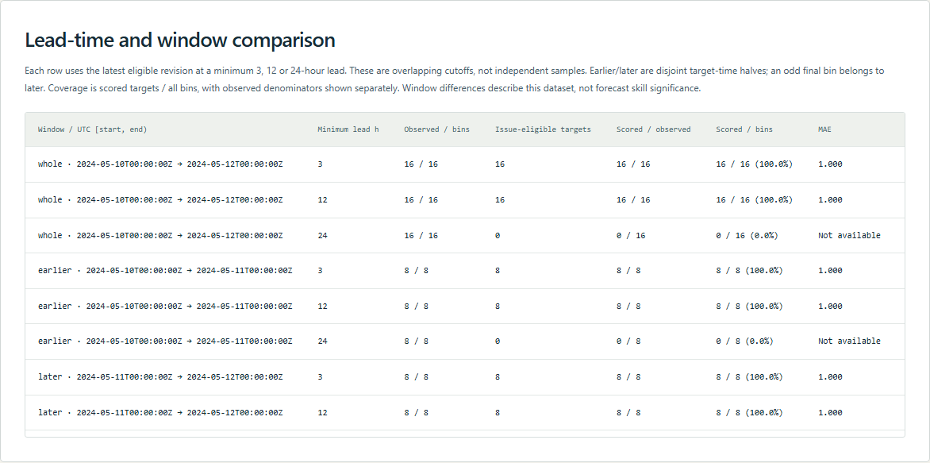
Figure 1 Visible portion of the actual installed app's synthetic-storm comparison table. All nine rows and their exported values were checked separately in the native journey.

A worked application journey
The worked example compares synthetic storm lead/window scores with empty observations with undefined errors. Interpret the results using the model assumptions and limits on the final page.
1. Open the application shortcut to start its local web interface and console. Select a prepared scenario or your own supported input; the examples require no external account or live hardware.
2. Choose synthetic-storm and inspect all nine lead/window rows. Compare selected observations with scored counts and the JSON export, then choose empty-window.
3. Review the main case alongside the boundary case shown in Figure 2. All nine lead/window rows matched scored counts and window partitions. Empty windows retained zero scored cases and null errors, rather than zero error.
4. Download the supported evidence report and retain the input/configuration with it. Recompute after an input change; do not reuse a result under a different configuration.
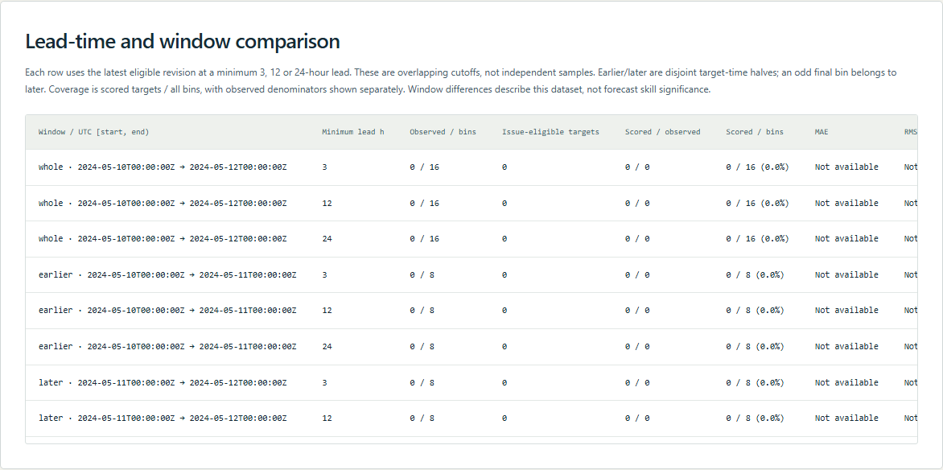
Figure 2 Visible portion of the actual installed app's empty-observation table: counts remain zero and errors are unavailable. Additional columns and the ninth row can be reached by scrolling in the app.

Important implementation details

Forecast comparison
Each lead gate retains issuance eligibility plus separate scored/bin and scored/observed denominators. Empty denominators produce null coverage rather than a fabricated zero error or successful forecast score.
weatherlab/engine.py lines 276 to 302
276 rows, scores = assess_forecasts(subset, replace(settings, lead_hours=lead))
277 result.append(
278 {
279 "window": label,
280 "start": start_time,
281 "end_exclusive": end_time,
282 "minimum_lead_hours": lead,
283 "bins": end - first,
284 "available_observations": available,
285 "missing_observations": end - first - available,
286 "forecast_targets": len({f.target for f in subset.forecasts}),
287 "issuance_eligible_targets": len(
288 {
289 r["target"]
290 for r in rows
291 if r["status"] in {"scored", "superseded", "missing-observation"}
292 }
293 ),
294 "observation_coverage": round(available / (end - first), 9)
295 if end > first
296 else None,
297 "scored_bin_coverage": round(scores["scored"] / (end - first), 9)
298 if end > first
299 else None,
300 "scored_observation_coverage": round(scores["scored"] / available, 9)
301 if available
302 else None,
Source file SHA256 0c4d0328d78f1814c7197159cbf46bdecd7699f2bf1292c82f8a030aa0b3f98b

Validation results and operating limits
Runtime source 5f2363643ca7fe7ce624550dcd45e0ae4cb0185a
Check | Observed evidence | Result
Published package | Exact public release, provider/sidecar hashes and installed resources verified; installed bytes unchanged. | Passed
Actual native core | The existing packaged CLI/API and native feature acceptance helper passed on the installed executable. | Passed
Scenario evidence | All nine lead/window rows matched scored counts and window partitions. Empty windows retained zero scored cases and null errors, rather than zero error. | Passed
UI and cleanup | Actual compiled-application browser journey passed. Both images were individually inspected; cleanup left no owned child process. | Passed

Installation and private data
Use the complete matching Windows portable folder from Releases, including all companion files; verify the SHA256 sidecar before extracting it. Keep application files separate from your inputs, downloaded reports and optional CLI history.
Return to this app's own console and press Ctrl+C. Closing its browser tab alone does not stop the service.

Limits and help
Frozen public/synthetic snapshots, not live weather, causal mission-impact predictions or operational recommendations.
These Windows portable checks used isolated synthetic inputs. System-wide installation, default-browser opening, desktop shortcuts and mobile installation were outside this test. Additional shortcut checks are recorded separately. No user data or Docker configuration changed.
Release and checksums | Runtime source | Project usage and limits

