Space Weather Impact Observatory Project Guide
  - By Jason Stys
Public source revision 5f2363643ca7
This edition documents the cited source. Validation observations below identify their own tested revision and time; they are not a promise that an unrun later revision passed.
Compare forecast verification at 3/12/24-hour minimum lead cutoffs over the whole target window and declared earlier/later halves. Coverage denominators, missing truth, exact selected issuance records and undefined errors travel with each result; revisions are never selected by their error. See the forecast comparison guide.
Inspect frozen observations and forecast revisions, compare lead/window coverage and export reviews with 1.1 portable applications.
Makes a complete offline review of sparse evidence practical while preserving missingness, issuance eligibility and the identity of the downloaded source/runtime.

Purpose operation and implementation
Signals. Evidence. Context. An offline analysis application designed and engineered by Jason Stys.
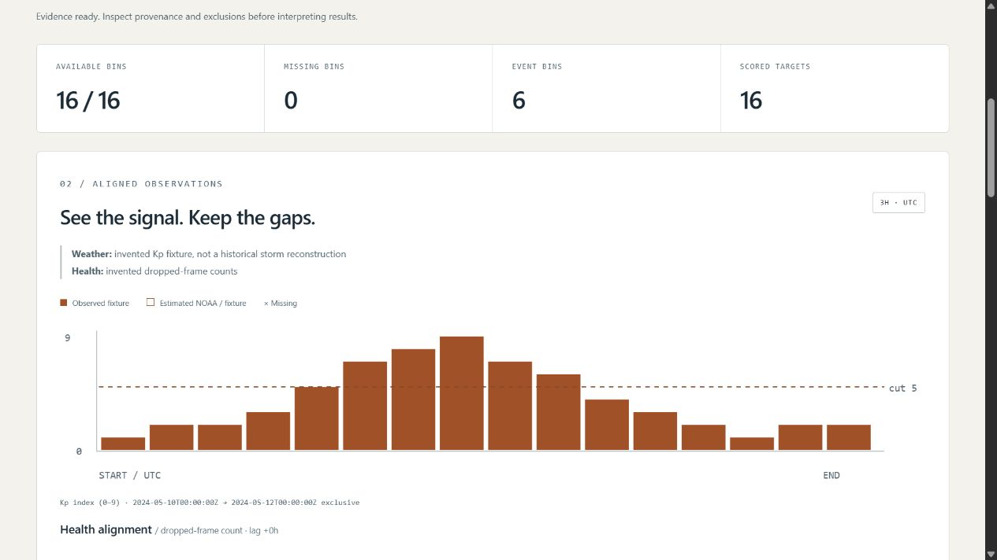
Actual synthetic analysis view
Inspect estimated planetary Kp, preserve missing observations, verify forecast eligibility, and explore descriptive—not causal—associations with supplied mission-health records. The app runs in your browser from source or an extracted portable download. Python handles data validation/statistics, TypeScript handles interaction/SVG, and SQL provides opt-in immutable local history.

What makes the evidence trustworthy
- A frozen, checksum-verified NOAA SWPC response with 56 estimated three-hour Kp bins; the separate forecast response preserves 17 predicted records with unknown issuance. They cannot be used for historical skill claims.
- Five additional invented cases: storm-shaped signal/health, missing bins, forecast revisions/leakage, constant signals and an empty observation window. No real mission-health data is bundled, and the synthetic May dates do not reconstruct a historical storm.
- Exact UTC three-hour alignment. A positive health lag pairs weather at t with health at t + lag; omitted/null values stay missing. No interpolation or missing-as-zero behavior.
- Forecast issue time must precede the target by at least the chosen lead. Only the latest eligible revision per target, selected without looking at its error, contributes to MAE/RMSE/bias and the threshold confusion table in JSON.
- Descriptive Pearson correlation with explicit insufficient/constant-series outcomes, separate-unit weather/health plots, exact bin inspector and filterable ledger. No p-values, confidence intervals, automatic lag optimization or causal inference.
- Full-context JSON, aligned-bin CSV, inert HTML and portable input JSON. Content SHA-256 and opt-in local SQLite history preserve reproducibility, not authenticated authorship.
- Read-only loopback service, finite browser controls, bounded CLI imports, strict dependencies, cross-platform/browser CI and exact-line documentation checks.
This is educational research software, not current conditions, an authoritative forecast, a spacecraft damage model, flight-qualified software or mission guidance. Kp is a quasi-logarithmic planetary index, not local radiation/dose. Association cannot establish that space weather caused a health event. Scientific limitations, data provenance.

Launch a download
Get your OS archive (Windows ZIP; Linux/macOS .tar.gz) and .sha256 from Releases. Verify the archive hash, extract the entire directory and launch SpaceWeatherObservatory (.exe on Windows). It opens a loopback website in your default browser. Stop the console with Ctrl-C. No global Python/Node installation, account, cloud API or administrator rights are needed for the portable app.
Bundles are unsigned/not notarized, targeting Windows x64, Linux x86_64 and macOS ARM64 CI environments—not all devices/distributions or mobile operating systems. Never bypass OS warnings, remove quarantine, disable security or run elevated. Use reviewed source if policy blocks unsigned apps. This is a local browser application, not public hosting or a multi-user authenticated service.

Run from source
Requirements: CPython 3.12–3.14 and Node 24. No third-party Python runtime dependencies.
python -m venv .venv
# Windows: .venv\Scripts\activate
# Linux/macOS: source .venv/bin/activate
python -m pip install --require-hashes -r requirements-dev.lock
npm ci
npm run build
python -m weatherlab serve
The printed URL is http://127.0.0.1:<ephemeral-port>/. serve --no-browser --port 8846 opts into a fixed local port. No network fetch is performed by the running app.
Start with NOAA frozen snapshot. Observe that health and scores are unavailable rather than invented. Choose Forecast revisions and leakage, expand the forecast ledger, then compare minimum lead 3 vs 12 vs 24 hours. Try Missing and estimated bins, a positive health lag, the missing filter and individual bin inspection. Help and provenance are available in the interface.

CLI and local input
python -m weatherlab export --scenario synthetic-storm --output evidence.json
python -m weatherlab export --scenario synthetic-storm --format input --output case.json
python -m weatherlab export --input examples/synthetic-storm.json `
--lag_hours 3 --lead_hours 12 --threshold 5 `
--output local-evidence.json --history local.sqlite3
Imports are strict UTF-8 JSON, at most 512 KiB, 256 grid bins and 2048 forecast revisions. Exact keys, finite ranges, UTC/grid alignment and uniqueness are validated. Imported provenance is unverified local input, even if its name imitates NOAA. File import and history are CLI-only, not browser upload endpoints. History is unencrypted local data; exports never overwrite, history is capped at 100 distinct reports and never pruned automatically. Use synthetic/non-sensitive records. See input/API contract.

File and feature map
Area | Responsibility
weatherlab/model.py | Typed immutable input, exact UTC, finite values, unique records, bounded duplicate-key-safe JSON
weatherlab/engine.py | Verified NOAA adapter, invented cases, exact joins, descriptive statistics, issue/revision gates and evidence identity
weatherlab/reports.py, resources/history.sql | JSON/CSV/HTML/input rendering, verified parameterized history with immutable triggers
weatherlab/server.py, __main__.py, launcher.py | Protected read-only loopback API, no-overwrite CLI and portable entry point
weatherlab/resources/ | Original public responses, checksums/date/URLs and SQL schema—not credentials or personal history
web/ | Semantic controls, independently scaled SVG plots, ledgers/inspector, safe rendering and unit contracts
tests/ | Finite grid, independent arithmetic/property, import/CLI/SQL/HTTP and actual browser acceptance
tools/ | Deterministic contracts/profiling, source inventories, frozen-app packaging/smoke and draft releases
.github/workflows/ | Validation, CodeQL and manually gated three-platform release
docs/, examples/, licenses/ | Design/usage/model/data/security/evidence, editable synthetic input and runtime notices

Every file is summarized in FILE_CATALOG. Source headers and definition contracts describe responsibilities and variables; CODE_INDEX gives generated exact definition/argument/variable locations instead of fragile duplicate line numbers in comments. CI rejects missing Python contracts/creator headers or stale indexes.

Author and sources
By Jason Stys. Portfolio · Help/contact/issues.
Original code is MIT. NOAA/NWS material remains attributed public-domain government information, not the author's copyrighted data. See third-party notices. No NOAA, NASA, government, military or contractor endorsement/affiliation is implied. Primary references: NOAA Kp product, NOAA scales and NWS reuse notice.

Portable release identity
The 1.1 release contract keeps the software version consistent across Python, npm, the running service and the UI. Versioned archives include RELEASE.json with source commit, platform and clean/dirty build status. Packaging tests the freshly extracted application, including its new practical workflow, from an unrelated temporary working directory. Windows uses ZIP; Linux/macOS use .tar.gz to preserve required native links and permissions. Published 1.0 assets remain unchanged. Check the selected release's source and version rather than assuming an older download contains current source improvements. See the portable operation and release guide.
Observed local packaging checks and boundaries: portable 1.1 validation.
Draft discovery uses a bounded complete authenticated release listing and numeric-ID verification; a published-only tag lookup cannot prove that an untagged draft is absent. The release guide documents fail-closed ambiguity/history limits and the no-overwrite policy.

Current scope and practical limits
- Frozen public and synthetic snapshots do not provide current conditions, causal mission-impact prediction or operational guidance.
- Lead cutoffs overlap and fixed-half comparisons are descriptive; they are not independent samples or statistical significance tests.
- Unsigned desktop portable packages; no system installer, hosted account service or native mobile installation.
The accompanying Validation Review records the exact tested baseline, workflow evidence, test scope and known gaps. The Excel workbook provides filterable workflow and test-source inventories; neither substitutes for the actual execution logs.

Source references and maintenance
Maintain the editable Markdown and this Word edition together. Preserve dated execution reports and re-run the documented checks before release.
README.md · SECURITY.md · docs/ARCHITECTURE.md · docs/reports/PORTABLE_RELEASE_20261109.md
Project source and current Actions · Contact Jason Stys

