Spacecraft Flight Software Testbed Project Guide
  - By Jason Stys
Public source revision 5f9dc95ad5df
This edition documents the cited source. Validation observations below identify their own tested revision and time; they are not a promise that an unrun later revision passed.
Break a task. Prove recovery. A deterministic C++20 executive, software-only device ports and a TypeScript mission-assurance console by Jason Stys.
The released 1.1.0 portable app brings the recovery-observability review into a source-bound downloadable bundle: compare onboard transitions with received confirmation, then export the same evidence shown in the UI.
The original deterministic C++ executive and Python replay oracle remain intact. Versioned archives, native-safe POSIX packaging and an extracted-executable Chromium journey make the new received-witness feature reviewable beyond a source checkout. An independent boot/reset oracle and downloaded JSON comparison prevent a static page or source-service fallback from passing acceptance.

Purpose operation and implementation
Inspect the recovery observability audit: onboard mode/boot/counter changes, actual received confirmations, delays and events hidden between packets. Received witnesses never become invented exact transition times, and missing confirmation never proves no occurrence.
Inject a hung task, stale sensor, missing telemetry, bad checkpoint, low-power index or corrupt command. Inspect the exact reset deadline, latched SAFE mode, checkpoint restore, lost volatile work and explicit return to science. Replay every frame against an identical-setting nominal reference and export the evidence.
This is an original educational implementation—not an RTOS, cFS/NOS3 distribution, flight-qualified system, real spacecraft controller, guidance/targeting system or hardware interface. All inputs are synthetic. Logical ticks are not seconds; sensor/power indexes are not physical measurements. SAFE is a software-state label, not a real-world safety assertion.

Try it
For a prebuilt desktop app, choose the matching version, OS and CPU from Releases. Version 1.1 uses Windows ZIP and Linux/macOS tar.gz, preserving POSIX executable modes and internal links. Verify SHA-256, extract the whole folder, inspect RELEASE.json and launch SpacecraftFlightTestbed (.exe on Windows). It opens the local website in your browser. Ordinary use needs no account, Python/Node installation, cloud service or administrator access. Builds are unsigned; retain OS protections. Stop the console with Ctrl+C. Mobile browsers can display the responsive UI, but no phone-native executable is supplied and the loopback service is deliberately not shared over a network.
The 1.1 package notes describe the recovery-observability update and extracted-app acceptance. Older 1.0 downloads predate that workflow. These are portable folders, not installers; a successful launch is not a clean-machine installation claim.
Source development requires Python 3.12–3.14, Node 24 and a C++20 toolchain (MSVC 2022/2026, GCC or Clang). The pinned CMake build dependency is installed below.
python -m venv .venv
.venv/Scripts/python -m pip install --require-hashes -r requirements-dev.lock
npm ci
.venv/Scripts/python tools/build_native.py
npm run build
.venv/Scripts/python -m flightlab serve
On Linux/macOS substitute .venv/bin/python. Do not use the Python development server as a public Internet service.

Features
Feature | Evidence you can inspect
Executive / four software modes | Deterministic boot, standby, science and latched SAFE transitions
Independent watchdog | Exact heartbeat deadline, restart count and two-tick boot interval
Validated checkpoints | Explicit 20-byte little-endian format, CRC32, bounds and version checks
Command discipline | CRC checks, monotonic identifiers, duplicate suppression and health gating
Simulated devices | Invented sensor/power values and explicitly absent downlink frames
Recovery ledger | Working vs committed payloads, volatile loss, command decisions and event timing
Dual perspectives | Onboard simulator truth or received-only downlink; chart gaps stay gaps
Reproducible evidence | JSON/CSV/inert HTML, full evidence hash and build-independent replay hash
Optional local history | CLI-selected, immutable, content-verified SQLite runs; 100-run cap
Portable bundles | Native C++ worker plus frozen Python service and offline browser assets

.venv/Scripts/python -m flightlab export --scenario watchdog-hang --format json --output evidence.json --history local-runs.sqlite3
No export is overwritten. CLI history is opt-in and never reachable through HTTP.
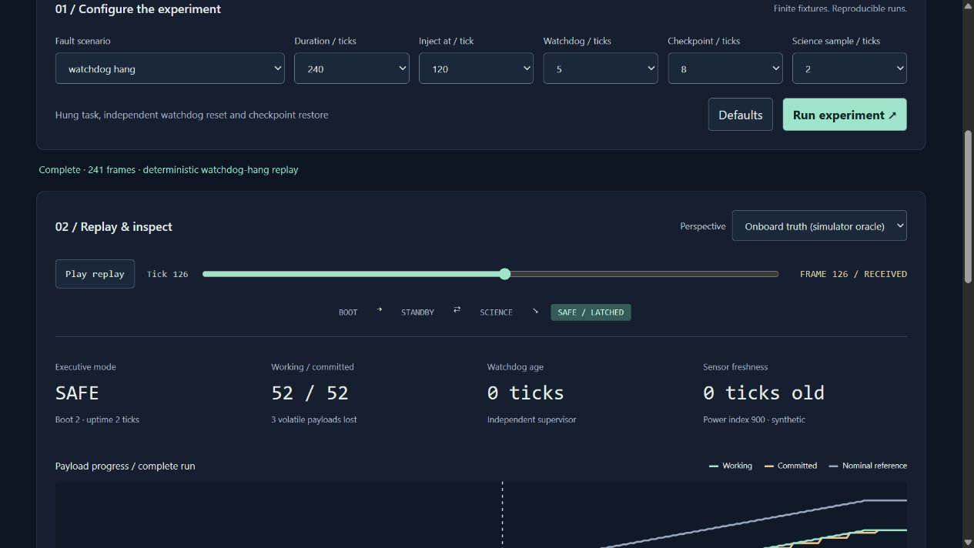
Actual recovery replay showing checkpoint restore and latched SAFE mode

Repository map
Path | Responsibility
native/core.* | Executive, supervisor, scheduled tasks, command checks and finite fault fixtures
native/checkpoint.* | Endian-independent checkpoint encoding and defensive decoding
native/cli.cpp | Fixed-argument native JSON worker; no arbitrary code or file execution
native/tests.cpp | 756 configuration fixtures, command/codec contracts and 5,000 seeded byte cases
flightlab/ | Strict worker bridge, loopback service, evidence reports, immutable SQL history and CLI
web/ | Accessible responsive console, gap-aware plots, replay and finite local preferences
tests/ | Independent Python oracles, actual HTTP/CLI/SQL and three-engine browser tests
tools/ | Native build, replay verification, exact-line documentation, packaging and guarded release
.github/workflows/ | Cross-platform validation, sanitizers/coverage, CodeQL and draft-only release
docs/ | All guides, architecture decisions, limitations, security, test results and source references

Every individual file is summarized in FILE_CATALOG. Headers describe responsibilities and variable roles; CODE_INDEX provides generated exact source locations rather than stale hand-maintained line numbers.

Validate
.venv/Scripts/python -m ruff check flightlab tests tools launcher.py
.venv/Scripts/python -m ruff format --check flightlab tests tools launcher.py
.venv/Scripts/python -m mypy flightlab
.venv/Scripts/python -m pytest --cov=flightlab --cov-report=term-missing
.venv/Scripts/python tools/validate_evidence.py
.venv/Scripts/python tools/verify_repo.py
npm run format:check
npm test
npm run build
npx playwright install chromium firefox webkit
npm run test:e2e
CI also runs Clang ASan+UBSan, GCC native line coverage, dependency audits, CodeQL for C++/Python/TypeScript and actual frozen executable smoke tests on three operating systems. No Actions artifacts or caches are uploaded. See VALIDATION for measured results and limitations; green checks are not flight certification or proof of absence of defects.

Documentation
User guide · Executive model · Architecture/ADRs · API · Security · Validation · Release/rollback · References/licenses.
For questions or defects, open a repository issue with the scenario/settings and expected vs observed behavior. For private security concerns, follow SECURITY. Do not post credentials or private operational telemetry. MIT licensed; created by Jason Stys. No agency or vendor endorsement is implied.

Current scope and practical limits
- Educational software-only executive; no flight hardware, operational SAFE assertion or mission qualification.
- Unsigned portable folder, not an installer or clean-machine installation proof. Exact-source three-OS builds and asset digests require publication review.
- Unsigned desktop portable folders, not system installers or clean-machine proof. Three-OS extracted-native checks drive an owned URL; default OS browser opening remains manual.
The accompanying Validation Review records the exact tested baseline, workflow evidence, test scope and known gaps. The Excel workbook provides filterable workflow and test-source inventories; neither substitutes for the actual execution logs.

Source references and maintenance
Maintain the editable Markdown and this Word edition together. Preserve dated execution reports and re-run the documented checks before release.
README.md · docs/ARCHITECTURE.md · docs/reports/PORTABLE_REFRESH_20261109.md
Project source and current Actions · Contact Jason Stys

