Spacecraft Flight Software Testbed Application Guide
Windows use and validation
By Jason Stys Version 1.1.0 10 November 2026
Compare onboard state with received recovery witnesses after a fictional watchdog hang. Prepared scenarios use the full Windows application and its existing model and report exports.
The published Windows portable application was installed and tested using isolated synthetic inputs. Provider and sidecar digests, release metadata and installed resource identities were checked. The installed file set remained unchanged after testing.

Capabilities and previous improvements
Compare onboard mode, boot and counter changes with downlinked witnesses, including missed transitions and reset windows. Separates what happened onboard from what a delayed telemetry stream actually observed.
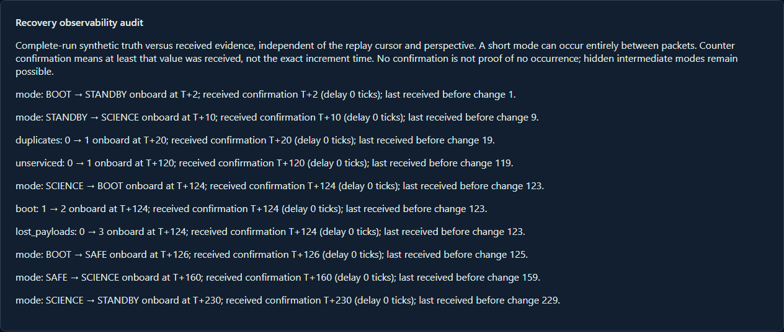
Figure 1 Actual installed application showing watchdog-hang recovery witness. Captured during the accepted native user journey with prepared synthetic inputs.

A worked application journey
The worked example compares watchdog-hang recovery witness with nominal reset-free reference. Interpret the results using the model assumptions and limits on the final page.
1. Open the application shortcut to start its local web interface and console. Select a prepared scenario or your own supported input; the examples require no external account or live hardware.
2. Run watchdog-hang, compare boot and reset transitions, then switch to the ground perspective. Inspect the received boot-change witness and download JSON; compare nominal.
3. Review the main case alongside the boundary case shown in Figure 2. The watchdog scenario produced one reset and a received boot-change witness. Nominal produced none; export matched the displayed complete run.
4. Download the supported evidence report and retain the input/configuration with it. Recompute after an input change; do not reuse a result under a different configuration.
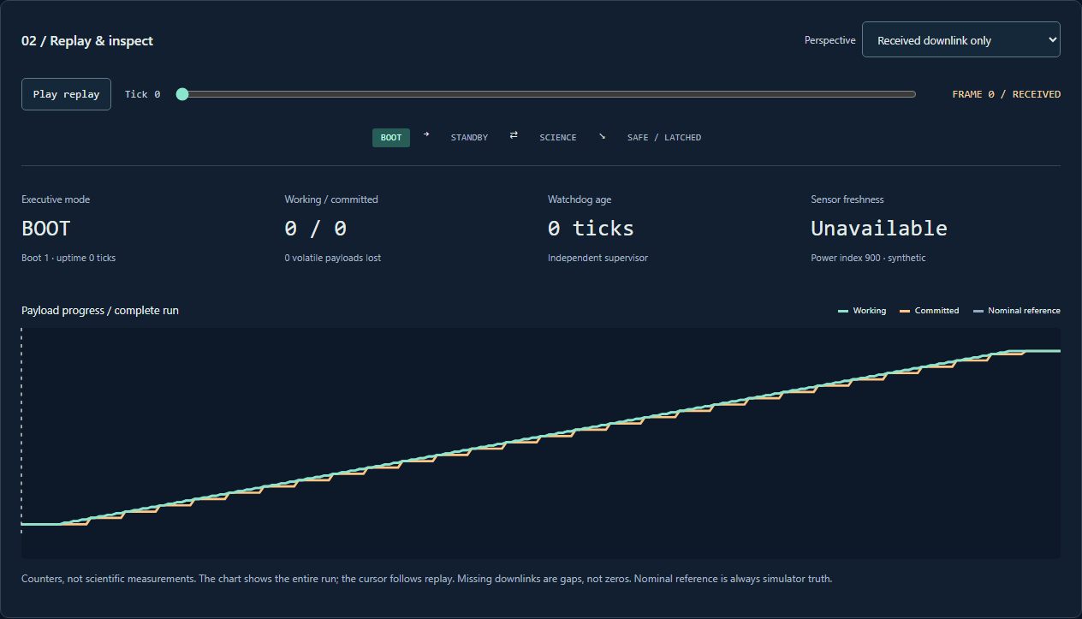
Figure 2 Actual installed application showing nominal reset-free reference. Captured during the accepted native user journey with prepared synthetic inputs.

Important implementation details

Observability
Confirmation is accepted only from a delivered frame before a later boot or incompatible mode. This separates onboard transitions from received evidence instead of inventing an observation time.
flightlab/observability.py lines 25 to 37
25 confirmation = None
26 for candidate in rows[index:]:
27 if candidate["boot"] != row["boot"]:
28 break
29 if field in {"mode", "boot"} and candidate[field] != row[field]:
30 break
31 if candidate["delivered"] and (
32 candidate[field] == row[field]
33 if field in {"mode", "boot"}
34 else candidate[field] >= row[field]
35 ):
36 confirmation = candidate["tick"]
37 break
Source file SHA256 8c32f47cb75173d4fed5315b37e11d8c0841bd895788c5b91421d4dc27e6f10d

Validation results and operating limits
Runtime source 5f9dc95ad5df564373d1304b13e4bb2464d13842
Check | Observed evidence | Result
Published package | Exact public release, provider/sidecar hashes and installed resources verified; installed bytes unchanged. | Passed
Actual native core | The existing packaged CLI/API and native feature acceptance helper passed on the installed executable. | Passed
Scenario evidence | The watchdog scenario produced one reset and a received boot-change witness. Nominal produced none; export matched the displayed complete run. | Passed
UI and cleanup | Actual compiled-application browser journey passed. Both images were individually inspected; cleanup left no owned child process. | Passed

Installation and private data
Use the complete matching Windows portable folder from Releases, including all companion files; verify the SHA256 sidecar before extracting it. Keep application files separate from your inputs, downloaded reports and optional CLI history.
Return to this app's own console and press Ctrl+C. Closing its browser tab alone does not stop the service.

Limits and help
Synthetic logical ticks and software modes only; no spacecraft/device ports, guidance, targeting or flight qualification.
These Windows portable checks used isolated synthetic inputs. System-wide installation, default-browser opening, desktop shortcuts and mobile installation were outside this test. Additional shortcut checks are recorded separately. No user data or Docker configuration changed.
Release and checksums | Runtime source | Project usage and limits

