Spacecraft Power and Thermal Lab Application Guide
Windows use and validation
By Jason Stys Version 1.1.0 10 November 2026
Attribute modeled service shortfall and explicit science shedding to component budgets. Prepared scenarios use the full Windows application and its existing model and report exports.
The published Windows portable application was installed and tested using isolated synthetic inputs. Provider and sidecar digests, release metadata and installed resource identities were checked. The installed file set remained unchanged after testing.

Capabilities and previous improvements
Show requested, served and unserved energy per load, interruption episodes and censored recovery, separating intentional shedding. Explains operational tradeoffs behind aggregate power and temperature traces.
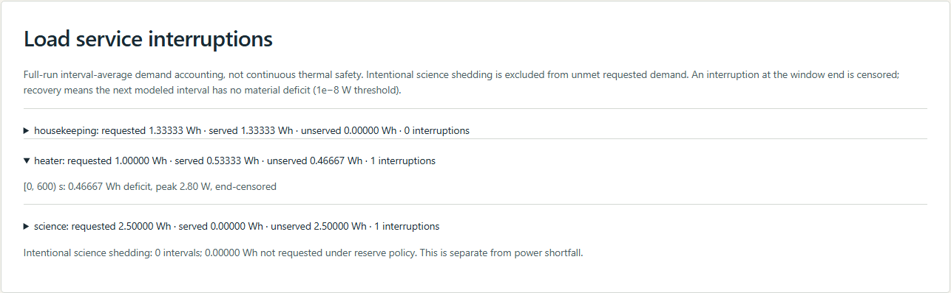
Figure 1 Actual installed application showing heater service shortfall. Captured during the accepted native user journey with prepared synthetic inputs.

A worked application journey
The worked example compares heater service shortfall with extended eclipse reserve policy. Interpret the results using the model assumptions and limits on the final page.
1. Open the application shortcut to start its local web interface and console. Select a prepared scenario or your own supported input; the examples require no external account or live hardware.
2. Inspect the load-service ledger and its interval boundaries. Compare heater contention with reserve-driven science shedding, then export the source-bound result.
3. Review the main case alongside the boundary case shown in Figure 2. The service ledger distinguished heater shortfall from reserve-driven science shedding, preserving exact accounting, original run identity and censored interval labels.
4. Download the supported evidence report and retain the input/configuration with it. Recompute after an input change; do not reuse a result under a different configuration.
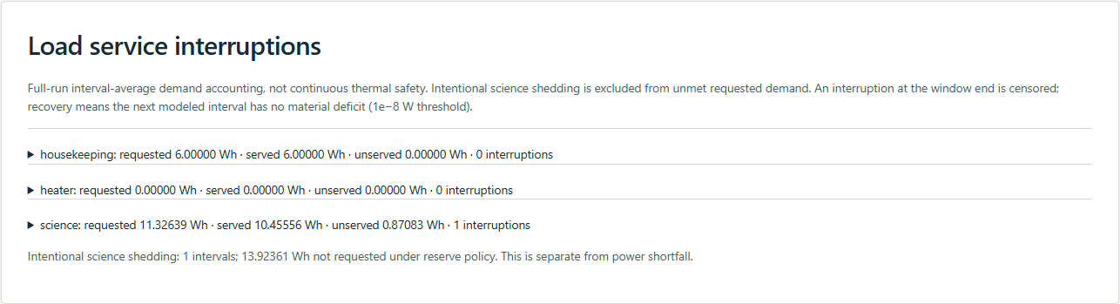
Figure 2 Actual installed application showing extended eclipse reserve policy. Captured during the accepted native user journey with prepared synthetic inputs.

Important implementation details

Service ledger
Requested and served component watts are integrated using each actual interval duration into watt-hours. Consecutive deficits retain interval boundaries and a separate peak, avoiding sampled-endpoint energy errors.
powerlab/service.py lines 23 to 49
23 for row in rows:
24 demand, served = (
25 (config.base_load_w, row["base_served_w"])
26 if component == "housekeeping"
27 else (config.heater_w * row["heater_on"], row["heater_served_w"])
28 if component == "heater"
29 else (row["payload_requested_w"], row["payload_served_w"])
30 if component == "science"
31 else (row["shed_requested_w"], 0.0)
32 )
33 deficit = max(0.0, demand - served)
34 hours = row["dt_s"] / 3600
35 demand_wh += demand * hours
36 served_wh += served * hours
37 shortfall_wh += deficit * hours
38 if deficit > 1e-8:
39 if active is None:
40 active = {
41 "start_s": row["time_s"] - row["dt_s"],
42 "end_s": row["time_s"],
43 "energy_wh": 0.0,
44 "peak_w": 0.0,
45 "right_censored": True,
46 }
47 active["end_s"] = row["time_s"]
48 active["energy_wh"] += deficit * hours
49 active["peak_w"] = max(active["peak_w"], deficit)
Source file SHA256 234567642a75dd245485003dbfe8a210b9c52de951d6d3f7f956960d12fae9bf

Validation results and operating limits
Runtime source 5f4f3ae0c6cf5e3f04bb0c3fc4ee5bbc94266d96
Check | Observed evidence | Result
Published package | Exact public release, provider/sidecar hashes and installed resources verified; installed bytes unchanged. | Passed
Actual native core | The existing packaged CLI/API and native feature acceptance helper passed on the installed executable. | Passed
Scenario evidence | The service ledger distinguished heater shortfall from reserve-driven science shedding, preserving exact accounting, original run identity and censored interval labels. | Passed
UI and cleanup | Actual compiled-application browser journey passed. Both images were individually inspected; cleanup left no owned child process. | Passed

Installation and private data
Use the complete matching Windows portable folder from Releases, including all companion files; verify the SHA256 sidecar before extracting it. Keep application files separate from your inputs, downloaded reports and optional CLI history.
Return to this app's own console and press Ctrl+C. Closing its browser tab alone does not stop the service.

Limits and help
Fictional single-body/battery educational model; no real spacecraft safety or hardware control.
These Windows portable checks used isolated synthetic inputs. System-wide installation, default-browser opening, desktop shortcuts and mobile installation were outside this test. Additional shortcut checks are recorded separately. No user data or Docker configuration changed.
Release and checksums | Runtime source | Project usage and limits

