Spacecraft Power Thermal Lab Project Guide
  - By Jason Stys
Public source revision 5f4f3ae0c6cf
This edition documents the cited source. Validation observations below identify their own tested revision and time; they are not a promise that an unrun later revision passed.
Every watt becomes a trade-off. An offline scientific-computing workbench by Jason Stys.
The released 1.1.0 HELIO portable app includes per-load service review: inspect requested and delivered energy, grouped shortfalls with censored boundaries, and deliberately shed science demand separately.
The C++ numerical model and independent Python energy/reference checks remain intact. The actual extracted UI is tested against an independent 6 W minus 3.2 W over 600 seconds energy calculation, component-to-total reconciliation and an exact JSON download. Product-version identity and preserved native notices make the practical analysis available in a reviewable portable bundle.

Purpose operation and implementation
Review per-load service interruptions: requested/served/unserved Wh, exact deficit intervals and observed recovery versus end censoring. Housekeeping, heater and science shortfall stay separate from deliberate reserve-policy science shedding.
Explore a fictional spacecraft's solar generation, battery reserve, electrical-load priorities and thermal response through imposed light/dark profiles. A C++20 worker computes bounded power allocation and a single-node RK4 thermal model. An independently structured Python implementation checks every numerical sample, then separately audits the electrical and thermal energy ledgers. TypeScript, HTML, CSS and SVG provide an accessible replay; SQL/SQLite provides optional local immutable evidence history.
All spacecraft parameters and environmental profiles are invented. This is educational numerical verification, not measured telemetry, orbital eclipse prediction, validated battery design, hardware control or flight-qualified analysis. Read the model and limits before interpreting results.
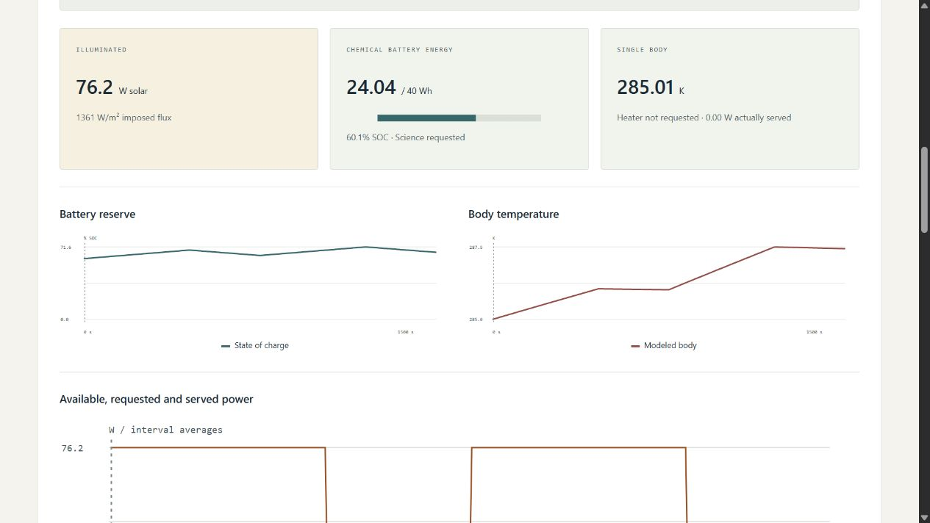
Actual local HELIO workbench

Features
- Nine experiments: illumination cycles, prolonged darkness, payload surges, cold/hot cases, empty/full batteries, analytic cooling and heater power contention.
- Finite battery, load-policy, thermostat and timestep controls; 324 combinations exercised against the actual C++ worker and independent Python reference.
- Charge/discharge limits, chemical-to-bus efficiency, explicit conversion losses, saturation, spill, and unmet demand. Housekeeping is served before heater, then science.
- Hysteretic reserve-aware science shedding and heater requests. Intentional science shedding is separate from unserved requested energy; a requested heater may receive less than its nominal power.
- Kelvin-based lumped-body integration, fixed ideal radiative sink, explicit heat fractions and separate external array/body assumptions. Sampling and physical-model limits stay visible.
- Interval replay, all-sample state/power plots, Celsius display without changing SI evidence, exact selected-interval allocation, and an in-memory pinned-result comparison.
- Complete JSON/escaped static HTML evidence, dimensioned interval CSV, editable strict input JSON, content hashes, and opt-in SQL history. No automatic payload collection, accounts or remote services.
- Cross-platform warning-as-error C++ builds, Clang ASan/UBSan, GCC line coverage, Python/TypeScript tests, three browser engines, dependency audits and three-language CodeQL.

Run a portable desktop bundle
Use the v1.1.0 release. Download the Windows x64 ZIP or Linux x64/macOS arm64 .tar.gz archive and its matching .sha256 file. Verify the digest and extract the entire SpacecraftPowerThermalLab folder, preserving _internal, licenses, POSIX links and executable permissions. Launch from the extracted folder, not from inside the archive.
- Windows x64: open SpacecraftPowerThermalLab.exe.
- Linux x64: run ./SpacecraftPowerThermalLab.
- macOS arm64: run ./SpacecraftPowerThermalLab from Terminal.
The executable opens your normal browser on an ephemeral 127.0.0.1 port. Keep its console running; Ctrl+C stops it. No Python/Node/compiler installation, administrator rights, account or cloud connection is needed for the bundled app. These are unsigned/unnotarized portable desktop applications, not mobile installers or public hosted services. Do not bypass OS security warnings; inspect/build source if your policy disallows unsigned software.

Source setup
Requires Python 3.12–3.14, Node 24, and a C++20 compiler: Visual Studio 2022/2026 C++ tools on Windows, GCC/Clang on Linux or Apple Clang on macOS. The development lock installs CMake; Python runtime and C++ model use only their standard libraries.
python -m venv .venv
.venv/Scripts/python -m pip install --require-hashes -r requirements-dev.lock
npm ci
.venv/Scripts/python tools/build_native.py
npm run build
.venv/Scripts/python -m powerlab serve
Use .venv/bin/python on Linux/macOS. Windows builds need the installed SDK's normal registry access; don't weaken OS security settings. If your execution sandbox restricts temporary files, use a task-owned writable TEMP/TMP directory. The native worker is mandatory: a missing worker never causes a reference-only success fallback.

Export or customize
.venv/Scripts/python -m powerlab export --scenario extended-eclipse --policy 1 --output reserve.json --history history.sqlite3
.venv/Scripts/python -m powerlab export --input examples/illumination.json --format html --output custom.html
Existing output destinations are never overwritten. CLI imports accept only the bounded schema, not executable code or device/network addresses. Imported battery capacity remains exactly what the file specifies; the browser battery preset does not override it. For imports, settings.battery records the unused preset; the actual value is input.config.battery_wh, which the UI/report exposes. Step/policy/heater controls still apply.
SQLite is optional, unencrypted, local-only and ignored by Git. It verifies report identity, uses immutable-entry triggers and caps at 100 distinct reports without automatic pruning. It is evidence history, not a resume/checkpoint mechanism. Reports include parameters, imposed inputs, numerical methods, units, limits and SHA-256 identities. Floating-point reports can differ slightly across compilers; benchmark metrics use declared tolerances, not an unsupported universal bit-identical claim.

Check the project
.venv/Scripts/python tools/build_native.py
.venv/Scripts/python -m ruff check powerlab tests tools launcher.py
.venv/Scripts/python -m ruff format --check powerlab tests tools launcher.py
.venv/Scripts/python -m mypy powerlab
.venv/Scripts/python tools/verify_repo.py
.venv/Scripts/python -m pytest --cov=powerlab --cov-report=term-missing
.venv/Scripts/python -m tools.benchmark
npm run format:check
npm test
npm run build
npx playwright install chromium firefox webkit
npm run test:e2e
.venv/Scripts/python tools/package_app.py
Linux additionally runs tools/build_native.py --sanitize with Clang, and --coverage with GCC, followed by the integration tests and gcovr. These are distinct builds; sanitizers and coverage are not claimed to have run under Windows. See executed results and test strategy.
GitHub workflows upload no Actions artifacts or caches. Portable releases are built, smoke-tested and uploaded directly to a draft release only after the exact source commit's Validation and CodeQL workflows pass. A separate review checks findings, download digests and actual app behavior before publication. No old runs are deleted automatically.

File and feature map
Path | Responsibility
native/core.hpp, core.cpp | Strict C++ parameter/profile types, allocation, hysteresis, RK4, serialization
native/cli.cpp, tests.cpp | Bounded stdin-only worker and seven analytic/security contract groups
powerlab/model.py, engine.py | Strict JSON/SI inputs, invented cases, sample-agreement and energy gates, report identity
powerlab/native.py, reference.py | Fixed native process/timeout contract; independent Python flows and RK4
powerlab/server.py, __main__.py | Protected read-only loopback API, explicit local CLI imports/exports
powerlab/reports.py, resources/history.sql | Inert reports and opt-in immutable hash-verified SQL history
web/ | Typed scientific presentation, charts, accessible controls, responsive styling
tests/ | Differential/property/analytic, schema, HTTP, persistence, browser and failure regressions
tools/ | Native builds, exact-line inventory, numerical benchmarks, packaging/smoke/release gates
examples/, docs/ | Editable invented profile, methods, results, provenance, screenshots and runbooks
.github/workflows/ | Pinned least-privilege cross-platform validation, CodeQL and manual draft packaging

Every source file has a responsibility/creator header and definition contracts. CODE_INDEX gives generated exact line locations for definitions, fields and variables without fragile duplicated line numbers in comments. FILE_CATALOG summarizes every source-intent file; CI rejects stale indexes.

Documentation, contribution and contact
Architecture · Model/equations · Input/API · User guide · Validation · Release/runbook · Security · Notices/references
For contributions, reproduce an issue with a synthetic case, add the relevant boundary/regression test, update model documentation and inventory, and run the checks above. Don't commit personal data, keys, histories or generated applications. New physical claims require independent validation evidence, not merely updated snapshots.
Created by Jason Stys. Portfolio/contact profile · Project help/issues. MIT project source. No agency, employer or mission affiliation/endorsement.

Current portable release
Version 1.1.0 includes the current practical workflow in Windows ZIP and Linux/macOS tar.gz portable folders, with OS/CPU/version labels and source-bound release metadata. Historical 1.0.0 downloads predate these improvements. These are unsigned portable applications, not installers; preserve the entire extracted folder and POSIX links. See release notes, local validation and release procedure for exact acceptance and publication boundaries.

Current scope and practical limits
- Fictional single-body/battery model; numerical agreement and balanced energy do not validate real batteries or establish spacecraft safety.
- No live hardware, power control or operational thermal assurance.
- Unsigned desktop portable folders, not system installers or clean-machine proof. Three-OS extracted-native checks drive an owned URL; default OS browser opening remains manual.
The accompanying Validation Review records the exact tested baseline, workflow evidence, test scope and known gaps. The Excel workbook provides filterable workflow and test-source inventories; neither substitutes for the actual execution logs.

Source references and maintenance
Maintain the editable Markdown and this Word edition together. Preserve dated execution reports and re-run the documented checks before release.
README.md · SECURITY.md · docs/ARCHITECTURE.md · docs/reports/PORTABLE_REFRESH_20261109.md
Project source and current Actions · Contact Jason Stys

