Spacecraft Telemetry Anomaly Studio Application Guide
Windows use and validation
By Jason Stys Version 1.1.0 10 November 2026
Review run-bound anomaly episodes and export detached human annotations. Prepared scenarios use the full Windows application and its existing model and report exports.
The published Windows portable application was installed and tested using isolated synthetic inputs. Provider and sidecar digests, release metadata and installed resource identities were checked. The installed file set remained unchanged after testing.

Capabilities and previous improvements
Group channel/context alerts into run-bound episodes with observed recovery, gaps and window-censored states; add human review and export. Makes anomaly investigation manageable without inventing recovery across missing telemetry.
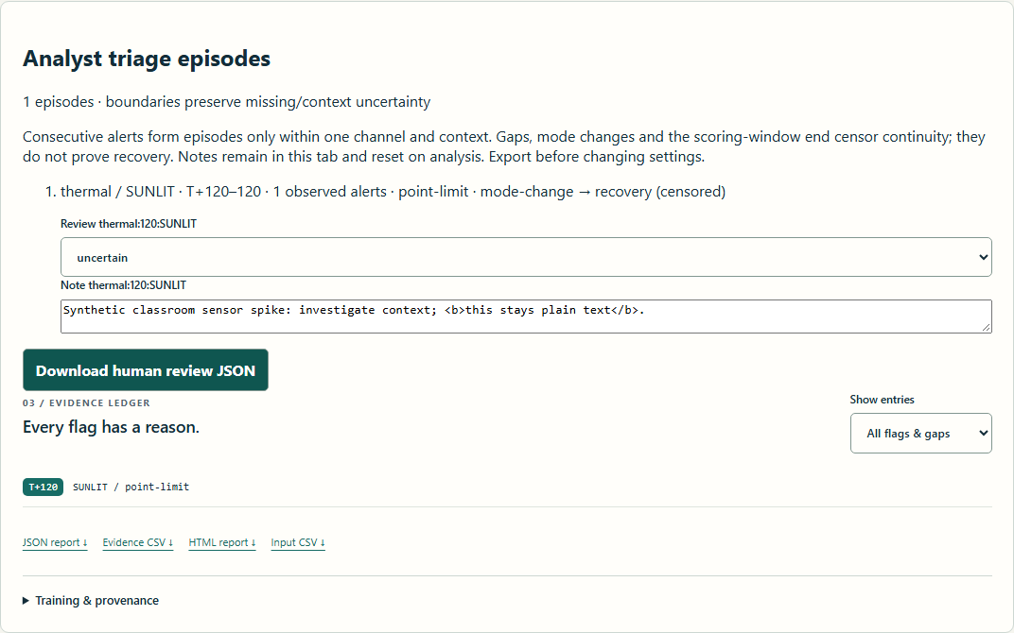
Figure 1 Actual installed application showing synthetic spike human triage. Captured during the accepted native user journey with prepared synthetic inputs.

A worked application journey
The worked example compares synthetic spike human triage with partial missing telemetry. Interpret the results using the model assumptions and limits on the final page.
1. Open the application shortcut to start its local web interface and console. Select a prepared scenario or your own supported input; the examples require no external account or live hardware.
2. Analyze isolated-spike and inspect the episode at tick 120. Record an uncertain review note and export it. Compare nominal and partial missing telemetry using the signal inspector.
3. Review the main case alongside the boundary case shown in Figure 2. The spike episode was 120 to 120 with a run-bound uncertain note. Twelve missing bus readings split that observation path while the thermal channel remained observable.
4. Download the supported evidence report and retain the input/configuration with it. Recompute after an input change; do not reuse a result under a different configuration.
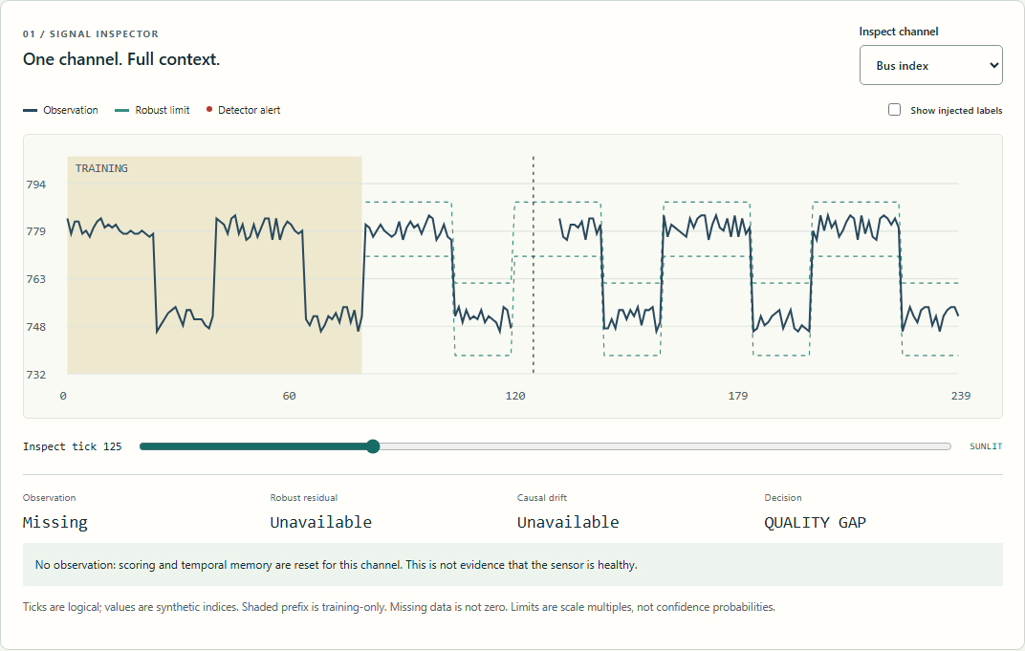
Figure 2 Actual installed application showing partial missing telemetry. Captured during the accepted native user journey with prepared synthetic inputs.

Important implementation details

Episodes
Mode changes, missing samples and actual recovery end episodes differently. Only observed recovery removes right censoring, so missing telemetry is not reported as a recovered fault.
telemetry/triage.py lines 25 to 38
25 boundary = (
26 "mode-change"
27 if previous is not None and row["mode"] != previous["mode"]
28 else "gap"
29 if decision["value"] is None
30 else "recovery"
31 if not decision["reasons"]
32 else None
33 )
34 if active is not None and boundary is not None:
35 active["end_boundary"] = boundary
36 active["right_censored"] = boundary != "recovery"
37 result.append(active)
38 active = None
Source file SHA256 2daf0f066670e9978ae8f852e85acc5a1ed8e4a9d72585a6ed5aad131f233f1b

Validation results and operating limits
Runtime source 616b8cc92be09622443e103cdc201ce1d0c16a55
Check | Observed evidence | Result
Published package | Exact public release, provider/sidecar hashes and installed resources verified; installed bytes unchanged. | Passed
Actual native core | The existing packaged CLI/API and native feature acceptance helper passed on the installed executable. | Passed
Scenario evidence | The spike episode was 120 to 120 with a run-bound uncertain note. Twelve missing bus readings split that observation path while the thermal channel remained observable. | Passed
UI and cleanup | Actual compiled-application browser journey passed. Both images were individually inspected; cleanup left no owned child process. | Passed

Installation and private data
Use the complete matching Windows portable folder from Releases, including all companion files; verify the SHA256 sidecar before extracting it. Keep application files separate from your inputs, downloaded reports and optional CLI history.
Return to this app's own console and press Ctrl+C. Closing its browser tab alone does not stop the service.

Limits and help
Synthetic statistical/heuristic demonstration; no live mission monitor, neural-model quality claim or real failure diagnosis.
Annotations are detached downloads and reset on a new analysis; they are not persistent shared review records.
These Windows portable checks used isolated synthetic inputs. System-wide installation, default-browser opening, desktop shortcuts and mobile installation were outside this test. Additional shortcut checks are recorded separately. No user data or Docker configuration changed.
Release and checksums | Runtime source | Project usage and limits

