Spacecraft Telemetry Anomaly Studio Project Guide
  - By Jason Stys
Public source revision 616b8cc92be0
This edition documents the cited source. Validation observations below identify their own tested revision and time; they are not a promise that an unrun later revision passed.
Review consecutive flags as run-bound triage episodes with explicit missing-value, mode-change and scoring-window boundaries. Add bounded human notes and export a review linked to the immutable evidence hash. Censored episodes never imply observed recovery; annotations never change detector decisions or synthetic truth. See the triage guide.
The released 1.1.0 portable app includes run-bound anomaly triage: inspect channel episodes with explicit recovery, gap, context and censored boundaries, add human notes, and download the review tied to its originating run.
The original label-isolated detector and metrics remain unchanged. An actual extracted-app analyst journey verifies a known spike, annotation export and note reset between analyses; independently restoring the previous version field reproduced every old benchmark hash before version-only IDs were refreshed. This makes the downloadable workflow match the practical source feature without claiming operational anomaly assurance.

Purpose operation and implementation
Separate signal from surprise. An explainable, offline-first telemetry analysis application by Jason Stys.
Fit robust limits on the past, score later observations causally, and inspect every flag. Compare a context-aware baseline with a pooled baseline on the same held-out observations. See false positives, misses, detection delay and missing data—not an inflated single accuracy number.
This is a teaching/portfolio application using invented telemetry indices and logical ticks. It is not an operational spacecraft monitor, flight-qualified system, physical model, command interface or failure diagnosis tool. It uses statistical learning and explicit heuristics, not a neural network or an external AI service. No agency endorsement is implied.
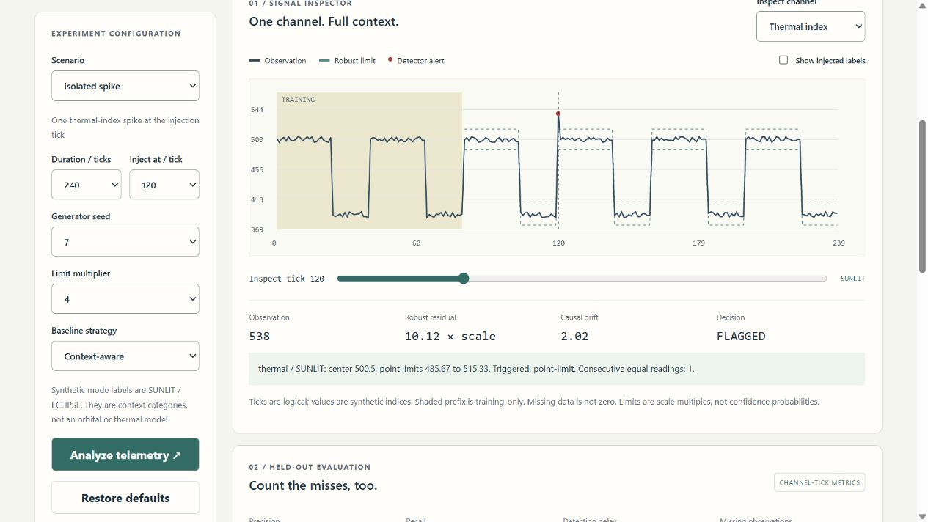
Actual local signal inspector showing a detected spike and frozen context-aware limits

Features
- Eight reproducible fixtures: nominal, isolated spike, multichannel burst, slow drift, stuck sensor, full telemetry gap, partial dropout and step shift.
- Three synthetic channels and two characterized context categories; frozen training prefix at ticks 0–79, held-out evaluation from tick 80 onward.
- Channel/context median–MAD point limits, causal EWMA drift and a six-repeat flatline rule. Every flag has a residual, limit and reason.
- Honest quality handling: absent values break chart paths, reset temporal state and are excluded from sensor confusion counts; missing does not mean healthy.
- Ground-truth labels are separated from the detector and used only after scoring for evaluation. Undefined denominators stay undefined.
- Interactive responsive browser inspector, channel/tick selection, label overlay, alert/gap ledger and alternate-strategy comparison.
- JSON, evidence CSV, inert HTML and import-schema CSV downloads; deterministic content hashes and reproducible benchmark reports.
- Strict CLI-only local CSV import; no browser uploads, remote ingestion, arbitrary models, scripts or spacecraft connections.
- Optional immutable SQLite history, unsigned portable desktop bundles, tests and pinned GitHub Actions with no artifact/cache uploads.

Try the app
Download the matching versioned portable archive from Releases: Windows ZIP or Linux/macOS tar.gz for version 1.1.0 onward. Verify its SHA-256, extract the whole folder, and launch TelemetryAnomalyStudio (.exe on Windows). It opens the local browser UI without requiring Python, Node, an account, cloud access or administrator rights. Ctrl+C stops the console service. Builds are unsigned; do not disable OS protections. Desktop bundles target their tested runner OS/architecture, not every historical OS. Mobile browser layout is tested; no phone-native executable is supplied.
For development: Python 3.12–3.14 and Node 24. Runtime analysis and serving use Python's standard library only.
python -m venv .venv
.venv/Scripts/python -m pip install --require-hashes -r requirements-dev.lock
npm ci
npm run build
.venv/Scripts/python -m telemetry serve
On Linux/macOS use .venv/bin/python. The service binds only 127.0.0.1 on an ephemeral port. It is not a public Internet server.
.venv/Scripts/python -m telemetry export --scenario slow-drift --output evidence.json --history local-runs.sqlite3
.venv/Scripts/python -m telemetry export --input examples/slow-drift.csv --output imported-report.html --format html
Imported accuracy metrics remain undefined because imports have no truth labels. Only numeric observations and characterized modes are accepted; the path is not included in reports. Exports never overwrite existing files. History is opt-in and capped at 100 immutable records.

Repository structure
Path | Responsibility
telemetry/detector.py | Frame schema, robust training, frozen bands and causal point/drift/flatline decisions
telemetry/engine.py | Deterministic generator, label isolation, evaluation, strict CSV parser, caching and evidence hashes
telemetry/reports.py | Structured/inert reports, import-schema CSV and parameterized immutable history
telemetry/server.py | Loopback-only read-only API, origin/Host controls and confined built assets
telemetry/__main__.py / launcher.py | Source/frozen app launch and local export/import CLI
telemetry/resources/history.sql | SQLite records, constraints and immutable triggers
web/ | TypeScript inspector, safe display transforms, accessible HTML/CSS and unit contracts
tests/ | Independent statistic/rule oracles, full configuration grid, causality, parser fuzz, HTTP/CLI/SQL and browser tests
tools/ | Benchmark verification, source/file inventory, frozen packaging and guarded draft release
examples/ | Clearly synthetic strict-schema CSV for local import testing
docs/ | Model contracts, guides, ADRs, security, validation evidence, benchmark reports and screenshots
.github/workflows/ | Cross-platform validation, CodeQL and draft-only release builds

The file catalog summarizes every file. Source headers describe responsibilities/functions/variables; the generated exact-line code index supplies current function and variable locations. CI rejects stale indexes rather than relying on manually duplicated line numbers.

Documentation and support
User guide · Detector/model contract · Architecture/ADRs · API/CSV · Security · Validation · Release/rollback · References/notices.
Created and maintained by Jason Stys, MIT licensed. Open an issue with synthetic settings, the report ID and expected vs observed behavior; use the private reporting guidance for security concerns. Do not publish personal data, credentials or sensitive operational telemetry.

Current portable release preparation
Version 1.1.0 includes the current practical workflow in Windows ZIP and Linux/macOS tar.gz portable folders, with OS/CPU/version labels and source-bound release metadata. Historical 1.0.0 downloads predate these improvements. These are unsigned portable applications, not installers; preserve the entire extracted folder and POSIX links. See release notes, local validation and release procedure for exact acceptance and publication boundaries.

Current scope and practical limits
- Synthetic telemetry and bounded rule-based detector evidence; no live spacecraft or hardware validation.
- Human notes are detached local downloads rather than server-persisted multi-user reviews.
- Unsigned desktop portable folders, not system installers or clean-machine proof. Three-OS extracted-native checks drive an owned URL; default OS browser opening remains manual.
The accompanying Validation Review records the exact tested baseline, workflow evidence, test scope and known gaps. The Excel workbook provides filterable workflow and test-source inventories; neither substitutes for the actual execution logs.

Source references and maintenance
Maintain the editable Markdown and this Word edition together. Preserve dated execution reports and re-run the documented checks before release.
README.md · docs/ARCHITECTURE.md · docs/reports/PORTABLE_REFRESH_20261109.md
Project source and current Actions · Contact Jason Stys

