SRE Observability Workbench Application Guide
Windows use and validation
By Jason Stys Version 1.1.1 11 November 2026
Investigate availability and latency evidence using explicit SLO windows, independent journey denominators and actual OpenTelemetry traces and logs. The Windows app can import observations or run a bounded service drill owned entirely by this process.
The installed 1.1.1 app passed its full native workflows and reopened the same synthetic profile created by 1.1.0 with exact saved evidence. Existing links were backed up and retargeted with read-back verification; default-profile shortcut activation was not independently exercised.

Capabilities and previous improvements
Compare owner/service/journey SLO bundles over identical windows, with quality, burn and weakened-objective review queues. Prevents pooled availability and changed denominators from hiding a failing user journey.
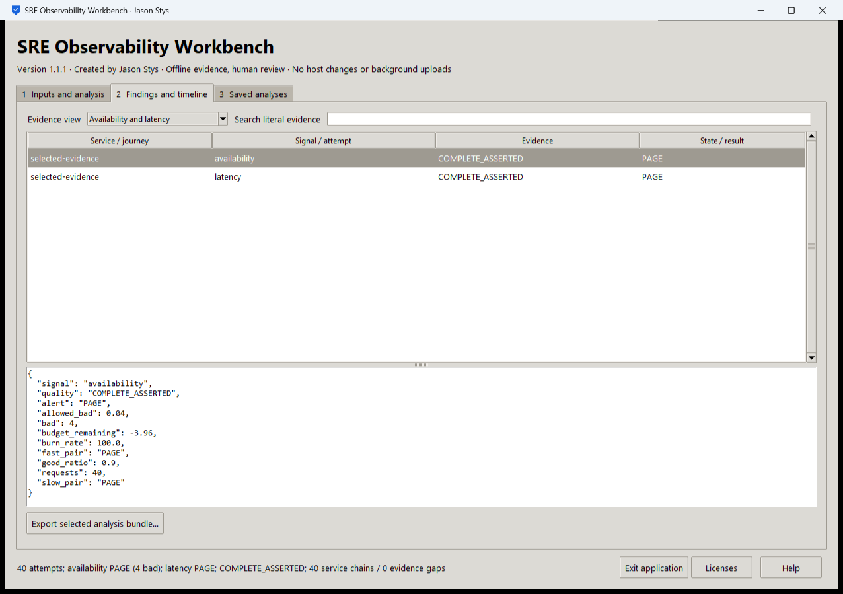
Figure 1 The actual installed drill recorded 40 requests, 4 bad attempts and availability and latency PAGE results. The view shows the selected objective and complete asserted evidence; this is not a healthy production-service claim.

A worked application journey
An SRE runs 40 owned loopback attempts with a finite injected-fault interval, inspects request/span/log correlation and recovery, then compares the same evidence under an explicit alternate objective and a multi-journey owner bundle.
1. Choose the bounded local drill or import your supported evidence/manifest. Set the explicit attempt count, fault interval, latency units and objective before running.
2. Inspect the availability/latency result and raw evidence. A PAGE result is an observed failed budget; changing an objective is a comparison, not a repair.
3. Open the independent journey review case and inspect each owner's quality and review queue. Retain missing observations and boundaries explicitly.
4. Export the selected complete bundle and reopen the same profile. Stop the app normally; the owned services drain and their listeners exit.
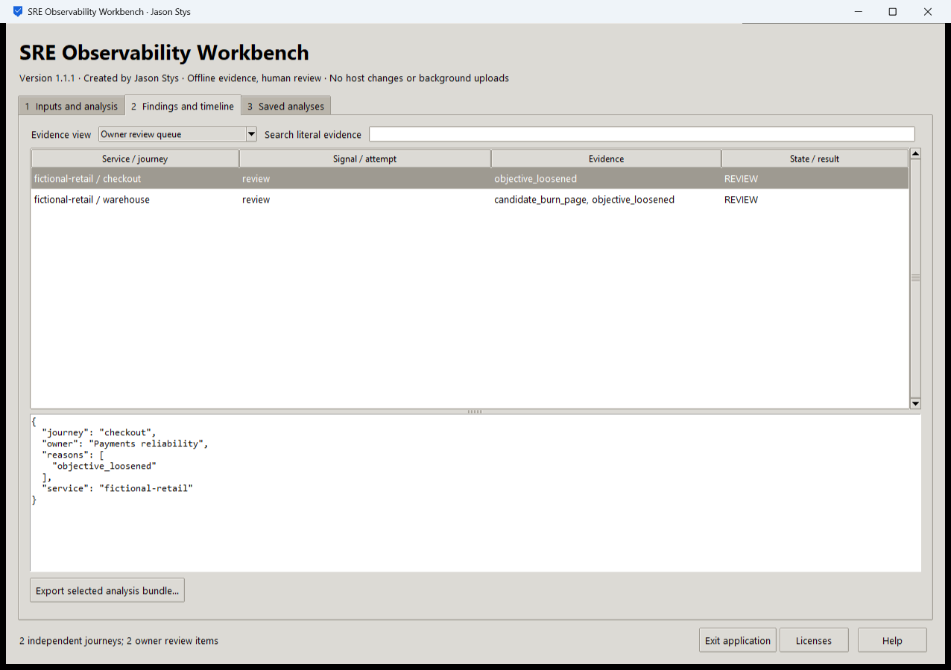
Figure 2 The installed app compares separately scoped service and journey objectives. Owner review items retain their own observation quality and denominator rather than being hidden in a pooled total.

Important implementation details

Check fixed state before a write can follow an alias
This pre-initialization check requires any existing fixed state member to be an ordinary single-link file without a Windows reparse attribute. Startup and connection admission apply it to the known marker/lock/SQLite recovery paths; ordinary recovery files are retained.
sre/desktop_state.py lines 213 to 225
213 def admit_existing(path: Path) -> None:
214 """Refuse pre-existing linked/nonregular fixed state before initialization can write through an alias."""
215 try:
216 info = path.lstat()
217 except FileNotFoundError:
218 return
219 if (
220 not stat.S_ISREG(info.st_mode)
221 or info.st_nlink != 1
222 or getattr(info, "st_file_attributes", 0)
223 & getattr(stat, "FILE_ATTRIBUTE_REPARSE_POINT", 0)
224 ):
225 raise Rejected("fixed workspace state must be unlinked one-link regular files")
Source file SHA256 0d56b4eb2129ba1b9e3b9bd0344c80e709f594b4d9dc99b6b32b860a3c208294

Validation results and operating limits
Runtime source 9e7f7789a0dd1d93c44dd26088de86812abc6d96
Check | Observed evidence | Result
Actual installed workflows | Full original domain, review and export controls passed two normal native launches; all 4 saved bundles retained exact original bytes. | Passed
Old-to-new profile | The actual installed 1.1.0 app created a synthetic profile; installed 1.1.1 reopened it and retained all 4 exact bundles without reset. | Passed
Source and distribution | Exact-main workflows and processed CodeQL passed with zero open main alerts. Five downloaded assets and installed files matched their verified SHA-256 identities. | Verified
PC and links | Existing links were backed up and retargeted with settings retained. Normal profiles and Docker were unchanged; default-profile shortcut activation remains separately untested. | Verified

Installation and private data
Download the matching Windows EXE and SHA256 sidecar from Releases. This is an unsigned portable app, not an MSI; Python installation and terminal commands are unnecessary. Keep the distribution and runtime notices together.
Open your own new or identified profile outside the installation. History is local plaintext protected by OS-owner access and an exclusive instance lock. Use Help for formats and limits; Exit application closes the owned workbench.

Limits and help
The app runs only a finite owned loopback service. It is not a production monitoring deployment or an external telemetry collector. Local synthetic evidence does not establish an operational SLO.
Reviewer names are assertions, not authenticated identities. These tests used isolated synthetic profiles and did not access existing user data, call external services or change Docker. Back up your complete profile before moving it.
Release and checksums | Runtime source | Usage and limits

