SRE Observability Workbench Application Guide
Windows use and validation
By Jason Stys Version 1.1.0 10 November 2026
Investigate availability and latency evidence using explicit SLO windows, independent journey denominators and actual OpenTelemetry traces and logs. The Windows app can import observations or run a bounded service drill owned entirely by this process.
The published Windows portable app passed independent download/installed-byte acceptance, two real compiled launches, exact saved evidence comparisons and normal exits. The figures show the installed app with fictional supplied records.

Capabilities and previous improvements
Compare owner/service/journey SLO bundles over identical windows, with quality, burn and weakened-objective review queues. Prevents pooled availability and changed denominators from hiding a failing user journey.
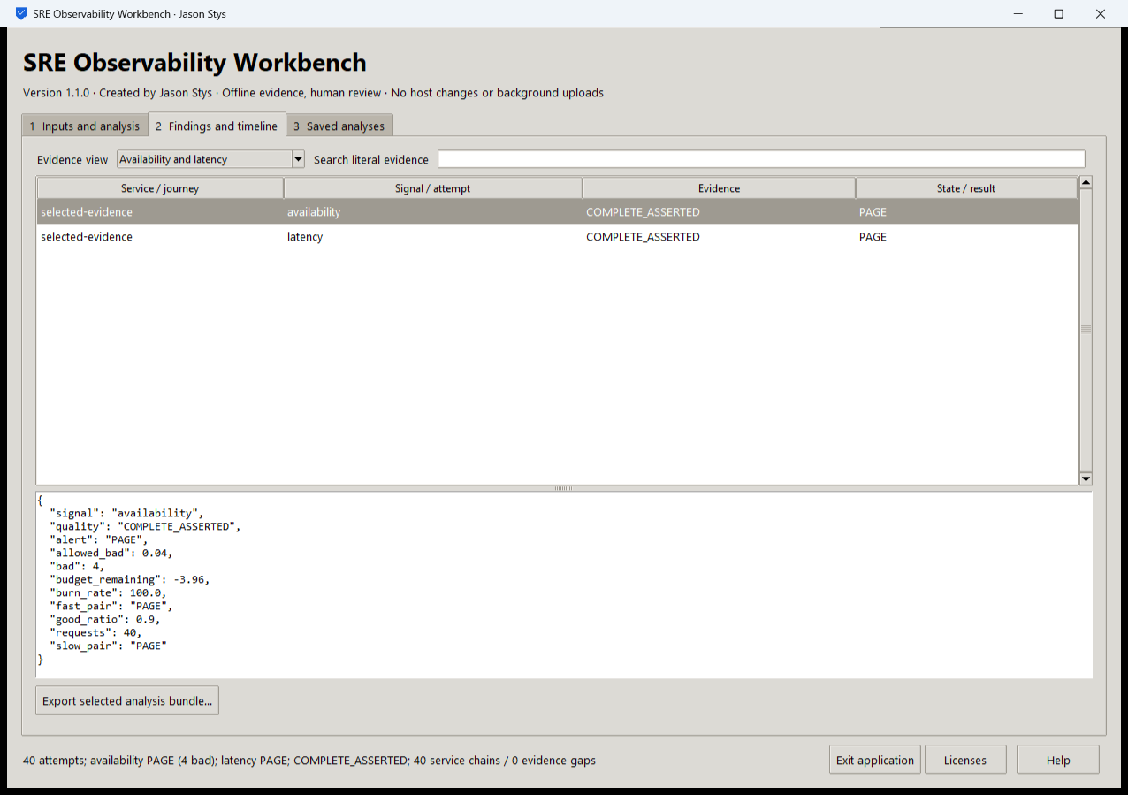
Figure 1 The actual installed drill recorded 40 requests,4 bad attempts and availability and latency PAGE results. The view shows the selected objective and complete asserted evidence; this is not a healthy production-service claim.

A worked application journey
An SRE runs 40 owned loopback attempts with a finite injected-fault interval, inspects request/span/log correlation and recovery, then compares the same evidence under an explicit alternate objective and a multi-journey owner bundle.
1. Choose the bounded local drill or import your supported evidence/manifest. Set the explicit attempt count, fault interval, latency units and objective before running.
2. Inspect the availability/latency result and raw evidence. A PAGE result is an observed failed budget; changing an objective is a comparison, not a repair.
3. Open the independent journey review case and inspect each owner's quality and review queue. Retain missing observations and boundaries explicitly.
4. Export the selected complete bundle and reopen the same profile. Stop the app normally; the owned services drain and their listeners exit.
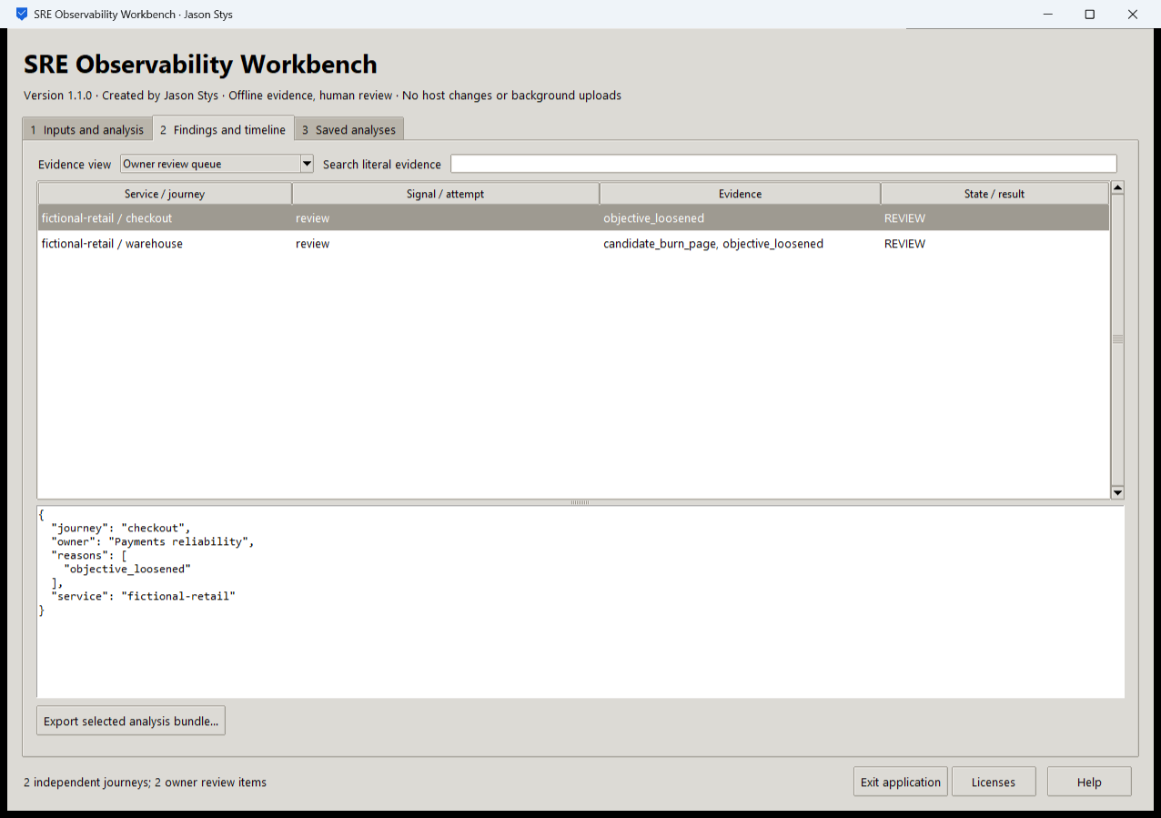
Figure 2 The installed app compares separately scoped service and journey objectives. Owner review items retain their own observation quality and denominator rather than being hidden in a pooled total.

Important implementation details

Run the actual bounded service drill
The adapter selects the original core or journey analysis, validates settings, and limits the owned drill to at most 50 attempts. It retains the raw gateway and worker evidence for later independent inspection.
sre/desktop_project.py lines 215 to 239
215
216 def analyze(
217 state: Workspace, parameters: dict[str, str], stage: Path
218 ) -> tuple[str, str, dict[str, bytes]]:
219 """Run actual core assessment, independent journey review or finite owned traffic; preserve complete raw attempt evidence."""
220 mode, output = parameters["mode"], stage / "bundle"
221 if mode == MODES[3]:
222 result = bundle.analyze(Path(parameters["manifest"]))
223 bundle.publish(result, output)
224 return (
225 mode,
226 f"{result['stream_count']} independent journeys; {len(result['review_queue'])} owner review items",
227 {path.name: read_bytes(path, MAX_BYTES) for path in output.iterdir()},
228 )
229 if mode not in MODES[:3]:
230 raise Rejected("unsupported native operation")
231 settings = policy(parameters)
232 extra: dict[str, bytes] = {}
233 expected: int | None
234 if mode == MODES[0]:
235 expected = number(parameters, "attempts", 1, 50)
236 events, evidence, extra = drill(
237 stage,
238 expected,
239 Faults(
Source file SHA256 96135dd69bfefdca52d3b86854729af2e4a005cf7c2e2d8431a1fc3bddf81870

Validation results and operating limits
Runtime source 1fc5acffbb82c894fcb5de7d4c27de98713eaa19
Check | Observed evidence | Result
Release and runtime | All 5 downloaded assets matched provider/sidecar hashes. Actual frozen CPython 3.14.10 and Tcl/Tk 9.0.4 matched their recorded runtime identities. | Passed
Real user workflow | Four exact saved bundles survived restart. The real drill produced 40 requests,120 SDK spans and 80 logs with 40 correlated chains; observed fault recovery and same-window objective comparisons passed. | Passed
Source and security | All current main workflows passed. Exact-source CodeQL analyses processed with zero open main alerts before publication. | Passed
Desktop delivery | New individual Desktop and Start-menu links target the installed accepted EXE. Shortcut metadata was read back; normal shortcut activation was not independently exercised. | Verified

Installation and private data
Download the matching Windows EXE and SHA256 sidecar from Releases. This is an unsigned portable app, not an MSI; Python installation and terminal commands are unnecessary. Keep the distribution and runtime notices together.
Open your own new or identified profile outside the installation. History is local plaintext protected by OS-owner access and an exclusive instance lock. Use Help for formats and limits; Exit application closes the owned workbench.

Limits and help
The app runs only a finite owned loopback service. It is not a production monitoring deployment or an external telemetry collector. Local synthetic evidence does not establish an operational SLO.
Reviewer names are assertions, not authenticated identities. These tests used isolated synthetic profiles and did not access existing user data, call external services or change Docker. Back up your complete profile before moving it.
Release and checksums | Runtime source | Usage and limits

