Unity Tactical AI Designer Application Guide
Windows use and validation
By Jason Stys Version 1.1.0 11 November 2026
Author fictional turn-based game scenarios, apply legal commands, inspect deterministic replay frames and compare generated encounters through a usable Windows designer around the original C sharp engine.
The published Windows app passed both actual visible native phases after independent download. Its original 48 tests and 500-seed reference evidence remain intact. No Unity Editor, PlayMode or multiplayer execution is claimed.

Capabilities and previous improvements
The original headless simulation, utility agent, serialization and Unity bridge contract remain. The designer adds board and avatar editing, command validation, replay navigation, durable current and previous projects, exact exports and a bounded seeded balance study inside the same application.
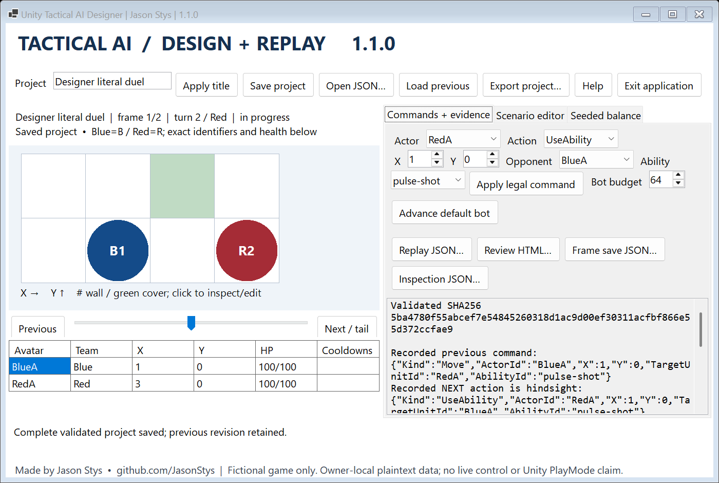
Figure 1 The installed designer displays the authored board, exact avatar state and replay cursor. Recorded next actions are explicitly hindsight, rather than a bot forecast.

A worked application journey
A game developer edits a small duel, applies a legal move and ability, compares replay frames, saves both revisions and runs a separate five-seed balance cohort before exporting actual completed results.
1. Open Scenario editor to edit the board, actors, abilities and title. Apply a validated scenario; rejected JSON or commands preserve the current project.
2. Use Commands and evidence to apply a legal command or advance the default bot. Inspect exact health, cooldowns, frame hashes and the replay cursor.
3. Save the project, reopen it or load its previous revision. Export project, replay, frame, inspection and review files to new destinations.
4. Use Seeded balance for original generated encounters. Choose first seed, matches and action cap; export the completed cohort CSV. Close with Exit application.
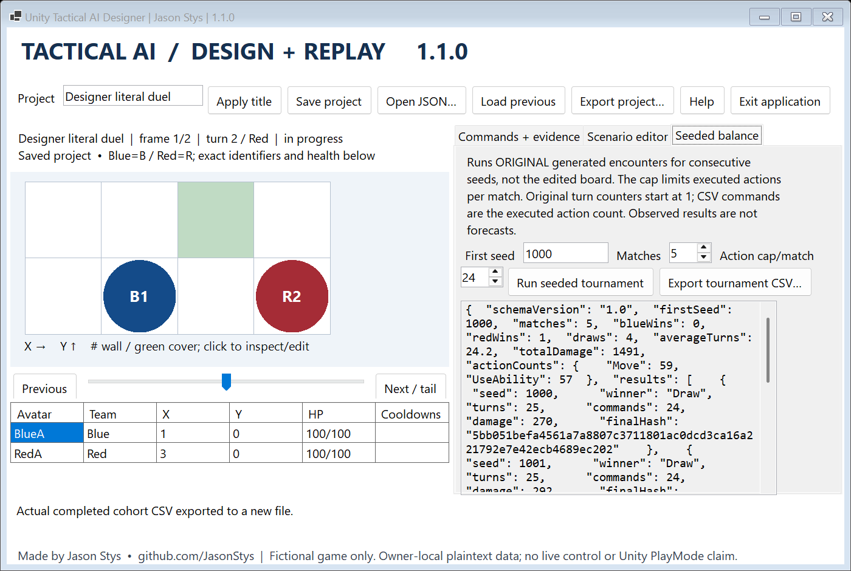
Figure 2 Five original generated matches use consecutive seeds and a 24-action cap. The displayed result is one red win and four draws; it does not evaluate the edited board.

Important implementation details

Advance a turn only after a legal command
The original engine rejects a missing or defeated actor and a wrong active team. Movement, abilities and waiting share the same atomic outcome; only a successful result advances the state.
src/TacticalAI.Core/TacticalEngine.cs lines 50 to 74
50 if (actor is null || !actor.IsAlive)
51 {
52 return ActionResult.Failure("The acting unit does not exist or is defeated.");
53 }
54
55 if (actor.Team != state.ActiveTeam)
56 {
57 return ActionResult.Failure("The acting unit does not belong to the active team.");
58 }
59
60 ActionResult result = command.Kind switch
61 {
62 ActionKind.Move => ApplyMove(state, actor, command),
63 ActionKind.UseAbility => ApplyAbility(state, actor, command),
64 ActionKind.Wait => ActionResult.Success(new ActionEvent("wait", $"{actor.Id} waited.")),
65 _ => ActionResult.Failure("The command kind is not supported."),
66 };
67
68 if (result.Succeeded)
69 {
70 state.AdvanceTurn();
71 }
72
73 return result;
74 }
Source file SHA256 f17bc29589b779e7e32a33c77ddaedebf095d691d43b72cb7431a31341c23d22

Validation results and operating limits
Runtime source 092d2cd22380a9f38ab6b8e2440c7583218f7546
Check | Observed evidence | Result
Installed native controls | Both visible WinForms phases passed through actual ordinary handlers, custom scenarios, exact exports, current and previous saves, restart and held-export Quit. | Passed
Original domain evidence | All 48 original tests passed; 500 seeded reference results stayed byte-identical at 253 blue wins, 238 red wins and 9 draws. | Passed
Distribution and security | All five downloaded release files matched provider hashes; all 279 installed files stayed unchanged. All exact-source main workflows and two raw CodeQL categories passed before publication. | Passed

Installation and private data
Extract the complete checksummed Windows x64 ZIP, retain its notices and launch TacticalAiDesigner.exe. The individual Desktop icon uses the tested self-contained .NET 10.0.15 application; no SDK or Unity installation is required.
Projects live outside the installation in an owner-local plaintext profile. Protect exports and use authorized inputs. Separate synthetic profiles were used for validation; ordinary user data was not opened.

Limits and help
This is a fictional game and deterministic simulation. Generated balance results describe the chosen seeds, action cap and agent policy; they are not predictions of player behavior.
The Unity bridge is a compiled contract check. Unity Editor, PlayMode, multiplayer, live control and a signed Windows installer were not validated. The local profile is not encrypted multiuser storage.
Release and checksums | Exact runtime source | Current usage and limits

