Versioned Product Knowledge Portal Application Guide
Windows use and validation
By Jason Stys Version 0.2.0 11 November 2026
Author a coherent product documentation catalog, search the exact saved content and compare source-cited editions without combining incompatible meanings or warnings.
The independently downloaded installed app passed all fourteen original journeys, two normal exits, accessibility and reflow checks; all 165 installed files stayed unchanged. A separate actual authoring/history/comparison capture exited normally. Four genuine startup failures now report failure rather than false success.

Capabilities and previous improvements
The original Astro site, schema, BM25 search, extractive abstention and version comparator remain. The full native app adds structured product, edition and topic authoring, literal previews, saved JSON/HTML exports and immutable revision history. Prepared examples are inputs inside this application.
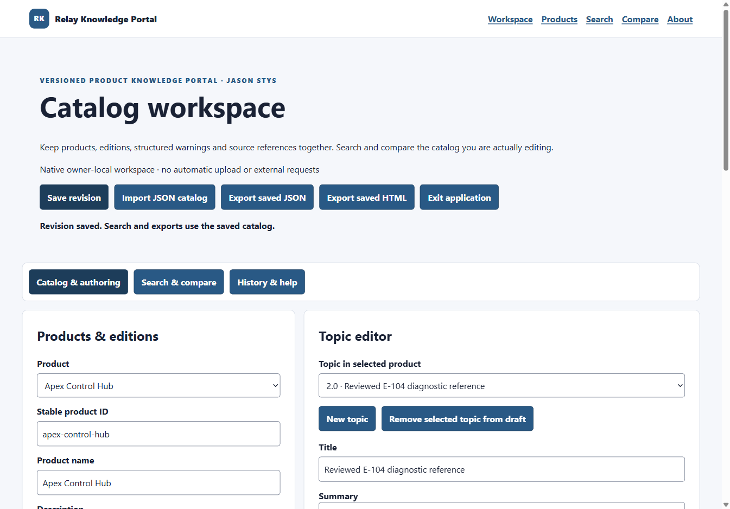
Figure 1 The actual installed app saved a revised E-104 title. The status confirms a saved revision; authoring, search and exports use this same catalog. Other editable fields continue below the viewport.

A worked application journey
A documentation owner maintains two supported product editions. An error number changes meaning between versions, so the owner authors a clear topic, saves a review revision and checks the complete cited before/after meanings before exporting.
1. Open the app or its Desktop icon. A new owner-local workspace contains twelve synthetic starter topics. Select a product, edition and topic; author structured sections, source references and warnings through the actual controls.
2. Validate and apply changes, then save a revision. Search and exports use the saved catalog. Unapplied fields require a Keep or Discard decision before changing context; pending real saves retain the workspace until completion.
3. Use Search & compare to filter by edition, search with the original engine and inspect a cited extract or abstention. Compare supported editions and read all changed meanings, missing sections, lifecycle labels and warnings.
4. Use History & help to review revisions. Restore appends history instead of overwriting it. Import only an authorized schema-valid JSON catalog. Export saved JSON or literal HTML to a new selected file. Use Exit application and wait for accepted work.
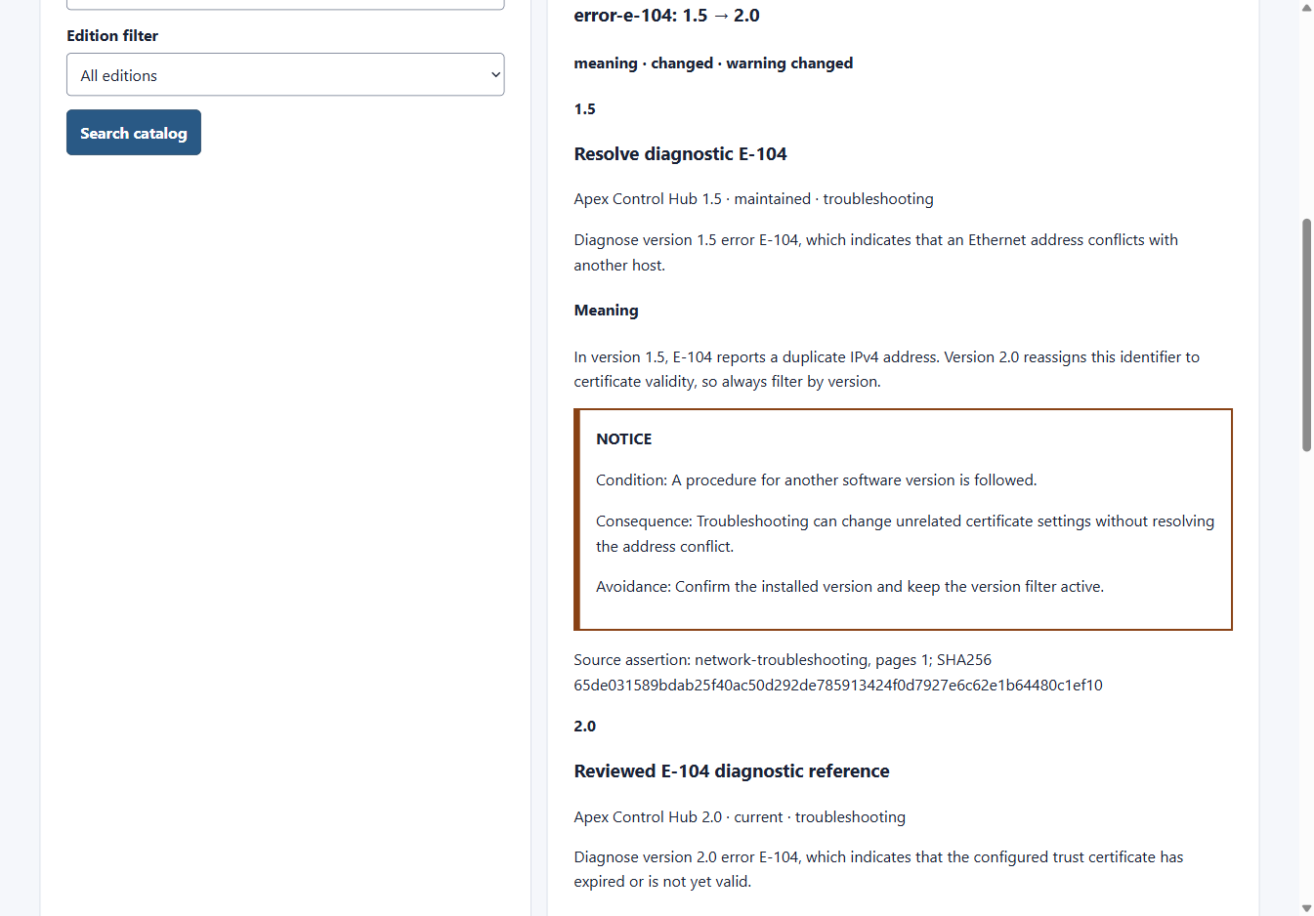
Figure 2 A normal scroll position shows the synthetic 1.5 warning and source assertion, followed by the different 2.0 diagnostic. The complete comparison remains scrollable; a checksum identifies source bytes and does not approve a procedure.

Important implementation details

Flush an immutable revision before switching the pointer
The application writes and flushes a complete saved catalog before replacing its current pointer. Failure preserves ownership and saved evidence for review. This is an ordered local commit, not an all-files transaction or publisher-authentication mechanism.
desktop/state.cjs lines 279 to 294
279 const bytes = Buffer.from(JSON.stringify(record) + "\n"),
280 digest = sha(bytes);
281 if (bytes.length > MAX_RECORD || total + bytes.length > MAX_TOTAL)
282 throw new Error("Revision storage exceeds its byte budget.");
283 newFile(path.join(folder, digest + ".json"), bytes);
284 const temporary = path.join(root, ".current-" + randomBytes(16).toString("hex") + ".tmp");
285 newFile(
286 temporary,
287 JSON.stringify({ schema: 1, workspace: marker.id, revision: digest }) + "\n",
288 );
289 // The completed immutable revision is durable before this single-file atomic pointer replacement.
290 // A failed rename preserves both previous current.json and the new record/temp for explicit review.
291 await fs.promises.rename(temporary, path.join(root, "current.json"));
292 records.set(digest, record);
293 total += bytes.length;
294 current = digest;
Source file SHA256 85e064982323a469f4b7d0015862dec8b8f32f0321dc131f16367b6684f33996

Validation results and operating limits
Runtime source 4c7770cb4210b6b4dfb18d6bca8d40ab7ea2c51b
Check | Observed evidence | Result
Installed workflows | Fourteen original cases passed: literal authoring, exact original search/comparison, validation/refusal, history/restart, real held save, Keep/Discard, exports retained through repeated Quit, mobile reflow and accessibility. Two normal exits; all 165 files unchanged. | Passed
Source and hosted | 192 unit cases, 38 browser cases, unchanged coverage floors, strict types/lint, 69 built HTML files, 50 search judgments and both dependency audits passed. All three main workflows and both processed CodeQL categories passed with no findings or open alerts. | Passed
Startup and distribution | Five actual Electron cases returned 1, 1, 1, 1 and 0 with the original 30-second timeout, saved-work and foreign-owner evidence intact. Both download identities and the complete installed inventory matched; individual icon metadata was verified. | Passed

Installation and private data
Verify the SHA256 sidecar and extract the complete Windows x64 ZIP. Keep all files/notices together and open KnowledgePortal.exe. The individual Desktop and Start-menu icons point to the verified installed program.
Workspace/history live outside the installation. No login or provider key is required. The app uses an isolated custom origin, literal content and a restricted main-frame bridge; it runs without a local web server.

Limits and help
One trusted OS owner and local plaintext data; no hosted account isolation, encryption, hostile same-account sandbox, live equipment integration or external AI. Source citations and checksums are evidence, not technical safety approval.
Unsigned Windows portable distribution; not a publisher-signed installer or clean-machine certification. Tests used fresh synthetic OS/profile paths and explicit dialog choices. Ordinary default-profile Desktop activation was not independently exercised.
Release and checksum | Exact runtime source | Native application guide

