Windows Identity Audit Lab Application Guide
Windows use and validation
By Jason Stys Version 1.1.1 11 November 2026
Review authorized offline identity snapshots and policies, compare direct membership changes, inspect expiry and incomplete evidence, and retain exact review reports. No live directory collection or account enforcement occurs.
The installed 1.1.1 app passed its full native workflows and reopened the same synthetic profile created by 1.1.0 with exact saved evidence. Existing links were backed up and retargeted with read-back verification; default-profile shortcut activation was not independently exercised.

Capabilities and previous improvements
Review nested protected-identity exposure, representative paths, source completeness and owner recertification/expiry queues. Keeps complete exposure separate from newly observed drift and avoids false removal claims from partial snapshots.
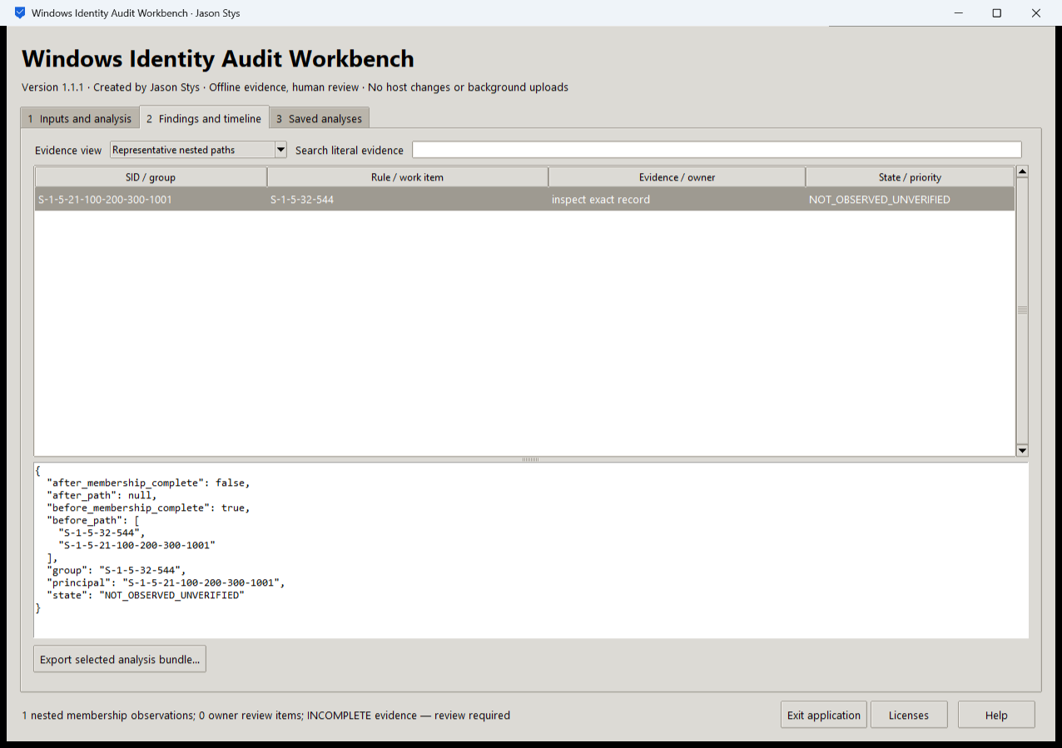
Figure 1 A separate workflow in the same installed workbench preserves its original review state and evidence rather than replacing it with a generic success message.

A worked application journey
An identity reviewer imports fictional before/after snapshots and a custom policy, inspects expiry and incomplete evidence, then exports the original findings.
1. Open the app and choose your supported authorized files or a prepared fictional scenario in Inputs and analysis.
2. Choose the required operation, inspect its actual parameters, acknowledge permission and Run selected analysis.
3. Inspect the original results in Findings and timeline, change evidence views and search literal records; retain unknown/inconclusive outcomes for review.
4. Export the selected bundle and reopen Saved analyses after a normal exit. Keep private evidence separate from any minimized handoff.
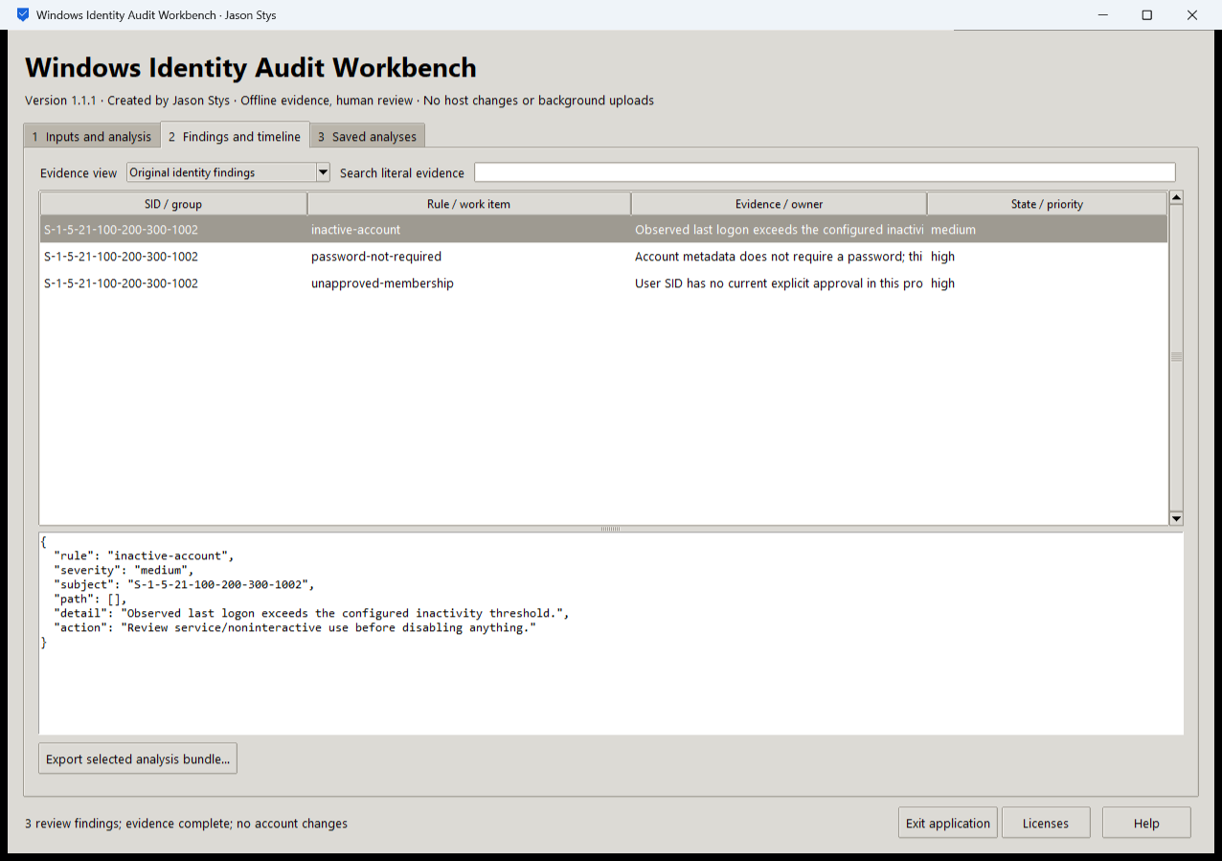
Figure 2 The installed workbench displays its accepted analysis and selected original evidence. These are fictional test inputs, not collected production records.

Important implementation details

Check fixed state before a write can follow an alias
This pre-initialization check requires any existing fixed state member to be an ordinary single-link file without a Windows reparse attribute. Startup and connection admission apply it to the known marker/lock/SQLite recovery paths; ordinary recovery files are retained.
identitylab/desktop_state.py lines 217 to 229
217 def admit_existing(path: Path) -> None:
218 """Refuse pre-existing linked/nonregular fixed state before initialization can write through an alias."""
219 try:
220 info = path.lstat()
221 except FileNotFoundError:
222 return
223 if (
224 not stat.S_ISREG(info.st_mode)
225 or info.st_nlink != 1
226 or getattr(info, "st_file_attributes", 0)
227 & getattr(stat, "FILE_ATTRIBUTE_REPARSE_POINT", 0)
228 ):
229 raise Rejected("fixed workspace state must be unlinked one-link regular files")
Source file SHA256 6ea8717ed3942a11931326a12a9040b4ee1702b56730deae9deb1a9069e58fad

Validation results and operating limits
Runtime source 87134618d3c19baeb5d760c4427a14a398244f3c
Check | Observed evidence | Result
Actual installed workflows | Full original domain, review and export controls passed two normal native launches; all 4 saved bundles retained exact original bytes. | Passed
Old-to-new profile | The actual installed 1.1.0 app created a synthetic profile; installed 1.1.1 reopened it and retained all 4 exact bundles without reset. | Passed
Source and distribution | Exact-main workflows and processed CodeQL passed with zero open main alerts. Five downloaded assets and installed files matched their verified SHA-256 identities. | Verified
PC and links | Existing links were backed up and retargeted with settings retained. Normal profiles and Docker were unchanged; default-profile shortcut activation remains separately untested. | Verified

Installation and private data
Use the matching Windows EXE, checksum and notices from Releases; no system Python or terminal setup is needed.
Open the verified Desktop icon. Help describes supported inputs and workflow limits; close through the app's owner controls and back up its external data directory after a normal exit.

Limits and help
Offline supplied membership evidence does not establish effective access, complete Windows authorization or authenticated approval. The GUI never launches PowerShell, collects host data or changes accounts. The disposable-runner collector lane remains separate.
Prepared inputs and acceptance used synthetic data only; normal profiles were not opened and Docker was unchanged. Local plaintext is trusted-OS-owner data, not protection against that OS user or administrator.
Release and checksums | Runtime source | Usage and limits

