Zero-Trust Segmentation Workbench Application Guide
Windows use and validation
By Jason Stys Version 1.1.1 11 November 2026
Review offline admission cases and direct transport permissions, compare policies and expiry boundaries, and inspect a saved source-bound permission graph. The graphical app analyzes evidence without changing firewall rules or authenticating live workloads.
The installed 1.1.1 app passed its full native workflows and reopened the same synthetic profile created by 1.1.0 with exact saved evidence. Existing links were backed up and retargeted with read-back verification; default-profile shortcut activation was not independently exercised.

Capabilities and previous improvements
Evaluate owner-authored continuity requirements at policy and exception boundaries with a hash-bound review queue. Shows upcoming access changes without granting access, renewing exceptions or assuming transitive trust.
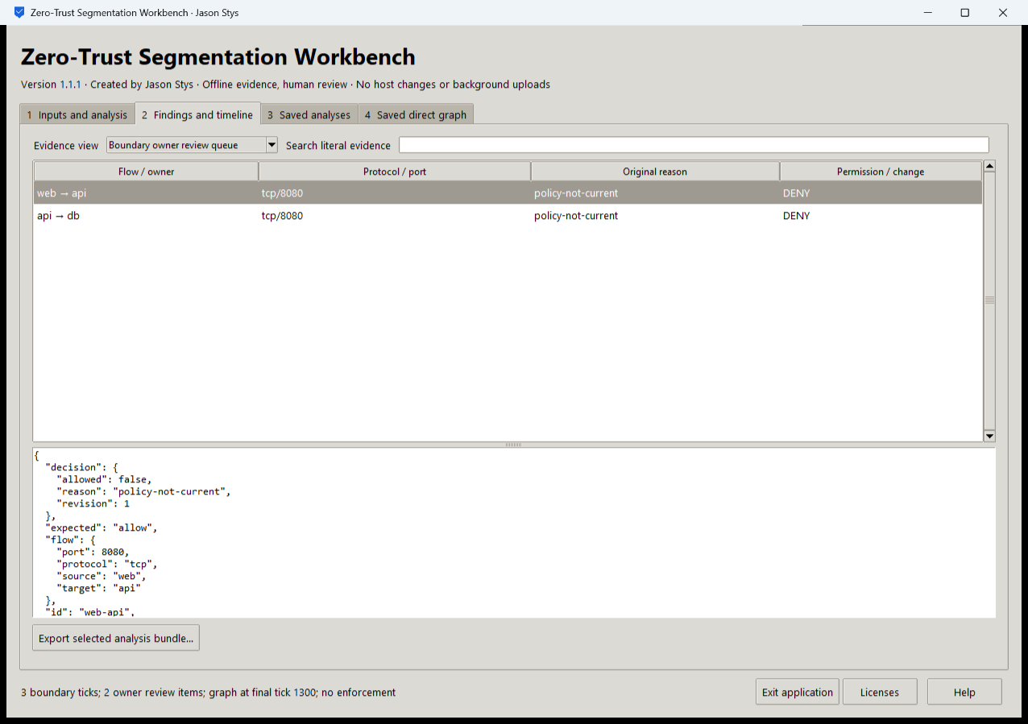
Figure 1 A separate workflow in the same installed workbench preserves its original review state and evidence rather than replacing it with a generic success message.

A worked application journey
A policy owner compares fictional policies, inspects direct transport permissions and expiry boundaries, and exports review evidence without applying firewall rules.
1. Open the app and choose your supported authorized files or a prepared fictional scenario in Inputs and analysis.
2. Choose the required operation, inspect its actual parameters, acknowledge permission and Run selected analysis.
3. Inspect the original results in Findings and timeline, change evidence views and search literal records; retain unknown/inconclusive outcomes for review.
4. Export the selected bundle and reopen Saved analyses after a normal exit. Keep private evidence separate from any minimized handoff.
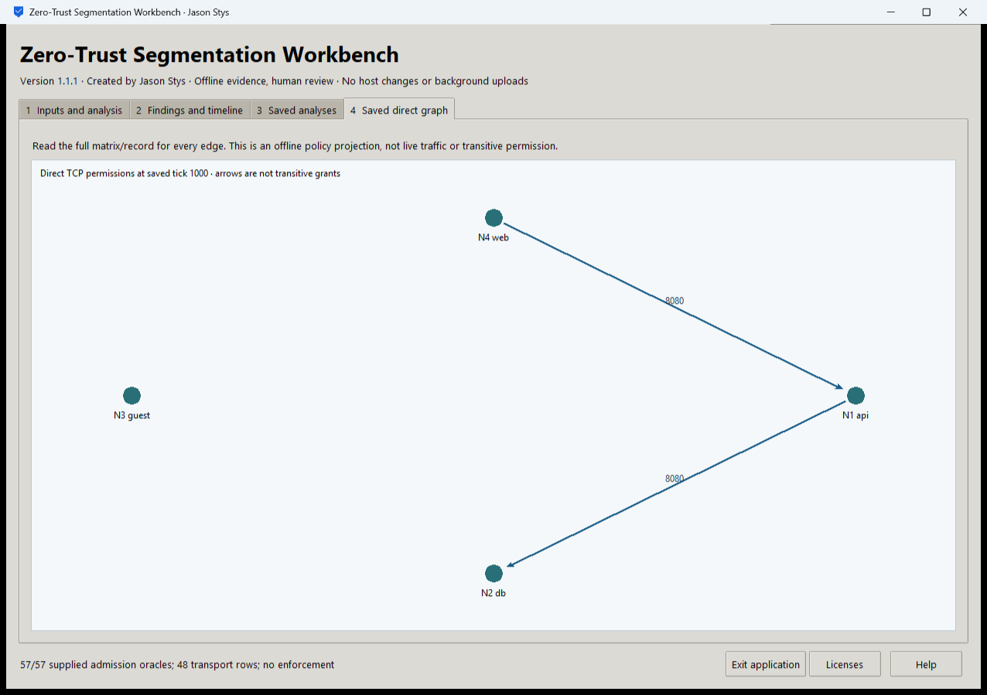
Figure 2 The installed workbench displays its accepted analysis and selected original evidence. These are fictional test inputs, not collected production records.

Important implementation details

Check fixed state before a write can follow an alias
This pre-initialization check requires any existing fixed state member to be an ordinary single-link file without a Windows reparse attribute. Startup and connection admission apply it to the known marker/lock/SQLite recovery paths; ordinary recovery files are retained.
ztlab/desktop_state.py lines 219 to 231
219 def admit_existing(path: Path) -> None:
220 """Refuse pre-existing linked/nonregular fixed state before initialization can write through an alias."""
221 try:
222 info = path.lstat()
223 except FileNotFoundError:
224 return
225 if (
226 not stat.S_ISREG(info.st_mode)
227 or info.st_nlink != 1
228 or getattr(info, "st_file_attributes", 0)
229 & getattr(stat, "FILE_ATTRIBUTE_REPARSE_POINT", 0)
230 ):
231 raise Rejected("fixed workspace state must be unlinked one-link regular files")
Source file SHA256 50b93172e64fc60f5ebe7661120ca9a9e292f8eab4f874d3f6b1f7fce980c47f

Validation results and operating limits
Runtime source bc5084b4f432e849711a640a22f3f893bee5bf0b
Check | Observed evidence | Result
Actual installed workflows | Full original domain, review and export controls passed two normal native launches; all 5 saved bundles retained exact original bytes. | Passed
Old-to-new profile | The actual installed 1.1.0 app created a synthetic profile; installed 1.1.1 reopened it and retained all 5 exact bundles without reset. | Passed
Source and distribution | Exact-main workflows and processed CodeQL passed with zero open main alerts. Five downloaded assets and installed files matched their verified SHA-256 identities. | Verified
PC and links | Existing links were backed up and retargeted with settings retained. Normal profiles and Docker were unchanged; default-profile shortcut activation remains separately untested. | Verified

Installation and private data
Use the matching Windows EXE, checksum and notices from Releases; no system Python or terminal setup is needed.
Open the verified Desktop icon. Help describes supported inputs and workflow limits; close through the app's owner controls and back up its external data directory after a normal exit.

Limits and help
Offline admission and direct transport projection only; no real traffic, certificates, mTLS, posture evolution or full zero-trust architecture. The GUI has no firewall, namespace, collector or enforcement path. The original privileged hosted kernel lane stays independent and was not executed locally.
Prepared inputs and acceptance used synthetic data only; normal profiles were not opened and Docker was unchanged. Local plaintext is trusted-OS-owner data, not protection against that OS user or administrator.
Release and checksums | Runtime source | Usage and limits

