

Jason’s Destiny Database

Project Report

DT228

Computer Science year 1

**Jason van Raamsdonk**

**C17764691**

School of Computing

Dublin Institute of Technology

**6th December 2017**



Declaration

I hereby declare that the work described in this dissertation is, except where otherwise stated, entirely my own work and has not been submitted as an exercise for a degree at this or any other university.



Signed:

Jason van Raamsdonk

6th December 2017

Table of Contents

*1.* Problem Description 4

*2.* Research 5

*3.* Technology Selection and Site Architecture 6

*4.* Low Fidelity Prototype 7

*5.* Development Plan 9

*6.* Testing Plan 10

*7.* Site Evaluation 11

*8.* Deployment 13

Appendices 14

# 

# Problem Description

My website acts as a miniature database for on particular online game. This game ‘Destiny’ has hit the shelfs almost four years ago and already has a massive following. The game offer people with a wide range of activities to complete and encounter and as a result a large amount of armour and weapons to collect. My websites goal is to provide players with information regarding everything the game has to offer in one convenient, easy to navigate location.

My Home page (index.html) provides the user with no real information, just simple a navigation bar and a search bar, alongside a portfolio of stunning images to sum of the game using high quality visuals. These images are not only to sum up the game, but also the websites available content to the user. The next page (armour.html) holds a table with each cell containing an image corresponding to a piece of armour from the game. When the user hovers over the image the statistics relating to that image appear. They next page (weapons.html) completes the same function as the latter page, however this page is focused on weapons not armour. The third page provides information on the three-different character a player may chose between in game. This page makes use of a slide show to present the user with three different images relating to the page, with simple text wrapped around images being used for the remainder of the content on the page. The final page (raids.html) represent activates players can do in game, alongside detailed information on how to successfully complete them. This page contains a video to provide the user with more thorough information. The navigation bar appears across every page, allowing the user to easily navigate from page to page. The footer which also appears across every page allows the user to fill in a contact for which requires them to enter their Xbox gamertag as the only mandatory field, along with link social media icons allowing them to quickly access social media.

The primary users of this website will be gamers who simply appreciate the game or are looking for information to help them with their play through. This website allows people to find all the information relating to ‘Destiny’ in one centralised location rather than searching the internet aimlessly attempting to secure some shred of useful information.

# Research

# The first website I researched was the website belonging to the actual developers of ‘Destiny’ the game (Bungie.net). This website was very impressive. Its home page had very little text content, but rather hyperlinked images that would bring you to more specific areas of the website when licked. This is where I got the idea to use a gallery of sort on my home page, with images that slightly move when you hover over them. Many of these pages utilised different scrolling effects. That is to say when you scroll in a downward direction, different images would change colour, increase or decrease in size, fade in and out etc.

The next website I examined was a quantum computing based website called D-Wave Systems ([www.dwavesys.com](http://www.dwavesys.com)). An interesting feature I drew from on this website was the navigation bar. It a simple five section navigation bar, positioned more to the right of the screen, with the company logo on the left side of the screen with a single colour background. When you hover over any of the list items on this navigation bar, an effect starts, and the word begins in a scrambled state and quickly unscrambles to drop down any reveal itself. However, I did not possess the ability to do this, nor could I find any material to aid me in the endeavour, so I resorted to a lesser fade in effect above each of the list items in my own navigation bar.

The final website I researched was the xboxlive website by Microsoft ([www.xbox.com/en-IE](http://www.xbox.com/en-IE)). This website has a plain, minimalistic look which proved to me that a website doesn’t need an overwhelming amount of effects tom has an impact, just a few, detailed features that have been fine tuned. The xboxlive website opens with a slide show with images of the newest titles released for Xbox. This website was what gave me the idea to add a slide show to my website. I initially had a navigation bar that remained fixed across all my pages. However, upon further examination of the xboxlive website I realised that some page look better without a fixed navigation bar, as it could potentially obscure content. This is why I choose to only implement a fixed navigation bar on two out of my five pages

Technology Selection and Site Architecture

I used the latest versions of HTML and CSS in the constructing/design of my website. I found this would be a more beneficial approach as most of the popular web browsers e.g. Google, Mozilla, Safari, all support it in full. Additionally, most of the online resources available online act under the assumption that you are using HTML 5 and CSS 3, so it proves to be problematic to make us of anything else.

Designing my webpage to be responsive wasn’t to hard. When I finished adding all of the features, and content to my website, I simply looked through the CSS and changed all the height, width, font-size, margin, padding, and border elements to implement the use of rem, vh, and vw rather than px and percentages. Before I completed this step, the website would simply fold in on itself whenever I would play with the size of the window. After I implemented these changes however, every aspect of the website was fully responsive and would scale properly according to the window size.

Other than on a desktop, I had anticipated that a website targeting a gamer demographic should probably have smartphone capabilities since allow of the website visitors would come from smart phones. In order to cater for this scenario, I put a condition in the CSS that if the website is viewed on a 500px or less size monitor, certain aspects of the website would change slightly, in turn making it presentable on mobile phones.

# 

Low Fidelity Prototype

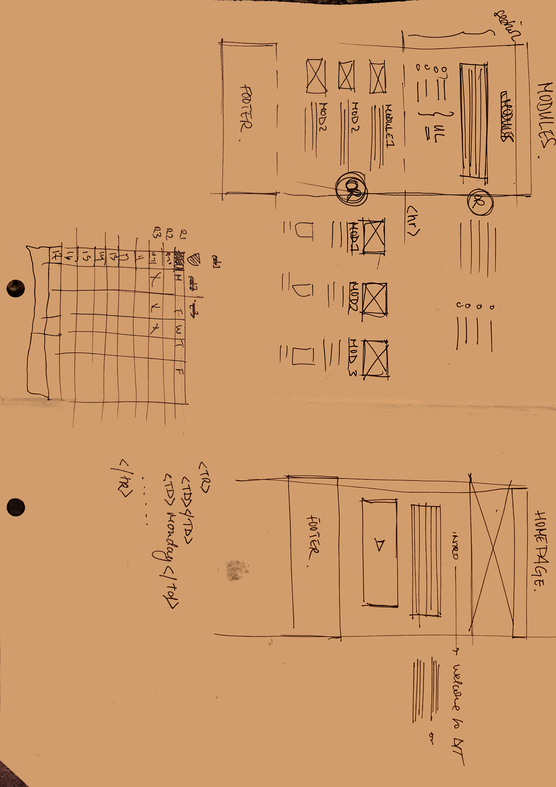

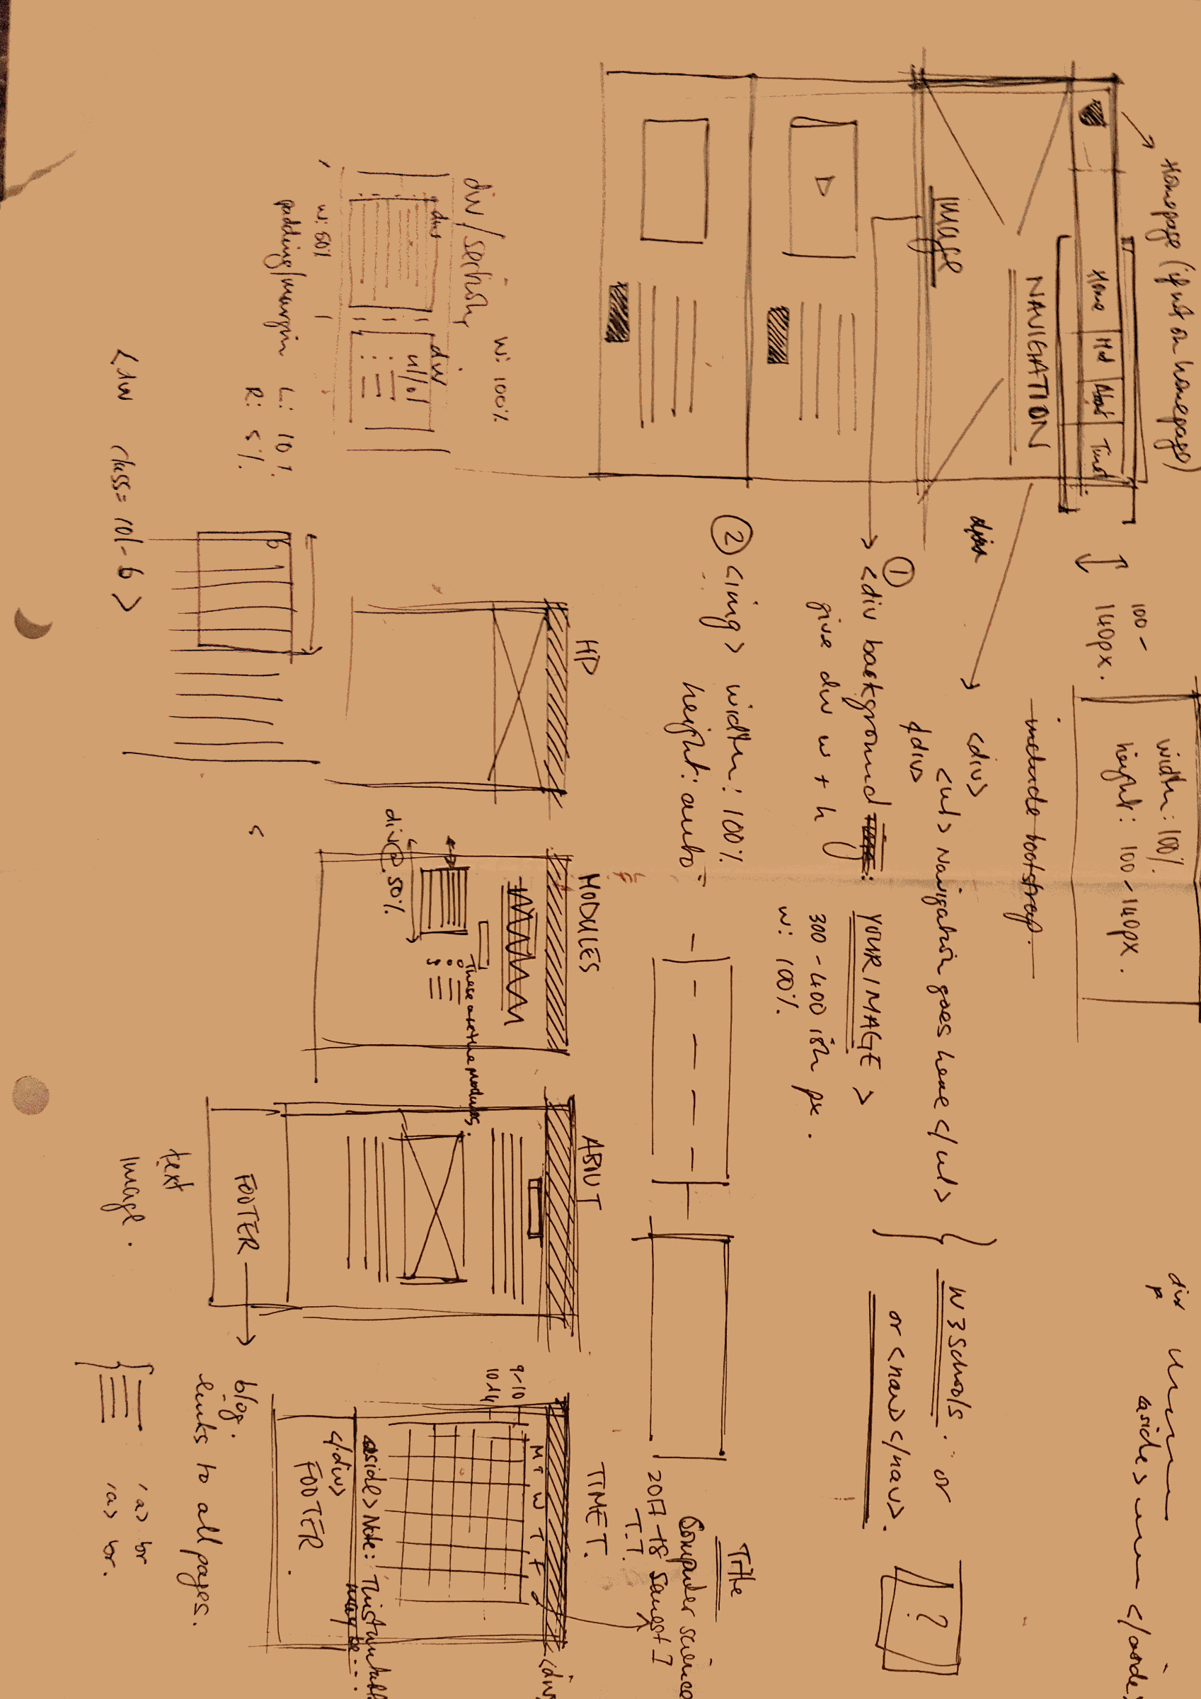

# Development Plan

I began the design process of my website my examining other well crafted websites, and choosing features from those website that I would like to see in my own. After this I began my sketching up some low fidelity prototypes for my websites basic layout using pen and paper. After many attempts I finally sketched a design that I liked and that was obtainable for me to complete. After this I chose a colour scheme that I would use throughout my website to make it feel consistent. I settled on a light blue and dark grey, and decided I would make use of the opacity element, as I previously found a good quality image which I wanted to use as a background, but it didn’t want it to be concealed. I decided to pick a colour scheme early on as through examination of other websites I realised that the majority of the ones that look better all have a colour theme that is shared across the entirety of the website.

After all the preliminary details were decide I began using HTML and CSS to start building the website. I first made a home page with a functioning navigation bar and footer with a form (no javascript at this point). Once this was complete I simply used the same content as the basis for all of the webpages, the only thing that would separate them would be content. The next thing to do was add some javascript to the website. I started by entering some form validating ensure that the user must enter some information to submit the form. I then went on to construct a three-image slide show on one of the pages. The javascript was the most time-consuming part of the website build. After this I thought my website was somewhat lacking in javascript, so I decided to design a search bar to go on the home page. After this stage was complete all I had to do next was fill in content to the website in visually appealing ways until I was done.

# Testing Plan

# 

# When all of the necessary HTML, CSS , and JavaScript were complete and my website was fully functioning, just before employment of the website onto a live server based hosting service, I decide to validate my mark-up. To my surprise there were almost 20 errors per page of HTML, which can to me as a surprise as brackets (the text editor which I used to build my website) presented me with no errors or warnings, and the website was already functioning as intended. The service I used to validate my mark-up was the w3schools own proprietary service for validation. If I had published my website beforehand I could of simply entered the url into the validator, but editing a already published website would have been an inconvenient experience. I instead uploaded the individual .html files into the validator and edited them accordingly.

# Even when I fixed the errors and warnings given to me by the validator the website functioned exactly the same as it had before. That is because most of the errors and warnings I encountered would only come into effect when I try to open my website on different browsers. Therefore, validating a website at this level is an exercise in making sure the website is cross browser compatible. I have opened my website in Google Chrome, Mozilla Firefox, and Internet Explorer. In these three web browsers my website is indistinguishable and perform identically. However, I did not have access to a Mac so unfortunately, I was not able to open my website in Safari (the apple proprietary web browser), but since none of the previous errors currently persist it should perform the same as in other web browsers.

# Site Evaluation

I evaluated my website using Nielsen’s Usability Heuristics for User Interface Design. Visibility of system status was implemented in two different ways. The user will always know what page they are currently on, due to a large title on every page just below the navigation bar and header. The second place where the visibility of system status is available to the user is when they complete the contact form in the footer of every page. The form will prompt the user with a message if it is filled in. Similarly, it will prompt the user with an error message asking them to fil in their name/gamertag if they have not done so already after hitting submit. ‘Match between system and the real world’, I have successfully completed this by using language almost identical to what the user/player would find in the game upon which this website is based. ‘User control and freedom’. This aspect was easy to handle as my website is only five pages in length. On some pages the navigation bar is fixed, meaning it will follow the user and allow them to enter another page quiet easily. Additionally, the title of each page as seen in the navigation bar is also present by way of a large title just below the header section.

‘Consistency and standards’, this is done very well on my website as I used the same HTML and CSS for each page before filling in the content. This ensures that each page has the same navigation bar, background image and footer, giving the website a consistent look throughout, meaning it is easy to use and intuitive for almost ay user, and especially the users in my target demographic. ‘Error prevention’, as I have mentioned before my website is quiet small being there is not much room for error, the only feature of my site that requires error checking is the contact from in the footer. This will prompt a message upon pressing the submit button, whereby if the user enters a name/gamertag, the site will say “your form has been submitted”, otherwise the message will say “please enter your name/gamertag”. ‘Recognition rather than recall’, this aspect didn’t really come in to play that much on my website as it was easy to navigate and quite intuitive, being no instructions were every needed, and therefore no repetition of instructions. ‘Aesthetic and minimalistic design’, as I mention earlier, I have found by examining other websites that only a handful of fine tuned features are required to make give a website a professional design, and because of this my website has a minimalistic approach when it comes to features, ensuring it is not overwhelming to any users. My website is based upon presenting information, that is why I only display text where absolutely necessary, and on some pages (armour.html and weapons.html) I have opted for a more visual approach that is easy to navigate.

I additionally conducted some usability tests with friends across Xbox to see what they thought of the website, and they all cam to the consensus that it was easy to navigate, looked pleasing to the eye, and was excellent at presenting information.

# 

# Deployment

When it came time to publish my website there were two options available, Mozilla thimble or a web hosting service. I opted for the free web hosting service as it seemed more official, also it was very intuitive to use and allows me to validate the entire website using the URL. Publishing the website this way was by no means difficult, I simply dragged and dropped all of the files straight from my laptop into the folders on the hosting service, it also allows you to see the website before you publish it to ensure you do not forget an images or files before you launch it.

A good example of how to properly take advantage of Search Engine Optimisation is the implementation of meta tags imbedded in the html files. These meta tags allow you to add key words and even a description of your website, giving it a higher priority when people search for it on web browsers provided they type words that correspond to your meta tags.

# 

# Appendices

*Find attached all weekly website progress logs*

Web Dev 1

Weekly Project Report – Week 7

Please provide a brief overview of the research or tasks that were completed on your project this week:

This week marks the start of the website assignment for web development.

I began further conceptualising an idea I’ve always had for a potential website.

This concept plays deeply into my interest in gaming, alongside my desire to have information available in an organised manner.

I aim to develop a website based around a specific game which I have yet to narrow down from a rather large list. I will then start to gather text on images cataloguing all the in-game weapons, armour, items etc. Once this step is then complete I will separate this items into categories in deem necessary, and design a page for each one. I will design these pages initially making use of a wireframe software, and attempt to design a website that is aesthetically pleasing. Once this is complete I will have used my created wireframe as a visually guide in creating my site. I will try to stay faithful to my design in making my site.

Web Dev 1

Weekly Project Report – Week 8

Please provide a brief overview of the research or tasks that were completed on your project this week:

This week I gathered all the material I needed to begin the creation of my website. This material includes over 100 image and a couple of image. As my website will have a few inventory style pages, I design over 10 table designs and choose the best four to be used. There will also be pages dedicated to information, so to make these types of pages more interesting I chose which html/css tags to include to show more on my knowledge of web design. The actual aesthetic design of my site has been sketched up on paper, and I spent some time on these designs, so I plan to follow them faithfully. The only design feature that remains is for me choose a colour scheme for my website, and I plan to do this at the very end to see how well different colours fit and then choose the right one.

Over the next week I will start creating the website using html/css, with some Javascript which we have just learned in week 9 of web development.

Web Dev 1

Weekly Project Report – Week 9

Please provide a brief overview of the research or tasks that were completed on your project this week:

This week I constructed the website index page using HTML and CSS, complete with a footer, navigation bar, contact form, header, and background, which took me a long time, but have a really professional design to them. I continue to copy this layout and use it in all five of my html pages. I have design a gallery on my home page, so the user is presented with images that sum up my website when first visited.

Next week I will continue to will my website with content.

.

Web Dev 1

Weekly Project Report – Week 10

Please provide a brief overview of the research or tasks that were completed on your project this week:

This week continued to fill each of my website pages with content, I used text were necessary, but for the most part I used images and on one page a video. I already had the information and over 50 images on my laptop ready to go, so it was just a matter of inputting it> This was a timely process as I had to get all of the different content to match the layoput of my page, meaning t]by the time I was finished I had over 400 lines of CSS.

Next week I will begin incorporating Javascript elements into my website.

Web Dev 1

Weekly Project Report – Week 11

Please provide a brief overview of the research or tasks that were completed on your project this week:

This week done some research on Javascript, and have decided on three Javascript based elements I would like to include on my website. The first feature was a search bar located on the homepage (index.html). This was the shortest piece of Javascript out of the three, but required about 30 lines of CSS I order to get it to blend in with the rest of the website. The second element was the form. All of the work for the form was previously complete in terms of HTML and CSS meaning the only thing I had to create was a way to check the input for the form and output messages. The last element of Javascript I decided on was a slideshow in which arrows would allow the user to navigate between three images. This was the lengthiest piece of Javascript by far.

Next week I will validate my website and then publish it.

Web Dev 1

Weekly Project Report – Week 12

Please provide a brief overview of the research or tasks that were completed on your project this week:

At this point my website was complete, and all I had to do in order to finish the project was validate the mark-up and publish it. In order to validate my mark-up, I used the service provided by w3schools. This service allowed me to upload me .html files and it would tell me the errors and warnings, I had about 20 errors on average per page which I quickly fixed. This made no real impact on my website that I could observe, however it means my website will have more success running on different web browsers.

I used a free web hosting service to publish my website. This was easy to manage. All I hade to do was drag and drop the files into the library provided. I was able to view the website before I published it on this service, to check if I was missing any files or images. After I realised nothing was missing I published the website.

Link: https://demonickynghts-database.000webhostapp.com/index.html