Performance Measure of disks
Access time
- Seek time: time to reposition the arm to the correct track
- Rotational latency: time it takes for the sector to be accessed under the head
Data-transfer rate
Mean time to failure

Optimization of Disk-block access
Read/Write by block
sizes range from a sector to hundreds of sector
typically 4kb to 16kb
Disk-arm scheduling
elevator algorithm
File organization
group the related information
defragment
Nonvolatile write buffers
log disk
RAID
high capacity and high speed
high reliability

RAID-0
non-redundant, most performance, potentially data loss
RAID-1
mirroring, most writing performance, higher cost
RAID-5
partitions data and parity among all N+1 disks
preferred with low update rate
Record

Fix-length Records
each record has the same length
insert
do not allow cross block record
delete
use a linked list to link all free slots

Variable-length Records
Slotted page header
each record has a pointer in the header
has free space between header and records

Sequential File Organization
Delete - use pointer chains
Insert - locate, insert in free space : insert overflow space
need to reorganize the file from time to time to restore the sequence

Multi-table clustering file organization
good for queries involving department * instructor

Buffer Manager…

Dense Index File
index every thing
generally faster
but larger and hard to maintain

Sparse Index File
index some key-value
actually index block
easy to maintain, slower
a good tradeoff

Secondary indices
we want to find all records in a certain filed
have to be dense
when file is modified each index on the file must be updated

B/B+ tree
Leaf node: $\left[\left\lceil \frac{n-1}{2}\right\rceil ,n-1\right]$ values
Non-leaf node: $\left[\left\lceil \frac{n}{2}\right\rceil ,n\right]$ children
root: at least two children

Static Hashing
obtain the bucket of a record directly
$$address B=h\left(searchkey\right)$$
random or uniform
Deficiencies
the number of buckets, if large then probably wastes
if small then probably not enough, and performance degrade due to too much overflows

Dynamic Hashing
use prefix i to map to $2^{i}$ buckets
database shrinks and extends dynamically
Benefits
Performance doesn't degrade with growth of file
Minimal space overhead
Disadvantage
Extra level of indirection to find desired record
Address table maybe very big(large than memory)

Basic steps in query processing
Parsing and translation
Optimization
Evaluation

How to measure costs
Generally measured as total elapsed time
disk access, CPU, network communication
Disk access
number of seeks
number of blocks read
number of blocks written
For simplicity
number of block transfers $t_{T}$
number of seeks $t_{s}$
cost for b block transfers plus S seeks
$$b*t_{T}+S*t_{S}$$
ignore CPU costs
Selection

Linear Search
Scan each file block and test all records.
$$Cost=b_{r} block transfer+1 seek$$
if selection is a key attribute
$$average Cost=\left(\frac{b_{r}}{2}\right)block transfer+1 seek$$
$b_{r}$ denotes number of blocks containing records from relation r

Primary index, equality on key
$$cost=\left(h_{i}+1\right)*\left(t_{T}+t_{S}\right)$$

Primary index, equality on non-key
$$cost=h_{i}*\left(h_{T}+h_{S}\right)+t_{S}+t_{T}*b$$
$$b=number of blocks containing records, consecutive blocks$$

Secondary index, equality on non-key
if retrieve a single record if the search-key is a candidate key
$$cost=\left(h_{i}+1\right)*\left(t_{T}+t_{S}\right)$$
retrieve multiple records if search-key is not a candidate key
$$\left(worst case\right) cost=\left(h_{i}+n\right)*\left(t_{T}+t_{S}\right)$$

Primary index, comparison
for $σ_{A}≥v\left(r\right)$ use index to find first tuple >=v and scan relation sequentially
for $σ_{A}≤\left(r\right)$ just scan relation sequentially till first tuple > v; do not use index.

Secondary index, comparison

External Sort-Merge
Total number of merge passes required: $\left\lceil \log_{M-1}\left(\frac{b_{r}}{M}\right)\right\rceil$

Total number of block transfer for external sorting:
$$b_{r}(2\left\lceil \log_{M-1}\left(\frac{b_{r}}{M}\right)\right\rceil +1)$$

Cost of seeks
$$2\left\lceil \frac{b_{r}}{M}\right\rceil +\left\lceil \frac{b_{r}}{b_{b}}\right\rceil *\left(2\left\lceil \log_{M-1}\left(\frac{b_{r}}{M}\right)\right\rceil -1\right)$$

Join Operation

Examples use the following information
Number of records of student: 5,000 takes: 10,000
Number of blocks of student: 100 takes: 400
r is called outer relation, s is inner relation of the join

Nested-Loop Join
$n_{r}*b_{s}+b_{r}$block transfers, plus
$n_{r}+b_{r}$ seeks

Block Nested-Loop Join
worst case:$b_{r}*b_{s}+b_{r} block transfer$
$$2*b_{r} seeks$$
Best case:$b_{r}+b_{s} block transfer+2 seeks$
Improvement:
$$Cost=\left\lceil \frac{b_{r}}{M-2}\right\rceil *b_{s}+b_{r} block transfers+2\left\lceil \frac{b_{r}}{M-2}\right\rceil seeks$$
$$M=memory size in blocks$$
Indexed Nested-Loop Join
$$Cost=b_{r}*\left(t_{T}+t_{S}\right)+n_{r}*c$$
C is the cost of traversing index and fetching all matching s tuples for one tuple or r
c can be estimated as cost of a single selection on s using the join condition

Merge Join
Sort first, then join the two relation
Can be used only for equal-joins and natural joins
$$Cost=b_{r}+b_{s} block transfers+\left\lceil \frac{b_{r}}{b_{b}}\right\rceil +\left\lceil \frac{b_{s}}{b_{b}}\right\rceil seeks$$
Hash Join
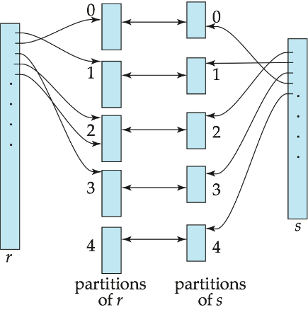
Evaluation of Expressions
1. Materialization
2. Pipelining

Query Optimization
1. Pushing Selections
2. Pushing Projections
reduce the size of the relation to be joined
3. Join order matters
Evaluation Plan example:
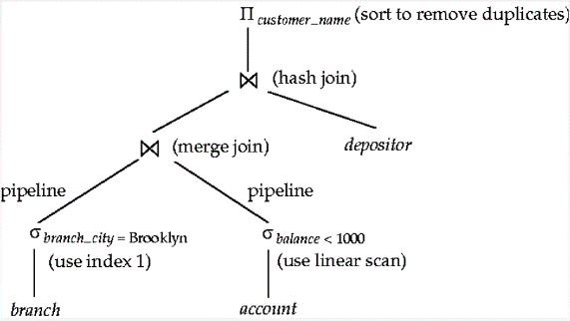

Statistical Information for Cost Estimation

Transaction
State
Active - the initial state.
Partially committed - after the final statement has been executed.
Failed - after finding the normal execution can no longer proceed.
Aborted - after the transaction has been rolled back
Committed - after successful completion

Serializability
conflict serializability
conflict equivalent: a schedule S can be transformed into a schedule S' by a series of swaps of non-conflicting instructions.
conflict serializable: if it is conflict equivalent to a serial schedule

view serializability
S and S' be two schedules with the same set of transactions.
if S read the initial value of Q, then S' must read the initial value of Q.
if S read the data written by T_j, then S' must also read it.
if S performs the final write(Q) operation in schedule S must also perform the final write(Q) operation in schedule S'.
view equivalence is also based purely on reads and writes.
conflict serializable => view serializable

Testing for Conflict Serializability
Precedence graph
a direct graph where the vertices are the transactions(names)
We draw an arc from $T_{i}$ to $T_{j}$ if the two transaction conflict, and $T_{i}$ accessed the data item on which the conflict arose earlier.
A schedule if conflict serializable if and only is its precedence graph is acyclic
Serializability order can be obtained by a topological sorting.

Test for View Serializability
falls in the class of NP-complete problems.
has some sufficient conditions for view serializability

Recoverable Schedules
If a transaction $T_{j}$ reads a data item previously written by a transaction $T_{i}$, then the commit operation of $T_{i}$ appears before the commit operation of $T_{j}$.
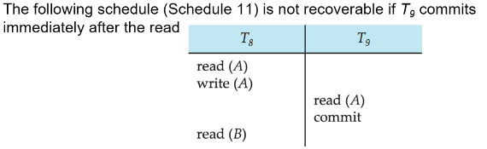

if $T_{8}$ should abort, $T_{9}$ would have read an inconsistent database state.

Cascading Rollbacks
a single transaction failure leads to a series of transaction rollbacks.
Cascade-less Schedules: cascading rollbacks cannot occur; for each pair of transactions $T_{i}$ and $T_{j}$ such that $T_{j}$ reads a data item previously written by $T_{i}$, the commit operation of $T_{i}$ appears before the read operation of $T_{j}$

Concurrency Control

Lock-Based Protocols
exclusive mode
shared mode
Pitfalls:
deadlock, request each other
Starvation, can be prevented though.

Two-Phase Locking Protocol
Growing Phase
may obtain locks
may not release locks
Shrinking Phase
may release locks
may not release locks
Lock points: from obtaining locks to releasing locks.

strict two-phase locking, must hold all its exclusive locks till it commits/aborts.
rigorous two-phase locking, all locks are held till commit/aborts.

Graph-Based Protocols
if $d_{i}→d_{j}$ then any transaction accessing both $di$ and $d_{j}$ must access $d_{i}$ before access $d_{j}$.
Only exclusive locks are allowed.
The first lock by $T_{i}$ may be on any data item. Subsequently, a data Q can be locked by $T_{i}$ only if the parent of Q is currently locked by $T_{j}.$
Data item can be unlocked at any time
A data item that has been locked and unlocked by $T_{i}$ cannot subsequently be relocked by $T_{j}.$
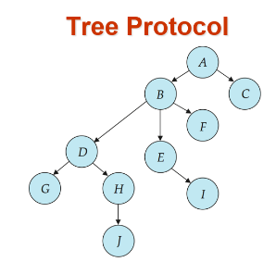

Deadlock Detection
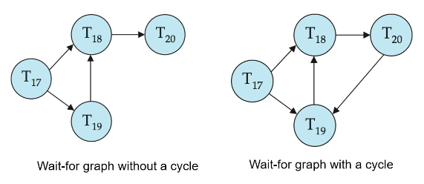
Deadlock Recovery
Total rollback: Abort the transaction and then restart it.

Multiple Granularity
intention-shared(IS)
intention-exclusive(IX)
shared and intention-exclusive(SIX)
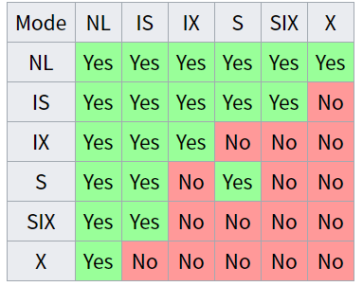

- The look compatibility matrix must be observed.
- The root of the tree must be locked first, and may be locked in any mode.
- A node Q can be locked by $T_{i}$ in S or IS mode only is the parent of Q is currently locked by $T_{i}$ in either IX or IS mode.
- A node Q can be locked by $T_{i}$ in X, SIX, or IX mode only if the parent of Q is currently locked by $T_{i}$ in either IX or SIX mode.
- $T_{i}$ can lock a node only if it has not previously unlocked and node(two-phase)
- $T_{i}$ can unlock a node Q only if none of the children of Q are currently locked by $T_{i}.$

Locks are acquired in root-to-leaf order, whereas they are released in leaf-to-root order.

Recovery System

Failure Classification
Transaction failure:
Logical errors: internal error
System errors: killed by system due to deadlock, for example
System crash
Disk failure

Log-Based Recovery
Log is kept on stable storage, a sequence of log records
- Register itself by writing a $<T_{i} start>$ log record
- Before executes write(X), a log record $<T_{i}, X, V_{1}, V_{2}>$ is written, where $V_{1}$ is the value of X before the write, and $V_{2}$ is the value to be written to X.
- When $T_{i}$ finishes it last statement, the log record $<T_{i} commit>$ is written.

Deferred database modification
records all modification to the log, but defers all the writes to after partial commit
A write(X) operation do not need to log old value

Immediate Database Modification

Undo and Redo of Transactions
Undo restores the value of all data items updated by $T_{i}$ to their old values, going backwards from the last log record for $T_{i}$
Redo set the value of all data items updated by $T_{i}$ to the new values, going forward from the first log record for $T_{i}$

Checkpoint
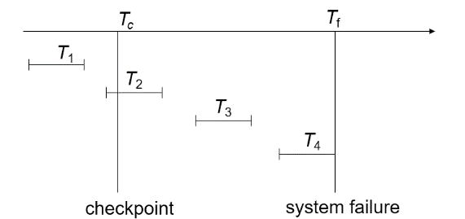
$T_{1}$ can be ignored, $T_{2}$ and $T_{3}$ redone, $T_{4}$ undone.
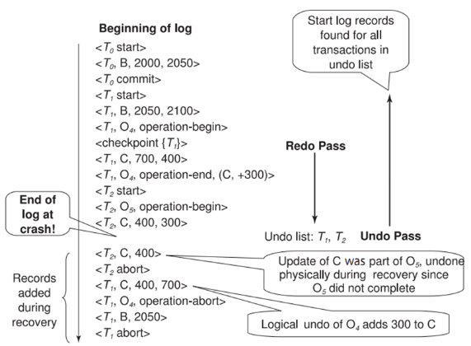

ARIES
- Uses log sequence number (LSN) to identify log records
Stores LSNs in pages to identify what updates have already been applied to a database page
- Physiological redo
- Dirty page table to avoid unnecessary redos during recovery
- Fuzzy checkpointing that only records information about dirty pages, and does not require dirty pages to be written out at checkpoint time
More coming up on each of the above …
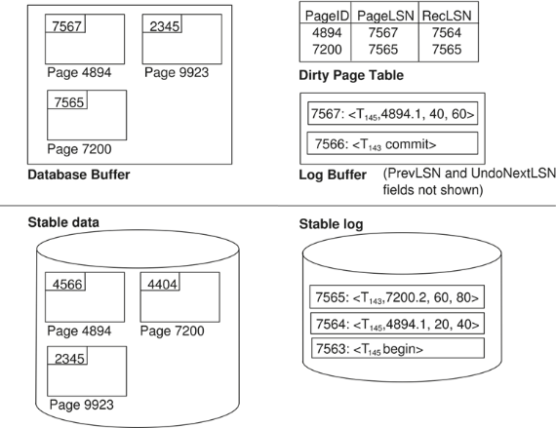
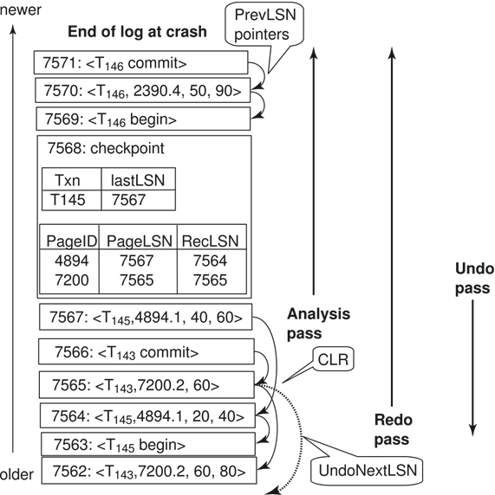
ARIES data structures
- Uses log sequence number (LSN) to identify log records
Stores LSNs in pages to identify what updates have already been applied to a database page
- Physiological redo
- Dirty page table to avoid unnecessary redos during recovery
- Fuzzy checkpointing that only records information about dirty pages, and does not require dirty pages to be written out at checkpoint time
More coming up on each of the above …

XML部分没有包括，但事实上会考大题，请注意

