Lab 11: Heat Transfer & Thermal Insulation

EG1003 Section BY1

Jason Yao

Date of Experiment: 10 August 2015

Due Date: 12 August 2015

**Abstract**

The objective of this lab was to design and build a thermally insulated container. A secondary objective was to win the competition between other EG 1003 teams. The container was successfully designed and built, and placed third in the EG 1003 competition. This lab is significant because it represents the need in civil engineering professions for thermally insulated building materials.

**Introduction**

Heat is a form of energy, and the transfer of heat occurs when there is a temperature difference between two sources. This transferal takes one of three forms, namely conduction, convection and radiation.

frac{Q}{t} = k \frac{A \left ( T_{hot} - T_{cold} \right )}{d} \,Conduction transfers heat between solids in contact with each other, flowing from the higher temperature solid to the lower temperature solid until both are at the same temperature, called the state of equilibrium. This heat flow rate is called conductivity, and is described in Fig. 1 for conduction, where Q is the amount of heat in m\*°C\*s, t is the amount of time in seconds, k is a thermal conductivity constant, A is the area of the contact interface of the solids in m2, T is the temperature in Celcius, and d the thickness of the barrier in metres.

Fig. : Conductivity equation

Convection transfers heat in a fluid medium, and occurs in two ways: forced convection and natural convection. Natural convection occurs where there is a temperature difference in the fluid medium itself, resulting in the higher temperature fluid cooling while the cooler fluid heating from heat transfer. Forced convection occurs when the fluid is forced to flow in a predetermined fashion, allowing for things such as radiators and computer coolers. The conductivity of convection is described in Fig. 2, where Q is again the heat transferred, t is the time in seconds, A is the surface area in m2, h is the convection coefficient, and ΔT is the temperature difference in Celcius.

frac{Q}{t} = hA \Delta T\,

Fig. : Conductivity of convection

frac{Q}{t} = \varepsilon \sigma A \left ( T_s^4 - T_{sur}^4 \right )\, Radiation is the heat transferral process from which electromagnetic energy is emitted by a heated surface source in all directions. Due to the nature of electromagnetic energy, this allows for the radiation process to not require any medium, allowing energy transferral through vacuum environments. An example of this process is the sun heating up the earth via its electromagnetic waves. The conductivity of radiation is described in Fig. 3, where Q is the heat transferred, t is the time in seconds, Ts is the surface temperature in Kelvin, ε is the emissivity constant, Tsur is the surrounding temperature in Kelvin, A is the surface area in m2, and σ is the Stefan-Boltzmann constant.

Fig. : Conductivity of radiation

These heat transferrals occur in thermodynamic systems, which can be described as one of three possible states: open, closed, and isolated.

Open thermodynamic systems are defined by the allowance of transfer of energy and mass, an example being an open pot of heated water. Since energy and mass from the heated water leaves in the form of steam, it is thus an open system.

Closed thermodynamic systems are defined by the allowance of only energy between the system and the surroundings, an example being a solar panel that absorbs energy from its surroundings, but does not exchange mass while doing so.

Isolated thermodynamic systems are only theoretically possible, and are systems in which no energy nor mass is exchanged between the system and the surroundings. An example of a system that attempts to be an isolated thermodynamic system is a Thermos cup, which tries to hermetically seal the heat inside.

This lab was a competition, and the competition rules are as follows: a container must be purchased, all materials must be inside the container, the container itself may not be larger than the largest cup provided, the egg may not be returned to the water, the container may not be held or covered during temperature readings, external heat sources are prohibited, and the egg must be inside the container within 30 seconds upon recieval.

As a consequence of these competition rules, some design axioms must be incorporated into the design of the thermally insulated system: 1.) that it must be of minimal design, in order to be competitive, 2.) That setup must be quick, and so the system must be prepared beforehand, 3.) That the system should be sealed, in order to minimize heat loss.

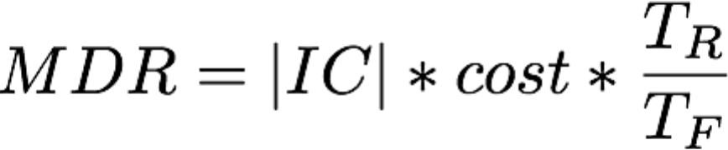The measurement used to determine the winner of the EG 1003 competition was the Minimal Design Ratio (MDR), of which the winner was the team with the associated lowest score, as described in Fig. 4. The MDR is comprised of cost in dollars, TR as room temperature, TF as final temperature, and IC as the insulating capacity.

.

Figure : Minimal design ratio

**Procedure**

The materials used in constructing the thermally insulated system included the following: one large foam cup, one cup lid, 18 Styrofoam pieces, one foot of tape, and one foot of aluminium foil.

Initially, a preliminary design of the thermally insulated system was sketched. Materials were obtained, and the construction process began. Ten Styrofoam pieces were placed into the cup in a matrix fashion in order to maximize the amount of air inside the system. A piece of aluminium foil was double wraped to serve as a heat trap once the egg was out of the water. Once the egg was out of the water, the attached heat sensor was taped to the egg, then wrapped in the heat trap. This was then placed inside the thermal container, along with the remaining Styrofoam pieces, before being sealed with the cup lid, and taped shut, as shown in Fig. 5. 15 minutes of data gathering time was allotted, and the results were recorded and analyzed.

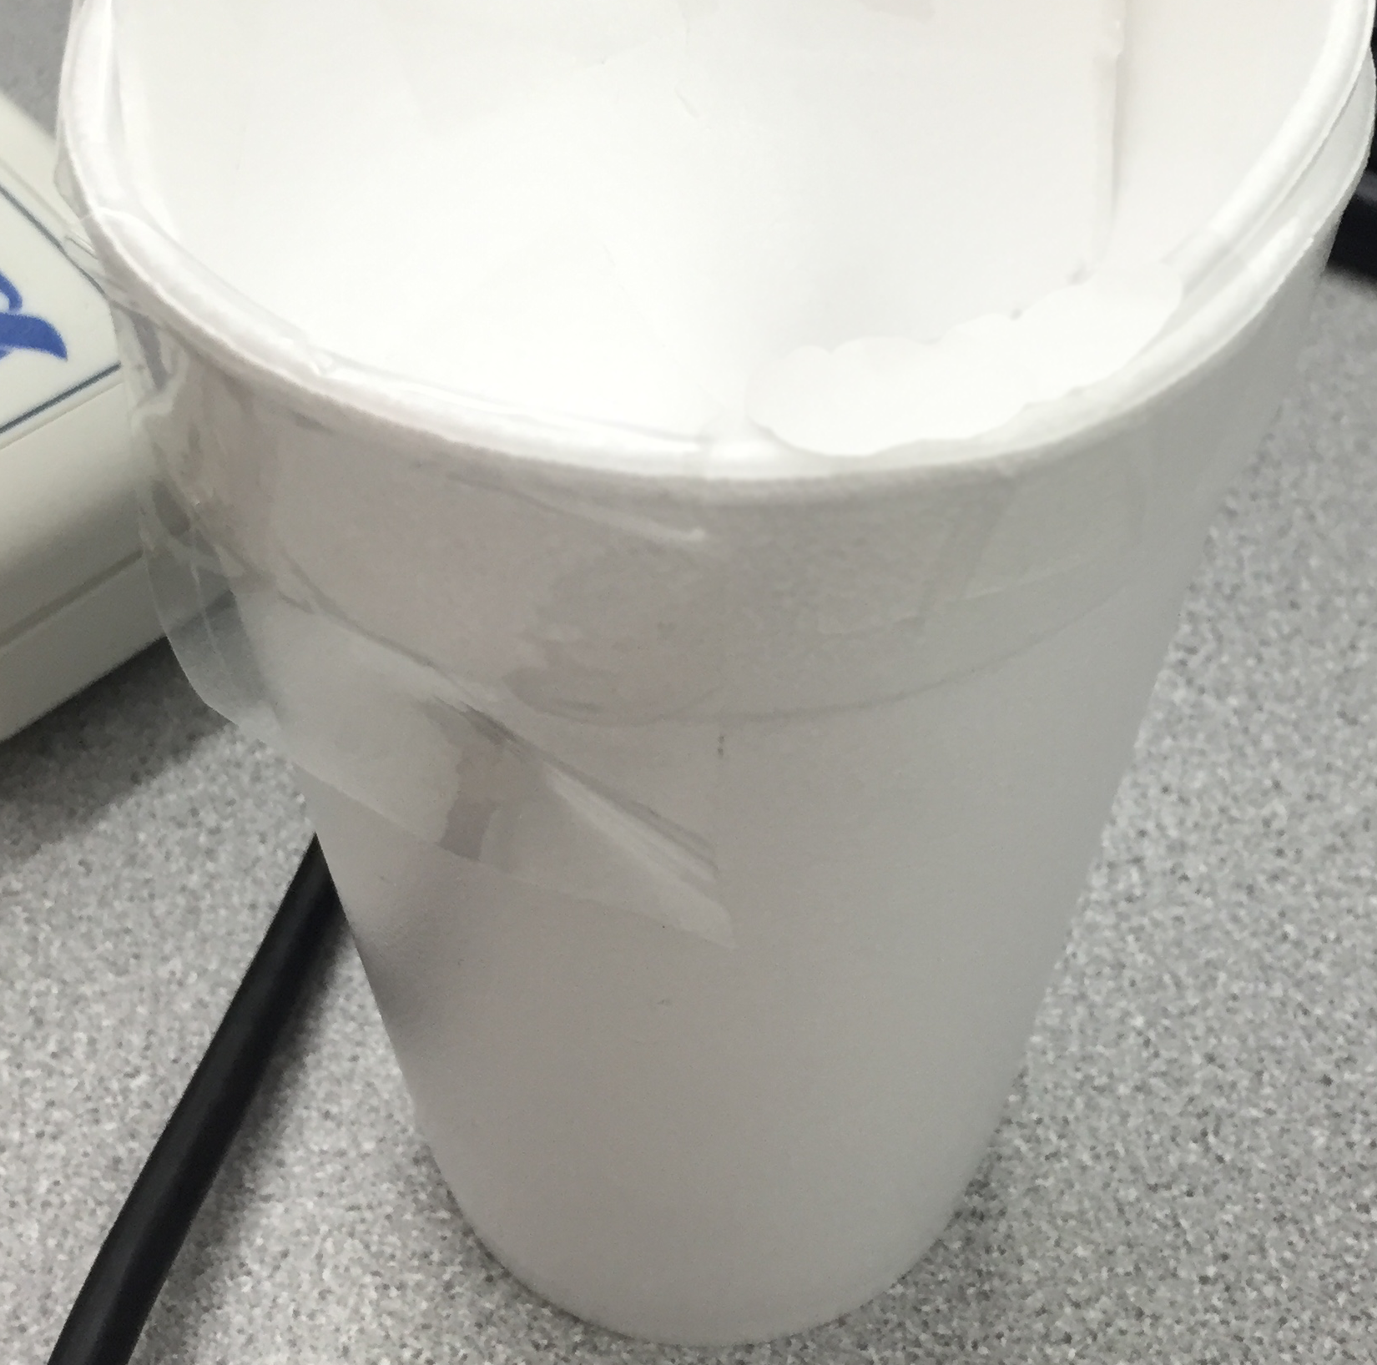

Fig. 5: Final thermal insulated system design

**Data/Observations**

The starting temperature of the system was around 176°F, and the ending temperature 15 minutes later was 161°F, resulting in a temperature loss of around 15°F over 15 minutes, as described in Fig. 6.

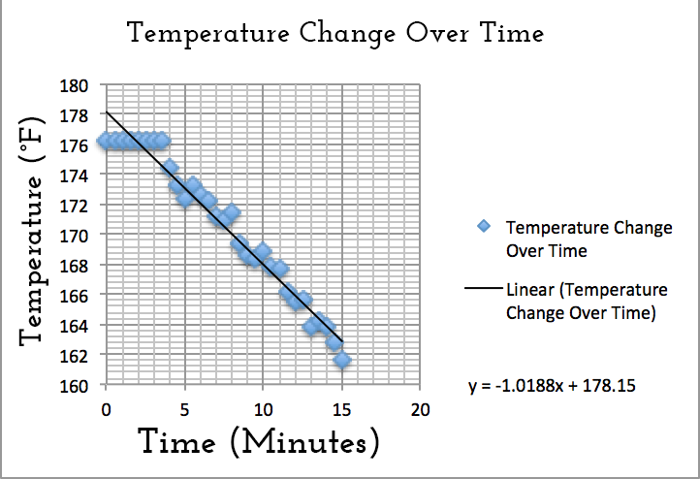

Fig. 6: Temperature change over time

The results of the EG1003 competition are shown in Fig. 7:

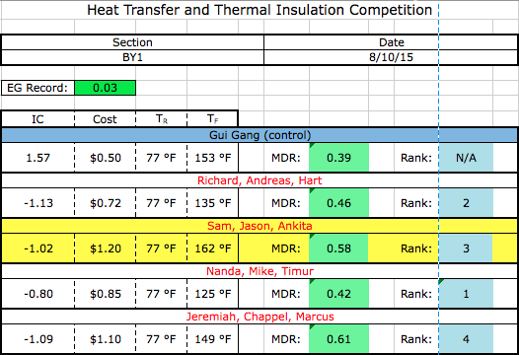

Figure 7: EG 1003 competition results

The calculated MDR is shown in Fig. 8:

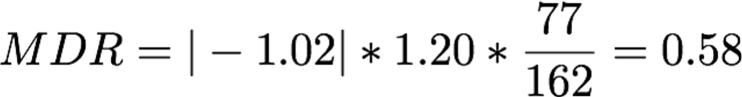

Fig. 8: Calculated minimal design ratio

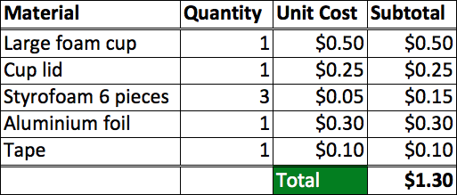The cost of materials for the insulated system is shown in Fig. 9:

Fig. 9: Material cost list

**Discussion/Conclusions**

Overall, the thermally insulated system placed third in the EG 1003 competition, primarily due to its high final temperature, which was the highest out of all EG teams. Even though the system insulated thermal transfer more effectively than other teams, it was less competitive due to the higher cost associated with constructing the system.

In order to minimize the design ratio, aluminium foil, due to metals having a high heat transferral property, should be removed from the design, allowing for a higher insulating capacity, as well as lowering costs.

Theoretically, a temperature versus time graph should be smooth, though since data gathering is done through physical, and potentially inaccurate instruments, “spikes” may occur during data recording. In order to get an idea of how the data performs on average, a trendline is used to show the averages along the graph.

This design succeeded in having the most heat remaining in the insulated system, though remained cost ineffective compared to other teams.

**Works Cited**

New York University Polytechnic School of Engineering. 2011. *“Lab 11: Heat Transfer and Thermal Insulation”.* EG 1003 Online Lab Manual. Accessed 10 August 2015 from manual.eg.poly.edu.

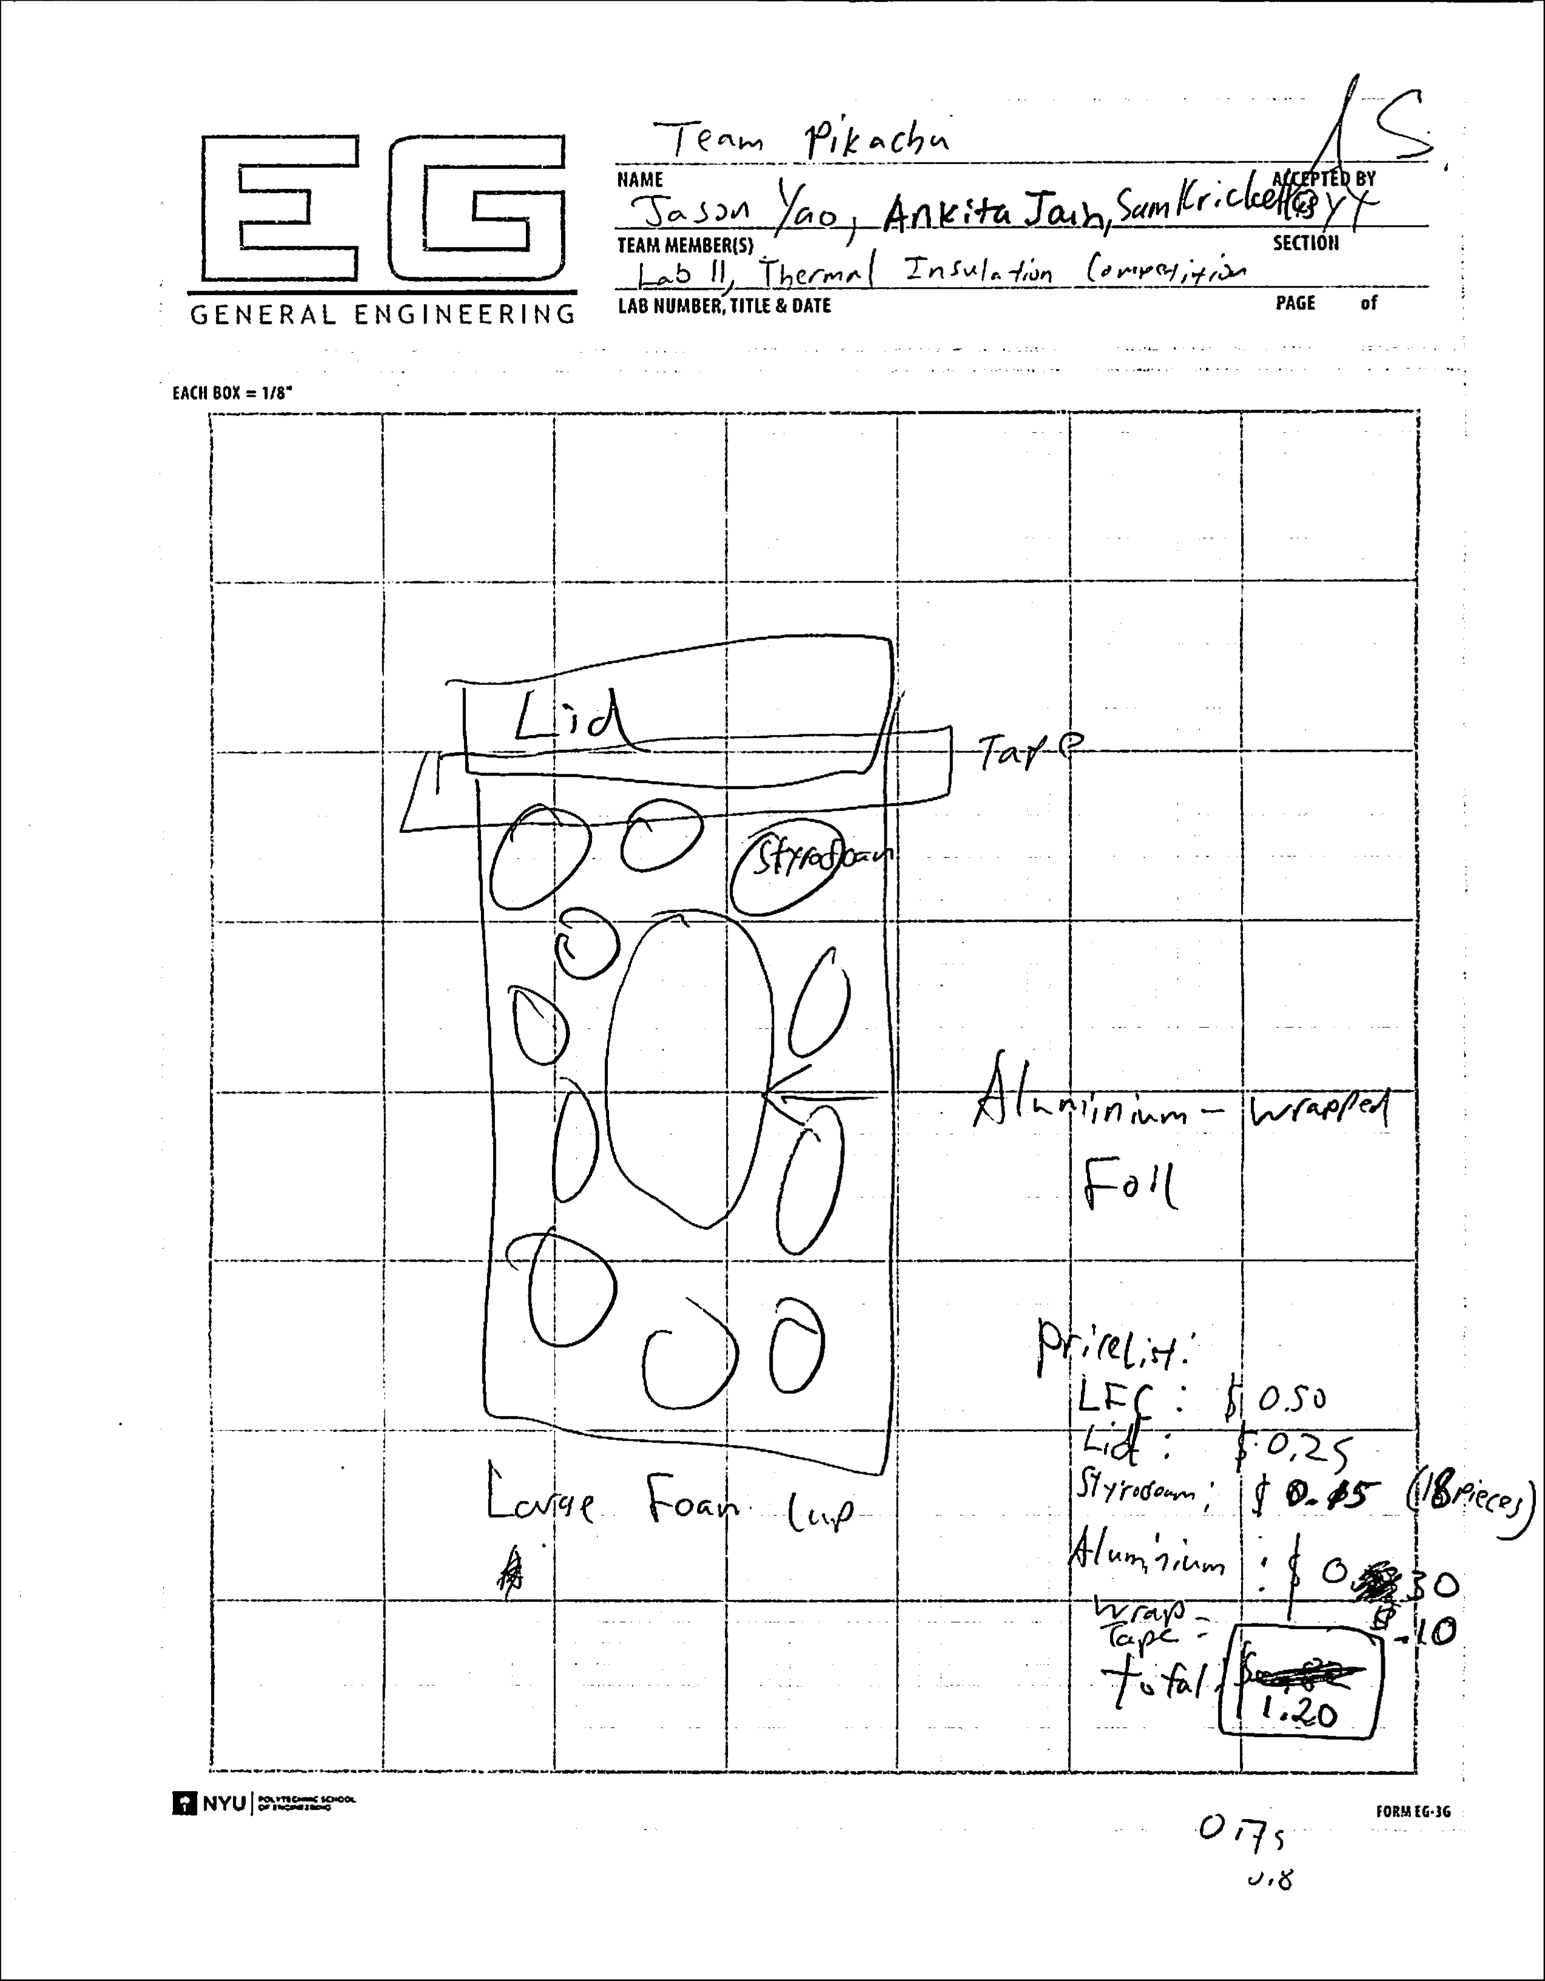

Fig. 10: Initial design notes