Lab 8: Lemon Car Competition

EG1003 Section BY1

Marcus Bachu, Chappel Sharrock, Jason Yao

Dates of Experiment: July 30, 2015

Date due: August 3, 2015

**Abstract**

The objective of this lab was to design and build a reduction-oxidation (redox) reaction powered car using citrus juice and metals used to create an electrochemical (Galvanic) cell. A secondary objective was to win the competition between the EG 1003 teams by achieving the highest Competition Ratio. The car was successfully built using capacitors powered by the redox reaction, and achieved second place in the EG 1003 competition. This lab is significant because it shows how redox reactions can be used as an alternative to conventional energy generation processes.

**Introduction**

As the lab was a competition, the winning team was the one with the highest Competition Ratio (CR), described in Fig. 1.

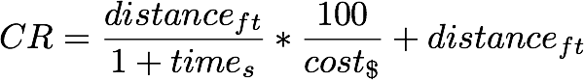

Fig. 1: Competition Ratio used to determine winning team

In this ratio, distanceft was the linear distance traveled by the car, times was the amount of time required for the vehicle to come to a stop, and cost$ was the total cost of the vehicle. Under this formula, the better the CR was, the higher the vehicle would place in the EG 1003 competition.

In order to powered the vehicle, a source of energy and a way to store that energy for continuous release was required. This meant that a battery of some kind had to be constructed in order for the vehicle to move. Batteries are devices that are made of smaller sections called cells, which create a voltage differential between two terminals of different metals. This voltage is created from a chemical redox reaction, in which the oxidation and the reduction of metals in an electrolytic solution causes a voltage differential between the two terminals.

An important thing to note is that the voltage differential depends upon which two metals are used in the Galvanic cell. This difference in voltage output is due to two properties of the metals themselves, namely electronegativity and ionization energy.

The electronegativity of an element is defined by the EG 1003 Lab Manual as “a measure of [an] element’s capability to attract another element’s electrons”. This means that a higher electronegativity in an element corresponds to a more powerful attraction on another element’s electrons, possibly resulting in pulling those electrons to the more electronegative element if the ionization energy requirement is met.

The ionization energy of an element is the amount of energy needed to remove an electron from an atom to form a cation and a free electron. A cation is an ion that has positive charge, and normally moves towards the negative electrode when undergoing electrolysis. A table of elements used in this laboratory along with their respective electronegativity and ionization energy values are shown in Fig. 2.

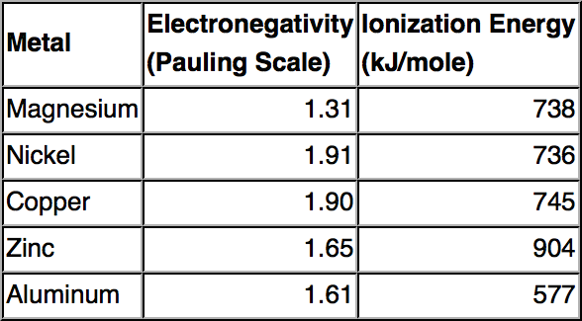

Fig. 2: Elements used in redox reactions and their electronegativity and ionization energy values

For a redox reaction utilizing a lemon as an electrolytic solution source, the largest difference between electronegativity of two metals would theoretically result in the highest voltage differential, and thus provide the most power to the vehicle for movement. From the elements above, that would mean that the two metals used for the redox reaction that would theoretically give the highest voltage would be magnesium paired with copper.

**Procedure**

Two cups of lemon juice, two strips of copper, two strips of magnesium, a piece of emery paper, four alligator clips, a Light Emitting Diode (LED), a multimeter, a LEGO to Alligator clip connector, a LEGO motor, three 1-Farad 2.5V capacitors, and a LEGO vehicle kit were used to construct the redox powered vehicle.

First, experimental data had to be gathered to confirm the relative voltage differential generation of different metals, which required testing a pair of metals and recording their voltage. Two strips of zinc and copper were acquired, and then cleaned with emery paper. These strips of zinc and copper were then inserted into a lemon with a 1.5cm separation between the two strips. Alligator clips were then connected to the two metals, and then connected to a load, which was an LED as shown in Fig. 3. A multimeter was then connected to the circuit in parallel, and a voltage was recorded, before the testing circuit was disconnected.

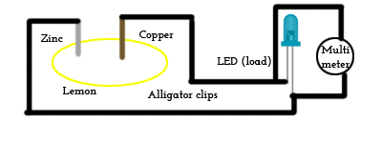

Fig. 3: Test circuit for zinc/copper single Galvanic cell combination

Next, the voltage generation of a pair of galvanic cells in series (also known as a galvanic battery) was to be tested. Another lemon was acquired, along with its respective zinc and copper strips. These strips were cleaned with emery paper, and then inserted into the second lemon in a similar fashion as the first. Alligator clips were then attached to both metal terminals in the second lemon and then wired to the first lemon’s terminals as shown in Fig. 4. A voltage was recorded, and the test circuit was then disconnected.

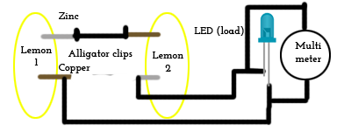

Fig. 4: Test circuit for zinc/copper double Galvanic cell combination

After the voltages were recorded, a decision had to be made of what pair of metals were to be used to power the Galvanic cell of the car. Magnesium and copper were chosen to act as the terminals in the Galvanic cell. The design of the car was then planned and approved before assembly began.

The vehicle was then constructed and tested with a normal load, before being altered to become lighter. While the vehicle was being assembled, capacitors were charged in parallel by a new Galvanic battery using a cup of lemon juice in place of each lemon, as shown in Fig. 5.

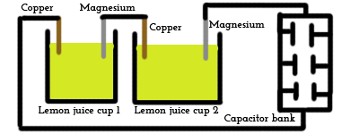

Fig. 5: Charging circuit utilizing copper & magnesium

Once the capacitors were fully charged after testing each one with a multimeter, the capacitors were then disconnected from the charging circuit and then wired into the vehicle. Once the vehicle was completed and wired to the capacitor bank from the motor, the car was placed into the EG 1003 competition.

**Data/Observations**

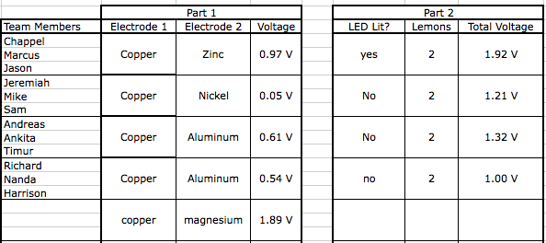The voltages differentials found from experimentation with different metal electrode pairings are listed in Fig. 6.

The lemon car’s final design was powered by three capacitors as shown in Fig. 7. In this design, the capacitors were connected in parallel in order to maximize total capacitance (amount of charge) in the capacitors.

Figure 6: Voltage of various metal pairing in a Galvanic cell (part 1) or battery (part 2)

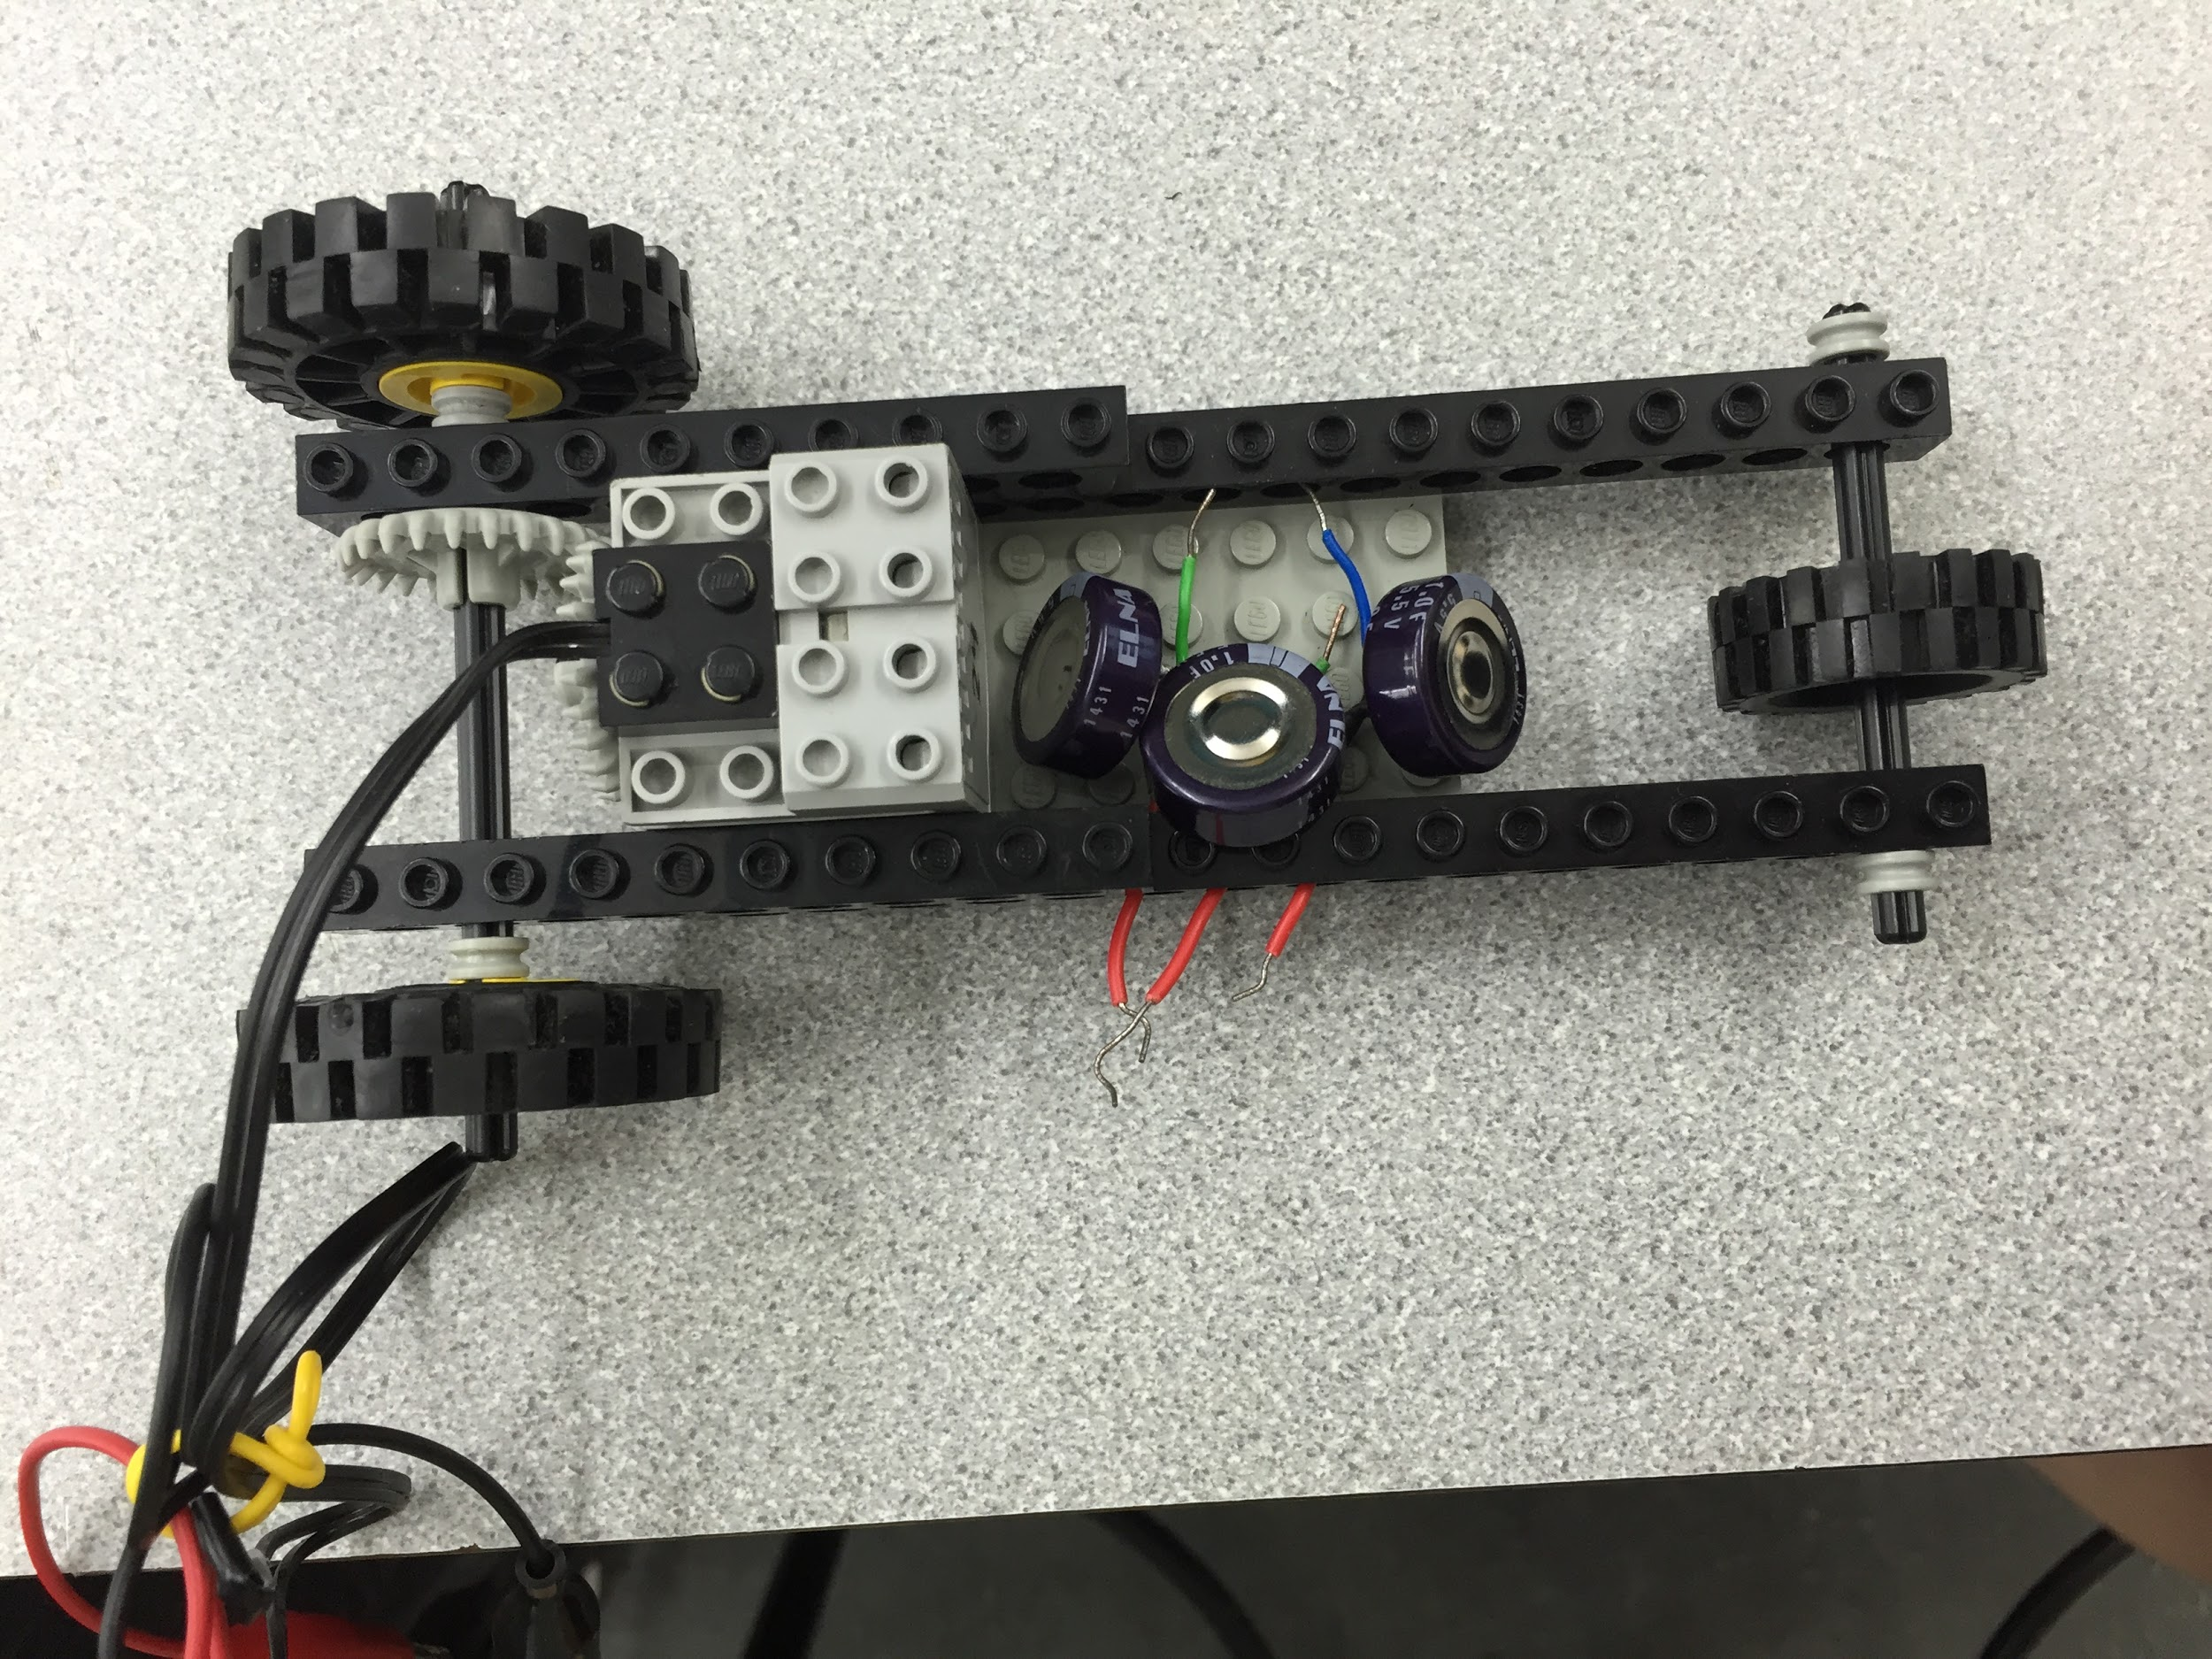

Fig. 7: Final vehicle design

Only three wheels were used in order to minimize the weight of the vehicle, and capacitors were chosen as the power storage solution instead of using cups of lemon juice due to the higher weight of the cups.

The overall cost of the car was $7.00, as shown in Fig. 8.

|  |  |  |  |
| --- | --- | --- | --- |
| **Item** | **Cost per unit** | **Quantity** | **Total** |
| **Lemon Juice** | $0.25/2 oz | 4 oz | $0.50 |
| **Zn Strip** | $0.50/strip | 2 strips | $1.00 |
| **Cu Strip** | $0.25/strip | 2 strips | $0.50 |
| **Mg Strip** | $1.00/strip | 2 strips | $2.00 |
| **Capacitors** | $1.00 | 3 | $3.00 |
| **Total** | N/A | | $7.00 |

Fig. 8: Cost breakdown

The overall cost of the car was $7.00. After competing in the class competition, the ratio attained was 4.65, as shown in Fig. 9.

Screen Shot 2015-08-02 at 4.10.06 PM.png

Fig. 9: Calculated CR of vehicle in EG 1003 competition

The results of the EG 1003 competition are shown below in Fig. 10.

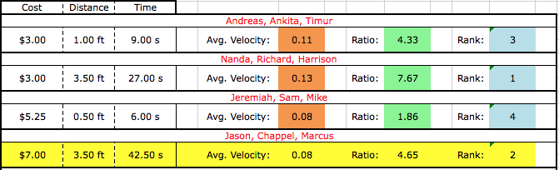

Fig. 10: EG 1003 competition results

**Discussion/Conclusions**

In order to design a successful lemon car, the distance traveled had to be maximized with the time elapsed and cost minimized. In order to maximise the distance traveled by the vehicle, the voltage output of the capacitors had to maximised as well. This was achieved by wiring the capacitors in parallel, allowing for the total capacitance of the circuit to be maximized.

The data from Fig. 6 was used to determine which metal pairings were most efficient in voltage output. From this list, it was determined that copper and magnesium provided the most voltage output out of the available materials. Thus, the metal pair with the highest potential difference, magnesium and copper (1.89 V), was used to charge the capacitors. In terms of the design of the car, a minimalist approach was taken. Only three wheels were attached to a single panel that was used to hold the capacitors, in order to minimize the total weight of the vehicle. Capacitors were chosen as the power storage solution due to their smaller and lighter form factor compared to the cups of lemon juice. A drawback of the capacitors was that voltage output decreased logarithmically over time, which resulted in an unsteady voltage output over time.

This design was successful, as the car tied with another team for the longest distance traveled (3.50 ft). However, the vehicle’s cost was too high compared to other team’s, with a total of $7.00, compared to the winning team’s total cost of $3.00. This design cost was the highest of all teams in the competition, and can thus be a source of improvement in future designs. The CR achieved was 4.65, which was second place overall. For this lab, we successfully built a redox reaction powered car and placed second in the competition between EG 1003 teams.

Some improvements for future designs could be the minimizing of cost through fewer capacitors, or more time allowed to fully charge the capacitors. Preliminary designs of the car also had wires from the capacitors that dragged on the ground. Using a larger front wheel could have avoided this issue altogether, and all of the voltage output of the capacitors could have then gone into powering the car.

**Works Cited**

New York University Polytechnic School of Engineering. 2011. *“Lab 8: Lemon Car*

*Competition”.*EG 1003 Online Lab Manual. Accessed 30 July 2015 from

manual.eg.poly.edu.

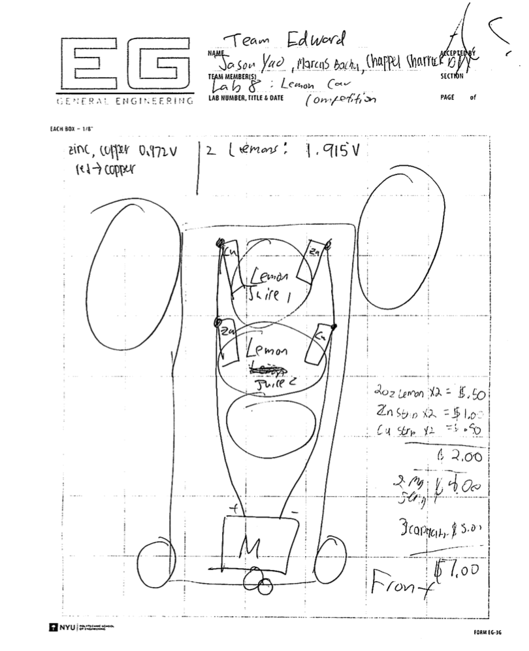

Fig. 11: Initial design notes