Warstone Content Inventory

## Card List - Current

|  |  |  |
| --- | --- | --- |
| **Type** | **Card** | **Estimate** |
|  |  |  |
| Rock | Pebble | 0.5 |
|  | Stone | 0.5 |
|  | Brick | 0.5 |
|  | Boulder | 0.5 |
|  | Mountain | 0.5 |
|  | Planet | 0.5 |
|  |  |  |
| Paper | Note | 0.5 |
|  | Card | 0.5 |
|  | Letter | 0.5 |
|  | Tome | 0.5 |
|  | Bookshelf | 0.5 |
|  | Library | 0.5 |
|  |  |  |
| Scissors | Pin | 0.5 |
|  | Scissors | 0.5 |
|  | Razor | 0.5 |
|  | Machete | 0.5 |
|  | Zweihander | 0.5 |
|  | Guillotine | 0.5 |
|  |  |  |
| TOTAL |  | 10 days |

## UI Components - Current

|  |  |  |
| --- | --- | --- |
| **Type** | **Component** | **Estimate** |
|  |  |  |
| Card | Player 1 Deck | 2.0 |
|  | Player 2 Deck |  |
|  | Rock Face |  |
|  | Paper Face |  |
|  | Scissors Face |  |
|  |  |  |
| Icon | Block / Ban | 1.0 |
|  | Taunt / Shield |  |
|  | Bolt |  |
|  | Energy |  |
|  | Life / Heart |  |
|  | Sword / Attack |  |
|  |  |  |
| Forms / Fields | Primary | 1.0 |
|  | Secondary |  |
|  | Dialog Background |  |
|  | Input Field |  |
|  |  |  |
| Meter | Energy Meter BG |  |
|  | Energy Meter |  |
|  |  |  |
| Misc | Arrow Indicator |  |
|  | Battlefield Frame |  |
|  | Card Glow Effect |  |
|  | Player HUD |  |
|  | Turn Timer Meter |  |
|  | Game Logo? | 1.0 |
|  |  |  |
| TOTAL |  | 4 days / 5 days |

## UI Page List

|  |  |
| --- | --- |
| **Page** | **Estimate** |
|  |  |
| Login | 0.5 |
| How to Play |  |
| Looking for Opponent… |  |
| *(New)* Choose Deck  Deck Grid  Edit Deck  Play | 1.0 |
| *(New)* Build Deck | 1.0 |
| *(New)* Store / Catalog | 1.0 |
| In-Game | 1.0 |
| Wrap-up |  |
|  |  |
| TOTAL | 5 days |

## Notes / Feedback

*Warstone is a hearthstone clone, we are looking to follow those ui layouts. (library, crafting)  
The lnf of warstone was established by dsl, it has a retro pixel style.   
This presents some challenges in terms of special text presentation for cards, like "2x" becomes hard to read.  
While the retro pixel style is charming, it is equally parts unappealing - for certain customers  
I’m wondering if the Art dept wants to dip a toe in to warstone at this point, since we are going to invest more effort with the inventory features.*

Design Doc: <https://docs.google.com/document/d/1RiVO2xMw1K5kjLUjUrwTqW62npumzT3udSq1tmA8pg8/edit>

# Warstone Theme Brainstorm

ProblemThe “Warstone” title has a heavy fantasy feel, and ‘hero’ cards display everyday earth objects that have an attack rating and health points, which felt strange to a playtester. The current theme is doesn’t mesh well.

Is this really a Rock Paper Scissors game? To push that theme, what labels/concepts can we use as an alternative to “Attack Rating”, “Hitpoints” and “Magic Spells”, which are more commonly associated with tactics/battle/RPG games? Is “Warstone” the right title for a Rock Paper Scissors game?

Goal  
Find a title, theme and game mechanics presentation that feels unified.

## Alternatives to Current Card Images

Hands   
*Rock Paper Scissors is a game played with hands. Is there a way to use hand imagery for this game?*

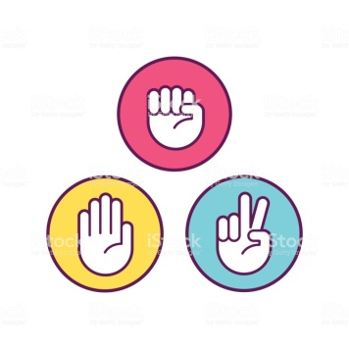 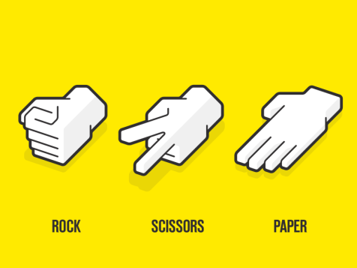 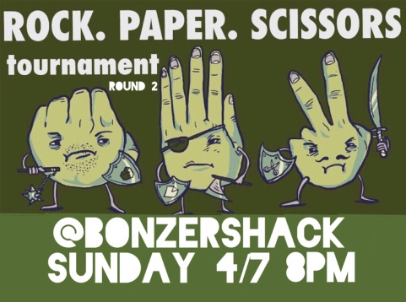

Anthropomorphic Objects  
*A playtester found that a Guillotine with health points was weird. Would it work to slap a pair of eyes on our objects to give them ‘life’?*

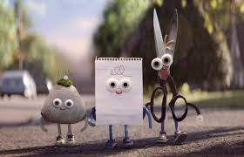 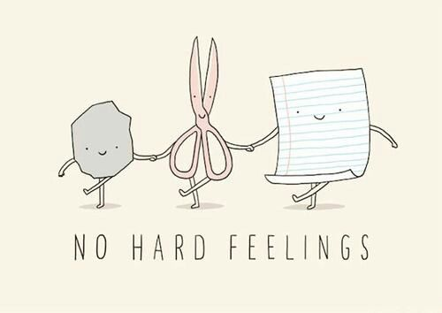

Fantasy Creatures / Characters shaped like everyday objects  
*Extending on anthropomorphism, and to stick with the fantasy theme implied by the game title and mechanics, maybe dimension-crossing wizards have invaded earth and use animation spells to attack each other.*

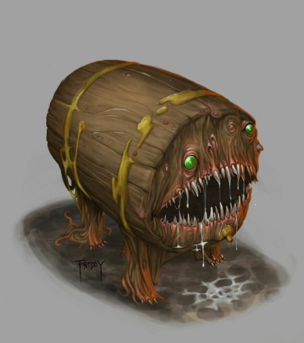 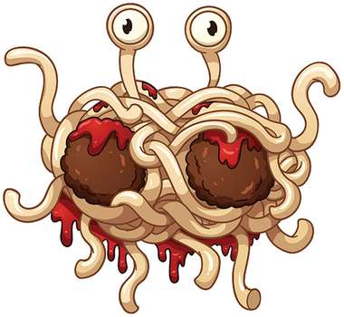

### Fantasy Creatures / Characters made of rocks, paper and metal/sharpness

*Convey rock, paper scissors through the material/texture of the characters.*

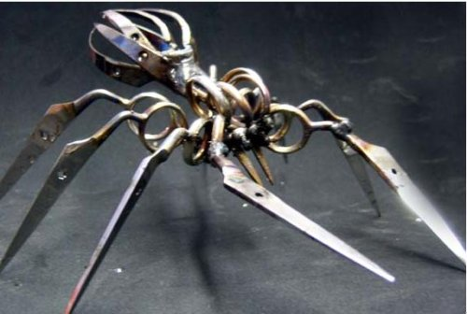 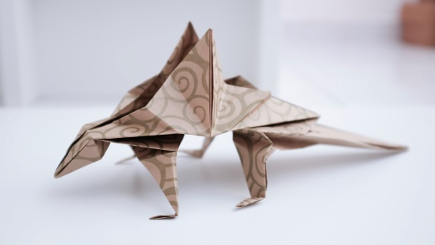 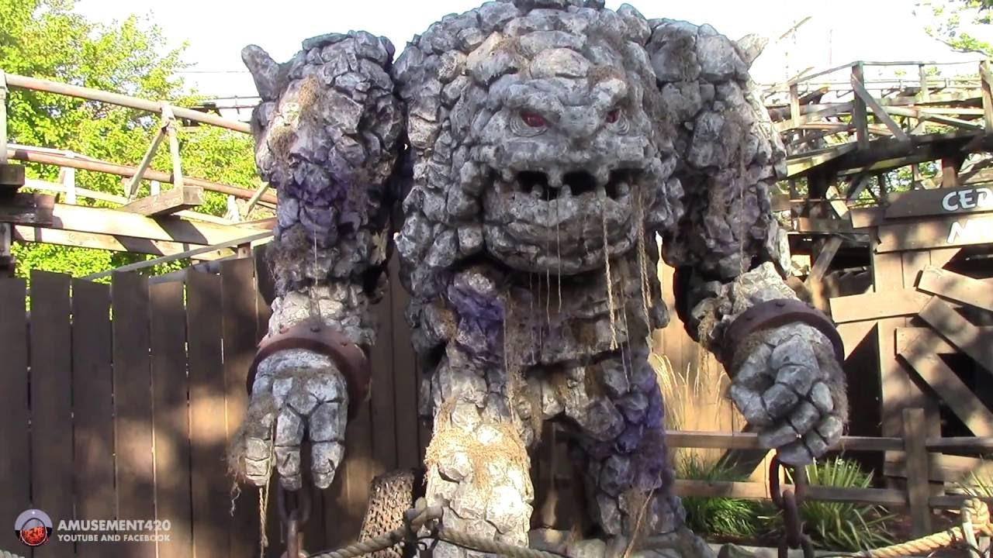

Factions  
*Ignore Rock Paper Scissors as a player-facing theme. Three warring factions; some factions deal double damage to certain other factions.*

