BC 11 0C 09 0C E1 00 81 3B

BC 11 0C 09 2D E1 00 81 1A

BC 11 02 09 3C E1 00 81 05

Trial2

射灯：

BC 11 0C 09 0C E1 00 81 3B

BC 11 0C 09 2D E1 00 81 1A

BC 11 0C 09 3C E1 00 81 05

Control: BC

Source address: 11 0C

Target address: 09 0C(1), 09 2D(1), 09 3C(1)

Length: 1 (So three bytes sent)

Data: 00 81 3B

Data: 00 81 1A

Data: 00 81 05

灯带：09 BC 11 0C 09 0B E1 00 81 3C 72

Control: BC

Source address: 11 0C

Length：1

Target: 09 0B Data: 00 81 3C

Target: 09 2D Data: 00 81 1A

Target: 09 3B Data: 00 81 02

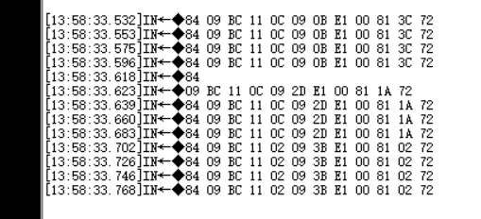

次卫浴室灯：

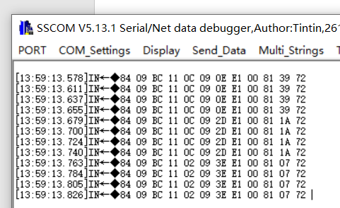

, 09 2D, 09 3E

Target: 09 0E Data: 00 81 39

Target: 09 2D Data: 00 81 1A

Target: 09 3E Data: 00 81 07

就寝：

Target: 17 01 Data: 00 80 29

Target: 09 2D Data: 00 80 1B 