PCA_with_qualtrics

Jason Cho,bc454

20 March, 2019

## rgeos version: 0.3-28, (SVN revision 572)  
## GEOS runtime version: 3.6.1-CAPI-1.10.1 r0   
## Linking to sp version: 1.3-1   
## Polygon checking: TRUE

## Loading required package: carData

##   
## Attaching package: 'car'

## The following object is masked from 'package:DescTools':  
##   
## Recode

## Loading required package: sp

## Checking rgeos availability: TRUE

## Parsed with column specification:  
## cols(  
## .default = col_integer(),  
## `Participant number:` = col_character(),  
## repair = col_character()  
## )

## See spec(...) for full column specifications.

## 1 : This voice agent made me feel: - Successful.   
## 2 : This voice agent made me feel: - Frustrated.   
## 3 : This voice agent made me feel: - Helped.   
## 4 : This voice agent made me feel: - Efficient.   
## 5 : This voice agent made me feel: - Happy.   
## 6 : This voice agent made me feel: - Agile.   
## 7 : This voice agent made me feel: - Pragmatic.   
## 8 : This voice agent was: - Extraverted, enthusiastic.   
## 9 : This voice agent was: - Critical, quarrelsome.   
## 10 : This voice agent was: - Dependable, self-disciplined.   
## 11 : This voice agent was: - Anxious, easily upset.   
## 12 : This voice agent was: - Open to new experiences, complex.   
## 13 : This voice agent was: - Reserved, quiet.   
## 14 : This voice agent was: - Sympathetic, warm.   
## 15 : This voice agent was: - Disorganized, careless.   
## 16 : This voice agent was: - Calm, emotionally stable.   
## 17 : This voice agent was: - Conventional, uncreative.   
## 18 : This voice agent was: - Smart.   
## 19 : This voice agent was: - Trustworthy.   
## 20 : This voice agent was: - Likeable.   
## 21 : This voice agent was: - Pragmatic.   
## 22 : This voice agent was: - Helpful.   
## 23 : A voice agent that always tried to correct itself after a mistake ... - ... would annoy me   
## 24 : A voice agent that always tried to correct itself after a mistake ... - ... would waste my time   
## 25 : A voice agent that always tried to correct itself after a mistake ... - ... would improve the conversation quality   
## 26 : A voice agent that always tried to correct itself after a mistake ... - ... would help me feel less frustrated

## Importance of components:  
## PC1 PC2 PC3 PC4 PC5 PC6 PC7  
## Standard deviation 3.168 1.7549 1.30776 1.1662 1.11781 1.07833 0.98180  
## Proportion of Variance 0.386 0.1184 0.06578 0.0523 0.04806 0.04472 0.03707  
## Cumulative Proportion 0.386 0.5044 0.57018 0.6225 0.67054 0.71526 0.75234  
## PC8 PC9 PC10 PC11 PC12 PC13  
## Standard deviation 0.91048 0.88146 0.85125 0.75904 0.72704 0.70638  
## Proportion of Variance 0.03188 0.02988 0.02787 0.02216 0.02033 0.01919  
## Cumulative Proportion 0.78422 0.81411 0.84198 0.86414 0.88447 0.90366  
## PC14 PC15 PC16 PC17 PC18 PC19  
## Standard deviation 0.62088 0.61482 0.54008 0.50031 0.4700 0.4588  
## Proportion of Variance 0.01483 0.01454 0.01122 0.00963 0.0085 0.0081  
## Cumulative Proportion 0.91848 0.93302 0.94424 0.95387 0.9624 0.9705  
## PC20 PC21 PC22 PC23 PC24 PC25  
## Standard deviation 0.41673 0.38640 0.37501 0.31742 0.30537 0.26189  
## Proportion of Variance 0.00668 0.00574 0.00541 0.00388 0.00359 0.00264  
## Cumulative Proportion 0.97714 0.98288 0.98829 0.99217 0.99575 0.99839  
## PC26  
## Standard deviation 0.20449  
## Proportion of Variance 0.00161  
## Cumulative Proportion 1.00000

##   
## Usually, principal components with variance > 1 are considered signficant(may differ by field). According to the summary above, 8 principal componenets account for ~ 77 percent of the total variance in the data. This means if we were to represent the data using just seven principal componenets, we will be able to explain 78 percent of variability in the data.

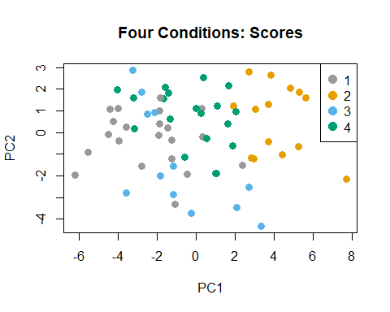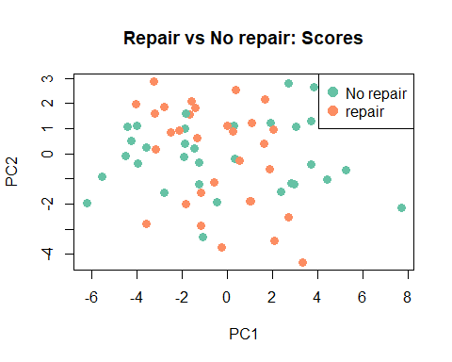

##   
## These two graphs represent scatter plots of all observations drawn on the first two principal components. PC1 and PC2 account for accumulated variance of ~50 percent in the data. Though not completely accurate, These scatter plots are good approximation of our high-dimensional dataset. As you can see from the first graph,All condition two observations are located on the right side of the graph, whereas condition one on the left side. Condition three and four, on the other hand, arn't clearly distinguishable from one another. This supports our findings from looking at boxplots. While condition 2 and condition 1 were consistently 'worse' and 'better' depending on the features, condition 3 and 4 had similar means. The second graph was color-coded based on repair vs no repair.

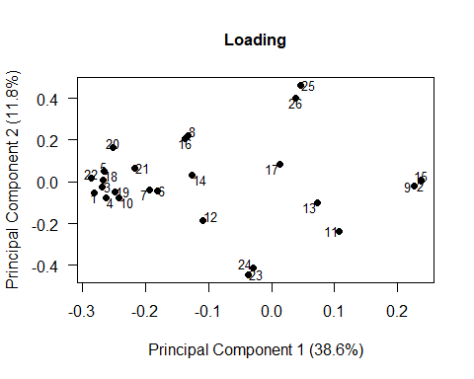

##   
## The graph above represents loadings of each features plotted on the first two principal components. I replaced feature names with numbers. From this graph we can see that

## This voice agent made me feel: - Successful.   
## This voice agent was: - Helpful.   
## This voice agent made me feel: - Helped.   
## This voice agent was: - Smart.   
## This voice agent made me feel: - Happy.   
## This voice agent was: - Trustworthy.   
## This voice agent was: - Pragmatic.   
## This voice agent was: - Dependable, self-disciplined.   
## This voice agent made me feel: - Pragmatic.   
## This voice agent made me feel: - Agile.   
## This voice agent was: - Likeable.

## These features are similar in characterisitcs. (These are clusterd on the left, labeld 22,1,3,4,18,5 and etc)

## This voice agent was: - Disorganized, careless.   
## This voice agent made me feel: - Frustrated.   
## This voice agent was: - Critical, quarrelsome.

## And, these features are similar in characterisitcs. (These are clusterd on the right 15,9 and 2

##   
## From this, we can deduce that the first feature group represents the 'good' group while the second group represents the 'bad'

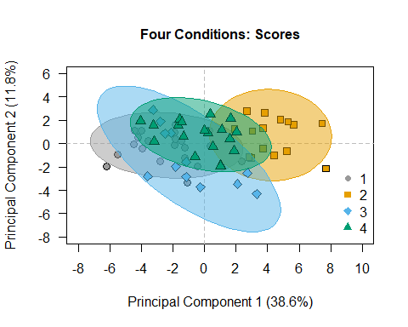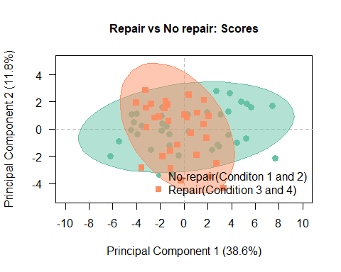

## Warning: package 'devtools' was built under R version 3.5.3

## Warning: package 'usethis' was built under R version 3.5.3

## Loading required package: ggplot2

## Warning: package 'ggplot2' was built under R version 3.5.3

## Loading required package: scales

##   
## Attaching package: 'scales'

## The following object is masked from 'package:readr':  
##   
## col_factor

## Loading required package: grid

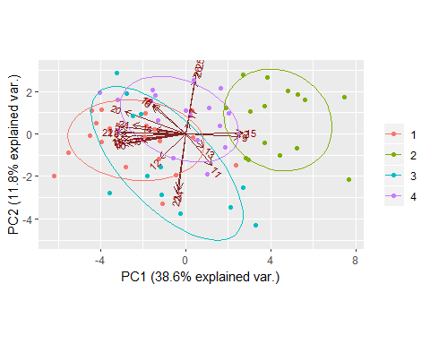

## 25 A voice agent that always tried to correct itself after a mistake ... - ... would improve the conversation quality   
## 26 A voice agent that always tried to correct itself after a mistake ... - ... would help me feel less frustrated

## 23 A voice agent that always tried to correct itself after a mistake ... - ... would annoy me   
## 24 A voice agent that always tried to correct itself after a mistake ... - ... would waste my time