How Inflation and Interest Rates Shape S&P 500 Performance (2016–2026)

Presented on:
July 19, 2025

Presented by:
Jason Daou

Table of Contents
Table of Tables 3
I. Introduction 4
Context 4
Objectives 4
Importance 4
Organization of This Report 5
II. Methodology 5
AI-Assisted Development Approach 5
Data Source 6
Tools Used 6
Approach 6
III. Findings and Results 7
Descriptive Statistics 7
Visualizations 7
Statistical Significance 9
Interpretation of Results 10
A Concrete Illustration of What Else Drives the Noise 10
Practical Implications and Limitations 11
IV. Conclusion and Recommendations 11
Conclusion 11
Recommendations 12
V. References 13
References 13
Appendix A: Processed Dataset Data Dictionary 13
Appendix B: Full Descriptive Statistics 14

Table of Figures
Figure 1-Effective federal funds rate, 2016–2026, the policy cycle at a glance 8
Figure 2-30- and 90-day moving averages smoothing daily S&P 500 noise. 8
Figure 3-Distribution of monthly S&P 500 returns. 8
Figure 4-. Monthly returns by policy regime. 8
Figure 5-S&P 500 return vs. CPI inflation, colored by regime. 9
Figure 6-Correlation matrix across key variables. 9
Figure 7-Daily S&P 500, colored by policy regime, with the COVID-19 crash annotated. 9
Figure 8-S&P 500, CPI, and Fed funds rate rebased to a common scale. 9

Table of Tables
Table 1-Data Source 6
Table 2-Statistical Significance Test Results 10
Table 3-Appendix A 14
Table 4-Appendix B 14

Introduction

Context
Every investment decision is made against a macroeconomic backdrop. Interest rates determine borrowing costs and how future corporate earnings are valued, while inflation reduces the real value of returns and drives central bank policies. Between 2016 and 2026, the United States economy moved through a complete monetary cycle, shifting from near-zero interest rates to a post-pandemic inflation surge, followed by aggressive rate hikes and eventual easing.
Financial professionals and individual investors must navigate this macroeconomic uncertainty. While conventional market wisdom claims that rising interest rates and high inflation always damage stock prices, these narratives are rarely backed by hard data. Financial commentary frequently repeats these assumptions without measuring their actual impact, consistency, or long-term accuracy.

Objectives
This project uses the 2016–2026 decade as a natural laboratory to test that narrative directly. Its objectives are to:
- Acquire and validate reliable macroeconomic and financial data directly from FRED (Federal Reserve Economic Data), with full source attribution.
- Construct a single, clean, analysis-ready dataset aligning a daily equity series with two monthly macroeconomic series.
- Quantify S&P 500 returns and volatility, and statistically test whether they relate to inflation and interest-rate conditions.
- Compare market behavior across distinct monetary-policy regimes (near-zero, hiking, easing).
- Translate the statistical results into an honestly caveated, business-relevant narrative, explicitly distinguishing correlation from causation.

Importance
Decision-makers frequently lack a clear, quantified picture of how United States equity performance co-moves with inflation and monetary policy. Without this grounding, asset allocation and risk management decisions risk being driven by recency bias, such as over-reacting to the most recent central bank decision, rather than by documented historical patterns. This project addresses that gap using official, publicly available data to establish an empirical baseline. By analyzing these relationships, this study provides the foundational groundwork necessary for informed market analysis and strategic asset allocation before executing advanced financial modeling.

Organization of This Report
Section 2 describes the data sources, tools, and analytical approach, including how AI assistance was used and bounded. Section 3 presents the findings: descriptive statistics, the eight visualizations, and formal statistical tests. Section 4 interprets those results and discusses their practical implications and limitations. Section 5 concludes and offers recommendations. Full references and supporting appendices follow in Section 6.

Methodology

AI-Assisted Development Approach
This project was developed with the assistance of an AI system (Claude, by Anthropic), used as a coding and planning collaborator throughout. Its role was deliberately bounded and is disclosed transparently:
- Planning assistance: structuring the overall analytical workflow, from dataset evaluation through notebook organization.
- Code drafting: Python code for data acquisition, cleaning, statistical analysis, and visualization, with clear variable names and inline documentation.
- Data verification: every series used was retrieved from FRED's public pages rather than generated or recalled from memory, with a traceable source for every figure reported.
- Human review and responsibility: all AI-drafted code, interpretations, and conclusions were reviewed by me before finalizing. The AI's output was a starting point, not a substitute for my own understanding — final analytical responsibility rests with me.

Data Source
Three official time series were combined, all retrieved from the Federal Reserve Bank of St. Louis's FRED database (fred.stlouisfed.org), which redistributes data directly from primary publishers without alteration:
Table 1-Data Source
Series | FRED ID | Publisher | Frequency
S&P 500 Index | SP500 | S&P Dow Jones Indices LLC | Daily (close)
Consumer Price Index (Urban) | CPIAUCSL | U.S. Bureau of Labor Statistics | Monthly
Effective Federal Funds Rate | FEDFUNDS | Federal Reserve Board of Governors | Monthly

Because FRED's daily SP500 history is licensed back only ten years, the effective combined analysis window is July 2016 to mid-2026.

Tools Used
Python 3 in a Jupyter Notebook was used throughout, with pandas and numpy for data wrangling, matplotlib and seaborn for visualization, and scipy for statistical testing.

Approach
The analytical pipeline followed five stages.
- Collection: all three series pulled directly from FRED's public CSV endpoint, no authentication required.
- Cleaning: FRED's missing-value marker was converted to numeric NaN; non-trading-day gaps in SP500 were dropped as genuinely non-existent observations, while the single missing CPI month (October 2025) was forward-filled, a low-impact treatment justified by CPI's slow-moving nature.
- Feature engineering: daily returns, rolling 21-trading-day annualized volatility, month-over-month and year-over-year inflation change, federal funds rate change in basis points, and a policy-regime label (near-zero / hiking / easing) based on documented FOMC turning points.
- Validation: the merged dataset is asserted to match an exact, verified shape (118 rows × 11 columns) before anything is saved, so any future drift is caught immediately rather than shipped silently.
- Analysis: descriptive statistics, correlation testing (Pearson, with pairwise deletion of the handful of rows where a lag-based feature is undefined at the start of the series), a two-sample test comparing volatility across regimes, and a simple linear regression.

Findings and Results

Descriptive Statistics
Over July 2016 to April 2026 (n = 118 monthly observations), the S&P 500 averaged a +1.07% monthly return (std. dev. 4.61%), ranging from 20.05% to +14.58% in any single month. Annualized volatility averaged 15.0% but spiked as high as 68.8% during the most turbulent month. Year-over-year CPI inflation ranged from 0.20% to 8.98% (mean 3.39%), above the Federal Reserve's conventional 2% target for most of the window, and the effective federal funds rate ranged from 0.05% to 5.33%, confirming the full policy cycle this project set out to study is captured in the data.

Visualizations
All eight charts below are generated directly from the validated dataset and saved at publication quality; each is interpreted rather than left to speak for itself.
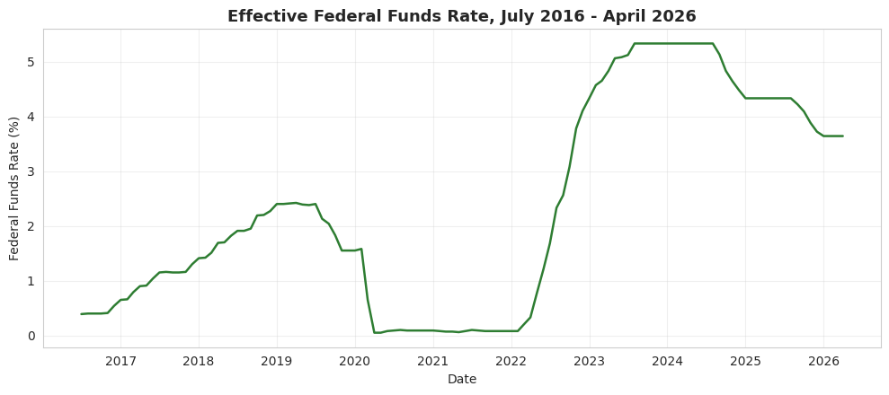  Figure 1-Effective federal funds rate, 2016–2026, the policy cycle at a glance | 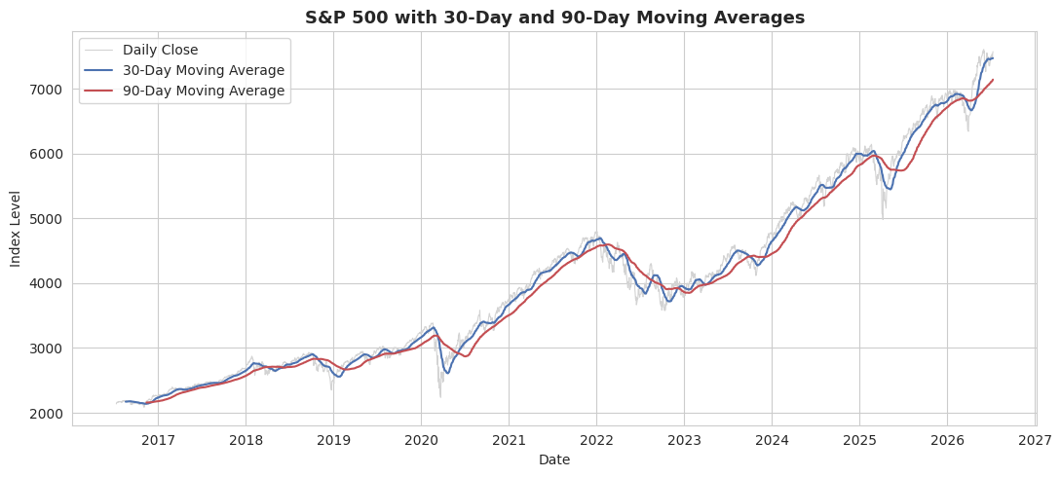  Figure 2-30- and 90-day moving averages smoothing daily S&P 500 noise.
Figure 1 shows the policy cycle unmistakably: flat near zero through 2021, a near-vertical climb through 2022–2023, a plateau, then a gradual descent from late 2024. Figure 2's moving averages make the major trend turns, the 2020 crash, the 2022 downturn, far easier to see than the raw daily series, at the cost of lagging behind sharp reversals.
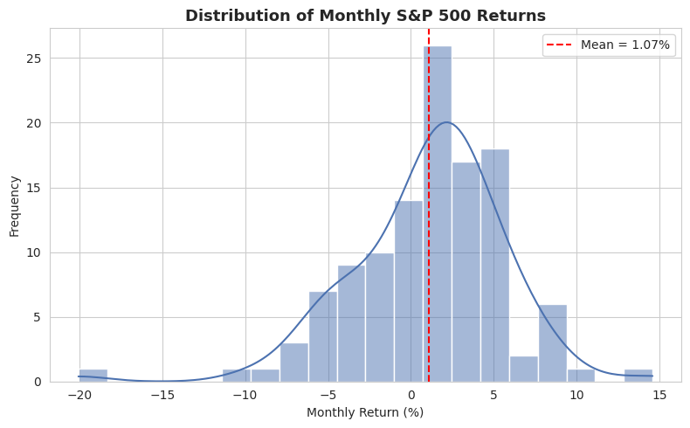  Figure 3-Distribution of monthly S&P 500 returns. | 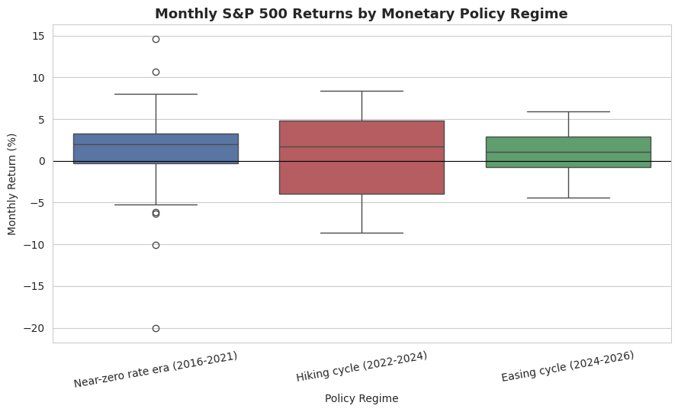  Figure 4-. Monthly returns by policy regime.
Figure 3 shows returns are roughly bell-shaped with a visible left tail, a small number of very bad months (crash events) pull the distribution away from a symmetric normal shape, a well-documented “fat tails” feature of financial returns. Figure 4 shows median returns are positive in all three regimes, but the hiking-cycle box is visibly wider with a lower whisker reaching further into negative territory.
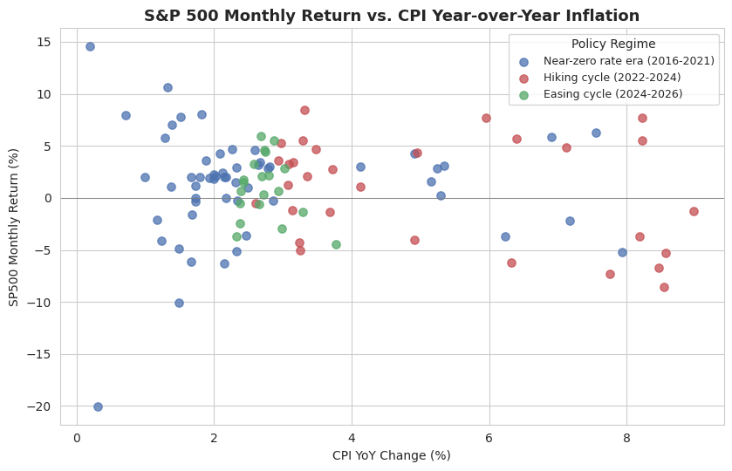  Figure 5-S&P 500 return vs. CPI inflation, colored by regime. | 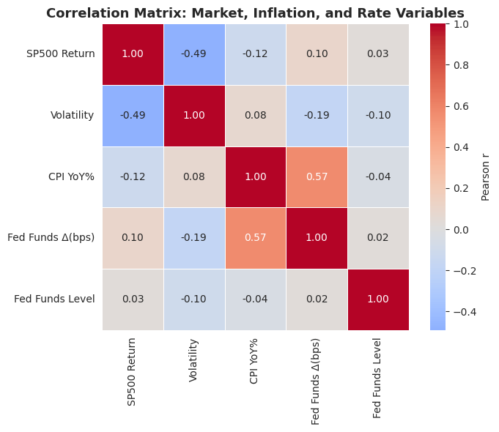  Figure 6-Correlation matrix across key variables.
Figure 6 identifies the strongest relationship in the dataset as monthly return versus monthly volatility (r = –0.49), higher-volatility months coincide with weaker returns, as expected. The pace of Fed funds changes correlates moderately with CPI inflation (r = 0.57), consistent with the Fed reacting to inflation. Direct correlations between returns and CPI (r = –0.12) or rate changes (r = 0.10) are both weak, visible in Figure 5 as a loose, noisy scatter rather than a tight trend.
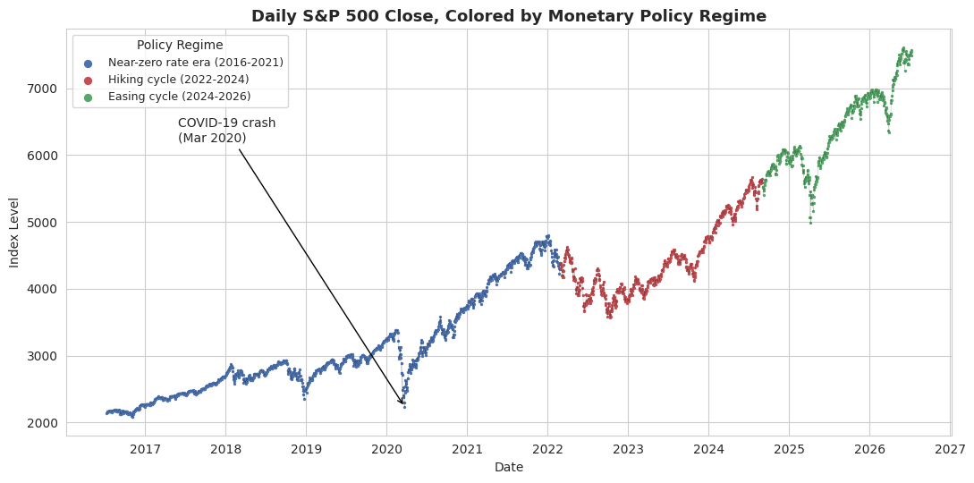  Figure 7-Daily S&P 500, colored by policy regime, with the COVID-19 crash annotated. | 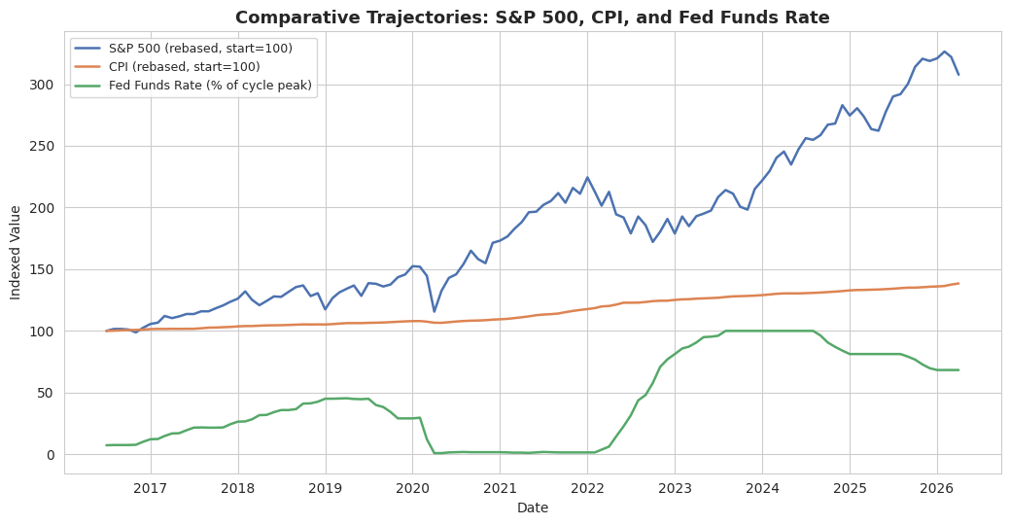  Figure 8-S&P 500, CPI, and Fed funds rate rebased to a common scale.
Figure 8 is the single most useful chart for a non-technical stakeholder: it shows in one image that equity growth (+254% cumulative price return over the window) has vastly outpaced inflation even after two significant drawdowns, while the federal funds rate cycled up and back down around it.

Statistical Significance
The correlations above were tested formally rather than read visually:

Table 2-Statistical Significance Test Results
Test | Result | Significant at 5%?
SP500 return × CPI YoY inflation (Pearson r) | r = –0.12, p = 0.207 | No
SP500 return × Fed funds change (Pearson r) | r = 0.10, p = 0.299 | No
Volatility × CPI YoY inflation (Pearson r) | r = 0.08, p = 0.431 | No
Volatility: hiking (16.6%) vs. near-zero (14.3%) regime (Welch's t) | p = 0.203 | No
Linear regression: monthly return ~ CPI YoY | R² = 0.015, p = 0.207 | No

None of the five tests reach conventional statistical significance. This means the true relationship at monthly resolution, over this sample, cannot be statistically distinguished from zero.

Interpretation of Results
Financial theory does not suggest that inflation and interest rates are the only factors driving monthly stock market returns. Many other influences, such as company earnings, investor sentiment, sector performance, and unexpected events, also affect the market. Because of this, looking at the relationship between just one factor and stock returns can only explain part of the overall picture.
The results still match financial theory. Higher inflation is linked to slightly lower stock returns, and changes in the Federal Funds Rate tend to follow changes in inflation because the Federal Reserve usually adjusts interest rates after inflation has already changed. The fact that these relationships are not statistically strong is also an important finding. It shows that, over this ten-year period and using monthly data, inflation and interest rates by themselves are not enough to explain most of the changes in the stock market.

A Concrete Illustration of What Else Drives the Noise
The second major period of high volatility in the dataset occurred in April 2025 and clearly shows this point. The sharp market movement was not caused by inflation or interest rates. Instead, it followed the U.S. government's announcement of new tariffs on April 2, 2025, which led to a rapid market sell-off of about 15 to 19 percent over a few trading days. The market then recovered quickly after a 90-day pause on the tariffs was announced. This added significant volatility to the dataset, but it was driven by trade policy rather than inflation or Federal Reserve interest rate decisions.
The COVID-19 market crash is another example. It was caused by a global health crisis and the financial uncertainty that followed, not by inflation or interest rates, even though interest rates were very low at the time.

Practical Implications and Limitations
Inflation and interest rates show a directionally consistent but statistically weak relationship with S&P 500 performance and volatility over 2016–2026 at monthly resolution. The hiking cycle does show higher average volatility and weaker average returns than the near-zero-rate era, matching the popular narrative, but the data cannot rule out that this difference is due to chance. Several limitations bound these conclusions: the sample is relatively small (n ≈ 106–118 monthly observations, since FRED's daily SP500 history is capped at ten years by licensing agreement), monthly aggregation can hide sharp single-day reactions to a specific CPI release or FOMC announcement, no confounders (earnings, fiscal policy, geopolitical shocks) are controlled for, and the SP500 series used is a price index that excludes dividends. None of these change the direction of the findings, but they mean the results should be read as a first, honest look — not a definitive model.

Conclusion and Recommendations

Conclusion
This project aimed to measure, rather than assume, how inflation and interest rates were related to S&P 500 returns and volatility between July 2016 and mid-2026. Using three official FRED datasets, a reliable and reproducible data collection process, and both descriptive and statistical analysis, the results show a clear but limited relationship. The direction of the relationship matches financial theory, but it is weak and not statistically significant when using monthly data over this period.
Two of the biggest periods of market volatility in the dataset, the COVID-19 market crash and the April 2025 tariff-driven sell-off, were not mainly caused by inflation or interest rates. This helps explain why these two variables cannot account for most of the month-to-month changes in the stock market.
Instead of claiming a strong cause-and-effect relationship that the data does not support, this project concludes that inflation and interest rates are only part of the story. The findings suggest that common explanations linking economic news directly to stock market performance should be supported by statistical evidence rather than assumptions.

Recommendations
- Do not use monthly CPI/Fed-funds correlation alone as a market-timing signal, the relationship is directionally sensible but too weak and statistically uncertain to drive allocation decisions by itself.
- Track volatility regime and shock events, not just rate direction, when assessing risk, both major stress periods in this dataset (COVID-19, the April 2025 tariff episode) were shock-driven rather than rate-driven.
- Extend the analysis with additional explanatory variables: unemployment, GDP growth, corporate earnings, or a trade-policy/geopolitical-risk indicator, before drawing firm conclusions for real investment decisions.

References

References
Federal Reserve Bank of St. Louis. (n.d.). S&P 500 (SP500) [Data set]. FRED, Federal Reserve Bank of St. Louis. https://fred.stlouisfed.org/series/SP500
Federal Reserve Bank of St. Louis. (n.d.). Consumer Price Index for All Urban Consumers: All Items in U.S. City Average (CPIAUCSL) [Data set]. FRED, Federal Reserve Bank of St. Louis. https://fred.stlouisfed.org/series/CPIAUCSL
Federal Reserve Bank of St. Louis. (n.d.). Federal Funds Effective Rate (FEDFUNDS) [Data set]. FRED, Federal Reserve Bank of St. Louis. https://fred.stlouisfed.org/series/FEDFUNDS
Raymond James. (2025, April). April 2025 market update. https://www.raymondjames.com/thewiseinvestorgroup/insights
Software and tools
- McKinney, W. pandas: a Foundational Python Library for Data Analysis and Statistics. pandas.pydata.org
- Harris, C.R. et al. NumPy. numpy.org
- Hunter, J.D. Matplotlib: A 2D Graphics Environment. matplotlib.org
- Waskom, M. seaborn: statistical data visualization. seaborn.pydata.org
- Virtanen, P. et al. SciPy 1.0: Fundamental Algorithms for Scientific Computing. scipy.org
- Project Jupyter. Jupyter Notebook. jupyter.org

Appendix A: Processed Dataset Data Dictionary

Table 3-Appendix A
Column | Description
DATE | First day of each month, July 2016 – April 2026 (118 rows)
SP500_month_open | S&P 500 close on the month's first trading day
avg_daily_return_in_month | Mean daily return within the month
avg_volatility_in_month | Mean 21-day annualized rolling volatility within the month
CPIAUCSL | Consumer Price Index, All Urban Consumers
FEDFUNDS | Effective federal funds rate (%)
cpi_mom_pct_change | CPI month-over-month % change
cpi_yoy_pct_change | CPI year-over-year % change
fedfunds_mom_change_bps | Fed funds rate change, month-over-month, in basis points
sp500_mom_pct_change | S&P 500 month-over-month % change
policy_regime | Near-zero rate era (2016–2021) / Hiking cycle (2022–2024) / Easing cycle (2024–2026)

Appendix B: Full Descriptive Statistics
Table 4-Appendix B
Variable | Mean | Std Dev | Min | Max
SP500 monthly return (%) | 1.07 | 4.61 | -20.05 | 14.58
Annualized volatility (%) | 15.0 | 9.7 | 4.2 | 68.8
CPI YoY inflation (%) | 3.39 | 2.11 | 0.20 | 8.98
Federal funds rate (%) | 2.33 | 1.90 | 0.05 | 5.33

