Welcome to use our project, we use the expo frame work to build the project.

Here is our setup introduction.

1.Unzip the project zip.

* 1. 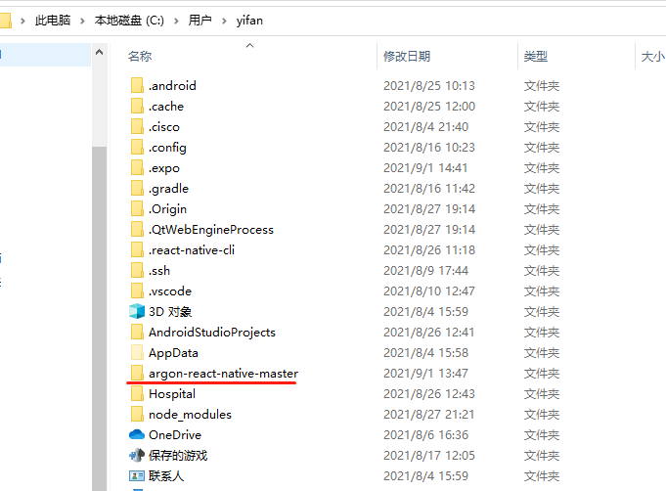[https://demos.creative-tim.com/argon-react-native/docs/?_ga=2.220118684.445414231.1629952775-375321197.1629952775#/install](https://demos.creative-tim.com/argon-react-native/docs/?_ga=2.220118684.445414231.1629952775-375321197.1629952775" \l "/install) （Here is the install introduction）
     1. Install
     2. run CMD and input npm install -g expo-cli
     3. Then input npm install
     4. Then run the expo start
     5. Before run expo start，mobile phone should connect the computer and turn on the USB test，And choose USB document translation。
     6. The First time run expo start on Android device it will automatically install app which name is expo go on your phone. Meanwhile it will also open the website terminal.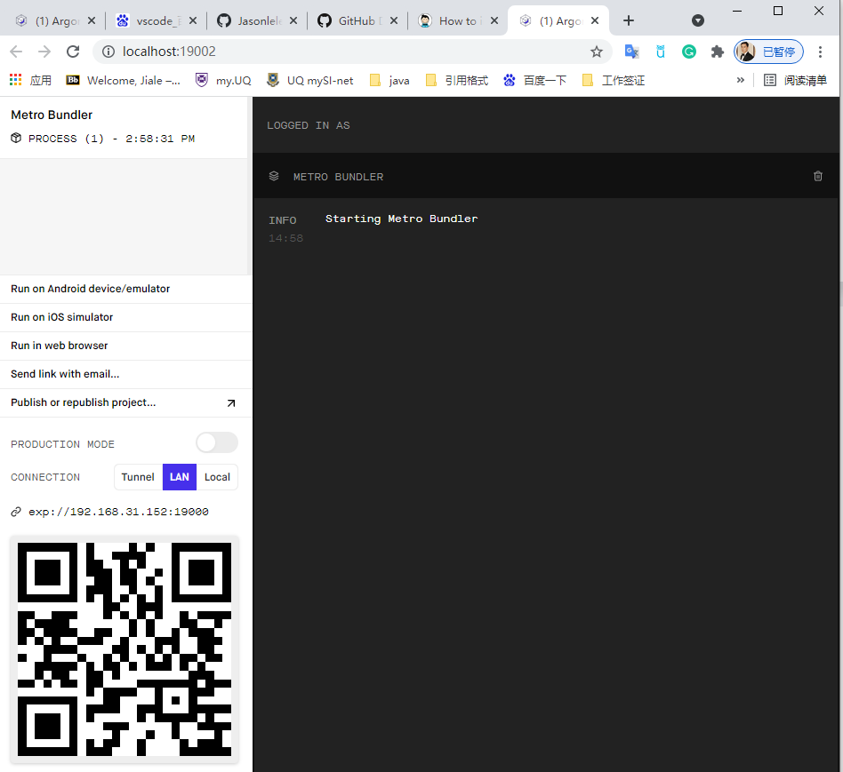
     7. Connect choose local，this connect can use android mobile phone or Android emulator。IOS only use simulator。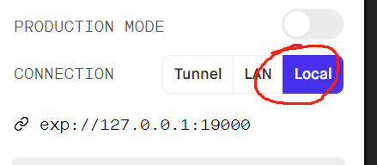
     8. Click run on Android，then it will automatically open app which named expo go 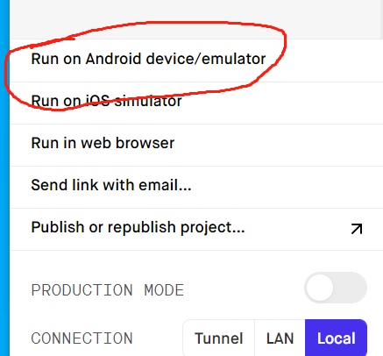

Expo website <https://docs.expo.dev/>