**1. Definition and Methodology**

In this analysis, all figures are standardized to offences per 100,000 inhabitants, a commonly used method for comparing crime rates across countries. We define this measure as: *standardized offences per 100,000 inhabitants = (count of offences / population) * 100,000*. The population data for New Zealand is sourced from the World Population Prospects: The 2019 Revision. The advantage of using this relative measure, instead of an absolute one, is that it accounts for changes in population size from 1980 to 2020. The data wrangling, analysis, and visualization were performed using an R project, which is open-source and available on GitHub at the following link: [Jasonludata/crime-analysis (github.com)](https://github.com/Jasonludata/crime-analysis).

This analysis focuses on violent and property crimes. It references the New Zealand Crime and Victims Survey, published by the Ministry of Justice, and defines violent crimes as homicide, acts intended to cause injury, sexual assault, and robbery. In contrast, property crimes are defined as burglary and theft.

**2. Overall Crime Trend**

Table 1 shows that standardized offences per 100,000 inhabitants for all crimes peaked before 2010. All crime categories experienced a significant drop in 2019/2020 compared to their peak year.

**

*Table 1: Standardized offences – peak year, recession, and percentage decline from peak to 2019/2020*

This analysis also compiled New Zealand recession years from online sources to explore potential correlations between standardized offences and economic conditions. Tables 1 and 2 show that property-related crimes both peaked and experienced the highest year-on-year increase during recession years.

**

*Table 2: Standardized offences – highest year-on-year increase, and recession*

**2, Homicide and Violent Crimes**

Homicide per 100,000 inhabitants is a widely used indicator to measure a country's safety and standard of living. Figure 1 shows New Zealand had a high homicide rate in the late 1980s, which dramatically declined during the National Party's rule in the 1990s. Although New Zealand’s 2019/2020 rate (3.0, based on this analysis) is significantly lower than its peak, it is still higher than that of similar countries, such as Australia (0.86) and the UK (1.0).

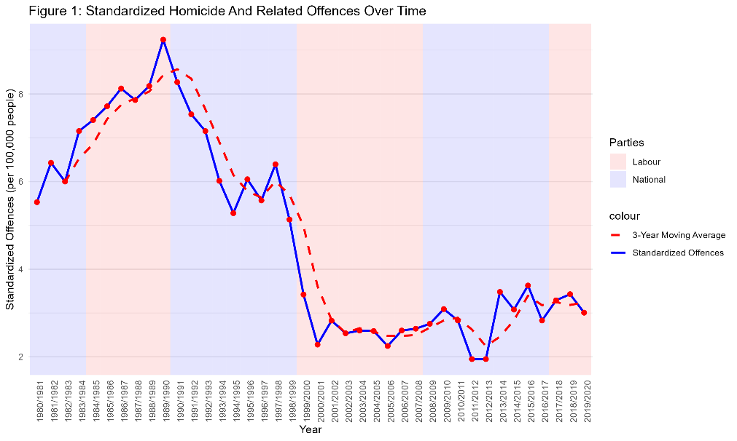

Figure 2, however, shows a different pattern, as violent crime dramatically increased from the early 1990s and peaked during the 2008 financial crisis. It then began a downward trend during the last National government. The 2019/2020 standardized violent crime rate is 233.77 per 100,000 inhabitants, which is 61.7% of its peak in 2008/2009.

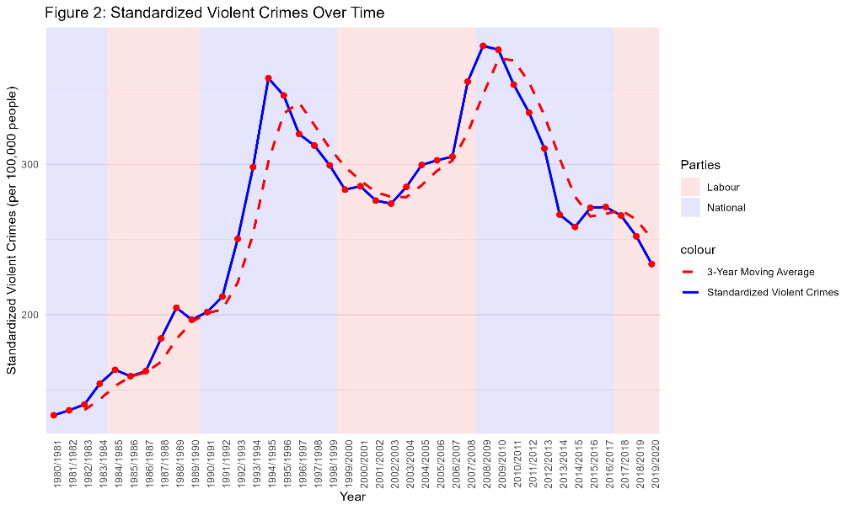

**3, Property-related Crimes**

Theft and burglary peaked in the early 1990s, similar to other crime categories. It is interesting to observe that convicted offences dramatically dropped during the two National governments but remained steady during the two Labour governments. However, there is a clear downward trend, with the 2019/2020 rate of 140.25 per 100,000 inhabitants being only 32.8% of its peak value in 1991/1992.