Supply Chain Profit and On-Time Delivery Improvement Using Reinforcement Learning

Dissertation Proposal

Submitted to National University

School of Technology and Engineering

in Partial Fulfillment of the

Requirements for the Degree of

DOCTOR OF PHILOSPHY

by

Jason C Miller

Cincinnati, Ohio

November 2025

Table of Contents
Chapter 1: Introduction 1
Background 2
Statement of the Problem 3
Purpose of the Study 4
Introduction to Theoretical or Conceptual Framework 4
Introduction to Research Methodology and Design (Nature of the Study) 6
Research Questions 7
Hypotheses 8
Significance of the Study 9
Definitions of Key Terms 10
Summary 13
Chapter 2: Literature Review 15
Theoretical or Conceptual Framework 16
Data Ethics and Legal Frameworks 21
Review of Relevant Literature 22
Reinforcement Learning 53
Documentation 70
Summary 70
Chapter 3: Research Methodology 73
Research Methodology and Design Process Diagram 73
Research Methodology and Design (Nature of the Study) 73
Population and Sample 75
Instrumentation 75
Operational Definitions of Variables 76
Study Procedures 79
Assumptions 89
Limitations 90
Delimitations 90
Ethical Considerations (Secondary Data) 91
Summary 91
Chapter 4: Findings 93
Final Data Preprocessing and Modeling Process Diagram 93
Data Preprocessing [(! Conditional/Optional --- Read Comment]) 93
Section Study Specific [(! Conditional/Optional --- Read Comment]) 98
Evaluation of the Findings 103
Limitations 103
Summary 103
Chapter 5: Implications, Recommendations, and Conclusions 105
Implications 105
Recommendations for Practice 106
Recommendations for Future Research 106
Conclusions 106
References 108
Appendix A Annotated Bibliography 126
Appendix B 138
Topic Description and Supporting Literature 138
Appendix C Recommended Datasets 139
Appendix D 140
Use of AI Disclosure 140

List of Tables

Begin a list of tables here…
List of Figures

Begin a list of figures here…

Chapter 1: Introduction
The uncertainty and volatility of the supply chain have been explored and addressed through big data over several decades (Chen et al., 2023). While the previous models for risk mitigation and resilience have been effective when applied to common disruptions, large-scale and unprecedented interruptions have shown these models to be lacking in response (Chen et al., 2023; de Lima et al., 2022). In the wake of global pandemics, economic upheavals, and political shifts, new approaches to supply chain management have become necessary (Suryawanshi & Dutta, 2022). Algorithms were created to anticipate demand, changes in economic environments, and material shortages, and machine learning programs were applied to increase the predictive abilities and response options for supply chain processes (Chen et al., 2023; Suryawanshi & Dutta,2022). Data-centric approaches to supply chain problems, especially machine learning and artificial intelligence methods, have been very successful in finding new insights and solutions (de Lima et al., 2022; Suryawanshi & Dutta, 2022). Further leveraging of machine learning may present new solutions to supply chain resiliency, specifically in using reinforcement learning (RL) (Aboutorab et al., 2022). Reinforcement learning uses autonomous agents to perform tasks through trial and error, using rewards or punishments. These tasks are done without direct human interaction. By choosing the reward functions, optimal outcomes may be reached (Aboutorab et al., 2022). Reinforcement learning has been effective in supply chain management, but the goal of this research is to expand its use from a single reward function to a dual policy, which seeks to increase profit while increasing on-time deliveries, simultaneously (Aboutorab et al., 2022; Chen et al., 2023; de Lima et al., 2022; Suryawanshi & Dutta, 2022).

Background
In the late 1950s, manufacturers began to focus on mass production (Shukla et al., 2011). The intent was to minimize individual production costs. This approach resulted in minimal flexibility, however. In response, material requirements planning (MRP) was introduced (Shukla et al., 2011). This addition highlighted the problem of a large work-in-progress (WIP) inventory on costs and lead-times. During the 1080s, the need for high-quality, low-cost, and reliable products drove the creation of just in time (JIT) in order to address efficiency and delivery times (Shukla et al., 2011). A new approach, known as Supply Chain Management, arose in the late 1990s (Mentzer et al., 2011). The supply chain describes the interconnectivity between customers, suppliers, manufacturers, and warehouses. Over time, the need for structured methods of management became more important and the supply chains extended in size and scope. Organizations began to implement Big Data Solutions to create more informed decision-making and prediction of trends and impacts to supplies (Maheshwari et al., 2021; Mentzer et al., 2011). As technology evolves, options for further improvements in supply chain management arise. The rise of machine learning and artificial intelligence (AI) has provided deep insights into prediction and response to changes in the supply chain environment (Maheshwari et al., 2021; Mentzer et al., 2011). Even these advances in technology leave room for progress (Maheshwari et al., 2021). Reinforcement learning may bridge that gap. By allowing the autonomous agents to perform trial and error tests on a dual policy model, new insights may be gained, as well as new approaches to supply chain resiliency.

Statement of the Problem
The problem to be addressed in this study is the lack of current data-centric models available to address the increase of uncertainty in the supply chain due to changes in the current environment, such as cost increases, material shortages, and delivery issues (Dubey et al., 2021; Guerra et al., 2024; Shekarabi & Mozdgir, 2025). Standard deterministic models for supply chain uncertainty have shown the inability to address or respond to volatility (Guerra et al., 2024; Shekarabi & Mozdgir, 2025). Past models account for common deviations in demand, lead times, and supply chain interruptions, but require a more responsive approach (Dubey et al., 2021; Shekarabi & Mozdgir, 2025). Reinforcement learning has been introduced but remains in the early stages of implementation in the supply chain (Rolf et al., 2023). Nearly all industries rely on a resilient supply chain to deliver goods and materials (Guerra et al., 2024). If the models for addressing uncertainty are insufficient in dealing with major interruptions, costs will rise, lead times will increase, and businesses may fail. Without the application of Data Science Methodologies to provide new insights through updated parameters and variables, current models may not be adapted to account for major interruptions or changes (Dubey et al., 2021; Shekarabi & Mozdgir, 2025). Data Science methodologies should be applied to the problem in order to choose the correct variables, identify underlying correlations, and establish predictive models that aid in the reinforcement of a resilient supply chain (Dubey et al., 2021). The problem may be approached through both Exploratory Data Analysis (EDA) and Confirmatory Data Analysis (CDA).

Purpose of the Study
The purpose of this quantitative, experimental, study is to explore reinforcement learning (RL), to increase the resilience of the supply chain through a dual-goal approach. The focus will be on two performance indicators: profit increase and on-time delivery. Data will be selected from an open-access source, with common supply chain factors, such as delivery costs and times. One goal is to identify the main variables that contribute to supply chain uncertainty during “normal” times and periods of large-scale interruptions. The study will examine the results of a reinforcement learning model on the data to determine the best variables for optimization of the supply chain during normal periods and those during major outages. The outcome of the study may provide a learning model for future research into various industries’ supply chains. It may lead to suggestions for prevention and response to future large-scale supply chain interruptions. Additionally, it may identify new insights into data-based decision-making within supply chain management, shipping, receiving, and warehousing.

Introduction to Theoretical or Conceptual Framework
This study presents the possibility of supply chain improvement through the use of Reinforcement Learning. The Cross Industry Standard Process for Data Mining (CRISP-DM) will provide the framework for the research. The CRISP-DM approach was established in the 1990s through a group effort by SPSS, Daimler-Chrysler, OHRA, and Teradata to provide structured guidance for data science projects (Shimaoka et al., 2024). It adopted previous processes, including SEMMA and KDD. Due to the robust nature of the framework, it has been implemented in recent options, such as Microsoft Team Data Science Process (TDSP). (Shimaoka et al., 2024). This model is optimal because of its technology-neutral and industry-independent approach (Kannengiesser & Gero, 2023). The process consists of six phases. The first phase is the establishment of a business understanding of the project's objectives. Secondly, an understanding of the data is required. This is followed by data preparation (Kannengiesser & Gero, 2023). The prepared data is then modeled for transformation. Step five sees an evaluation of the modeled data against the objectives of the project. The final step is the deployment of the model into the organization (Kannengiesser & Gero, 2023).
The CRISP-DM process guided the development of the problem statement by establishing an understanding of the problem. This led to the creation of the purpose statement, which sets the direction of the research process to address the problem. With the direction established, the necessary data can be chosen. The data will be explored and assessed for use, followed by preparation and modeling, where the Reinforcement Learning models will be tested. The results will then be assessed as part of the fifth step in the CRISP-DM process (Kannengiesser & Gero, 2023). For the final step of the process, the findings will be documented in the remainder of this dissertation.
As the research focuses on reinforcement learning, a secondary framework is required (Sharma et al., 2021). This framework begins with a literature review, followed by a framework synthesis. The literature review is comprised of scope determination, definition of terms, article collection, inclusion-exclusion criteria, and article analysis. The synthesis continues with the collected literature and a primary A-Priori framework (Sharma et al., 2021). This entails the identification of coding dimensions, followed by the combining of the articles and the coding scheme. Once the articles are coded and analyzed, the A-priori model is updated (Sharma et al., 2021).
Considering the subject matter of supply chain management, another framework will be used (Stroumpoulis & Kopanaki, 2022). This framework, which has been effective in supply chain management assessment, utilizes three pillars of the supply chain. The three pillars are economic orientation, environmental orientation, and social orientation. Components of each pillar are divided into supply chain management resources and IT resources (Stroumpoulis & Kopanaki, 2022). These two categories are assessed for their contributions to business capabilities. The capabilities are explored for their individual applications to economic results, environmental impact, and social impact. These applications are then transitioned into action items, such as economic performance, environmental performance, and social performance (Stroumpoulis & Kopanaki, 2022). The actionable items are combined into sustainable supply chain management strategies. Once the strategies are implemented, they are reviewed, where the cycle begins anew (Stroumpoulis & Kopanaki, 2022).

Introduction to Research Methodology and Design (Nature of the Study)
The quantitative approach was chosen for this study, as the core of the study is the application of data science techniques in the supply chain setting. The quantitative methodology is optimal when discussing statistical and numerical information. The design of choice is the experimental approach. Data will be chosen from an online repository containing supply chain delivery times, costs, vendors, transportation routes, warehousing, and inventory levels. The data will be assessed through reinforcement learning models to determine the best approach for simultaneous optimization of cost and delivery times. Through scenario testing, various combinations of variables, reward levels, parameters, and decision factors, each model will be assessed for consistency, robustness, simplicity, and dynamic ability (Zhou et al., 2024). The options for models are the Q-learning, policy gradient (strategy gradient), SARSA, and Deep Q Network (DQN) (Zhou et al., 2024). When compared against each other, the two models that showed the best improvement percentages were the Q-learning and SARSA models (Rolf et al., 2023). These both performed well using variables that corresponded directly with costs and shipping times (Rolf et al., 2023). For this study, those focus areas are also best served by using the Q-learning and SARSA models.
The dataset will be drawn from historical costing, shipping, and inventory data gathered from an open-sourced database (Constante et al., 2019). The chosen data consists of real-world information on several areas of the supply chain. The population will be comprised of sections containing order data, pricing information, and shipping data. Other optional categories within the datasets are sales reports, shipping types, and locations (Constante et al., 2019).
The reinforcement learning models can be adapted to different variables to understand the effectiveness of each method on profit and on-time deliveries. Comparison of each model may also identify the best approach to optimization. Different scenarios may help to determine the ability to optimize both cost and delivery goals simultaneously. While assessing the combination of goals, the impact on computational cost, time, and drain may be explored.

Research Questions
The research is intended to determine the ability of Reinforcement Learning to mitigate risk factors within the Supply Chain and maximize profits while maximizing on-time deliveries of goods and services. Computational resources used to apply Reinforcement Learning models are also a focus for minimization.

RQ1
To what extent can a Reinforcement Learning model be applied to the complexities of the supply chain in order to optimize profit and on-time delivery?

RQ2
Is one method of Reinforcement Learning better suited to optimizing the Supply Chain process than others (e.g. Q-learning or SARSA)?

RQ3
Can different reward options improve the increase in profit or increase in on-time deliveries?

RQ4
Can a Reinforcement Learning model be applied to increase profits by at least 10% and increase on-time deliveries by at least 20%?

Hypotheses

H1₀
A Reinforcement Learning model cannot be applied to the complexities of the supply chain in order to optimize profits and on-time delivery.

H1_{a}
A Reinforcement Learning model can be applied to the complexities of the supply chain in order to optimize profits and on-time delivery.

H2₀
There is no one method of Reinforcement Learning that is better suited to optimizing the Supply Chain process than others.

H2_{a}
There is one method of Reinforcement Learning that is better suited to optimizing the Supply Chain process than others.

H3₀
Different reward options cannot improve the increase in profits or increase in on-time deliveries.

H3_{a}
Different reward options can improve the increase in profits or increase in on-time deliveries.

H4₀
A Reinforcement Learning model cannot be applied to increase profits by at least 10%, increase on-time deliveries by at least 20%.

H4_{a}
A Reinforcement Learning model can be applied to increase profits by at least 10%, increase on-time deliveries by at least 20%.

Significance of the Study
The sustainability of any business is systemic and of the utmost importance (Ingenbleek & Krampe, 2023). This includes all aspects of the business, from finance to human resources, and the supply chain (Ingenbleek & Krampe, 2023; Ngo et al., 2023). Recent supply chain interruptions such as COVID-19 and blockages of transport lanes have highlighted the need for a more robust and resilient model to address these and other issues (Ivanov & Tu, 2025; Ngo et al., 2023). Aside from the unforeseen circumstances that lead to major supply chain interruptions, the unprecedented growth and expansion of global trade and economic shifts have demanded an improved hybrid approach to reinforcement of the supply industry (Tiwari et al., 2024). To this end, the digitization of supply processes, data, and structures has been implemented across most of the modern organizations (Tiwari et al., 2024). This digitization has prompted the implementation of data science solutions, such as machine learning, artificial intelligence, forecasting models, and reinforcement learning (Ivanov & Tu, 2025). Many of these approaches are still in the early stages of use and continue to develop in complexity and ability (Tiwari et al., 2024). This research seeks to further the exploration into reinforcement learning applications across the supply chain industry. The core improvement being addressed is the combination of profit-increase with on-time delivery improvement as a joint goal. The trade-off between cost and speed of delivery has long been an expectation of supply chain management (Straight, 2024). If these two components can be addressed simultaneously, it can benefit all businesses that rely on the supply chain for product procurement, warehousing, and delivery.

Definitions of Key Terms
Artificial Intelligence (AI)
The simulation of human intelligence in machines that are capable of learning, reasoning, and decision-making to perform tasks traditionally requiring human input.
Big Data Analytics
The use of advanced computational techniques to analyze extremely large and complex datasets, enabling better decision-making and prediction in supply chain management.
Confirmatory Data Analysis (CDA)
A hypothesis-driven approach that applies statistical testing to validate or reject assumptions derived from exploratory data analysis or theory.
CRISP-DM (Cross Industry Standard Process for Data Mining)
A structured data science framework consisting of six phases—business understanding, data understanding, data preparation, modeling, evaluation, and deployment—that guides project development.
Deep Q Network (DQN)
An advanced reinforcement learning method that combines Q-learning with deep neural networks to handle complex, high-dimensional decision-making problems.
Exploratory Data Analysis (EDA)
An analytical approach focused on summarizing, visualizing, and identifying patterns in datasets before applying formal statistical methods.
Just-In-Time (JIT)
An inventory management strategy that minimizes stock by receiving goods only as they are needed in the production process, reducing waste and storage costs.
Lead Time
The amount of time between the initiation of a supply chain process (such as placing an order) and its completion (such as product delivery).
Machine Learning (ML)
A subset of artificial intelligence that enables systems to learn from data and improve performance on tasks without being explicitly programmed.
On-Time Delivery
A performance metric that measures the percentage of customer orders delivered either upon the promised date or earlier.
Policy Gradient (Strategy Gradient)
A reinforcement learning method that directly optimizes decision-making policies by adjusting them in the direction of improved performance based on gradient estimation.
Q-Learning
A reinforcement learning algorithm that uses a value-based approach to estimate the expected rewards of actions, enabling agents to choose the most effective strategies.
Reinforcement Learning (RL)
A machine learning paradigm in which an agent learns to make decisions by interacting with an environment, receiving feedback in the form of rewards or penalties, and optimizing behavior over time.
Reward Function / Reward Options
The mathematical formulation used in reinforcement learning to assign value to actions, guiding the agent toward desired outcomes such as cost reduction or improved delivery times.
SARSA (State-Action-Reward-State-Action)
A reinforcement learning algorithm that updates action values based on the current state, chosen action, received reward, and next state-action pair.
Supply Chain
A network of organizations, people, activities, information, and resources involved in producing and delivering a product or service from suppliers to end customers.
Supply Chain Management (SCM)
The coordination and integration of supply chain activities—including procurement, production, transportation, warehousing, and distribution—to improve efficiency, reduce costs, and enhance customer satisfaction.
Uncertainty / Volatility
The degree of unpredictability in supply chain operations caused by factors such as fluctuating demand, material shortages, transportation delays, and global disruptions.
Variables / Parameters
Quantifiable elements in a model or dataset that influence outcomes. Variables are measurable factors, while parameters are constants used to define model behavior.
Work-in-Progress (WIP)
Partially finished goods or materials that are in production but not yet completed, which represent tied-up capital and impact inventory costs.

Summary
This study focuses on using Reinforcement Learning (RL) to improve supply chain profit increases and on-time delivery. The research identifies the increasing uncertainty in supply chains due to factors like cost increases, material shortages, and delivery issues as the core problem. It aims to explore machine-learning options for increasing supply chain resilience in a post-COVID-19 environment, focusing on profit increases and on-time delivery as key performance indicators.
The study will employ a quantitative, experimental approach, using historical data from DataCo Global company archives, and will analyze data with reinforcement learning models, specifically Q-learning and SARSA. The research questions address the extent to which reinforcement learning can be applied to supply chain complexities, whether certain reinforcement learning methods are better suited for optimization, and how different reward options can improve profit increases and on-time delivery. The study also includes a literature review, topic description, and suggestions for further research.

Chapter 2: Literature Review
The problem to be addressed in this study is the lack of current data-centric models available to address the increase of uncertainty in the supply chain due to changes in the current environment, such as cost increases, material shortages, and delivery issues (Dubey et al., 2021; Guerra et al., 2024; Shekarabi & Mozdgir, 2025). To date, most approaches to data-driven models for supply chain resiliency have focused on single areas of improvement, such as cost reduction, multiple vendors, or improved shipping lanes (Shekarabi & Mozdgir, 2025). While efforts to improve one area may yield positive results, the changes may negatively affect other areas (Guerra et al., 2024). An example would be the multi-sourcing of raw material, where delivery times may be reduced significantly, but the cost of production increases because of smaller orders or shorter lead times. The need exists for one improvement to refrain from negatively affecting other metrics (Guerra et al., 2024).
The purpose of this quantitative, experimental, study is to explore reinforcement learning (RL), to increase the resilience of the supply chain through a dual-goal approach. The focus will be on two performance indicators: profit increases and on-time delivery. Reinforcement learning provides the ability to set goals and assign reward functions to allow the program to test outcomes (Zhou et al., 2024). By setting simultaneous goals and experimenting with various reward functions, a more robust supply chain management approach may be discovered. Not only will the optimal model be chosen, but the best possible combinations of reward functions will be established.
This chapter opens with a discussion of the supply chain. The origins and history will be explained, as well as the developments over time. Comparisons between early iterations and modern designs will be explored to understand the changes and developments that led to modern versions of the supply chain. Significant occurrences, such as the COVID-19 global pandemic and Panama Canal blockage are essential contributors to the state of the current global supply chain. As Big Data has become more prevalent in all business areas, it has also permeated the supply chain. The rise of Big Data and its applications in the supply chain will be outlined. Reinforcement learning, one aspect of machine learning, will be presented for its history, usage, and potential applications, along with its connections to forecasting and risk management with the supply chain industry. Finally, the applicable frameworks for this research will be outlined and explained.

Theoretical or Conceptual Framework
This research investigates how Reinforcement Learning can enhance supply chain operations, using the Cross Industry Standard Process for Data Mining (CRISP-DM) as its foundational framework. Developed in the 1990s by a consortium including SPSS and Daimler-Chrysler, CRISP-DM offers structured guidance for data science initiatives (Shimaoka et al., 2024). It was built upon earlier methodologies like SEMMA and KDD, and its robust design has led to its adoption in contemporary applications such as Microsoft's Team Data Science Process (TDSP) (Shimaoka et al., 2024). This model is highly suitable due to its neutrality towards specific technologies and independence from particular industries (Kannengiesser & Gero, 2023). It is comprised of six stages: defining the project's business objectives, understanding the available data, preparing the data, developing models from the prepared data, evaluating the models against the project's objectives, and deploying the final model within the organization (Figure 1) (Kannengiesser & Gero, 2023).

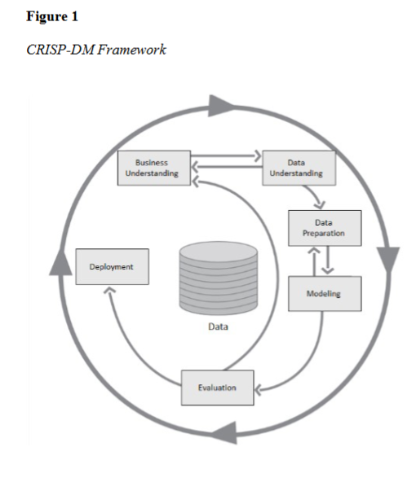

The CRISP-DM methodology informed the articulation of the research problem by facilitating a clear understanding of it. This understanding then led to the formulation of a purpose statement, setting the direction for the research. Following this, relevant data will be selected, explored, and evaluated. Subsequently, data preparation and modeling will occur during which Reinforcement Learning models will be tested. The outcomes will then be assessed in the fifth stage of the CRISP-DM process (Kannengiesser & Gero, 2023). The findings from the final stage will be documented within the remainder of this dissertation.
Given the study's focus on reinforcement learning, a complementary framework from Sharma et al. (2021), the A-Priori Framework, is also employed (Figure 2). This framework begins with a thorough literature review, followed by a synthesis phase. The literature review involves defining the scope, terms, and criteria for article collection and analysis. The synthesis then integrates the gathered literature with an initial A-Priori framework (Sharma et al., 2021). This involves identifying coding dimensions, merging articles, and applying the coding scheme. After articles are coded and analyzed, the A-Priori model is refined (Sharma et al., 2021).
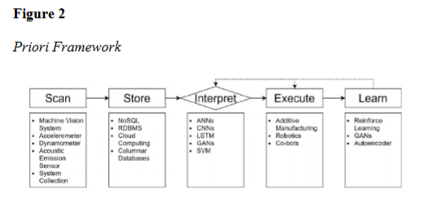
For the supply chain management aspect, another framework by Stroumpoulis & Kopanaki (2022) will be utilized (Figure 3). The Supply Chain Assessment Framework, proven effective in supply chain assessment, is structured around three core pillars: economic, environmental, and social orientation. Within each pillar, components are categorized into supply chain management resources and IT resources (Stroumpoulis & Kopanaki, 2022). These categories are then evaluated for their contributions to business capabilities. The individual applications of these capabilities—leading to economic outcomes, environmental impacts, and social impacts—are further examined. These applications are subsequently translated into actionable items, such as improving economic, environmental, and social performance (Stroumpoulis & Kopanaki, 2022). These actionable items are then integrated into sustainable supply chain management strategies. Once these strategies are implemented, they are reviewed, initiating a new cycle of continuous improvement (Stroumpoulis & Kopanaki, 2022).
Figure 3
Supply Chain Assessment Framework
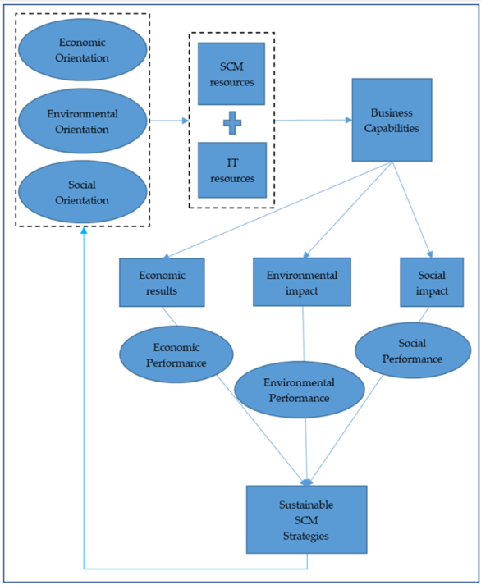
The use of three frameworks can be complicated, but considering the essential factors in this research, all three are necessary to ensure that all steps are taken to perform a thorough study. Certain aspects of each framework coincide or complement each other. The Supply Chain Assessment Framework (SCAF) addresses three areas of an organization when used exclusively (Stroumpoulis & Kopanaki, 2022). In this case, only the economic pillar is being explored. Within that pillar, only the supply chain component is included. One shared step between all three frameworks is the initial step of objective definition (Kannengiesser & Gero, 2023; Sharma et al., 2021; Stroumpoulis & Kopanaki, 2022). The A-Priori Framework phase of the literature review can be performed with the CRISP-DM data assessment and SCAF contributions sections. Pairing of the CRISP-DM and A-Priori data preparation and synthesis phases lead directly into model creation, which fulfills both frameworks’ requirements (Sharma et al., 2021; Stroumpoulis & Kopanaki, 2022). The outcomes of the models will then be assessed for their application to the prescribed organizational objectives (Kannengiesser & Gero, 2023; Sharma et al., 2021; Stroumpoulis & Kopanaki, 2022). All three frameworks are completed by documenting and publishing the results (Kannengiesser & Gero, 2023; Sharma et al., 2021; Stroumpoulis & Kopanaki, 2022).

Data Ethics and Legal Frameworks
This study will be submitted to the National University Institutional Review Board (IRB) prior to analysis of the data to ensure that no ethical or legal requirements are violated. The dataset for this study was housed on a publicly accessible site at Mendeley Data (Constante et al., 2019). The public is authorized to access and use this data for research purposes. There is no confidential information contained in the dataset. Since no participants were involved in the dataset, there are no consent, anonymity, or personally identifiable information (PII) issues. In the absence of human or animal test subjects, there were no ethical or legal issues concerning the treatment of test subjects. The use of publicly available resources negates the insertion of bias, as well as personal and professional experiences, which increases the level of confidence. The author certifies that IRB approval will be procured and proof of acceptance will be attached in Appendix E.

Review of Relevant Literature

The Supply Chain
While the concept of supply chain management has existed indefinitely, the term was originally documented in 2003 in an article by Keith Oliver and Tim Laseter (Handfield, 2024). The two men were consultants for Booze Allen during the 1970s and claimed to have begun using the term when consulting with their clients (Handfield, 2024). The structured architecture of a logistics-based supply chain was attributed to early military operations (Ahmed, 2025). The primary components were identified as consumption, distribution, and production. This defined a specific arena between consumers and producers (Ahmed, 2025).
The modern concept of the supply chain (SC) consists of a network of organizations, facilities, and processes that are used for creating, manufacturing, warehousing, and shipping products (Jenkins, 2025). It may contain actions such as product design, raw material procurement, demand planning, inventory management, sales assignment, and order management. Supply chain management can affect nearly every aspect of a business. The average business has an expenditure of 10 to 20 percent of total revenue to manage the supply chain (Jenkins, 2025). A well-run supply chain can provide a favorable return on investment or a loss of profitability. This also contributes to the liquidity or cash flow of the organization. The SC has the ability to give a competitive edge to a business through risk management and streamlining of delivery processes (Jenkins, 2025).
There are four primary models for the supply chain: the fast model, continuous-flow model, efficient model, and custom-configured model (Figure 4) (Lee, 2023). The fast model is an agile design that suits businesses that need to respond quickly to market changes (Lee, 2023). The products often have short lifecycles or are affected by trends (Jenkins, 2025). The continuous-flow model is the most traditional type of approach (Lee, 2023). It is used by organizations that produce fairly uniform products repetitively. Each stage of the supply chain is balanced and designed to run smoothly and adapt to minor changes with ease (Lee, 2023). Businesses that deal in highly competitive commodity production employ the efficiency model (Jenkins, 2025). The products are often similar to competitors and require responsive forecasting and efficiency to compete across price points (Jenkins, 2025). The custom-configured or flexible model suits those operations that provide configurable or customized products (Lee, 2023). In this model, flexibility is favored over speed. The product needs to be delivered accurately, fully, and reliably. This model works well for furniture manufacturers, musical instrument producers, and computer manufacturers (Lee, 2023).
Figure 4
Types of Supply Chain Models
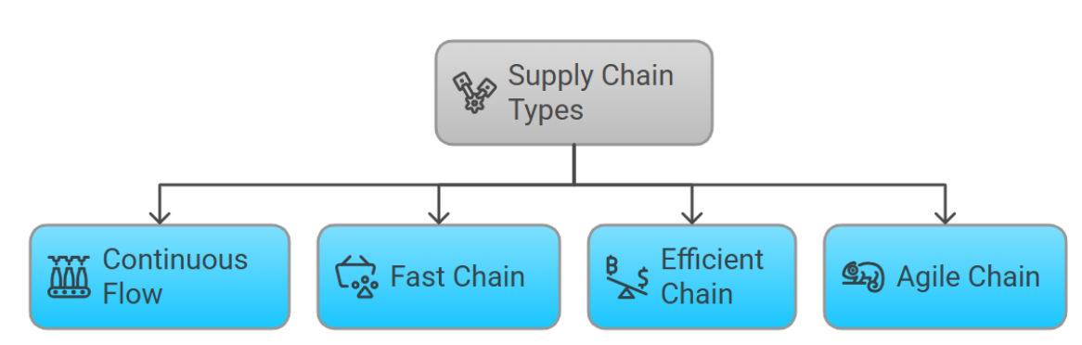

Origins and Early Development.
The early forms of supply channels emerged during the first industrial revolutions, which occurred around 1760 in England (Farar, 2024). During this period, the scale of supply routes expanded exponentially (Farar, 2024). Prior to this time, supply chain existed in limited regions until the advent of railroads, which extended the distance that goods could be transported (Ashcroft, 2021). Several well-established routes had existed before railroads connected different regions (Farar, 2024). The Silk Road was a highly traveled route between China and Rome. Goods, such as metals, spices, wool, and silk were passed from merchant to merchant as they made their way across continents. Another 2,000-kilometer road between the Mediterranean and the Arabian Peninsula was known as the Incense Route (Farar, 2024). It claimed this name because of the transport of myrrh and frankincense. China had also created a Grand Canal between the 5th century BC and the 13th century. It spanned over 2,000 kilometers and served to deliver construction materials and rice (Farar,2024). This system of canals still exists and is used today. Even with these extensive transport routes, travel was difficult, dangerous, and time-consuming. It also served wealthy individuals, as most poor people traded locally (Farar, 2024).
The industrial revolution changed the way in which goods were supplied across the globe (Whitfield, 2024). It took place from 1760 to 1840. Technology emerged that allowed for semi-automated production lines and mechanical textile manufacturing (Figure 5). In 1764, James Hargreaves invented the Spinning Jenny and in 1785, Edmund Cartwright developed the Power Loom (Whitfield, 2024). Not only did railroads connect places across great distances, but the creation of coal-powered steam engines increased the speed of transportation (Farar, 2024). While Europe saw great improvements in the supply chain during this period, the United States lagged behind as industrialization had not caught up with its European counterparts. It was not until around 1870 that the US surpassed Europe as an industrial leader (Farar, 2024). At that time, the US was able to overtake India as the world's top cotton producer (Whitfield, 2024). Since sea travel had been a long and difficult process in the past, the invention of the steamship in 1813 shifted the ability of the US to deliver cotton and other goods across the ocean much more quickly. This created a new trade route between the Americas and other continents (Whitfield, 2024).
Figure 5
Industrial Evolution
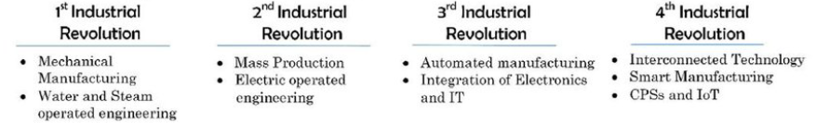
Between the mid-19th century and the beginning of the 20th century, the Second Industrial Revolution, otherwise known as the Technological Revolution, occurred (Whitfield, 2024). It took place primarily in the US, Germany, and England. It saw the creation of the telegraph and the addition of electricity to iron and steel production processes. In 1913, Henry Ford developed the early version of mass production (Whitfield, 2024). This led to the rise of product standardization. Another major improvement in trade routes began in 1869 with the opening of the Suez Canal. It opened new routes between Asia and Europe (Whitfield, 2024). Over 300 million tons of goods are shipped through the Suez Canal annually. In 1914, the Panama Canal was opened, connecting the Pacific and Atlantic Oceans. The addition of these two canals led to a drop in shipping costs of 70% between 1840 and 1910 (Whitfield, 2024).
Throughout the early 1900s and into the 1950s, the localized models of the supply chain grew into larger global models (Ashcroft, 2021). Logistics-specific companies began to emerge, such as UPS. Shipping and loading processes began to use automated and machine-based processes (Ashcroft, 2021). Even the military began to apply an analytical approach to logistics following World War II. A new concept was formed and applied to the transportation industry, known as a unit load (Ashcroft, 2021).

The 1950s.
The 1950s saw the first offerings of transportation-based courses at many universities (Ahmed, 2025). While the broader and more generalized curriculum focused on transportation, it largely excluded modern core concepts, such as supply chain, sourcing, and logistics. A lack of technology and an absence of focus on customer and vendor interaction contributed to the absence of data quantification in these classes (Ahmed, 2025). One major advance during the 1950s was containerization (Whitfield, 2024). Until that point, ships were loaded manually, one piece at a time. Malcom McLean pioneered the use of standardized containers which were not only easy to load, but were also transferable directly between ships, trains, and trucks. While Asian countries embraced the use of these standard containers, the Western world focused on building traditional ports. This allowed Asia to dominate the transport industry, even today (Whitfield, 2024). The United States did advance its logistics through the Federal Aid Highway Act of 1956 (Ahmed, 2025). It created the National Interstate Highway and Defense System. The Interstate Commerce Commission (ICC) oversaw all road and railway regulation and began offering the ICC Practitioner exam for transportation professionals through the ICC Practitioners Association. It still exists today as the Transportation Practitioners Association 1984 and the Transportation Law, Logistics and Policy Association 1994 (Ahmed, 2025). Communications continued to evolve as well (Whitfield, 2024). This allowed specificity of requirements to be communicated effectively, which led to a "just-in-time" delivery model. Japan leveraged this model into its Lean Manufacturing approach in the automotive and electronics industry (Whitfield, 2024).

The 1960s.
In the early 1960s, DHL emerged as a new logistics-based option, followed by FedEx as the 1970s arrived (Ashcroft, 2021). Trucks had become the choice for time-dependent shipping and became known as "physical distribution." It was for this concept that the National Council of Physical Distribution Management was created (Ashcroft, 2021). This period saw the rise of computerization, where inventory management, tracking, scheduling, and planning were created (Whitfield, 2024). IBM developed the first forecasting and inventory management system in 1967. This became known as the "Communications Revolution" (Whitfield, 2024).

The 1970s.
The decade of the 1970s saw further growth and evolution of logistics and the supply chain (Ahmed, 2025). Physical delivery and physical distribution were combined to form a larger concept of logistics. Higher education and professional journals began to engage in the development of the supply chain. Two major academic journals were introduced during the 1970s: the Transportation Journal and the Journal of Business Logistics (Ahmed, 2025). The Journal of Business Logistics (JBL) was produced at the Ohio State University and was published by the NCPDM. It remains one of the top academic journals today (Ahmed, 2025). It was during this period that JC Penney introduced the first real-time warehouse management system (WMS) (Ashcroft, 2021). It was able to update inventory in real-time and maintain accurate stock levels. With inventory levels being automated, the company was able to expedite shipping and focus on other aspect so the supply chain (Ashcroft, 2021).

The 1980s.
The term "supply chain management" was coined in 1982 by Keith Oliver (Ashcroft, 2021). Oliver, an English logistician, referred to supply chain management as the method of planning, establishing, and overseeing the supply process to ensure customer needs are met as effectively as possible. He saw it as an end-to-end process of material procurement through production and end-user consumption (Ashcroft, 2021). The use of the term physical distribution also transitioned into logistics (Ahmed, 2025). Newer terminology also emerged as the NCPDM renamed itself to the Council of Logistics Management (CLM) in 1985, while Donald F. Wood and James C. Johnson changed their textbook's name from Contemporary Physical Distribution to Contemporary Physical Distribution and Logistics (Ahmed, 2025).
The 1980s saw changes in technology and laws that changed the supply chain and logistics field (Ashcroft, 2021). Personal computers became more prevalent, allowing businesses to use spreadsheets and map-based interfaces to improve planning and execution processes. By the mid-eighties, supply chains had become recognized as an essential, albeit complex and expensive, part of business operations (Ashcroft, 2021). The government and lawmakers also began to understand the fundamental necessity of the supply chain to American businesses (Ahmed, 2025). The Motor Carrier Act of 1980 rescinded regulations on freight rates and entry conditions. Another deregulatory act, the Staggers Rail Act of 1980, allowed railroad companies to negotiate their contracts with reduced oversight. This led to the government selling its common stocks in Conrail. Deregulation of transport lanes in the US resulted in more flexibility and competition in the supply chain industry (Ahmed, 2025).

The 1990s.
As businesses began to see more value in a total-cost concept of the supply chain, negotiations between suppliers and transporters increased (Ahmed, 2025). Even Johnson and Wood decided to revise the title of their textbook by dropping Physical Distribution and simply calling it Contemporary Logistics. This underscored the overall acceptance of logistics as an end-to-end process (Ahmed, 2025). Technological advancements continued during this decade, including enterprise resource planning (ERP), advanced planning, and advanced scheduling (Ashcroft, 2021). Global transport and supply gained market share during the nineties, both in export and import (Ashcroft, 2021). This was largely due to the emergence of the Internet and electronic data interchange (Ahmed, 2025). In July 1995, Amazon opened its first online store and went public in 1997 (Ashcroft, 2021). It was the first Internet business to reach one million customers (Ashcroft, 2021). Companies began to tout their logistics solutions approach, rather than simply identifying as transportation companies (Ahmed, 2025). This led to the rise of new third-party logistics organizations (Ahmed, 2025).
Technological advancements were not limited to communications and data management (Ashcroft, 2021). In 1996, J Edward Colgate and Michael Peshkin invented the first cobot. The cobot was a collaborative robot, designed to interface safely with humans in production (Ashcroft, 2021). General Motors employed the pair to create the cobot as a solution to improve production in conjunction with human labor (Ashcroft, 2021).

The 2000s.
As transportation became known as logistics in previous decades, the early 21st century saw logistics giving way to supply chain management (Ahmed, 2025). While the concept of supply chain management became widely accepted in large businesses, smaller and medium-sized companies were slow to adopt the model. It was seen as the overall interaction of all activities between sourcing, production, and delivery processes (Ahmed, 2025). One driving force behind the growth of supply chain management was the creation of online and distance learning. Organizations from universities to private businesses began to offer courses online, which allowed companies to become more competitive in the supply chain arena. Distance learning has become a core necessity in teaching supply chain management (Ahmed, 2025). One company, the Logistics Management Institute claims that they are the longest operating distance learning organization in the world (Ahmed, 2025).

Between 2010 and 2020.
A period of digitization occurred during this decade, as information materials, or hard copies, evolved into digital files (Ahmed, 2025). This allowed for seamless flows of data between companies and their individual departments. This flow of information was key in the streamlining of just-in-time logistics and physical logistics flows (Ahmed, 2025). Instead of digitization being used to improve supply chains, it became a necessity. It provided fast, secure, and accurate information and instantaneous communication across all areas of the business (Ahmed, 2025). While the Internet of Things (IoT) and Artificial Intelligence (AI) had existed before this period, it was not until the early 21st century that it was widely applied across businesses, and specifically, their supply chains (Ashcroft, 2021). The implementation of these technologies became known as Industry 4.0. This technological revolution encountered a major interruption with the arrival of Covid-19 (Ashcroft, 2021). It was a global pandemic that interfered in nearly every aspect of business. Instead of disrupting further use of AI and the IoT, it underlined the need for these tools to mitigate future mass interruptions. Along with risk mitigation, a new push for localization began (Ashcroft, 2021).

Post COVID-19 State.
A new concept in AI has begun to emerge in the post Covid-19 era (Ahmed, 2025). It has become known as agentic AI (Figure 6). Past iterations of AI were assigned to individual tasks, while agentic AI uses intelligent agents that analyze information, provide decisions, and implement them into the supply chain, independent of human interaction (Ahmed, 2025). The agents are able to analyze numerous variables at once, such as weather, traffic patterns, possible interruptions, and supplier issues. This allows for real-time adjustments to schedules, routes, and suppliers. The AI systems are able to add a level of resilience that human interaction alone cannot provide (Ahmed, 2025).
Figure 6
Agentic AI
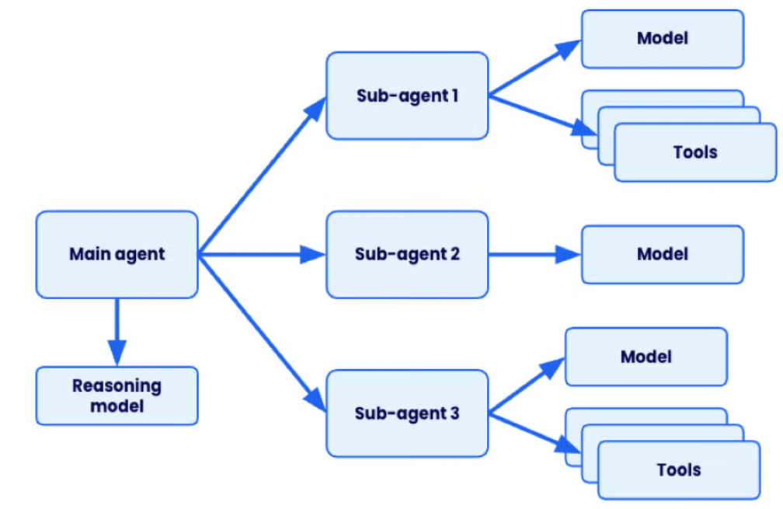
Industry 4.0, or the Fourth Industrial Revolution, continues to evolve in a post Covid-19 world (Whitfield, 2024). Instead of steam, electricity, or automation, this revolution is based on AI, the IoT, and Big Data. There are nine pillars of the Industry 4.0 model. These are AR, IoT, 3D printing, digital twins, cybersecurity, big data, horizontal and vertical integration, autonomous robots, and additive manufacturing (Whitfield, 2024).
The future of Industry 4.0 does not necessarily exclude human interaction. Emerging technologies still exist as tools for human use (Whitfield, 2024). One aspect that continues to gain popularity is the diversification of suppliers. While it may provide stability in the procurement of supplies and materials, it is a difficult process to move from once-reliable, inexpensive suppliers to a new diverse supply base. It may take considerable time and effort to accomplish this diversification (Whitfield, 2024). Another consideration in the future of the supply chain industry is ethical and sustainable sourcing (Farar, 2024). Not only do nearly three-fourths of consumers see these factors as important, but sustainability may be a key driver of cost reduction in the future (Farar, 2024).

Big Data
Big Data is a term that describes large amounts of information categorized by four core characteristics: veracity, volume, variety, and velocity (Figure 7) (Ikegwu et al., 2022). The concept of veracity describes data in terms of accuracy and credibility (Boddapati et al., 2021). Data must be complete, correct, and truthful. The quality of analysis depends on the veracity of the information being used. If the data is incorrect or incomplete, the results of analysis will likely be skewed, inaccurate, or even wrong (Boddapati et al., 2021). Veracity can be verified through data cleansing, validation, and good data governance procedures. High-quality data analysis relies on the highest quality data inputs (Boddapati et al., 2021). The volume of information refers to the overall size and amount of data (Rodrigues Jr et al., 2021). Datasets may be considered to be Big Data regardless of the actual size or amount of information. The type of data, field of research, and desired results can determine whether a dataset is seen as Big Data. The size itself is of less concern than the usefulness and manageability of the information (Rodrigues Jr et al., 2021).
Figure 7
Big Data Components
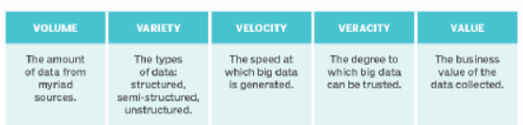
Variety is a fairly common description in non-data related discussions but has a specific connotation in Big Data (Naeem et al., 2022). At a high level, it can refer to either structured, semi structured, or unstructured data. Within these groups, several subcategories exist. These may include video files, text, social media posts, audio files, or pictures (Naeem et al., 2022). Even structured data contains categories like integers, floats, characters, and strings. The importance of variety in Big Data is the ability to structure it for storage, analysis, and identification. It also served as a basis for comparison between data groups and types (Naeem et al., 2022). Velocity is often described as speed with direction, and this concept is similar in Big Data (Ghasemaghaei, 2021). Velocity explains the rate at which data is procured, compiled, and assessed. As the world continues to evolve technologically, the amount of data produced increases, as well. This requires Big Data processes to adapt in speed and agility to keep up with the level of incoming information (Ghasemaghaei, 2021). Simply capturing the data quickly is insufficient for effective analysis. The data needs to be processed and analyzed at equal speeds. The concepts for this are real-time analytics, in-memory computing, and stream processing. These allow organizations to assess information immediately and provide insights as quickly as possible (Ghasemaghaei, 2021).

History.
The use of data to make decisions is nothing new in human history. Some of the earliest examples date back to 18,000 BCE, with the use of tally sticks (Frican, 2021). The first large-scale data project occurred in 1937 in response to the Social Security Act. President Franklin D. Roosevelt tasked IBM with tracking contributions from over 26 million people and over 3 million employers. IBM created the punch card reading machine to automate the massive project (Frican, 2021). The first official data center was established in 1965 by the United States Government (Yoo, 2022). It housed over 742 million tax returns and over 175 million fingerprint sets. The process was performed by transferring the records to magnetic tape and stored in a single place. While the project lost funding, it is still considered to be the beginning of the electronic data storage era (Yoo, 2022). The British Government developed the first data-processing machine in 1943 (O'Regan, 2021). It was known as the Colossus and was employed in World War II to decode Nazi ciphers. It was able to identify patterns within messages at over 5,000 characters every second. This reduced the decoding time from weeks to mere hours (O'Regan, 2021).
In the late 1980s and early 1990s, Robert Cailliau and Tim Berners-Lee created the World Wide Web at the CERN Institute (Frican, 2021). They also invented URLs, HTML, and HTTP, leading to the internet age. By 1996, the cost of electronic storage became lower than using paper documentation. In 2005, Roger Mougalas found that large sets of data were nearly impossible to manage with the current tools (Frican, 2021). He referred to this issue as Big Data. In the very same year, Hadoop, an application that could handle this level of data, was created. It was a combination of Google's MapReduce and a software framework known as Nutch (Frican, 2021).

Addition of Artificial Intelligence.
Before the advent of Artificial Intelligence's modern form, more rudimentary iterations existed (Boddapati et al., 2021). These versions were relatively simple and focused on rule-based procedures. They were also restricted by the size and design of the data being analyzed. The implemented rules were also a limiting factor, along with strictly formatted data. (Boddapati et al., 2021). These restrictions prevented the AI systems from evolving or advancing. The lack of progress led to an eventual stalling of AI-related use (Boddapati et al., 2021).

Current State.
A major event in the history of Big Data was the arrival of Machine Learning (ML) (Boddapati et al., 2021). This was an advancement in traditional forms of Artificial Intelligence. The main difference was the divergence from rule-based approaches. Machine Learning algorithms were able to learn directly from data (Boddapati et al., 2021). These Machine Learning models were able to identify patterns, make predictions, and improve with the addition of additional input (Mijwil et al., 2022). This was a major step forward from basic classification to fully predictive applications (Mijwil et al., 2022). It is the ability to adapt that underscores the advancement in modern Machine Learning systems (Aggarwal et al., 2025). The issues in early development of ML were the need for vast amounts of information and the inability to explain the inner working of the systems, also known as the Black Box problem (Aggarwal et al., 2025).
One problem was overcome as AI and ML were incorporated into Big Data systems (Boddapati et al., 2021). With the expansion of the internet, sources like social media, Radio Frequency (RF) tracking, digital records storage, and digital inventory monitoring provided extensive amounts of data. Other applications, such as complex Neural Networks, benefitted from the large sources of data (Boddapati et al., 2021). The larger, more diverse datasets led to improvements in pattern recognition and predictive ability (Aggarwal et al., 2025). Technological advancements, paired with the evolution in Machine Learning applications also allowed for development in facial recognition, large language models, warehouse automation, and audio translation (Aggarwal et al., 2025).
Future developments in ML/AI include data centricity (Boddapati et al., 2021). This is the approach which focuses on improved data governance in order to produce higher-level models and results. Deep learning is also being employed to model several aspects simultaneously. A new method of ML is also increasing in popularity, known as AutoML (Boddapati et al., 2021). Combinations of various methods may yield new systems and methods for ML (Mijwil et al., 2022). Applications in nearly all aspects of life are expected as more data becomes available. The fields of medical and infectious disease are two primary areas where AI and ML are expected to provide benefits (Mijwil et al., 2022).

Usage in the Supply Chain.
One of the most important areas of improvement and streamlining efforts is the supply chain (Gopal et al., 2024). In response, many organizations have leveraged Big Data. The approach to the use of Big Data is known as data-driven innovations (DDI). These DDI methods are essential to keep a competitive edge in business competition (Gopal et al., 2024). The focus on data allows businesses to base their decision-making processes on facts and reliable information. As technology has become intertwined with nearly all aspects of businesses, the ability to collect, store, and analyze data has become a core part of daily operations. Data-related tools include radio frequency identification (RFID), the Internet of Things (IoT), and enterprise resource planning (ERP) (Gopal et al., 2024). Organizations that employ data-based approaches show improved results in prediction, inventory management, and profit over those that lack a Big Data-driven framework. The use of large datasets is not without its issues, however. Some challenges include the cost and ability to store the data and the experience in deciding which data is relevant and which is time-wasting (Gopal et al., 2024).

Data Science.
One response to the issue of data relevance is the use of data science and data scientists (Jahani et al., 2023). This discipline focuses on information governance, where data is clean, accurate, complete, and relevant. The field combines machine learning, artificial intelligence, and statistics (Jahani et al., 2023). Data is mined from available sources, depending on the type of business, whether retail, production, or shipping (Gopal et al., 2024). These sources may be RFID sensors, sales documents, bills of lading, or other field-specific tools (Gopal et al., 2024). Data scientists are able to identify patterns and insights from large datasets through the use of AI, ML, and data mining (Jahani et al., 2023). The costs involved in using data science and Big Data often result in tangible benefits, such as reduced costs, improved lead times, and more manageable inventory levels. These improvements offset the costs and increase the efficiency of the organization (Figure 8) (Jahani et al., 2023).
Figure 8
Data Science in the Supply Chain
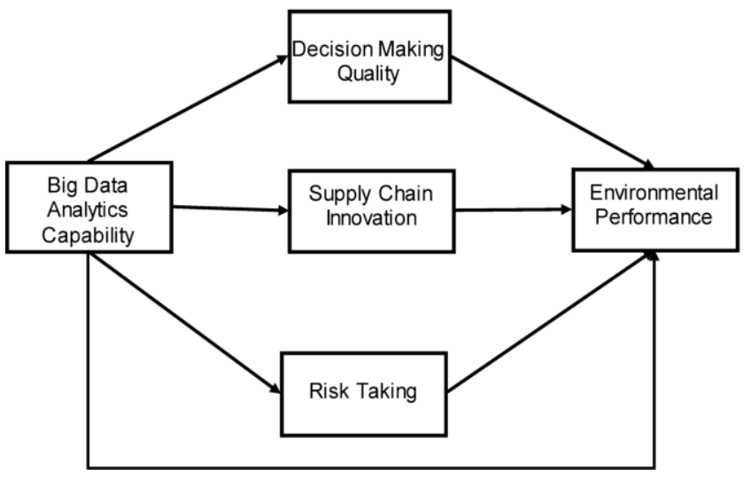
Integrating data science into supply chain management (SCM) comes with its own set of challenges (Pooja, 2024). Issues such as data availability and quality limited technical expertise, integration and adaptability hurdles, concerns around transparency and explainability, and ethical considerations can all create significant obstacles (Pooja, 2024). Implementation of strategies that improve data quality, strengthen technical capabilities, support seamless integration, promote transparency, and ensure ethical use of data can offset these issues. When adopted thoughtfully and strategically, data science can unlock substantial value in supply chain optimization (Pooja, 2024). It has the power to transform supply chains into more efficient, agile, sustainable, and ethically responsible operations—ultimately boosting competitiveness and elevating customer satisfaction (Pooja, 2024).

Enterprise Resource Planning.
As businesses grow both in size and complexity, new opportunities and challenges arise (Chandra & Chinta, 2025). The ability to provide customers with the right products at the right time becomes a goal and a hurdle. To address this expansion, all aspects of the business need to be connected and working in step with each other. It is for this reason that organizations employ enterprise resource planning (ERP) systems (Chandra & Chinta, 2025). Companies that focus on the allocation of goods will often use the Distribution Requirements Planning (DRP) approach, which is better suited for their business model (Gopal et al., 2024). Resource and requirements planning provide insight into production rates, inventory levels, and order statuses (Figure 9) (Gopal et al., 2024). The use of ERP, while beneficial, can be costly to implement (Chandra & Chinta, 2025). It can take years to establish a functioning ERP system, depending on the skill level and experience of the organization (Chandra & Chinta, 2025).
Figure 9
ERP in the Supply Chain
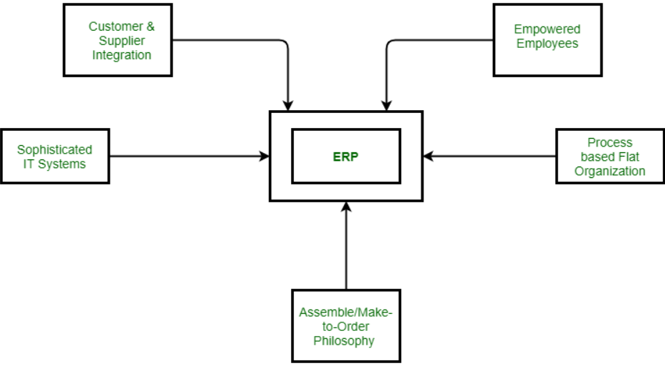
The future of supply chain–focused ERP systems will be rooted in cloud computing (Al-Amin et al., 2023). Although cloud-based ERP offers significant advantages, such as improved scalability, real-time visibility, and enhanced collaboration. It also introduces notable challenges. One of the most critical concerns is the increased security risk for users across the supply chain (Al-Amin et al., 2023). Protecting data confidentiality becomes especially important when implementing a cloud-based ERP. Because supply chain ERP systems store vast amounts of sensitive operational, supplier, and customer information, maintaining robust confidentiality measures is essential. Without proper safeguards, this highly valuable data can become vulnerable to security breaches, posing substantial risks to supply chain operations (Al-Amin et al., 2023).

Cloud Computing.
Another option for data storage and analysis is cloud computing (Yengula et al., 2023). This process allows for storage of vast amounts of data and is able to function without direct input from users. Cloud computation offers certain specific benefits, like resource pooling, wide network access, quick elasticity, on-demand usage, and measured service (Figure 10) (Yengula et al., 2023). In contrast to ERP systems, cloud computing is relatively inexpensive for market entry (Gopal et al., 2024). This allows smaller businesses to use Big Data in their operations (Gopal et al., 2024). Some challenges come with the use of cloud computing (Yengula et al., 2023). Security of data can be costly but is a necessary component of conducting business online. Access may also be restricted due to bandwidth limitations (Yengula et al., 2023).
Figure 10
Supply Chain Cloud Computing
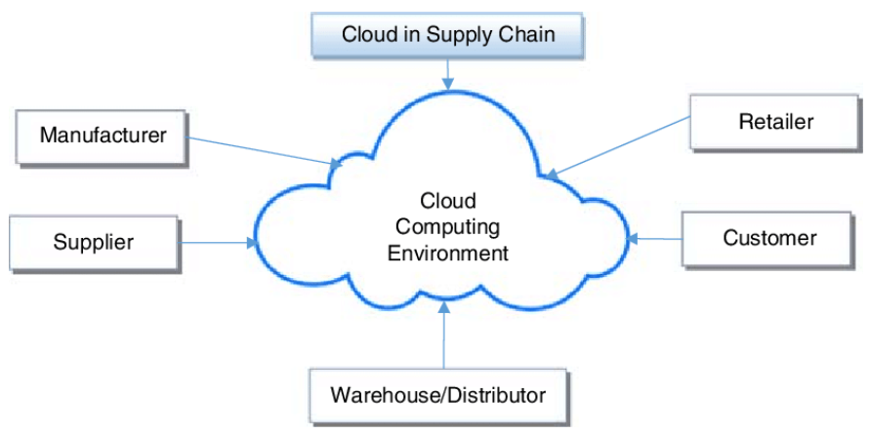
Small and medium-sized businesses are especially vulnerable to cyberattacks, which further amplifies cybersecurity risks across the supply chain (Mhaskey, 2024). Data privacy concerns in cloud environments primarily center on who controls, manages, and protects the sensitive information stored and processed online. Cloud infrastructures often involve complex configurations and interconnected systems across both public and private platforms, making integration challenging (Mhaskey, 2024). As organizations exchange large volumes of data through multiple cloud-based applications and services, ensuring data consistency and reliability becomes essential. This shift also demands strong change-management efforts. Effectively communicating the benefits of the new system, addressing potential concerns, and securing support from key stakeholders are all critical to ensuring a smooth transition (Mhaskey, 2024).

Data Mining.
The need for large amounts of data led to the development of data mining (Shu & Ye, 2023). It is both a deductive and inductive approach to gathering data. It focuses on complex causal heterogeneity. The goal of data mining is to increase a model’s predictive power (Shu & Ye, 2023). It provides automatic and semi-automatic searches for non-linear relationships. Effective mining can avoid “convenience” samples. These are provisions that include sampling biases which are not adequate probability samples (Shu & Ye, 2023).
Within data mining, there are several sub-sections, such as Classification, Regression Analysis, Clustering Analysis, Decision Tree Inductions, and Correlation Analysis (Papakyriakou & Barbounakis, 2022). These techniques are effective in the analysis of structured data. However, structured data only accounts for 20% of all collected data. This denotes the importance of data cleansing, as unstructured data can be more difficult to assess than structured or semi-structured information (Papakyriakou & Barbounakis, 2022).
A major obstacle to using data-driven methods for supply chain management is the substantial effort required for both implementation and maintenance (Longard et al., 2022). Because each use case typically demands a customized solution, developing these systems requires extensive work and specialized expertise. Highly skilled personnel are needed to design and program the algorithms. Furthermore, production environments continually evolve, necessitating ongoing adjustments to the algorithms to keep them accurate and effective (Longard et al., 2022).

RFID.
In industries where large numbers of goods require real-time tracking and analysis, the Radio Frequency Identification (RFID) is the prime option (Boddapati et al., 2021). It is a tag that emits a low-frequency radio signal, allowing tracking of inter-company movements, inventories, and production rates. It also prevents loss through theft, misplacement, and inventory mistakes (Boddapati et al., 2021). Since the data is self-contained, it can be continuously monitored and analyzed (Unhelkar et al., 2022). Any changes in shipping information, stock amounts, production levels, and warehouse space can be seen immediately. Pairing the RFID system with data analytics tools, patterns can be quickly identified, and necessary adaptations can be made in real-time (Unhelkar et al., 2022). The responses to changes may be a reduction or increase in production rates, reallocation of inventory to other areas, or using alternative shipping lanes (Figure 11) (Boddapati et al., 2021). Even with the benefits of using RFID, there are limitations (Unhelkar et al., 2022). Since the transmitters require programming, there is room for error in the programming process. There is also a large expense involved with the use of RFID. It can cost up to ten times more to implement RFID over traditional bar-coding systems (Unhelkar et al., 2022). This may restrict the use of RFID to larger businesses (Boddapati et al., 2021). While smaller businesses may not be able to afford the system, they also may not have the need due to smaller inventories. Traditional barcode systems may be the best option (Boddapati et al., 2021).
Figure 11
RFID in the Supply Chain
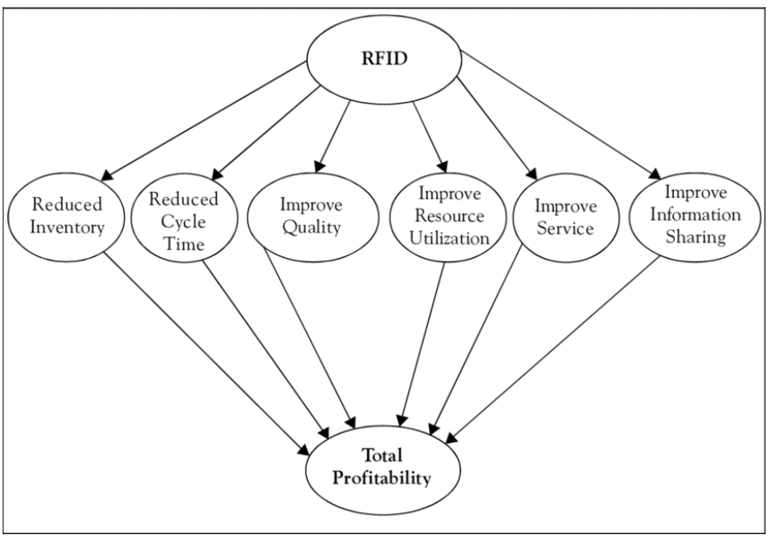
Challenges such as integration issues and security vulnerabilities remain important areas requiring continued research and development (Al Mahmud et al., 2025). As RFID technologies advance, they hold the potential to further optimize supply chain processes, such as manufacturing, shipping, distribution, inventory management, and retail. Employing them in supply chain management can lead to a more efficient and resilient supply chain ecosystem (Al Mahmud et al., 2025).

Blockchain.
Blockchain is a revolutionary creation, changing everything from economics, politics, and legal systems around the world (Tripathi et al., 2023). It began with the creation of bitcoin in 2008. The creator went by the pseudonym Satoshi Nakamoto. This was the first iteration of a cryptocurrency. The intent was to replace cash as a digital transaction (Tripathi et al., 2023). Blockchain reached a second milestone with the invention of smart contracts. This added an aspect of stock-like transactions, as opposed to standard cash transactions. The third generation of blockchain saw the movement beyond the financial industry (Tripathi et al., 2023). It presented services for government, healthcare, and science. The fourth generation is in progress with the introduction of AI into the blockchain process (Tripathi et al., 2023). The growth of blockchain and bitcoin is evident in the increase of its value (Ko et al., 2023). In 2010, Lazlo Hanyecz used 10,000 bitcoin to purchase $30 worth of pizza. Eight years later, the same 10,000 bitcoin was estimated to be worth over $80 million. Blockchain may eventually allow smart contracts to become digitally embedded in databases. They can be transparent and prevent tampering (Ko et al., 2023). The primary benefit of blockchain is the lack of need for third parties (Tripathi et al., 2023).
When introduced into supply chain management, blockchain provides a decentralized framework (Bello & Daraojimba, 2024). Moving from traditional supply chain processes, which lack real-time data, contain large amounts of hard copies, and manual interventions, blockchain offers new options. It is secure and decentralized (Bello & Daraojimba, 2024). The smart contracts provide automation for numerous processes, from payment acceptance to order fulfillment (Ko et al., 2023). By reducing errors and eliminating the need for intermediaries, supply chain management can be more reliable and efficient. The end-to-end supply chain can be visible due to the transparency provided by blockchain (Figure 12) (Ko et al., 2023). Predictive analytics are enhanced by the ability to gather and house large amounts of data, as well as the visibility provided by blockchain (Bello & Daraojimba, 2024). By coupling with AI and the Internet of Things (IoT), blockchain can access a vast amount of data to optimize storage, logistics, and predictive models. It may also provide a safeguard against unexpected supply chain interruptions through predictions and identification of event triggers (Bello & Daraojimba, 2024).
Figure 12
Blockchain in the Supply Chain
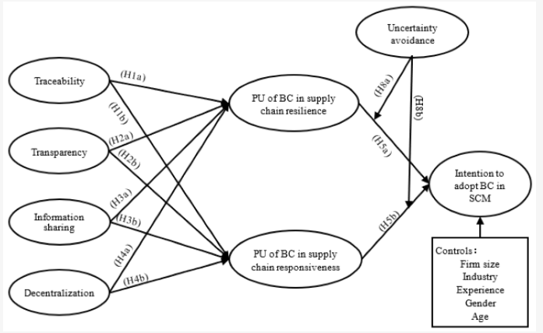
As powerful a tool as Blockchain is, there are some concerns when implementing it into a supply chain management model (Cordova et al., 2021). One issue is the alignment to globalization. As blockchain grows in popularity, businesses around the world face the issue of finding a global standard. This is an issue with any new technology (Cordova et al., 2021). New technologies also experience growing pains in adoption and implementation. Employees must learn new systems and approaches. Innovations in data management must also be expected. The way in which data is collected, housed, cleansed, and processed must be reexamined (Cordova et al., 2021). Human interaction with the new processes may affect the success of a new implementation. A base-level of skilled employees is needed to ensure proper roll-out and use of the new methods. This also suggests possible downtime as systems are switched and processes are exchanged (Cordova et al., 2021).

Internet of Things (IoT).
The Internet of Things (IoT) is an ongoing revolution in systems of sensory and actuation devices which gather, analyze, and share information in a wide array (Koohang et al., 2022). The IoT has been described as a global network of physical tools which are connected through the Internet. Other descriptions depict it as an interconnected set of devices which are remotely controlled and act as entry points to the Internet (Koohang et al., 2022). Between 2012 to 2018, the use of IoT rose from 8.7 billion to over 50 billion users. This was impressive, especially considering that usage in homes and retailers remained relatively unchanged. The growth was largely driven by the increase of tablets and smart phones (Koohang et al., 2022). The use of these devices was not limited to personal use, as businesses began to leverage them for productivity increases (Sallam et al., 2023). The supply chain, specifically, has seen numerous benefits from the IoT. The processes of monitoring, optimizing, and analysis of supply chain operations have been enhanced through integration with product tracking, repetitive maintenance, waste reduction, routing choices, and inventory control (Figure 13). This integration has led to increased efficiency, cost reduction, improved sustainability, and enhanced quality (Sallam et al., 2023). Nearly every industry has adopted the IoT into their supply chain management architecture (Koohang et al., 2022). Specific focus areas are tracking, agility, and visibility. Information sharing through the IoT has been shown to provide boosts to inventory control, planning, and end-to-end control over supply chain procedures (Koohang et al., 2022).
Figure 13
IoT and the Supply Chain
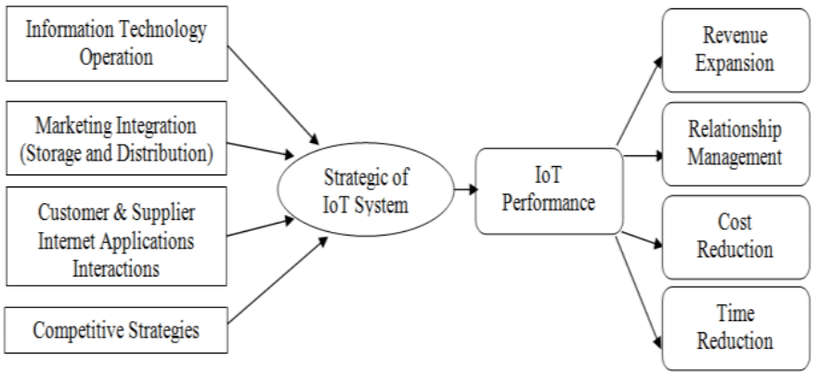
IoT implementation within organizations has not been limited to business-exclusive processes (Koohang et al., 2022). Businesses have employed the use of IoT within their personnel resources. Employees can use the devices to improve communication, knowledge sharing, and increase autonomy. Not only do these factors show benefits, but employees report increased productivity and job satisfaction (Koohang et al., 2022). Employees are using both business-provided devices and personally owned tools. The personal devices have been reported by IT executives as beneficial to employee productivity and organizational goal attainment (Koohang et al., 2022). There remain many challenges to the use of IoT in a business setting (Sallam et al., 2023). Interoperability must be thoroughly blueprinted and properly implemented. Scalability is also an ongoing issue, as the technology evolves and the business grows (Sallam et al., 2023). Security of data and devices can be a challenge, especially when a combination of personal and business tools is being used (Koohang et al., 2022). Another consideration is regulatory compliance (Sallam et al., 2023). In response to these issues, it becomes paramount to employ adequate change management processes, personnel training, and roadmaps for optimal practices in IoT usage (Sallam et al., 2023).
IoT technologies have become a critical focus for gaining competitive advantages across suppliers, distributors, manufacturers, retailers, and consumers (Tan & Sidhu, 2022). However, current system infrastructures still fall short when handling complex tagging requirements. From a software design perspective, challenges persist in system architecture. This is particularly true in data collection, storage, scalability, and maintenance (Tan & Sidhu, 2022). Many industrial systems rely on on-premises servers to ensure efficiency, reliability, and scalability, with databases and modules tailored to meet the needs of large organizations and their business models. However, developing and maintaining on-premises solutions demands highly skilled personnel and substantial computing resources for installation, upgrades, and ongoing system evaluation (Tan & Sidhu, 2022).

Business Intelligence (BI).
Business Intelligence is a concept that describes the use of an organization's data resources for analysis in the decision-making process (Romero et al., 2021). It is based on historical data which is collected from internal sources, such as spreadsheets, databases, sales documents, and data warehouses (Cheng et al., 2023). Once analyzed, the data can be used to find patterns and trends, as well as determine strategic directions. The data can be shown in visualizations that allow people in every aspect of the business to draw their own conclusions and identify pattern and connections (Cheng et al., 2023). The ability to find trends and patterns from historical data has led to data becoming one of the most valued assets in business, today (Romero et al., 2021). Its usage also demands improved tools for collection, analysis, and decision-making. Adoption of Business Intelligence systems has benefited large numbers of businesses in development of new management processes, business approaches, and direction-setting (Figure 14) (Romero et al., 2021). The effectiveness of Business Intelligence tools is most often measured by Key Performance Indicators (KPIs) (Cheng et al., 2023). These indicators may include the speed and accuracy of decision-making, data accuracy, and the efficiency of report generation (Cheng et al., 2023).
Figure 14
Supply Chain Business Intelligence
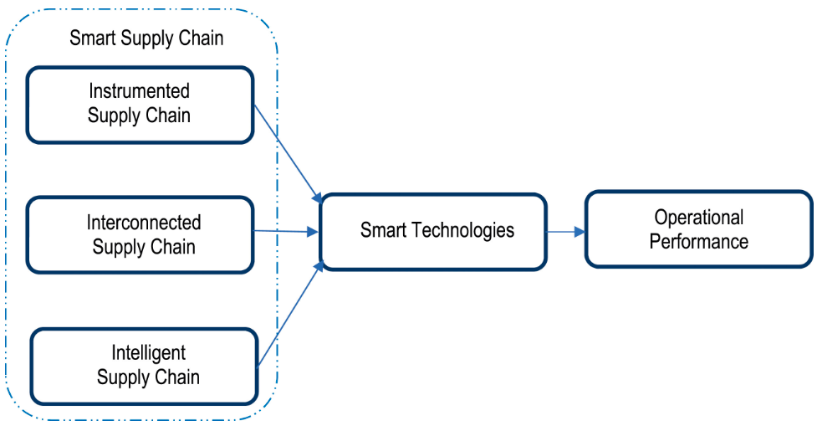
The term "Business Intelligence" can be traced back as far as 1865 (Skyrius, 2021). Richard Millar Devens first used the phrase in the “Cyclopædia of Commercial and Business Anecdotes.” He was referring to a banker, Sir Henry Furnese, who used the gathering and assessment of information to act before his competitors (Skyrius, 2021). In 1958, Hans Peter Luhn, an IBM computer scientist, suggested the use of technology to gather business intelligence and the potential associated with its use. By the late 1960s, translation of data into actionable items was restricted to those with specialized skills. Information was mostly siloed and disorganized (Skyrius, 2021). Data analysis was unfocused and open to misinterpretation. Edgar Codd published a paper in 1970 describing a relational database model. It was widely accepted and implemented across the globe. The first of these databases was the decision support system (DSS). It was considered to be the basis for modern versions of business intelligence models (Skyrius, 2021). As the value of BI became recognized during the 1980s, more tools were developed for more efficient organization and access to information. Data warehouses, OLAP, and executive information systems were created to meet those needs and work with the DSS (Skyrius, 2021).
A major barrier to achieving supply chain visibility is the limited adoption of technologies capable of tracking and capturing operational data (Delgado et al., 2025). While AI and Industry 4.0 innovations have the potential to transform supply chain management, many organizations, particularly small and medium-sized enterprises, lack both the financial resources and the technical expertise needed to implement these solutions. The challenge is further intensified by the absence of global standards for data collection, integration, and sharing, making it difficult to align practices across supply chain partners (Delgado et al., 2025).
Trust issues among supply chain actors also pose a significant obstacle (Delgado et al., 2025). Second- and third-tier suppliers may be reluctant to share detailed operational information due to fears of losing competitive advantage or facing additional compliance requirements. These concerns are often reinforced by differing corporate cultures and a lack of clear incentives to encourage transparency. As a result, many focal firms maintain only limited visibility beyond their immediate suppliers and often remain unaware of the second- and third-tier suppliers involved in earlier stages of production (Delgado et al., 2025).

Reinforcement Learning

Machine Learning Beginnings.
The early iterations of Machine Learning arose int the early 20th century (Michelucci, 2024). A pioneer int the field, Alan Turing, saw the potential in machines to replicate human intelligence. He published a paper "Computing Machinery and Intelligence," where he posed the question if machines were able to think. He suggested what is now known as the Turing Test (Michelucci, 2024). The test was designed to assess the lengths to which a machine could depict intelligent processes that were inseparable from those of a human. A human assessor conducts a conversation with a machine and a human, which are both out of sight. A successful test of a machine occurred when the interrogator was unable to distinguish between the machine and its human counterpart (Michelucci, 2024).
The first computers were established to act out complex computations and were able to store both data and the blueprints for performing tasks on the data (Cohen, 2025). As technology improved, the computers began to use mathematical explanations for real-world data and occurrences. At this point, data was still being assessed within the parameters of pre-written instructions. To enhance the computers' abilities, new instructions were applied that allowed the systems to learn by creating their own rules based on the input of large sets of data (Cohen, 2025). The results were then applied to predictions and classification. The new learning process became known as Artificial Intelligence (AI) (Cohen, 2025). This was followed by the development of Machine Learning (ML), where computers could improve decision-making processes with the addition of new data and analysis (Foote, 2022). One way of accomplishing this task was the creation of the Neural Network (Foote, 2022). In the late 1950s, Frank Rosenblatt introduced the perceptron, which was the first neural network (Michelucci, 2024). The perceptron was modeled on biological neurons and designed to operate in a similar fashion, as a classifier. It was able to use input data, multiplied against optimal weight coefficients to assess whether a neuron was activated or not. Rosenblatt's work introduced the idea that machines could learn from data automatically, as opposed to pre-written frameworks (Figure 15) (Michelucci, 2024).
Figure 15
Machine Learning Events
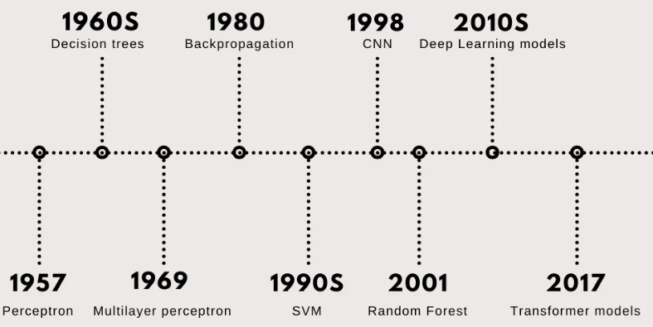
As more algorithms were introduced to mimic the activity within a human brain, new architectures were created that used numerous interconnected nodes employing weighted decision connections (Cohen, 2025). These webbed connections were arranged into computational layers, and the architectures became known as Deep Learning (DL) (Cohen, 2025). By the 1960s, Machine Learning algorithms were being widely used to solve mathematical equations (Foote, 2022). By the end of the decade, a new concept began to develop. The idea of Vision Learning became a focus of development. The intent was to allow computers to analyze visual inputs, leading to facial and object recognition (Foote, 2022). In 1967, the nearest neighbor algorithm was developed, which allowed for basic identification of patterns. During the period of 1968 to 1969, the algorithm evolved into the K nearest neighbor algorithm (Foote, 2022).
The rise of modern Artificial Intelligence and Machine Learning can be divided into four distinct periods: the Founding Period, the First Golden Age, the Second Golden Period, and the Third Golden Period (Zhang & Lu, 2021). During the Founding Period, scientists discussed the simulation of intelligence in machines. An academic conference in 1956 was held at Dartmouth University. It was there that John McCarthy coined the term Artificial Intelligence, which has been used since in describing the discipline (Zhang & Lu, 2021). The First Golden Age ushered in the practical use of AI in expert systems, such as the Hearsay-11 Language Understanding System, the MTCIN Disease Diagnosis and Treatment System, and the Bender Chemical Mass Spectrometry System. As evidence of the emerging technology, several universities, like Carnegie Mellon University, Stanford University, and the Massachusetts Institute of Technology received Research and Development government grants for AI (Zhang & Lu, 2021). Another concept, knowledge engineering, was added by Mitchell Feigenbaum in the 1970s. He also identified a major hurdle, which was the procurement of data on a large scale. This led to a stalling of AI research (Zhang & Lu, 2021).
Over the last half of the 20th century, the cost of computing fell drastically (Crafts, 2021). Between 1940 and 1949, the cost of computation per million units was roughly 25.7. This number fell to 0.000592 in the 1970s. By 2006, costs had dropped to 0.000000000137 (Crafts, 2021). Computing power also increased at an exponential rate. In 1997, Xavier Sala-i-Martin based a paper on 4 million regressions. These regressions took 33 hours, as compared to Milton Friedman's 40-hour computation time for one regression in the 1940s (Crafts, 2021). These advancements led to the Second Golden Period (Zhang & Lu, 2021). This era was marked by the advent of the Hopfield neural network and the backpropagation algorithm. In the early 1980s, speech recognition and translation moved into the forefront. Regardless of these advancements, the public still had not accepted AI or ML as relevant to everyday life (Zhang & Lu, 2021). This led to another stalling period for AI around the turn of the century. During the early 21st century, a Second Golden Period began. The backpropagation (BP) algorithm and neural networks took root in large-scale environments. Savings in costs and efficiency became evident (Zhang & Lu, 2021). One example, the PROSPECTOR expert system was able to assess multi-million-dollar mineral deposits. With the success of expert systems, as well as the excitement generated by Deep Blue, AI once again moved into the forefront of public focus. (Zhang & Lu, 2021). Computing power also continued to grow. Paired with the development of deep learning and big data methods, custom computer processors allowed researchers to expand AI development on a larger scale (Zhang & Lu, 2021).
In the period following 2006, a Third Golden Era arrived (Zhang & Lu, 2021). The driving factor for the new surge in AI development was the creation of parallel processing. It provided a faster, more powerful means of processing data. Storage capacity also expanded, allowing for warehousing of large datatypes such as maps, images, social media posts, and audio files (Zhang & Lu, 2021). The mass adoption of the internet for mobile devices drove the demand for AI applications. In 2012, the concept of deep learning was put into practice with visual and speech recognition (Zhang & Lu, 2021).
Deep learning saw several evolutions through the years (Sevilla et al., 2022). In the Pre-Deep Learning Era, which spanned 1950 to 2010, training compute, or the total computing power needed to train an AI model, followed Moore's Law (Sevilla et al., 2022). Moore's Law states that transistor density doubles bi-annually. In this case, the training compute doubled every 17 to 29 months. After 2010, during the Deep Learning Era, the training compute changed to a doubling every 4 to 9 months. By 2015, large-scale models, such as AlphaGo entered the market (Sevilla et al., 2022). This Large-Scale Era saw compute increase overall, but the doubling effect was reduced to 8 to 17 months (Sevilla et al., 2022).

Reinforcement Learning Development.
Reinforcement Learning (RL) is a method of applying AI agents to perform trial-and-error procedures based on reward functions to learn from its environment (Shakaya et al., 2023). As more trials are performed, the RL system adds knowledge from previous experiments. The design of RL models is intended to imitate the processes of the human brain (Shakaya et al., 2023). Rather than using traditional control models, where physical constraints are used to determine optimal behaviors, RL uses trial-and-error approaches (Moos et al., 2022). These traditional models were known as white box models, where RL models are known as black box models due to unknown functions within the models. The agents perform ongoing interactions to acquire new direction in order to determine optimal solutions (Figure 16) (Moos et al., 2022).
Figure 16
Machine Learning Model
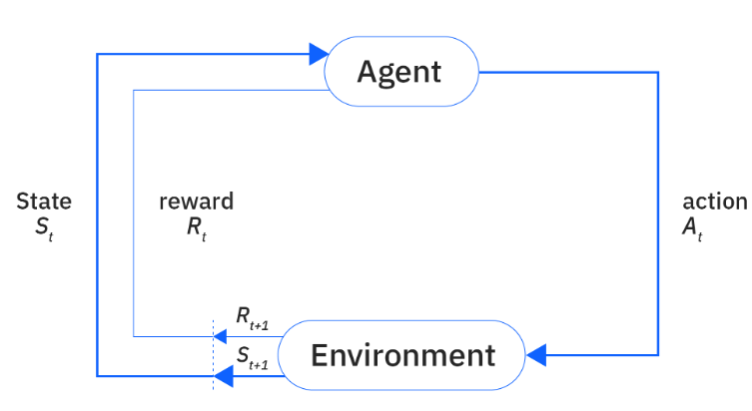
RL methods have proven to be effective in a wide array of applications and fields (Shakaya et al., 2023). It excels when completing sequential tasks of problem-solving and decision-making. This is due to the use of three components. It uses Temporal Difference (TD) learning, optimal controls through Dynamic Programming (DP), and human learning psychology. Edward Thorndike applied the theory of the "Law of Effect" in 1911 (Shakaya et al., 2023). The primary idea behind the theory was that positive responses to interactions resulted in similar reactions to the same situations. Conversely, negative reactions to choices result in different choices given similar situations (Shakaya et al., 2023). While RL is an effective tool, it does not guarantee robust results (Moos et al., 2022). The uncertainty of real-world situations may lead to further variability in the models. Recently, steps have been introduced to enhance robustness in RL models. Observation robust designs can be used to warp the perception of the policy's system state (Moos et al., 2022). Disturbance robust methods add external input to simulate uncertainty in the system. Action robust approaches corrupt the agent's output to influence the transitions of the systems. Transition robust designs manipulate transition probabilities between states to account for uncertainties (Moos et al., 2022).
The evolution of Reinforcement Learning has occurred over several decades and can be attributed to many factors, but some milestones stand out as important moments (Shakaya et al., 2023). As previously discussed, Thorndike's proposal of the "Law of Effect" in 1911 spurred on the development of trial-and-error learning (Van Eck & Kruuse, 2025). One of the earliest uses of the term "reinforcement" was attributed to Ivan Pavlov in his research into conditioned responses (Madden et al., 2023). Using the Law of Effect as a basis for a learning model, Alan Turing proposed a "pleasure-pain system" in 1948 (Blum & Blum, 2022). In 1950, Claude Shannon developed a rudimentary learning model for playing chess (Naeem et al., 2023). He also created a mechanical mouse that could navigate a maze in 1952. It was known as Theseus and it demonstrated the ability of trial-and-error learning (Naeem et al., 2023). In 1956, Richard Bellman developed an early iteration of optimal control problem solutions, known as the Bellman equation (Figure 17) (Meyn, 2024). He further applied the Bellman equation to his Dynamic Programming (DP) method. The method provided a tool for solving optimal control problems (Meyn, 2024). In 1959, using a TD-based learning model, Arthur Samuel created a program for playing checkers and developing strategies for winning (Raut et al., 2025).
Figure 17
Bellman Equation
As the 1960s began, Ronald Howard presented the policy iteration approach for the Markov Decision Process (MDP) (Figure 18). The MDP is a mathematical framework for problems-solving and decision-making in spite of uncertainty (Asadi et al., 2025). Throughout the 1970s, Harry Klopf brought RL to the forefront of research for learning models (Savage, 2025). In 1989, Chris Watkins introduced the concept of Q learning DP (Meyn, 2024). Another advance in game-applied learning was introduced by Gerald Tesauro in 1992 (Moos et al., 2022). He employed advanced TD learning to compete in backgammon (Moos et al., 2022). One widely noted milestone occurred on May 11, 1997, when IBM's Deep Blue bested the world chess champion Garry Kasparov (Sood, 2022). The year 2000 saw the arrival of the Policy Gradient method (Shakaya et al., 2023). This method used the gradient for the reward with respect to the policy parameters to update the policy. Independent of the value function, each policy is exclusively depicted by its own function approximation (Shakaya et al., 2023). Vijay R. Kondaand John N. Tsitsiklis presented a new set of actor-critic algorithms in 2000. These were applied to simulation-based optimization of the MDP within areas of random policies set within defined parameters (Shakaya et al., 2023).
Figure 18
Markov Decision Model
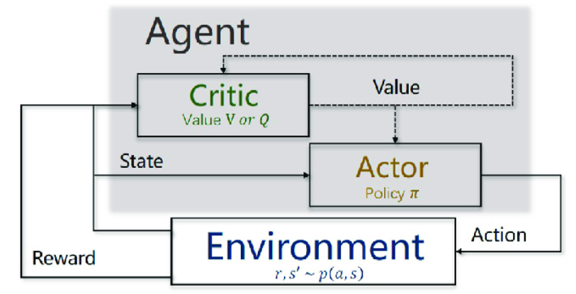
The period between 2005 and 2015 saw the emergence of deep learning (Shakaya et al., 2023). Natural language processing, robotics, video games, image and speech recognition, and even video games experienced leaps in development (Shakaya et al., 2023). In early 2015, Google DeepMind produced a new type of Deep Reinforcement Leanring agent called a Deep Q-network (Terven, 2025). It learned optimal policies directly through high-dimensional data inputs and employing end-to-end Reinforcement Learning. In 2016 and 2017, Google DeepMind introduced AlphaGo and AlphaGo Zero, respectively. AlphaGo used Monte Carlo simulations to beat human players in full-sized games of Go (Terven, 2025). AlphaGo Zero went a step further and used only reinforcement learning and basic game rules to outperform AlphaGo. With the introduction of AlphaZero in 2018, the algorithm was able to add chess and shogi to its ability to excel in learning new approaches and strategies (Terven, 2025). Google DeepMind improved over its previous models in 2019 when it presented AlphaStar, the first DRL agent to achieve Grandmaster in a video game known as StarCraft II (Liu et al., 2023). It was also the first program to compete at the level of top league professionals in the game's original version (Liu et al., 2023). Also, in 2019, OpenAI used OpenAI Five to beat world champions in the professional online game Dota 2 using DRL (Samala et al., 2024).
Google DeepMind once again provided a submission that outperformed all previous models (Guei et al., 2025). MuZero was able to reach superhuman abilities in visually complex, difficult tasks without definition of deeper dynamics. It used a combination of tree-based searching approaches and dep learning algorithms (Guei et al., 2025). Another of Google's creations, AlphaFold was employed to predict structures within proteins (Nussinov et al., 2022). It was able to do so with precision to an atomic level without input of similar structures (Nussinov et al., 2022). Most recently, Google DeepMind created AlphaCode to address novel programming problems and provide original solutions (Kolter, 2022).

Applying Reinforcement Learning to the Supply Chain.

Applications.
Reinforcement Learning (RL) has been applied with great success in several areas of the supply chain (Rolf et al., 2023). The primary areas of focus have been inventory controls. Secondary areas have been information management and transportation issues. Inventory management is often addressed by using RL agents to optimize the movements of materials between production and warehousing sites across the supply chain (Rolf et al., 2023). Transportation issues differ from inventory problems as transport focuses on routes, and shipping options, where inventory works with stock levels, production rates, and storage areas. Information flows are substantially more complex. They require input on users, data types, information requirements, and security (Rolf et al., 2023). The effectiveness of RL models has been demonstrated by applying them to the beer distribution game (Kegenbekov & Jackson, 2021). The beer game is a teaching tool used in supply chains to explain how uncertainty can affect end-to-end operations. An RL model based on Q-learning can be assigned to the beer game with no specific information on cost or other guidelines. While RL models outperformed in nearly all aspects against human competitors (Kegenbekov & Jackson, 2021). When paired with the OR-Gym, an open-source database that houses common supply chain problems structured as RL environments, the RL models showed considerable improvements. The use of the Q-learning model in supply chains has still been limited to theoretical applications (Kegenbekov & Jackson, 2021). It is a strong resource, however, and should be effective in this research using two goals. The use of a dataset outside of OR-Gym will require proper data cleansing and preparation in order to appear as an RL environment, but the model will still function similarly (Kegenbekov & Jackson, 2021).

Algorithms.
Reinforcement Learning describes a wide use of machine learning algorithms to solve problems (Rolf et al., 2023). Different models employ various algorithms based on the type of problem, the industry, and the desired outcomes (Kegenbekov & Jackson, 2021). The most widely used algorithm in supply chain management is Q-learning (Rolf et al., 2023). This makes sense, as Q-learning is one of the most mature approaches available. It has the ability to learn reward programs, as well as stochastic transitions. It also belongs to the non-model class of RL, where agents are able to learn directly from interacting with data and reacting to rewards (figure 19) (Rolf et al., 2023). Q-learning has been especially effective in inventory management when applied to a four-tiered supply chain model (Kegenbekov & Jackson, 2021). The four tiers are the manufacturer, distributor, warehouse, and retailer. In this model, the demand was established as nonstationary within a Poisson distribution (Kegenbekov & Jackson, 2021). Recent increases in the use of deep artificial neural networks have shown promise in supply chain-related problem solving (Rolf et al., 2023). Techniques such as PPO, A2C, A3C, and DQN function well on large-scale unstructured data (Rolf et al., 2023). The A2C algorithm provided excellent results in closed-loop supply chain replenishment (Kegenbekov & Jackson, 2021). An adaptation of the Soar RL algorithm was used to address risk in agile logistics-based supply chain approaches. The simulation was established as an asymmetrical wargame style environment. When addressing a single product or a multi-period system with stochastic stable demand, RL proved to be effective in problem solving (Kegenbekov & Jackson, 2021).
Figure 19
Q-Learning Model
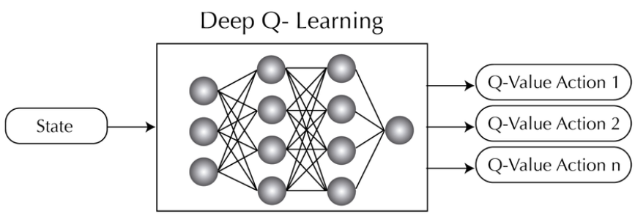
In varying configurations and topologies, the proximal policy optimization (PPO) algorithm provided better results in higher profits than other models (Stranieri & Stella, 2022). One benefit of the PPO is that it does not require hardcode action space or hyperparameter tuning (Kegenbekov & Jackson, 2021). When paired with a non-complex supply chain model, the PPO shows strong results for adaptive controls in multi-level supply chain models. It is only when large amounts of complexity are introduced into the model that the PPO tends to falter (Kegenbekov & Jackson, 2021). In contrast, the VPG algorithm only reaches a moderately successful local maximum compared to PPO. The local maximum is reduced significantly when the number of warehouses is increased. The A3C algorithm has been shown to be the fastest DRL algorithm, but due to the complexity in hyperparameter tuning, it suffers in high-level results (Stranieri & Stella, 2022). Another method which does not require hyperparameter tuning is Bayesian optimization (BO). However, it suffers when the demand exceeds the capacities and when there is more than one product. The cause for this is the rigid, non-dynamic (s, Q)-policy preventing the creation of an efficient approach (Stranieri & Stella, 2022).
While the PPO algorithm has proven effective in generating higher profits, its lack of use for delivery time improvement, as well as the issues with complex supply chain models leave a need for this research (Stranieri & Stella, 2022). The VPG shows increased difficulty in dealing with multiple variables, such as warehouses and products. Looking at the A3C algorithm as an option for supply chain improvement, despite its speed, it suffers from similar issues as the previous algorithms. It also requires a high level of hyperparameter tuning (Stranieri & Stella, 2022). Bayesian optimization (BO) falters when used to address the purpose of this study. It cannot handle multiple goals or large demand which are both necessary for real-world supply chain models. These commonly used algorithms each have significant limitations and inabilities to adequately address the issue of multi-goal optimization (Stranieri & Stella, 2022). With the lack of available algorithms for SCM usage, new avenues must be explored. The intent of this research is to find suitable means of optimization where limited options currently exist.

Strengths.
Reinforcement Learning models are able to make decisions in real-time, based on all available data (Rolf et al., 2023). This allows response to interruptions and issues in fast and effective methods. The flexibility of RL agents provides the ability to react to small or large changes, as well as short and long-term shifts (Rolf et al., 2023). While the use of RL in long-term decision-making processes has been proven effective in theory, it has not been used in practice as often as in short-term use. This is due, in part, to the need for immediate responses to unexpected interruptions (Rolf et al., 2023). Another reason is a limited scope and narrowly defined input and objectives. Long-term managerial decision-making processes are more often analyzed at a human level, where the rapid response of an RL model is not seen as needed. The model is also unable to provide the full complexity needed for long-term directions-setting (Rolf et al., 2023). Regardless of the length of time, RL provides options that traditional heuristics have not (Yan et al., 2022). Heuristics have been unable to stray from pre-set rules and parameters for decision-making. They rely on separate predictive models for forecasting, while RL models have an integrated optimization and predictive capability. These abilities make RL a strong tool for decision-making in supply chain management, especially when addressing interruptions and inventory response (Yan et al., 2022). RL models are also able to learn from their own decisions based on successes and failures. Another strength lies in the use of an environment with which to interact. RL models do not require modeling assumptions and simulation environments (Yan et al., 2022).
One of the core principles of Reinforcement Learning is the ability to function similarly to the human brain (Rolf et al., 2023). This allows the algorithms to mimic reasoning when approaching decision-making. However, the fact that the processes are data-based gives more weight to the responses provided. Rather than acting on "instincts" or feelings, RL models function solely on hard data. The RL models being applied to the supply chain are continuously being improved and adapted to respond to global issues, such as pandemics, geopolitical upheavals, and transportation problems (Rolf et al., 2023). The ability to connect and use the Internet of Things (IoT) only enhances the models' response to changes in the market and environment (Yan et al., 2022). The widely accepted use of RL and predictive analytics in the supply chain represent a major turning point in the integration of technology in new arenas (Kalusivalingam et al., 2022). RL's usage is a gateway to resilience, sustainability, and optimization, not only in the supply chain, but in nearly every industry (Kalusivalingam et al., 2022).

Limitations.
The benefits of RL considerably outweigh the drawbacks, but its limitations should be considered when choosing to implement Reinforcement Learning (Kalusivalingam et al., 2022). These considerations include, but are not limited to resource intensity, computational complexity, model interpretability and transparency, application to real-world scenarios, integration into existing systems, security concerns, privacy issues, ethical considerations, the limited number of domain-specific applications, human and AI interaction, and the availability of quality data (Kalusivalingam et al., 2022). The implementation of RL models is a complex and intensive process, which requires a level of expertise and sometimes, a significant monetary investment. This may negatively affect smaller businesses which may lack necessary funds, experience and infrastructure (Kalusivalingam et al., 2022). The level of complexity in an organization will also affect the use of RL (Yan et al., 2022). As supply chain coordination, pricing, legal concerns, negotiations, and staffing require various groups of people, tools, and approaches, one RL model may not be sufficient. Multiple models may be necessary, which presents a new set of issues. Multi-agent systems are available to counter these issues, but these systems can be costly and require investments of time, personnel, and assets (Yan et al., 2022).
As mentioned earlier, the "black box" nature of DRL and AI models can disrupt acceptance, understanding, and trust in the processes (Kalusivalingam et al., 2022). The disconnect between the users and the systems may lead to resistance in use, poor results due to mistrust or misuse, or misinterpretation (Henriques et al., 2024). Transparency can be difficult across the organization, especially in areas of compliance, decision justification, and auditing (Kalusivalingam et al., 2022). The issue of adaptability to real-world situations may be partly because of a limited visibility to the whole environment (Yan et al., 2022). Without a complete overview of the environment, a model my produce flawed insights, based only on the truncated view of the data (Yan et al., 2022). The use of historical data also may present unforeseen issues (Kalusivalingam et al., 2022). While the historical records account for previous trends, interruptions, and variances, they cannot represent outside influences, such as geopolitical changes, pandemics, or natural disasters. The effectiveness of each RL model in dynamic environments depends on the exposure to data which accurately represents the dynamic nature of the business (Kalusivalingam et al., 2022).
Another issue that disproportionately affects smaller businesses in the integration of RL models into existing systems (Kegenbekov & Jackson, 2021). Not every organization will have an infrastructure that supports RL models. Existing systems may be incompatible or insufficient to support the use of DRL or AI models (Kegenbekov & Jackson, 2021). Company workflows and operations may also need to be adapted in order to implement these models (Kalusivalingam et al., 2022). This may result in increased costs and lost time in retraining personnel and redesigning workflows (Kalusivalingam et al., 2022). The addition of RL systems also affects the legal and human resources departments of an organization (Deschamps et al., 2024). While most of the ethical and legal issues involved in the use of RL arise from the collection, use, and protections of data, other issues arise from the use of RL itself (Shethiya, 2024). There are few regulatory options for RL, DRL, or AI, currently, but the need remains to perform RL analysis in an ethical manner. The intent and application of RL should be for the betterment of humankind, and its use should be restricted against bringing harm to anyone (Shethiya, 2024). The data being used should also be safeguarded for privacy and security (Kalusivalingam et al., 2022). However, steps to act ethically and legally require time and funding. The same issues arise when meeting established regulations, such as GDPR (Kalusivalingam et al., 2022).
The use of RL and predictive models across various industries yields different results (Kalusivalingam et al., 2022). The lack of domain-specific applications hinders the widespread use in different industries. Where the systems may be effective in one area, they may falter in others (Kalusivalingam et al., 2022). The structure of an organization, types of data, analytical needs, and infrastructure have a large impact on the type of RL used, and the desired results (Kegenbekov & Jackson, 2021). The lack of domain-specific RL application can make it difficult to choose and implement the correct RL model. Until more industry-specific models become available, it remains a case-by-case choice of system (Kegenbekov & Jackson, 2021). This issue is exacerbated by the general novelty of AI and machine learning in business (Kalusivalingam et al., 2022). The rise of machine learning and big data approaches have exceeded the skills of the workforce. The necessary data experts for implementation of these models are not always available for small to mid-sized organizations. This limits the ability to leverage new technologies like RL (Kalusivalingam et al., 2022). Even with proper implementation, the user base is still mostly new to the use of AI and RL (Kalusivalingam et al., 2022).
The need for quality and sufficient amounts of data can also be a hurdle to overcome in RL adoption (Kalusivalingam et al., 2022). Quality decision-making analysis requires similarly high-quality input. Supply chains can be limited by the amount, relevancy, and granularity level of data (Kalusivalingam et al., 2022). Most organizations that are adopting RL deal with a very raw form of data. A lack of data cleansing and classification can hamper efforts to utilize RL, as well (Kalusivalingam et al., 2022). Even agents that have been properly trained need to access real-time information in order to perform optimally (Rolf et al., 2023). Supply chains that will profit the most from RL will require access to a large amount of real-time data and historical data. Even with this access, many supply chains do not have available data from suppliers and vendors, which is essential in viewing the whole environment (Rolf et al., 2023).

Documentation
The literature search strategy used for this research included Google Scholar, National University Library options, and ProQuest. Other peer-reviewed journal and scholarly article searches were used as necessary. Several cross-referenced sources were also used, such as IEEE Xplore and Journal of Behavioral Data Science. The searches for information included books containing seminal, historical, or other relevant input. All journals and articles have been restricted to those submitted from 2021 to present. This ensures that the collected information is current and relevant. The keywords and phrases used to find articles and journal entries included data science, reinforcement learning, artificial intelligence, deep learning, time-series, supply chain optimization, logistics optimization, and machine learning. Variations of these terms assisted in obtaining relevant information that directly and indirectly contributed to a deeper understanding of the research topic, problem, and purpose statements.

Summary
With increasing uncertainty within the supply chain due to cost increases, material shortages, and delivery issues, a lack of current data-centric models to address these issues requires research (Dubey et al., 2021; Guerra et al., 2024; Shekarabi & Mozdgir, 2025). Past data-driven models focused on single issues, while real-world complications often require simultaneous solutions for multiple problems (Shekarabi & Mozdgir, 2025). When addressing multiple issues separately, one solution may yield negative responses in another metric (Guerra et al., 2024). This highlights the need for dual-variable approaches to optimization issues (Guerra et al., 2024).
Reinforcement Learning (RL) provides a way to implement a dual-goal approach for supply chain resiliency (Zhou et al., 2024). The two performance indicators for this research are profit increases and on-time delivery. RL uses these two goals as set outcomes and employs reward functions to determine the optimal approach to reaching the goals (Zhou et al., 2024). The RL model will be assigned to accomplish both goals simultaneously to prevent one outcome from detracting from the other goal. The RL model is capable of testing various scenarios and learning from each one to improve further analysis (Zhou et al., 2024).
To understand the nature of the environment, the issues, and the possible solutions, a literature review has been presented. The origins and history of the supply chain were described with the evolution over time. Early iterations were compared to current models to explain previous successes and gaps. These responses to interruptions and variations in the supply chain were shown in small-scale normal occurrences and large-scale issues such as pandemics and global transportation events.
The driving factor behind modern supply chain design and evolution is Big Data. Big Data has been implemented into nearly all aspects of business. The rise and development of Big Data was outlined to show the influence, improvement, and challenges to its use in the supply chain. In order to approach the research effectively, the CRISP-DM method was explained and applied to the problem. Data-related tools that aid in supply chain management, the use of Big Data, and the leveraging of Reinforcement Learning were provided. These examples included radio frequency identification (RFID), the Internet of Things (IoT), and enterprise resource planning (ERP) (Gopal et al., 2024).
Reinforcement learning, one aspect of machine learning, and the basis of this research was presented for its history, usage, and potential applications, along with its connections to forecasting and risk management with the supply chain industry. Its prior use in the supply chain was explained including strengths and limitations. Based on the literature provided, RL appears to be a robust tool but lacking in application to multiple simultaneous outcomes. However, the extensive use of single-reward systems in the supply chain has proven to be a good choice for accomplishing the dual-goal objective of this study.

Chapter 3: Research Methodology
The problem to be addressed in this study is the lack of current data-centric models available to address the increase of uncertainty in the supply chain due to changes in the current environment, such as cost increases, material shortages, and delivery issues (Dubey et al., 2021; Guerra et al., 2024; Shekarabi & Mozdgir, 2025). The purpose of this quantitative, experimental, study is to explore reinforcement learning (RL), to increase the resilience of the supply chain through a dual-goal approach. The focus will be on two performance indicators: profit increases and on-time delivery.
This chapter will outline the specific details of the research methodology and design as they apply to the study problem, purpose, and research questions. The categories of population size, sampling method, and sample size will be explained. The chapter will outline any instruments employed, their background, as well as their validity and reliability. All variables will be presented from the dataset with their corresponding data types, categories, and relevance. The data collection and cleansing will be described as well. Analysis strategies used to create models to assess the research hypotheses and research questions will be explained. The chapter will close with the presentation of assumptions, limitations, and delimitations of the study.

Research Methodology and Design Process Diagram
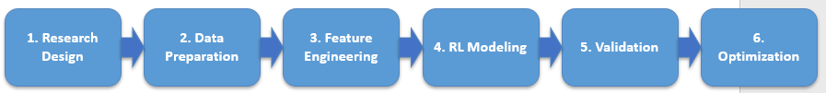

Research Methodology and Design (Nature of the Study)
The quantitative approach was chosen for this study, as the core of the study is the application of data science techniques in the supply chain setting. The quantitative methodology is optimal when discussing statistical and numerical information. The design of choice is the experimental approach. Data representing common supply chain transactions and processes will be analyzed using Reinforcement Learning (RL). Consideration was given to the alternate method of a qualitative approach. The qualitative methodology uses a five-phase structure (Bingham, 2023). The phases include data organization, sorting of data, initial coding, identification of patterns and themes, and theory application. While these steps are applicable to this study, qualitative approaches focus more on narrative elements of processes (Bingham, 2023). It lacks in the ability to represent the population due to small sample sizes (Taherdoost, 2022). It is also limited on the ability to generalize results. Quantitative methodologies have both of these abilities. They also allow for replication of studies over time because of the standardization of approaches (Taherdoost, 2022). For these reasons, the quantitative approach suits this study.
As this study is intended to identify causation among variables, the experimental approach is appropriate. The non-experimental method, which searches for correlation within the variables, is also not an option for this research. As the purpose of the study is to compare changes in reward functions and their effects on simultaneous outcomes, the approach is comparative, rather than corollary. Recent studies show success where machine learning processes are applied to complex decision-making problems either in place or in conjunction with traditional operational research methods (Ali et al., 2022). This suggests that the use of Reinforcement Learning, combined with the quantitative research approach, is appropriate and should be successful (Ali et al., 2022).
The process for this research begins with identification of the environment in which the RL agents will operate (Hong, 2024). This step consists of goal definition, possible actions, and the choices of rewards and penalties. The second phase is the state space designation. The state space represents the available configurations that the agents can understand. With the state space established, the action space is then specified (Hong, 2024). It is the set of all available actions which can be performed by the agents. The fourth stage is the creation of the reward structure, which informs the agents if they are nearing or distancing from the assigned goals. The fifth and final step is the choosing of the appropriate RL algorithm (Hong, 2024). The RL model will be trained and assessed for effectiveness. Once the model is accepted, various scenarios will be explored, where the rewards and penalties will be adjusted and outcomes will be compared (Hong, 2024).

Population and Sample
The population selected for this study was a compilation of supply chain entries used by the DataCo Global company (Constante et al., 2019). The data contains information from sporting goods, clothing, and electronics supply chains. There are 180,520 entries consisting of various transactions. Each entry has 53 columns of data. The columns represent order information including pricing, profit per order, order status, regional data, product category, shipping data, shipping type, and delivery time (Constante et al., 2019). The complete dataset will be used, as large amounts of data are necessary for in-depth analysis (Hong, 2024). The population will be divided into testing and training data for the Reinforcement Learning process.

Instrumentation
Various programs and algorithms will be used to prepare and analyze the data. The primary tool used will be the Python environment (Moens, 2025). Python offers several RL libraries which are useful in this type of research. The extension of Jupyter and Jupyter Notebook provide the ability to cleanse and standardize the data. PyTorch is a deep learning library that is flexible and able to leverage tensor computations. These computations are a cornerstone in RL (Moens, 2025). Many frameworks rely on static graphs. PyTorch employs a resilient, dynamic computational graph. This allows for real-time adjustments and changes to strategies. The optimized tensor computations establish a faster environment for agents to perform their learning processes. Next, OpenAI Gym will provide a basic policy gradient RL algorithm known as CartPole (Moens, 2025). This algorithm is trained to balance a pole on a cart. OpenAI Gym also presents other necessary libraries, such as Numpy, Torch, and Matplotlib. Matplotlib is able to plot the response of the RL model to rewards and penalties until the agent is no longer improving over time (Moens, 2025).

Operational Definitions of Variables
Operational definitions of the variables utilized in this study are included within this section. The study has several independent variables and one dependent variable which are defined below. Within the dataset, certain variables are linked or may be combined to create improved versions of each variable. The first set of variables represents order-related information. The second group consists of shipping data. This is followed by product and financial variables. Lastly, there are the variables that describe geographic locations.

Order Id
This is a unique number assigned to each transaction that identifies the grouping of all variables within a single order.

Type
This variable describes the payment method of each order, whether cash, debit, credit, transfer, or payment. It is not necessarily relevant to the initial analysis; it may be helpful in future exploration.

Days for Shipping (Real)
These entries define the total actual days in shipping from the company to the recipient of the order. They will be compared against the expected time in shipping for each order.

Days for Shipment (Scheduled)
When an order is placed, an expected time in shipping is provided, based on the region, distance, and shipping mode.

Late delivery risk
The actual time in transit for each order is compared to the anticipated delivery time and the difference between the two measurements results in the score for the risk of a delivery not meeting the scheduled days for shipment.

Order Country
Each order is assigned to the country where the order originated. This provides data for shipping distance, time, and method.

Order Item Discount
For costing purposes, each item that receives a discount is documented for computation of the total cost.

Order Item Quantity
The total number of items per order is cataloged for costing calculation.

Order Item Total
This variable is a calculated value based on the cost per item multiplied by the number of items in each order.

Order Profit per Order
Using the order item total and subtracting the costs associated with production, procurement, and shipping, the total profit is computed for each order.

Order Region
While each order is linked to a country, each subsequent country is assigned to a regional group for the purpose of categorization.

Product Category Id
This variable denotes each specific type of product in each order. It allows for separation of item types within each order.

Product Price
This is the corresponding price assigned to each product id. The price represents the cost of a single item.

Shipping Mode
This is the means of shipping products to customers. Each order can be shipped by first class, same day, second class, and standard class.

Rolling Average Delivery Delay by Region
This is an engineered field that calculates the mean delay time for all orders within each region.

Recent Late Delivery Ratio
This is also an engineered field that accounts for the number of late deliveries divided by the total number of orders delivered.

Study Procedures
This section will outline the steps followed for the data-related procedures in this study. The steps will include data collection, integration, and preprocessing. The preprocessing procedure includes raw data exploration, data cleansing, preparation, feature engineering, and preprocessed data exploration. An overall presentation of the exploratory data analysis (EDA) will be provided. The data modeling process will be outlined, along with data mining steps, including model validation and hyperparameter tuning. Finally, the model evaluation will be described, using the model fit and diagnostics.

Data Collection/Acquisition
The data for this research was provided through a public domain license from the owner, Fabian Constante (Constante et al., 2019). The DataCo Supply Chain Dataset is a group of structured and unstructured files containing supply chain information which was used by the DataCo Global company for analysis. This publicly available data was provided for generation of knowledge through correlational analysis of structured and unstructured data. It was also intended for use in analysis of sales, distribution, provisioning and production within a supply chain setting (Constante et al., 2019). The products included range from sports to clothing and electronics. The dataset consists of three individual spreadsheets: DataCoSupplyChainDataset.csv, DescriptionDataCoSupplyChain.csv, and tokenized_access_logs.csv. The former entry contains the core data, while the latter sheets provide input for enhancement and categorization of the core information (Constante et al., 2019).

Data Integration
Considering that the core file contains nearly all relevant data for this study, little integration was necessary. However, the secondary Description file contains information that is helpful in explaining the nature of each column in the core file. It aided in the choice of included and excluded fields in the preprocessing steps. By applying the definitions from the Description file with the core file, categorization was cleaner and easier to define. This was especially true in columns that seemed to contain recursive or similar data.

Data Preprocessing
As stated previously, the preprocessing phase includes several steps. These steps include raw data exploration, data cleansing, data preparation, feature engineering, and preprocessed data exploration.

Raw Data Exploration.
This is the initial analytical phase conducted to understand the structure, quality, and characteristics of the dataset before preprocessing and modeling. The intent of this process ensures the reliability of downstream machine learning and reinforcement learning models. It involves examining the number of observations and variables, verifying data types, identifying missing values or duplicates, and detecting outliers or inconsistencies. Descriptive statistics and basic visualizations are used to assess distributions of key variables such as profit and delivery time. This process ensures the dataset is reliable, unbiased, and properly aligned with the supply chain optimization objectives.

Data Cleansing.
The first step in data cleansing will be to purge the columns that are not relevant to the study or analysis. The 53 columns will be reduced to 13, which refer specifically to shipping mode, cost and profit, and regional data.

Data Preparation
The remaining columns will be explored for missing data, errors, and formatting issues, such as white space issues and leading or trailing spaces. The problems to be identified are extra spaces, special characters, and capitalization errors. These issues will be corrected using pandas in Jupyter Notebook. The results will also be verified to determine if each region appears once, and only once in the dataset.
The dataset contains entries with mixed scales, which denotes that values appear as single digits, hundreds, and percentages (Hosseinzadeh et al., 2023). There are also categories with a high level of cardinality. A number of categories are either recursive or repetitive. The financial data also may tend to be skewed (Hosseinzadeh et al., 2023). For these reasons, normalization of the data will likely be necessary. This process is not only important for standard data cleansing, but especially for RL policies. Certain fields require normalization for specific reasons (Hosseinzadeh et al., 2023).
When dealing with risk assessment, visualization, and RL rewards, min-max scaling is an effective approach (Hosseinzadeh et al., 2023). For reduction of highly skewed categories, log normalization will be used. The fields of profit and cost may be particularly prone to skewness and outliers. Log normalization aids in convergence stabilization, stops gradient explosion, and facilitates comparison of policies across regions (Hosseinzadeh et al., 2023).

Data Feature Engineering
The primary purpose of any feature engineering in this study is to enhance identification of late delivery risk, optimize the selections of shipping modes, lower costs, and increase profits and on-time deliveries (Verdonck et al., 2024). Regarding RL processes, it also supports the state representation. In cases of numerical data, integers are effective variables, but ratios may provide better insights. This is especially true with financial and costing variables (Verdonck et al., 2024). Some examples of these entries include shipping cost ratios, profit per unit, and profit margin. These features are created by dividing shipping costs by order item total, order profit per order-by-order item quantity, and order profit per order-by-order item total, respectively. This aids in normalization across order sizes (Verdonck et al., 2024).
Shipping delay information is also helpful in predicting late deliveries (Verdonck et al., 2024). By aggregating the actual delivery date and the scheduled delivery date, an accurate delivery delay can be quantified. Rather than a binary result, a range is more helpful, especially in comparison of shipping modes. Further feature engineering entails creation of average shipping mode late risk, average shipping mode profit, and historical shipping mode on-time rate.
Engineering within the regional data also helps to normalize the data. Determination of orders for each region is a basic need. Other steps include average delays per region, average profit per region, and profit per region by shipping mode. During initial data exploration, product level features have not been deemed as necessary, but may become helpful at a later time. These features may include average delays by product and average profit per product.
Additional steps include categorical encoding and scaling (Verdonck et al., 2024). The categorical encoding entails changing the shipping mode to integers and shipping modes and regions into One-hot variables. Scaling consists of log transforming order item total and shipping cost, as they are heavy-tailed features (Verdonck et al., 2024).
Some RL-specific engineering will also be performed to frame a State-Action-Reward model (Liu et al., 2022). For the State (S) portion, a historical late risk per shipping mode is effective. Others include a regional risk score and order value. The Action (A) section only requires engineering of the shipping mode. Within the Reward (R) area, rewards and penalties should be assigned. The reward will be denoted as the Profit. A Late Penalty is assigned as a "one" for a late entry and "zero" otherwise (Liu et al., 2022). With α and β as tunable weights, it would appear as:
$\max_{π}​J(π)=E_{π}​[\sum_{t=0}^{T}{γ^{t}}(αP_{t}-βD_{t})]$
where $α>0$= weight for profit
$β>0$= weight for delivery time penalty
Profit is maximized
Delivery time is minimized via subtraction

Preprocessed Data Exploration.
The preprocessed information is expected to yield improved insights into the initial exploration. The aggregated data for late delivery risk will be broken down into regions. This should result in similar outcomes across each region. Next, the order data will be separated into Shipping Mode, Delivery Risk, and Average Profit. Cross-referencing these three variables will show the average profit variance across regions and shipping modes.
Finally, compiling the profit per order with each shipping mode and breaking the results down by region will show the level of varied results. This will provide much deeper insights into the differences in shipping mode profits in each region. By reviewing the plots, the nature of shipping modes, as well as profits, become highlighted, as the previous data exploration may have shown fewer differences between these variables.

Summary of EDA Findings
The dataset contains 180,519 rows and 53 columns covering order, shipping, geographic, cost, and profit information. No missing or erroneous values were identified. Order volume varies significantly across regions, with the top eight regions ranging from approximately 8,000 to 28,000 orders. Standard Class dominates shipping volume (~110,000 orders), followed by Second Class, First Class, and Same Day. Average cost per order is nearly identical across shipping modes, indicating similar order size and pricing regardless of shipping method.
Data cleansing will reduce the dataset from 53 to 13 relevant columns focused on shipping mode, costs, profits, and regional attributes. Formatting issues only in the Order Region field (extra spaces, special characters, inconsistent capitalization) will be corrected and verified.
Due to mixed data scales, high cardinality categories, and skewed financial variables, normalization will be applied. Min–max scaling will support risk assessment and RL reward modeling, while log normalization will address skewness in cost and profit variables, improving convergence stability and policy comparison.
Feature engineering will be conducted to support late delivery risk identification, shipping mode optimization, cost reduction, and profit maximization. New features include cost and profit ratios, profit margins, delivery delay measures, historical late risk by shipping mode, regional performance metrics, and encoded categorical variables. Additional RL-specific engineering will frame the problem as a State–Action–Reward model, with shipping mode as the action and a reward function combining profit, late delivery penalties, and shipping cost.

Data Modeling
The intent of data modeling in this study is to address the prediction of late orders, the optimization of shipping modes, the increase of profits, and the facilitation of RL decision-making (Wan et al., 2023). By modeling these aspects, a balance can be established between scalability, analytical preciseness, and compatibility with the RL process. The three core entries to be modeled are Orders, Shipping Modes, and Delivery Results. The order aspect is modeled to map each order to a shipping mode and region. The Shipping Mode remains the categorical decision variable, which functions as the Action in the RL model. The Delivery Results drive the risk level of orders as well as the choice of Shipping Mode.
Within the core entities, specific feature-level modeling must be addressed. The Order Item Total, Shipping Cost, and Order Profit Per Order variables can be derived into Shipping Cost Ratio, Profit Margin, and Profit Per Unit. As previously noted, other aggregations yield Average Delay Per Region, Average Profit Per Region, and Profit Per Region by Shipping Mode variables.
For the physical data model, a denormalized, flat table is optimized for the RL process (Wan et al., 2023). This includes the following attributes: a single row per order, encoded categorical variables, and scaled or log-transformed numerical features. The region and shipping mode statistics are pre-aggregated and then re-joined. This structure reduces join operations and improves performance in training RL pipelines (Wan et al., 2023).
The finalized model must be RL-ready, interpretable, and extensible (Wan et al., 2023). RL-ready indicates that the numeric ranges are stable. Interpretability refers to the ability to visualize and diagnose data with minimal effort. Being extensible means that future exploration may include product-level, country-level or other initially excluded features (Wan et al., 2023).

Data Mining
After preprocessing, data mining continues to discover patterns and hidden relationships between variables (Shu & Ye, 2023). The core mining processes needed for analysis are classification, association rule mining, clustering, sequential and decision mining. Classification identifies predictive patterns within the late delivery risk and high and low profit orders. The intent is to predict an outcome class (Shu & Ye, 2023). The applicable algorithms are logistic regression as a baseline, decision trees for rule identification, and random forest with XGBoost for the definition of pattern strengths. Association rule mining finds the hidden relationships within the data, as well as co-occurring conditions (Shu & Ye, 2023). Apriori and FP-Growth are acceptable algorithms for this task. They can identify anti-patterns which have been repeated within the business processes. For establishment of an unsupervised structure, clustering will be performed on profit, late delivery risk, shipping days, and order volume (Shu & Ye, 2023). Hierarchical and K-Means clustering algorithms are optimal choices for this process. The sequential and decision mining tasks are specifically performed for reinforcement learning framing. It defines the state, action, and reward (Shu & Ye, 2023).
Some high-value patterns should be identified (Shu & Ye, 2023). These patterns may include geographical and shipping mode comparisons, below-average profits within shipping modes, and risk versus volume correlations. Specifically, within the risk and volume relationships, those regions with higher volume orders, but consistently high late delivery risk, optimization opportunities are high (Shu & Ye, 2023).

Model Validation and Hyperparameter Tuning.
Evaluation of the model ensures that it works efficiently on unseen data and prevents overfitting on the training dataset (Rimal et al., 2024). One approach will be using a 20/80 split, where the data will be divided into a training set of 80% and a testing set of 20%. For the assessment of model performance, a cross-validation method will be applied. This entails splitting the data into five to ten folds, training across the various subsets, and averaging the performance among the folds (Rimal et al., 2024). This method yields a more stable performance validation and lowers the amount of variance. The core metrics for validation include precision, recall, accuracy, F1 score, and ROC-AUC. Precision indicates the number of correct predictions versus the actual occurrences (Rimal et al., 2024). This metric helps to avoid expedited shipping unnecessarily. Accuracy is an overall measure of the model. It assesses the ability to predict ont0iem and late deliveries. Recall functions similarly to precision, but the number of occurrences, such as late deliveries, were correctly predicted. A high recall score yields fewer missed delays. The F1 score establishes the balance between precision and recall. It balances missed delays against false alarms. The model's effectiveness at separating classes is captured by the ROC-AUC metric (Rimal et al., 2024). In this case, it assesses the ability to discern between high and low risk shipments. Other metrics which focus mainly on profit are the Mean Absolute Error (MAE), Root Mean Squared Error (RMSE), and R² Score. The MAE provides an average of the errors in predictions. The RMSE assigns penalties to any large errors. An R² Score describes the proportion of variance (Rimal et al., 2024).
Hyperparameter tuning improves a model's performance by identifying the optimal combination of hyperparameters (Rimal et al., 2024). These hyperparameters are settings within the model that control the learning processes. One option for tuning is a grid search. While this is a thorough method which tests nearly all parameter combinations, it uses a high level of computation power. A better choice for this dataset is a randomized search. It is faster, similarly effective as a grid search, and tests a random set of parameters. With this large of a dataset, it is the better option (Rimal et al., 2024).

Model Evaluation
The intent of model valuation is to determine the ability to predict late deliveries accurately and estimate the level of profit per order. The evaluation assesses the reliability level to which the model may be used to make informed decisions (Goretzko et al., 2023). It also explores the model's ability to generalize beyond the training data. The evaluation ensures that the results are correct, accurate, and not misleading (Goretzko et al., 2023).

Model Fit and Diagnostics.
One assessment tool is the confusion matrix, which identifies true and false positives and negatives (Goretzko et al., 2023). A true positive is a correct prediction of an occurrence which happened, where a true negative is a correct prediction of an occurrence which did not. The false positive indicates a prediction of an event which did not happen. A false negative represents a prediction that an event would not happen, but does (Goretzko et al., 2023).
The fitment of a model describes the performance on testing and training data (Goretzko et al., 2023). Overfitting of a model suggests that the model performs well with the training data, but poorly on the testing set. The model may be too complex. Underfitting means that the model does not perform well on either the testing or training data. This happens when the model is too simple. Comparison of the performance between the training and testing data is used to make this determination (Goretzko et al., 2023).
Evaluation of specific metrics may yield insights into individual fields (Goretzko et al., 2023). When addressing late delivery risk, a high recall score indicates good performance on risk mitigation. A well balanced F1 score shows strong reliability. Well established decision boundaries result in good ROC-AUC scores. Profit-related fields can be assessed with low RMSE corresponding to accurate profit prediction and high R² showing that the model identifies variability (Goretzko et al., 2023). Ideally, the model should reflect an F1 score greater than 0.80, a balance between precision and recall, and a low gap between training and testing performance. The RMSE should be low compared to the average profit and the R² should be above 0.70 (Goretzko et al., 2023).

Assumptions
There are assumptions, limitations, and delimitations that may be drawn from the study. One assumption is that profit is a function of the shipping mode. This may hold true, but approaching the problem as a correlated factor should not have any bearing on the reliability or functionality of the model. Another assumption is that late delivery risk is only based on the shipping mode, rather than the geography or other outside influences. The same assessment of the model should hold true in this case, as well. The model will still be able to optimize based on the data applied. The final assumption is that product types have no influence on late delivery risk or profit. As long as profit is measured as a percentage of cost, this should mitigate any differences between product types.

Limitations
One limitation of the study was the absence of external factors on shipping times. No weather-related delay data was available. There was also a lack of information on shipping routes regarding blockages, territorial issues, or fiscal interferences. The data also only shows the shipping mode without specifically identifying if there were different vendors providing the shipping services. Other outside influences, such as seasonality were notably absent. The majority of the variables consist of descriptive information, rather than causal. While profit is an available field, factors such as handling, warehousing, and labor are not available.

Delimitations
There are several delimitations in the research. Within the scope of the dataset, there are no external datasets incorporated, no real-time logistics information, and the analysis is limited only to the available compiled variables. Temporal delimitations include a lack of forecasting outside of the timeframe within the dataset, no data on market interruptions after the data collection, and absence of any retraining due to updated logistical data. In addition, while there are 53 variables, the study only relies on data regarding shipping times, profits, and regional geography. Modeling within the study is restricted to descriptive analytics and supervised machine learning. Delimitations with respect to reinforcement learning framing, state transitions will be constructed artificially, and rewards will be engineered using late delivery and costing outcomes. Geographic delimitations include the restriction of regions to those contained in the dataset, no external geographic benchmarking, and no outside logistical benchmarks.

Ethical Considerations (Secondary Data)
This study received approval from the National University’s Institutional Review Board (IRB) prior to data collection. No anonymity-related issues exist, as the data contains no trace back or personally identifiable information. All identifiable product data has been codified as numeric, generic information.
The data is securely stored in accordance with IRB requirements. The data is thoroughly anonymized and contains no personal information. Therefore, the data has been made freely available via a GitHub repository and openly licensed under Creative Commons Attribution 4.0 International license.

Summary
This study uses a quantitative research approach to apply Reinforcement Learning (RL) techniques to supply chain decision-making. Rather than examining causation or simple correlations, the research uses a comparative design to evaluate how changes in reward functions affect the outcomes of profit and late delivery risk.
The dataset comes from the DataCo Global supply chain records (Constante et al., 2019) and contains 180,519 transactions with 53 variables related to orders, shipping, profit, cost, and geography. After preprocessing, the dataset will be reduced to 13 relevant variables. Data cleansing will correct formatting inconsistencies, and normalization techniques (min–max scaling and log transformation) will be applied to address skewness and improve RL stability.
Feature engineering will create financial ratios, delay metrics, and regional performance indicators to better support optimization. The RL problem will be structured using a State–Action–Reward framework where:
- State includes regional risk, historical late delivery rates, and order value.
- Action is the shipping mode selection.
- Reward combines profit, late delivery penalties, and shipping cost.
Exploratory analysis showed that Standard Class shipping consistently had the lowest late delivery risk, while profit and risk varied significantly across regions and shipping modes.
Data modeling will produce a flattened, RL-ready structure with encoded and scaled features. Data mining techniques (classification, clustering, association rules) will be used to identify patterns in profitability and late delivery risk. Model validation will use cross-validation and performance metrics such as precision, recall, F1 score, ROC-AUC, RMSE, and R². Randomized search was selected for hyperparameter tuning due to dataset size.
The study assumes profit and late delivery risk are influenced primarily by shipping mode. Limitations include absence of external factors (weather, vendors, seasonality) and lack of cost components such as labor or warehousing. Delimitations restrict the study to available dataset variables, exclude external benchmarking, and use engineered state transitions for RL modeling.
Overall, the study develops and evaluates an RL-based framework to optimize shipping mode selection, reduce late deliveries, and improve profitability within a supply chain context.

Chapter 4: Findings
Begin writing here…
Checklist:
☐ Begin with an introduction and restatement of the problem and purpose sentences verbatim, and the organization of the chapter.
☐ Organize the entire chapter around the research questions
☐ Identify all the steps that were planned in Chapter 3, explain how you deviated from your plan and why, what delimitations and limitations arose, and how you handled those. Be specific. All information in this Chapter needs to be backed by your code, metrics, and measurements. No general statements should be included, other’s work should only be referenced for comparison and contrast of your results if necessary.
☐ Link to your GitHub code and data should be included here.
☐ License codes, datasets, and links should be included here.

Final Data Preprocessing and Modeling Process Diagram
☐ Include the Diagram created as a diagramming tool that describes the process of your study and depicts all the details of all stages of your completed research. Small diagrams that refer to components of your product, algorithm, or design can be added below.

Data Preprocessing [(! Conditional/Optional --- Read Comment])
[ Note that the following blue sections are completely optional and only if you had deviated from your plan, and these steps are not captured in Chapter 3, due to limitations and delimitations that arose from your data and models.]
DO NOT Rewrite the sections of Chapter 3.
Begin writing here…
Checklist:
☐ Describe the different stages of your study, referring to all details recorded.
☐ Describe the exact steps of your study plan:

Data Cleaning
☐ Include the size, observations, variables, types of variables, missing values, affected variables of the original dataset, the methods of imputation you plan to include, size, and limitations after the cleaning ( if known otherwise, you should include those in Chapter 4), etc.
☐ Detail the cleansing processes, such as outlier detection, handling missing data through imputation and deduplication, and ensuring data quality.

Data Preprocessing
☐ Explain the transformations of variables, including normalization, standardization, encoding categorical data, and introducing artificial variables. Document the methods used with supporting literature.
☐ Discuss strategies like limiting sample size, bootstrapping, and resampling techniques. Validate these processes with appropriate statistical methods.
☐ Mention the software programs, platforms, and their versions used for data preparation. Include programming scripts or modules in the Appendix.

Data Integration
☐ Describe the process and tools for merging data from different digital sources or datasets, addressing issues like schema integration, entity resolution, and data format normalization.
☐ Include the programming module for data integration in the Appendix.

Data Feature Engineering
☐ Explain how and why you are creating interaction features between variables.
☐ Discuss the creation of polynomial features and their relevance to the model.
☐ Detail any aggregated features from multiple data sources or grouped observations.
☐ Describe the methods used to scale features and the rationale behind the choice.
☐ Justify the use of log transformation for reducing skewness in continuous variables.
☐ Outline using PCA or other techniques to reduce the feature space.
☐ Discuss methods for selecting the most relevant features (e.g., filter, wrapper, and embedded methods).
☐ If relevant, detail how date and time information is transformed into features useful for prediction (e.g., extracting day of the week, lag features).
☐ For datasets with textual data, describe preprocessing steps like tokenization, stemming, and lemmatization.
☐ Present an analysis of feature importance and how it influenced the feature engineering process.

Data Exploration
☐ You should include the data exploration, identifying the similarities, contrasts, and anomalies you observed. Documentation should include graphs, charts, and tables created programmatically. (Do not include ALL different graphs for all variables; instead, focus on the findings that provide new insights, guide your research, and alter your steps or identified constraints).
☐ Examples can be qqplots proving normality and histograms. Parallel boxplots and time series plots identify differences in distributions and boxplots for initial populations with vast amounts of data. 5-number summaries in tables along with standard deviations, recognizing differences in internal variation of comparing populations, loess graphs that compare time series, interactive graphs identifying differences of tendency measures, heatmaps, scatterplot matrices, etc…
☐ Document only the most insightful visualizations and tables that guide the research direction.

Data Modeling [Mandatory, specific to your study process and results]
Begin writing here…
☐ In this paragraph, you should discuss the modeling method or methods you followed in every detail.
☐ Discuss in detail why the requirements of using the specific model are satisfied by your sample. (You may need to support this with evidence, graphs, or diagnostics)
☐ Describe the input selection process, training, testing, the data you used for testing, and the included or excluded variables.
☐ Explain the different approaches you followed to your resulting model.
☐ Support with evidence about the superiority of the resulting model and discuss the methods you followed to reach that. This may include measures of error, methods of dropping variables, RSME, entropy, AIC/BIC or stepwise regression, ANOVA tables followed by Tukey’s test, etc., and/or other diagnostics.
☐ Present relevant graphs, charts, and tables generated by the algorithm or created for analysis.

Model Validation, and Hyperparameter Tuning [Mandatory, specific to your study process and results]
Begin writing here…

Checklist
☐ Validate the model to ensure its accuracy and generalizability. Employ methods like cross-validation, ROC curves, precision-recall curves, and confusion matrices. The above are just examples of measures for validation; depending on your research focus, another type of measure may be appropriate. ( For LLMs, Blue Score, Rouge Score, Hallucinations Score etc..)
☐ Discuss hyperparameter tuning strategies, such as grid or random search, and their impact on model performance.
☐ Compare the model with alternative models or algorithms, focusing on error metrics and performance measures.
☐ If applicable, use triangulation or other methods to validate the model's results.
☐ Include programming modules related to data modeling in the Appendix.
☐ Include the programming modules for model validation and hyperparameter tuning in the Appendix.

Results Presentation [Mandatory, specific to your study process and results]
Begin writing here…
Checklist:
☐ Briefly discuss the overall study. Organize the presentation of the results by the research questions/hypotheses.
☐ Objectively report the results of the analysis without discussion, interpretation, or speculation.
☐ Provide an overview of the demographic information collected. It can be presented in a table. Ensure no potentially identifying information is reported.

Data Modeling Evaluation [Mandatory, specific to your study process and results]
Begin writing here…
Explanation and metrics in tabular and graphical format.
☐ If applicable, present the results of any predictive models or machine learning algorithms.
☐ Discuss model performance metrics (accuracy, precision, recall, F1 score, etc.).
☐ Compare different models if you experimented with multiple approaches.

Model Comparisons and Diagnostics [Mandatory, specific to your study process and results]
Begin writing here…

Model Fit and Diagnostics [Mandatory, specific to your study process and results]
Begin writing here…

Checklist
☐ Complete written, tabular, and graphical explanations.
Evaluate the model fit using appropriate statistical tests and diagnostic plots like residual plots, qqplots, and influence plots.
☐ Discuss the methods used for diagnosing issues with the model, such as overfitting or underfitting, and the steps taken to address these issues.
☐ Include evidence supporting the model's fit, such as R-squared, adjusted R-squared, F-statistics, and p-values.
☐ For Classification Models: Elaborate on classification metrics such as accuracy, precision, recall, F1 score, and the AUC-ROC curve. Explain the significance of each metric and the scenarios in which they are instrumental. ( consider entropy as well when applicable)
☐ For Regression Models: Discuss regression metrics like MSE, MAE, and R-squared. Provide insight into what these metrics convey about model performance.
☐ Custom Metrics: If any custom metrics are used, describe them and justify their relevance to the project's objectives.
☐ Optimization Metrics and Findings

Data Analysis [(! Conditional/Optional --- Read Comment])
Begin writing here…

Checklist
☐ Present post-EDA and comprehensive analysis for drawing inferences at the end of the study.
☐ Present findings in written and visual forms, including discussions on graphs, charts, and tables.
☐ Include the programming module used for data analysis in the Appendix.

Section Study Specific [(! Conditional/Optional --- Read Comment])
Begin writing here…

Checklist

Optional Sections based on the project
☐ Validation and Sensitivity Analysis:
- Discuss how the validity of your findings was assessed.
- Perform sensitivity analysis if relevant.
☐ Subgroup Analysis:
- If your study involves different subgroups, present findings for each subgroup.
- Discuss any variations or patterns observed across subgroups.
☐ Time-Series Analysis (if applicable):
- If your data involves a temporal dimension, present time-series analyses.
- Identify trends or patterns over time.
☐ Spatial Analysis (if applicable):
- If your data has a spatial component, present spatial analyses.
- Use maps or spatial visualizations to convey information.
☐ In the case of Inferential Hypothesis Testing:
    - State the hypotheses tested in your study.
    - Present the results of statistical tests (t-tests, ANOVA, chi-square, etc.).
    - Include p-values and confidence intervals.

Error Analysis and Model Refinement:
Begin writing here…

Checklist
☐ Conduct a thorough error analysis to understand the model's limitations and areas for improvement.
☐ Refine the model based on the error analysis, adjusting features, model parameters, or algorithm.
☐ Document the model refinement process and the subsequent improvements in model performance.

Model Interpretation and Explainability:
Begin writing here…

Checklist
☐ Provide a clear interpretation of the model results, explaining the significance and impact of critical features.
☐ If applicable, use techniques for model explainability, such as feature importance scores, SHAP values, or LIME, to make the model's decisions more transparent.
Optional Sections for LLM-Specific Projects
Begin writing here…

Checklist
- Validation and Sensitivity Analysis
  - Evaluate model robustness across prompt variations and temperature settings
  - Perform sensitivity analysis on key prompt templates or model hyperparameters
- Error Analysis and Model Refinement
  - Analyze common failure modes (e.g., hallucinations, factual errors)
  - Refine prompts, adjust temperature, or fine-tune on targeted data
  - Document improvements in accuracy, coherence, and factuality
- Model Interpretation and Explainability
  - Use attention-weight visualizations to interpret token-level focus
  - Apply embedding-space analysis to compare semantic shifts across models
- Inferential Hypothesis Testing (if evaluating statistical claims)
  - State hypotheses about model performance differences (e.g., GPT-4 vs. PaLM)
  - Report p-values and confidence intervals from paired evaluation runs
- Quality Control
  - Define QA checks for response consistency, profanity filtering, and safety
  - Automate sampling of model outputs for manual review
  - Track snapshot versions and data-drift metrics
Optional Sections for RAG-Specific Projects
Begin writing here…

Checklist
- Validation and Sensitivity Analysis
  - Test retrieval precision@k and generation ROUGE/L sensitivity to index parameters
  - Vary embedding models or retrieval backends and measure downstream effect
- Error Analysis and Model Refinement
  - Examine failure cases where retrieved context is irrelevant or misleading
  - Refine retrieval query strategies, re-ranker thresholds, or rerank modules
- Model Interpretation and Explainability
  - Visualize retrieval relevance scores and attention over retrieved passages
  - Use example-based explanations to show grounding effectiveness
- Inferential Hypothesis Testing
  - Hypothesize gains from RAG vs. vanilla generation
  - Report statistical significance of improvements in factual accuracy
- Quality Control
  - Establish metrics for retrieval freshness, index completeness, and response latency
  - Implement automated sanity checks on retrieval corpus integrity
  - Monitor system uptime and end-to-end RAG pipeline health

Optional Sections for Digital Twins–Specific Projects
Begin writing here…

Checklist
- Validation and Sensitivity Analysis
  - Compare simulated outputs against ground-truth sensor readings under varied loads
  - Perform parameter sensitivity sweeps on key physical constants or boundary conditions
- Error Analysis and Model Refinement
  - Identify discrepancies between digital twin predictions and actual system behavior
  - Calibrate surrogate models or adjust simulation fidelity parameters
- Model Interpretation and Explainability
  - Use sensitivity mapping to highlight critical system components
  - Generate “what-if” scenario analyses to explain model responses
- Inferential Hypothesis Testing
  - Test hypotheses about twin fidelity improvements with successive calibrations
  - Present p-values for error-reduction benchmarks
- Quality Control
  - Define QC protocols for data ingestion (sensor validation, timestamp alignment)
  - Automate simulation consistency checks (mass/energy balance)
  - Log versioned CAD data and simulation code for traceability

Research Question # (Hypotheses when necessary)
Repeat for each question
Text…
☐ Report all the results (without discussion) salient to the research question/hypothesis. Identify common themes or patterns.
☐Use tables and/or figures to report the results as appropriate.
☐ For quantitative studies, report any additional descriptive information as appropriate. Identify the assumptions of the statistical test and explain how the extent to which the data met these assumptions was tested. Report any violations and describe how they were managed as appropriate. Make decisions based on the results of the statistical analysis. Include relevant test statistics, p values, and effect sizes in accordance with APA requirements.

Evaluation of the Findings
Begin writing here…
Checklist:
☐ Interpret the results considering the existing research and theoretical or conceptual framework (as discussed in Chapters 1 and 2). Briefly indicate the extent to which the results were consistent with existing research and theory.
☐ Organize this discussion by research question/s
☐ Do not draw conclusions beyond what can be interpreted directly from the results.
☐ Devote approximately one to two pages to this section.

Limitations
☐ Discuss any limitations of your study, including data limitations, methodological constraints, or external factors that may impact the findings.

Summary
Begin writing here…
Checklist:
☐ Summarize the key points presented in the chapter.

Chapter 5: Implications, Recommendations, and Conclusions
Begin writing here…
Checklist:
☐ Begin with an introduction and restatement of the problem and purpose sentences verbatim and a brief review of methodology, design, results, and limitations.
☐ Conclude with a brief overview of the chapter.

Implications
Begin writing here…
Checklist:
☐ Organize the discussion around each research question and (when appropriate) hypothesis individually. Support all the conclusions with one or more findings from the study.
☐ Discuss any factors that might have influenced the interpretation of the results.
☐ Present the results in the context of the study by describing the extent to which they address the study problem and purpose and contribute to the existing literature and framework described in Chapter 2.
☐ Describe the extent to which the results are consistent with existing research and theory and provide potential explanations for unexpected or divergent results.
☐ Identify the most significant implications and consequences of the dissertation (whether positive and/or negative) to society/desired societal outcomes and distinguish probable from improbable implications.

Research Question 1/Hypothesis
Text…

Recommendations for Practice
Begin writing here…
Checklist:
☐ Discuss recommendations for applying the study findings to practice and/or theory. Support all the recommendations with at least one finding from the study and frame them in the literature from Chapter 2.
☐ Do not overstate the applicability of the findings.

Recommendations for Future Research
Begin writing here…
Checklist:
☐ Based on the framework, findings, and implications, explain what future researchers might do to learn from and build upon this study. Justify these explanations.
☐ Discuss how future researchers can improve upon this study, given its limitations.
☐ Explain what the next logical step is in this line of research.

Conclusions
Begin writing here…
Checklist:
☐ Provide a robust and concise conclusion to include a summary of the study, the problem addressed, and the importance of the study.
☐ Present the “take-home message” of the entire study.
☐ Emphasize what the results of the study mean with respect to previous research and either theory (PhD studies) or practice (applied studies).

References
Aboutorab, H., Hussain, O. K., Saberi, M., & Hussain, F. K. (2022). A reinforcement learning-based framework for disruption risk identification in supply chains. Future Generation Computer Systems, 126, 110–122. https://doi.org/10.1016/j.future.2021.08.004
Aggarwal, R., Sachan, S., Verma, R., & Dhanda, N. (2025). Traditional AI vs modern AI. In:The confluence of cryptography, blockchain, and artificial intelligence. In: (1st ed.). CRC Press. http://www.taylorfrancis.com/chapters/edit/10.1201/9781032711515-3/traditional-ai-vs-modern-ai-rishika-aggarwal-shachi-sachan-rajat-verma-namrata-dhanda
Ahmed, M. (2025, March 25). Evolution of supply chain management and logistics. SCM Dojo. http://www.scmdojo.com/history-and-evolution-of-supply-chain-and-logistics/?srsltid=AfmBOopRabQhsdMFQT86phrxdh9imM8_-jMLbnkRU0GkCpW6etXcTSyg
Al-Amin, M., Hossain, M. T., Islam, M. J., & Biwas, S. K. (2023). History, features, challenges, and critical success factors of enterprise resource planning (ERP) in the era of Industry 4.0. European Scientific Journal, ESJ, 19(6), 31. https://doi.org/10.19044/esj.2023.v19n6p31
Al Mahmud, A., Hossan, Z., Tiwari, A., Khatoon, R., Sharmin, S., Hosain, S., & Ferdousmou, J. (2025). Reviewing the integration of RFID and iot in supply chain management: Enhancing efficiency and visibility. Journal of Posthumanism, 3, 409–437.
Ali, A., Said, R. A., Rizwan, H. M. A., Shehzad, K., & Naz, I. (2022, February 16). Application of computational intelligence and machine learning to conventional operational research methods [Conference session]. 2022 International Conference on Business Analytics for Technology and Security (ICBATS), Dubai, United Arab Emirates. http://ieeexplore.ieee.org/abstract/document/9759033
Asadi, A., Chatterjee, K., & de Raaj, J. (2025). Lower bound on Howard policy iteration for deterministic Markov decision processes. Computer Science, 4, 12254. https://doi.org/10.48550/arXiv.2506.12254
Ashcroft, S. (2021, December 5). The history of supply chain management. Supply Chain Digital. http://supplychaindigital.com/supply-chain-risk-management/history-supply-chain-management
Bello, B. G., & Daraojimba, A. I. (2024). Blockchain in supply chain management: A review of efficiency, transparency, and innovation. International Journal of Science and Research Archive, 11(7), 173–181. https://doi.org/10.30574/ijsra.2024.11.1.0028
Berger, R., Wagner, R., Dion, P. M., & Matthias, O. (2025). Disrupting disruptions: Enhancing supply chain resilience—lessons from the US air force. Annals of Operations Research, 347(3), 1163–1192. doi:10.1007/s10479-025-06527-6
Bingham, A. J. (2023). From data management to actionable findings: A five-phase process of qualitative data analysis. From Data Management to Actionable Findings: A Five-Phase Process of Qualitative Data Analysis, 22, 1. https://doi.org/10.1177/16094069231183620
Blum, L., & Blum, M. (2022). A theory of consciousness from a theoretical computer science perspective: Insights from the conscious Turing machine. Computer Sciences, 119(21), 1–11. https://doi.org/10.1073/pnas.2115934119
Boddapati, V. N., Galla, E. P., Jana, Bauskar, S., Patra, G. K., Kuraku, C., & Madhavaram, C. R. (2021). Harnessing the power of big data: The evolution of AI and machine learning in modern times. ESP Journal of Engineering & Technology Advancements, 1(2), 134–146. https://doi.org/10.56472/25832646/JETA-V1I2P116
Chandra, P., & Chinta, R. (2025). Enhancing supply chain efficiency and performance through ERP optimisation strategies. Journal of Artificial Intelligence & Cloud Computing, 1(4), 1–7. https://doi.org/10.47363/JAICC/2022(1)418
Cheng, J., Singh, H. S. M., Zhang, Y. C., & Wang, S. Y. (2023). The impact of business intelligence, big data analytics capability, and green knowledge management on sustainability performance. Journal of Cleaner Production, 429, 139410. https://doi.org/10.1016/j.jclepro.2023.139410
Chen, L., Dong, T., Peng, J., & Ralescu, D. (2023). Uncertainty analysis and optimization modeling with application to supply chain management: A systematic review. Mathematics, 11(11), 2530. https://doi.org/10.3390/math11112530
Cohen, S. (2025). Chapter 1 - The evolution of machine learning: Past, present, and future In: Artificial Intelligence in pathology (2nd ed.). Elsevier. https://doi.org/10.1016/B978-0-323-95359-7.00001-7
Constante, F., Silva, S., & Pereira, A. (2019). Dataco SMART SUPPLY CHAIN FOR BIG DATA ANALYSIS [Data set]. Mendeley Data. https://doi.org/10.17632/8gx2fvg2k6.5
Cordova, R. S., Maata, R. L. R., Epoc, F. J., & Alshar’e, M. (2021). Challenges and opportunities of using blockchain in supply chain management. Global Business and Management Research: An International Journal, 13(3), 204–217.
Crafts, N. (2021). Artificial Intelligence as a general-purpose technology: an historical perspective. University of Sussex Journal, 3(37), 521–536. https://doi.org/10.1093/oxrep/grab012
de Lima, F. A., Seuring, S., & Sauer, P. C. (2022). A systematic literature review exploring uncertainty management and sustainability outcomes in circular supply chains. International Journal of Production Research, 60(19), 6013–6046. https://doi.org/10.1080/00207543.2021.1976859
Delgado, F., Garrido, S., & Bezerra, B. S. (2025). Barriers to visibility in supply chains: Challenges and opportunities of artificial intelligence driven by industry 4.0 technologies. Sustainability, 17(7), 2998. https://doi.org/10.3390/su17072998
Deschamps, T., Chaput, R., & Matignon, L. (2024, July 29). Multi-objective reinforcement learning: an ethical perspective [Conference session]. RJCIA, La Rochelle, France. http://hal.science/hal-04711663/
Dubey, R., Gunasekaran, A., Childe, S. J., Fosso Wamba, S., Roubaud, D., & Foropon, C. (2021). Empirical investigation of data analytics capability and organizational flexibility as complements to supply chain resilience. International Journal of Production Research, 59(1), 110–128. doi:10.1080/00207543.2019.1582820
Edwin Cheng, T. C., Kamble, S. S., Belhadi, A., Ndubisi, N. O., Lai, K., & Kharat, M. G. (2022). Linkages between big data analytics, circular economy, sustainable supply chain flexibility, and sustainable performance in manufacturing firms. International Journal of Production Research, 60(22), 6908–6922. doi:10.1080/00207543.2021.1906971
El Sayed, M. A., Farahat, F. A., & Elsisy, M. A. (2022). A novel interactive approach for solving uncertain bi-level multi-objective supply chain model Elsevier BV. doi:10.1016/j.cie.2022.108225
Farar, J. (2024, April 29). From caravans to ecommerce: History of the supply chain. Easy Post. http://www.easypost.com/blog/2024-04-29-from-caravans-to-ecommerce-history-of-the-supply-chain
Foote, K. D. (2022). The history of machine learning and its convergent trajectory towards AI. In S. Carta (Ed.), Machine learning and the city: Applications in architecture and urban design (p. 302). Wiley. http://10.1002/9781119815075.ch9
Frican, G. (2021, April 2). The history of big data. LightsOnData. http://www.lightsondata.com/the-history-of-big-data/
Ghasemaghaei, M. (2021). Understanding the impact of big data on firm performance: The necessity of conceptually differentiating among big data characteristics. International Journal of Information Management, 57, 102055. https://doi.org/10.1016/j.ijinfomgt.2019.102055
Gijsbrechts, J., Boute, R. N., Van Mieghem, J. A., & Zhang, D. J. (2022). Can deep reinforcement learning improve inventory management? Performance on lost sales, dual-sourcing, and multi-echelon problems. Manufacturing & Service Operations Management, 24(3), 1349–1368. https://doi.org/10.1287/msom.2021.1064
Gopal, P. R. C., Rana, N. P., Krishna, T. V., & Ramkumar, M. (2024). Impact of big data analytics on supply chain performance: An analysis of influencing factors. Annals of Operations Research, 333, 769–797. https://doi.org/10.1007/s10479-022-04749-6
Goretzko, D., Siemund, K., & Sterner, P. (2023). Evaluating model fit of measurement models in confirmatory factor analysis. Educational and Psychological Measurement, 84(1), 123–144. https://doi.org/10.1177/00131644231163813
Govindaiah, S. (2019). Reinforcement learning applied to manufacturing material handling [Doctoral dissertation, The University of Alabama in Huntsville]. ProQuest Dissertations & Theses. http://www.proquest.com/pqdtglobal/docview/2309521851/
Guei, H., Ju, Y. R., Chen, W. Y., & Wu, T. R. (2025). Demystifying MuZero planning: Interpreting the learned model. IEEE Transactions on Artificial Intelligence, 1–11. https://doi.org/10.1109/TAI.2025.3591082
Guerra, J. H. L., Bernardi De Souza, F., Pires, S. R. I., Salgado, M. H., & Sá, A. L. R. D. (2024). Supply chain risk management (SCRM) process: An analysis in the aerospace industry Emerald. doi:10.1108/bij-12-2023-0844
Handfield, R. (2024, May 6). The origins and growth of supply chain management – and the need for a common lexicon. NC State University. http://scm.ncsu.edu/scm-articles/article/the-origins-and-growth-of-supply-chain-management
Henriques, J., Rocha, T., de Carvalho, P., Silva, C., & Paredes, S. (2024, April 30). Interpretability and explainability of machine learning models: Achievements and challenges [Conference session]. International Conference on Biomedical and Health Informatics 2022, Bern, Switzerland. https://link.springer.com/chapter/10.1007/978-3-031-59216-4_9
Hong, Z. (2024, April 30). 5 key steps involved in formulating a real-world problem as a reinforcement learning task. Medium. http://medium.com/@zhonghong9998/5key-steps-involved-in-formulating-a-real-world-problem-as-a-reinforcement-learning-task-55638279daddOpens a new window
Hosseinzadeh, M., Azhir, E., Ahmed, O. H., Ghafour, M. Y., Ahmed, S. H., Rahmani, A. M., & Vo, B. (2023). Data cleansing mechanisms and approaches for big data analytics: a systematic study. Journal of Ambient Intelligence and Humanized Computing, 14, 99–111. https://doi.org/10.1007/s12652-021-03590-2
Ikegwu, A. C., Nweke, H. F., Anikwe, C. V., Alo, U. R., & Okonkwo, O. R. (2022). Big data analytics for data-driven industry: a review of data sources, tools, challenges, solutions, and research directions. Cluster Computing, 25, 3343–3387. https://doi.org/10.1007/s10586-022-03568-5
Ingenbleek, P. T. M., & Krampe, C. (2023). Sustainability in the supply chain – understanding suppliers’ resource allocation for sustainability issues. Supply Chain Management, 28(7), 28–42. https://doi.org/10.1108/SCM-08-2022-0305
Ivanov, D., & Tu, Y. (2025). Supply chain viability in the post-COVID era. Omega, 137, 103359. https://doi.org/10.1016/j.omega.2025.103359
Jenkins, A. (2025, May 9). Supply chain defined. Oracle NetSuite. http://www.netsuite.com/portal/resource/articles/erp/supply-chain.shtml
Jahani, H., Jain, R., & Ivanov, D. (2023). Data science and big data analytics: A systematic review of methodologies used in the supply chain and logistics research. Annals of Operations Research, 1. https://doi.org/10.1007/s10479-023-05390-7
Joel, D. (2023). Comprehensive supply chain analysis: Optimizing operations for efficiency and customer satisfaction [Data set]. Kaggle. http://www.kaggle.com/datasets/dorothyjoel/us-regional-sales
Kalusivalingam, A. K., Sharma, A., Patel, N., & Singh, V. (2022). Enhancing supply chain resilience through AI: Leveraging deep reinforcement learning and predictive analytics. International AL, ML Journal, 3(9), 1–23. http://www.cognitivecomputingjournal.com/index.php/IJAIML-V1/article/view/68
Kannengiesser, U., & Gero, J. S. (2023). Modelling the design of models: An example using crisp-dm. Proceedings of the Design Society, 3, 2705–2714. https://doi.org/10.1017/pds.2023.271
Kegenbekov, Z., & Jackson, I. (2021). Adaptive supply chain: Demand–Supply synchronization using deep reinforcement learning. Algorithms, 14(8), 240. doi:10.3390/a14080240
Ko, K., Jeong, T., Woo, J., & Hong, J. W. K. (2023). Survey on blockchain-based non-fungible tokens: History, technologies, standards, and open challenges. International Journal of Network Management, 34(1), 2245. https://doi.org/10.1002/nem.2245
Kolter, J. Z. (2022). AlphaCode and “data-driven” programming. Science, 378(6624), 1056. https://doi.org/10.1126/science.add8258
Koohang, A., Sargent, C. S., Nord, J. H., & Paliszkiewicz, J. (2022). Internet of Things (IoT): From awareness to continued use. International Journal of Information Management, 62, 1–10. https://doi.org/10.1016/j.ijinfomgt.2021.102442
Krishnakumar, A., Ogras, U., Marculescu, R., Kishinevsky, M., & Mudge, T. (2023). Domain-specific architectures: Research problems and promising approaches. ACM Transactions on Embedded Computing Systems, 22(2), 1–26. https://doi.org/10.1145/356394
Lee, S. (2023, September 6). The four main supply chain models. Western Governors University. http://www.wgu.edu/blog/the-four-main-supply-chain-models2309.html
Liles, J. (2023). Improving deep reinforcement learning methodology for autonomous defense and escort of military high-value assets [Doctoral dissertation, Air Force Institute of Technology]. AFIT Scholar. http://scholar.afit.edu/etd/7667/
Liu, J., Chai, C., Luo, Y., Lou, Y., Feng, J., & Tang, N. (2022, August 2). Feature augmentation with reinforcement learning [Conference session]. 2022 IEEE 38th International Conference on Data Engineering (ICDE), Kuala Lumpur, Malaysia. http://ieeexplore.ieee.org/abstract/document/9835530
Liu, R. Z., Shen, Y., Yu, Y., & Lu, T. (2023). Revisiting of AlphaStar. IEEE Transactions on Games, 16(2), 317–330. https://doi.org/10.1109/TG.2023.3265975Opens a new window
Lu, Y. (2025). A multimodal deep reinforcement learning approach for IoT-driven adaptive scheduling and robustness optimization in global logistics networks. Scientific Reports, 15(1), 25195. doi:10.1038/s41598-025-10512-1
Longard, L., Schiborr, L., & Metternich, J. (2022). Potentials and obstacles of the use of data mining in problem-solving processes. Procedia CIRP, 107, 252–257. https://doi.org/10.1016/j.procir.2022.04.041
Madden, G. J., Mahmoudi, S., & Brown, K. (2023). Pavlovian learning and conditioned reinforcement. Journal of Applied Behavioral Analysis, 56(3), 498–519. https://doi.org/10.1002/jaba.1004
Maheshwari, S., Gautam, P., & Jaggi, C. K. (2021). Role of big data analytics in supply chain management: Current trends and future perspectives. International Journal of Production Research, 59(6), 1875–1900. doi:10.1080/00207543.2020.1793011
Mentzer, J. T., DeWitt, W., Keebler, J. S., Min, S., Nix, N. W., Smith, C. D., & Zacharia, Z. G. (2011). Defining supply chain management. Journal of Business Logistics, 22(2), 1–25. https://doi.org/10.1002/j.2158-1592.2001.tb00001.x
Meyn, S. (2024). The projected Bellman equation in reinforcement learning. IEEE Transactions on Automatic Control, 69(12), 8323–8337. https://doi.org/10.1109/TAC.2024.3409647
Mhaskey, S. V. (2024). Exploring cloud computing adoption in supply chain management: Key drivers and challenges. International Journal of Computer Trends and Technology, 72(8), 114–124. https://doi.org/10.14445/22312803/IJCTT-V72I8P117
Michelucci, U. (2024). Machine learning: History and terminology. In: Fundamental mathematical concepts for machine learning in science. Springer, Cham. https://doi.org/10.1007/978-3-031-56431-4_2
Mijwil, M. M., Aggarwal, K., Sonia, S., Al-Mistarehi, A. H., Alomari, S., Gök, M., Alaabdin, A. M. Z., & Abdulrhman, S. H. (2022). Has the future started? The current growth of artificialintelligence, machine learning, and deep learning. Iraqi Journal for Computer Science and Mathematics, 3(1), 115–123. https://doi.org/10.52866/ijcsm.2022.01.01.013
Moens, V. (2025, September 17). Reinforcement learning (PPO) with torchrl tutorial. PyTorch. http://docs.pytorch.org/tutorials/intermediate/reinforcement_ppo.html
Moos, J., Hansel, K., Abdulsamad, H., Stark, S., Clever, D., & Peters, J. (2022). Robust reinforcement learning: A review of foundations and recent advances. Machine Learning & Knowledge Extraction, 4(1), 276–315. https://doi.org/10.3390/make4010013
Naeem, M., Jamal, T., Diaz, J. L., & Butt, S. A. (2022). Trends and Future Perspective Challenges in Big Data. Advances in Intelligent Data Analysis and Applications, 1, 309–325. https://doi.org/10.1007/978-981-16-5036-9_30
Naeem, S., Anam, S., Ali, A., & Zubair, M. (2023). A brief history of information theory by Claude Shannon in data communication. Journal of Applied and Emerging Sciences, 13(1), 1–9. https://doi.org/10.36785/jaes.131550
Ngo, V. M., Quang, H. T., Hoang, T. G., & Binh, A. D. T. (2023). Sustainability-related supply chain risks and supply chain performances: The moderating effects of dynamic supply chain management practices. Business Strategy and the Environment, 33(2), 839–857. https://doi.org/10.1002/bse.3512
Nussinov, R., Zhang, M., Liu, Y., & Jang, H. (2022). Alphafold, artificial intelligence (AI), and allostery. The Journal of Physical Chemistry B, 126(34), 6372–6383. https://doi.org/10.1021/acs.jpcb.2c04346
O'Regan, G. (2021). The first digital computers. In: A brief history of computing. Springer, Cham. http://link.springer.com/chapter/10.1007/978-3-030-66599-9_4
Papakyriakou, D., & Barbounakis, I. S. (2022). Data mining methods: A review. International Journal of Computer Applications, 183(48), 5–19.
Pooja, A. P. (2024). Supply chain optimization with data science. Grenze International Journal of Engineering & Technology (GIJET), 10(2), 137.
Raut, R., Chaudhari, M., Raipalli, S., & Banginwar, S. (2025, February 21). Enhancing AI strategy in checkers through minimax and alpha-beta pruning techniques [Conference session]. 2025 International Conference on Sustainable Energy Technologies and Computational Intelligence (SETCOM), Gandhinagar, India. http://ieeexplore.ieee.org/abstract/document/10932634
Rimal, Y., Sharma, N., & Alsadoon, A. (2024). The accuracy of machine learning models relies on hyperparameter tuning: Student result classification using random forest, randomized search, grid search, bayesian, genetic, and optuna algorithms. Multimedia Tools and Applications, 83, 74349–74364. https://doi.org/10.1007/s11042-024-18426-2
Rodrigues Jr, J. F., Florea, L., de Oliveira, M. C. F., Diamond, D., & Oliveira Jr, O. N. (2021). Big data and machine learning for materials science. Discover Materials, 1(12), 1. https://doi.org/10.1007/s43939-021-00012-0
Rolf, B., Jackson, I., Müller, M., Lang, S., Reggelin, T., & Ivanov, D. (2023). A review on reinforcement learning algorithms and applications in supply chain management. International Journal of Production Research, 61(20), 7151–7179. doi:10.1080/00207543.2022.2140221
Romero, C. A. T., Ortiz, J. H., Khalaf, O. I., & Prado, A. R. (2021). Business intelligence: Business evolution after industry 4.0. Sustainability, 13(18), 10026. https://doi.org/10.3390/su131810026
Sallam, K. M., Mohamed, A. W., & Mohamed, M. (2023). Internet of things (iot) in supply chain management: 1 challenges, opportunities, and best practices. Sustainable Machine Intelligence Journal, 2, 1–32. https://doi.org/10.61185/SMIJ
Samala, A. D., Bojic, L., Vergara-Rodriguez, D., Klimova, B., & Ranuharja, F. (2024). Exploring the impact of gamification on 21st-century skills: Insights from DOTA 2. International Journal of Interactive Mobile Technologies, 17(18), 33–54. https://doi.org/10.3991/ijim.v17i18.42161
Savage, N. (2025). A rewarding line of work. Communications of the ACM, 68(6), 8–10. https://doi.org/10.1145/3727966
Sevilla, J., Heim, L., Ho, A., Besiroglu, T., Hobbhahn, M., & Villalobos, P. (2022, July 18). Compute trends across three eras of machine learning [Conference session]. 2022 International Joint Conference on Neural Networks (IJCNN), Padua, Italy. http://ieeexplore.ieee.org/abstract/document/9891914
Shakaya, A. K., Pillai, G., & Chakrabarty, S. (2023). Reinforcement learning algorithms: A brief survey. Expert Systems with Applications, 231, 120495. https://doi.org/10.1016/j.eswa.2023.120495
Sharma, A., Zhang, Z., & Rai, R. (2021). The interpretive model of manufacturing: a theoretical framework and research agenda for machine learning in manufacturing. International Journal of Production Research, 59, 4960-4994. https://doi.org/10.1080/00207543.2021.1930234
Shekarabi, H., & Mozdgir, A. (2025). Robust, resilient, and responsive food supply chain redesign considering uncertainty and pandemic disruptions Springer Science and Business Media LLC. doi:10.1007/s10479-025-06465-3
Shethiya, A. S. (2024). Smarter systems: Applying machine learning to complex, real-time problem solving. Integrated Journal of Science and Technology, 1(1), 2–7. http://ijstpublication.com/index.php/ijst/article/view/3
Shimaoka, A. M., Ferreira, R. C., & Goldman, A. (2024). The evolution of CRISP-DM for data science: Methods, processes and frameworks. SBC Computing Reviews, 4(1), 28–43. https://doi.org/10.5753/reviews.2024.3757
Shu, X., & Ye, Y. (2023). Knowledge discovery: Methods from data mining and machine learning. Social Science Research, 110, 102817. https://doi.org/10.1016/j.ssresearch.2022.102817
Shukla, R. K., Garg, D., & Agarwal, A. (2011). Understanding of supply chain: A literature review . International Journal of Engineering Science and Technology (IJEST), 3(3), 2059–2072.
Skyrius, R. (2021). Business intelligence definition and problem space In: Business Intelligence. Springer. http://link.springer.com/chapter/10.1007/978-3-030-67032-0_2
Sood, S. (2022, March 8). Could IBM’s Deep Blue chess program feel triumphant? [Conference session]. Advances in Information and Communication, United States. http://link.springer.com/chapter/10.1007/978-3-030-98012-2_55
Straight, B. (2024, April). More complex trade-offs are necessary to maintain a high-performing supply chain. Supply Chain Management Review, 1. http://www.scmr.com/article/maintaining-high-performing-supply-chain-trade-offs
Stranieri, F., & Stella, F. (2022, September 1). A deep reinforcement learning approach to supply chain inventory management [Conference session]. European Workshop on Reinforcement Learning 15 (2022), Milan, Italy.
Stroumpoulis, A., & Kopanaki, E. (2022). Theoretical perspectives on sustainable supply chain management and digital transformation: A literature review and a conceptual framework. Sustainability, 14(8), 4862. https://doi.org/10.3390/su14084862
Suryawanshi, P., & Dutta, P. (2022). Optimization models for supply chains under risk, uncertainty, and resilience: A state-of-the-art review and future research directions. Transportation Research Part E: Logistics and Transportation Review, 157, 102553. https://doi.org/10.1016/j.tre.2021.102553
Taherdoost, H. (2022). What are different research approaches? Comprehensive review of qualitative, quantitative, and mixed method research, their applications, types, and limitations. Journal of Management Science & Engineering Research, 6(1), 53–63. https://doi.org/10.30564/jmser.v5i1.4538
Tan, W. C., & Sidhu, M. S. (2022). Review of RFID and IoT integration in supply chain management. Operations Research Perspectives, 9, 100229. https://doi.org/10.1016/j.orp.2022.100229
Terven, J. (2025). Deep reinforcement learning: A chronological overview and methods. AI, 6(3), 46. https://doi.org/10.3390/ai6030046
Tiwari, M. K., Bidanda, B., Geunes, J., Fernandes, K., & Dolugi, A. (2024). Supply chain digitisation and management. International Journal of Production Research, 62(8), 2918–2926. https://doi.org/10.1080/00207543.2024.2316476
Tripathi, G., Ahad, M. A., & Casalino, G. (2023). A comprehensive review of blockchain technology: Underlying principles and historical background with future challenges. Decision Analytics Journal, 9, 2–17. https://doi.org/10.1016/j.dajour.2023.100344
Unhelkar, B., Joshi, S., Sharma, M., Prakash, S., Mani, A. K., & Prasad, M. (2022). Enhancing supply chain performance using RFID technology and decision support systems in the industry 4.0–a systematic literature review. International Journal of Information Management Data Insights, 2(2), 1–12. https://doi.org/10.1016/j.jjimei.2022.100084
Van Eck, M., & Kruuse, H. (2025). Thorndike’s law of effect and its influence on legal practitioners’ ethics: Lembore v minister of home affairs. South African Law Journal, 142(3), 455–466. https://doi.org/10520/ejc-jlc_salj_v142_n3_a2 PDF View Full Text
Verdonck, T., Baesens, B., Óskarsdóttir, M., & Broucke, S. V. (2024). Special issue on feature engineering editorial. Machine Learning, 113, 3917–3928. https://doi.org/10.1007/s10994-021-06042-2
Wan, M., Zha, D., Liu, N., & Zou, N. (2023). In-processing modeling techniques for machine learning fairness: A survey. ACM Transactions on Knowledge Discovery from Data, 17(3), 1–27. https://doi.org/10.1145/3551390
Whitfield, G. (2022, March 7). The history of global supply chains. All Things Supply Chain. http://www.allthingssupplychain.com/the-history-of-global-supply-chains/
Yan, Y., Chow, A. H. F., Ho, C. P., Kuo, Y., Wu, Q., & Ying, C. (2022). Reinforcement learning for logistics and supply chain management: Methodologies, state of the art, and future opportunities. Transportation Research Part E: Logistics and Transportation Review, 162, 102712. doi:10.1016/j.tre.2022.102712
Yang, Y., Wang, M., Wang, J., Li, P., & Zhou, M. (2025). Multi-agent deep reinforcement learning for integrated demand forecasting and inventory optimization in sensor-enabled retail supply chains. Sensors (Basel, Switzerland), 25(8), 2428. doi:10.3390/s25082428
Zhou, T., Xie, L., Zou, C., & Tian, Y. (2024). Research on supply chain efficiency optimization algorithm based on reinforcement learning. Advances in Continuous and Discrete Models, 2024(1), 51. doi:10.1186/s13662-024-03834-3
ZIYA. (2025). Supply chain dataset: Sensor-driven supply chain data with efficiency labels and IoT metrics [Data set]. Kaggle. http://www.kaggle.com/datasets/ziya07/bdt-mba-supply-chain-dataset

Appendix A
Annotated Bibliography
Aboutorab, H., Hussain, O. K., Saberi, M., & Hussain, F. K. (2022). A reinforcement learning-based framework for disruption risk identification in supply chains. Future Generation Computer Systems, 126, 110–122. https://doi.org/10.1016/j.future.2021.08.004

This study focused on risk management in the supply chain setting. The problem was that while risk identification is necessary for a functioning supply chain, the process is tedious and time-consuming. As algorithms have increased in effectivity and efficacy, their use in risk identification and management has become more prevalent across the supply chain industry. The purpose of the study was to utilize reinforcement learning to proactively identify risks within supply chain operations. The methodology used was the Proactive Risk Identification (RL-PRI) approach. The data was collected from the ABC global logistics company, which was based in Australia. The data contained information on the logistics details for their suppliers in the United Kingdom and South Africa. The model consisted of four components. These were data collection, data preparation, entity recognition, and the RL recommender system. The RL system was applied to the data and the risks which were identified were compiled. These results were then compared to the risks which were found through conventional methods by risk managers from ABC. The comparison between the collections of risk factors showed that the RL model was effective in identifying the same risk factors as the risk managers, but also in detecting risks that were missed by conventional methods. The strength of this article was the verification of the risk factors found by RL to real-world risk managers’ findings. Future research was suggested to be applied to more complex supply chains, where risk factors may be more difficult to identify.

Berger, R., Wagner, R., Dion, P. M., & Matthias, O. (2025). Disrupting disruptions: Enhancing supply chain resilience—lessons from the US air force. Annals of Operations Research, 347(3), 1163–1192. doi:10.1007/s10479-025-06527-6

This article presents a solution for civilian supply chain resiliency. The researchers suggested that the military supply chain model could be applied to civilian chains to improve their responsiveness and resiliency. The problem was that major events, such as pandemics can disrupt supply chains beyond the response plans for variations in demand, supply, and production. These events are known as Black Swan events in military supply chains. The purpose of the study was to integrate the military methodology to maximize the number of successful results, while minimizing loss and collateral damage. Data was collected from the Joint Expeditionary Force experiment website. The specific data groups for the study were fuel, spares, trucks, electrical power, drones, communication, and helicopters. The algorithm, known as the Cassandra model, was applied in six ways: dependee, dependent, consequence, probability, cluster, completeness, and instantiation. Ten different models were created with five 8,000-10,000 nodes. The findings showed that the algorithms, paired with easy-to-understand visualizations and graphical interfaces allowed supply chain managers to reach the maximum successful results, while minimizing losses. The strength of the study was the ability to adjust for loss, while also re-tasking for higher-priority results. The main weakness was that the model was generic and was not applied to real world civilian supply chain data. Future studies should apply the Cassandra model to real-world civilian supply chains to understand the compatibility of the approach and the quality of the results.
Gijsbrechts, J., Boute, R. N., Van Mieghem, J. A., & Zhang, D. J. (2022). Can deep reinforcement learning improve inventory management? Performance on lost sales, dual-sourcing, and multi-echelon problems. Manufacturing & Service Operations Management, 24(3), 1349–1368. https://doi.org/10.1287/msom.2021.1064

This article explores the use of Deep Reinforcement Learning (DRL) for inventory management within the supply chain. The problem is that inventory management can become difficult when there are multiple storage locations, shipping lanes, and large inventory numbers. The purpose of the research was to apply DRL to three issues within the supply chain: lost sales, dual-sourcing, and multi-echelon inventory management. The methodology of the Markov Decision Process was applied to each of the supply chain issues. This was accomplished through the application of the Asynchronous Advantage Actor Critic (A3C) DRL algorithm. Several parameter settings were used in each assessment. When compared to standard heuristics and other dynamic programming approaches, the A3C DRL model outperformed or matched its counterparts. The findings were that the A3C DRL model was effective at problem solving and optimizing inventory issues within the supply chain. This was especially important where problem-dependent heuristics were ineffective. Suggestions for future research are to apply the model to create provable near-optimal structural policies or design specialized policy insights. The strength of the article was that, while the initial tuning was time-consuming and utilized extensive computational resources, further application of the model required only minor changes to the tuning parameters. The weakness of the study was the lack of focus on the dual sourcing issues. The algorithm may be effective in solving these issues, but the problem was not specifically addressed.

Guerra, J. H. L., de Souza, F. B., Pires, S. R. I., Salgado, & de Sá, A. L. R. (2024). Supply chain risk management (SCRM) process: An analysis in the aerospace industry. Benchmarking: An International Journal, ahead-of-print(ahead-of-print), 1. https://doi.org/10.1108/BIJ-12-2023-0844
The problem in this article was that the aerospace industry depends on a reliable supply chain and requires adequate risk management. Research was performed from three perspectives: the dimensions identified in supply chain risk management methods, mitigation processes, and risks evident within the sector. The purpose of the study was to analyze the effectiveness of risk management methods based on process steps versus higher-level dimensions. The data was collected through an initial survey, followed by interviews with aerospace professionals from various aspects of the supply chain. The interviews were used to develop a deeper understanding of the survey results and possible new insights which may not have been evident from the surveys. The methodology for the research was a hybrid qualitative-quantitative approach. A non-parametric Friedman by ranks method was used to assess the survey data. A probability score of one to five was assigned to each survey question about risk areas. The probability outcomes were compared to actual occurrences of risk factors. Ten dimensions were identified within the supply chain risk management processes that may minimize or mitigate risk. The dimensions directly affect aspects of the supply chain, such as roles and responsibilities, incentives, scope, skill development, resources, and methods of integrating actions into the supply chain. The suggested research for the future was to explore the relationships between tiers of the supply chain. The strength of this article lies in the researchers' higher-dimensional approach to risk assessment, rather than a focus on the steps within the process. A specific weakness of the study was the lack of specificity of risk factors. The focus was on the risk management process, rather than addressing a process for different risk factors.

Kegenbekov, Z., & Jackson, I. (2021). Adaptive supply chain: Demand–Supply synchronization using deep reinforcement learning. Algorithms, 14(8), 240. doi:10.3390/a14080240

The researchers sought to apply deep reinforcement learning to increase the resilience of the supply chain. The problem was that supply chains needed to be responsive to variations in demand and operational issues. These failures can cause a ripple effect across the supply chain. The purpose of the study was to use deep reinforcement learning to mitigate risks through synchronization of inbound and outbound processes. The researchers used the Proximal Policy Optimization algorithm for the study. This algorithm did not require hyperparameter tuning or hard coded action space. Using these attributes in a simple supply chain setting resulted in a task unspecified and general approach to adaptivity in a multi-level supply chain. The PPO algorithm was applied to the standard Markov decision process using data obtained from OR-gym, an open-source collection of RL environments related to logistics and operations research. The PPO algorithm uses an actor-critic method of DRL. The findings were that, when compared to the standard base-stock policy, the PPO was more effective at providing a positive net profit. Not only did it achieve a reward which was 2.7% higher, but the standard deviation was much smaller. One weakness of the research was that due to RL’s approach of mapping from the current state to an action which yields the maximum reward, the reliance on simulated environments should be closely monitored. Also, the assumption is that the supply chain has full end-to-end visibility. This is not always the case in real-world examples.

Rolf, B., Jackson, I., Müller, M., Lang, S., Reggelin, T., & Ivanov, D. (2023). A review on reinforcement learning algorithms and applications in supply chain management. International Journal of Production Research, 61(20), 7151–7179. https://doi.org/10.1080/00207543.2022.2140221

This article explores the increasing complexity of the modern supply chain and the ability to make decisions based on discrete and continuous data. Drawing from the availability of mass amounts of data and increased computing power, reinforcement learning has been applied to supply chain management. The study was focused on creating a classification framework for the research into academic papers on reinforcement learning. The papers were classified by data sources, supply chain drivers, industrial sectors, and algorithms. The semi-systematic literature review was conducted, which is a combination of quantitative and qualitative approaches. This was appropriate due to the various methods used in the academic papers. The method used began with three research questions and drew from the selected data source of Scopus. The search terms: reinforcement AND learning AND supply AND chain were entered. The results were filtered so that dummy documents, irrelevant articles, and poor scientific process-based articles were excluded. A descriptive analysis was performed based on tears published, countries, and publication types. Citation network analysis was also applied. The remaining step was to assign classifiers according to the pre-selected classes. Finally, the gaps in research were identified. The results showed that the most common algorithm was the classic Q-learning method. Secondly, the most common application for reinforcement learning in the supply chain was inventory management. The major insight was the use of toy-like supply chain management problems using artificial data in a majority of the publications. The only weakness of the study was the minimal number of publications available for classification. The search terms may have contributed to the small number of articles, as well as the single source of data.

Shekarabi, H., & Mozdgir, A. (2025). Robust, resilient, and responsive food supply chain redesign considering uncertainty and pandemic disruptions. Annals of Operations Research, 1–44. https://doi.org/10.1007/s10479-025-06465-3

This article focuses on the reevaluation of the supply chain within the food supply industry. The problem is that the level of uncertainty is very high in the current environment because of disruptions from global pandemics to breakdowns in the delivery of goods. The intent of the research was to address redesign efforts to reduce uncertainty and create a more robust supply chain through distribution choices, inventory management, and locations of facilities. The issue of uncertainty was addressed through hybrid stochastic optimization method. Several resilience strategies were employed, including dual-channel distribution, capacity increases, and fortification. For large issues, such as pandemics, the Benders Decomposition algorithm was implemented. The data was collected from industry benchmark publications for the food service supply chain. By employing a combination of two-stage stochastic programming and strong optimization methods, both deep and random uncertainties were reduced by 22%. One suggestion for future research included expansion of the studies into industries other than food supply. Another suggestion was to include operational and tactical choices, which would expand the complexity of the problem. More specific techniques and metaheuristics may be applied to the problems with higher complexity for evaluation of their effectivity. The results contribute to the theories of understanding uncertainty management in supply chains and theoretical discourse on supply chain resilience. One main strength of the article is the successful application of the Benders Decomposition algorithm in reduction of uncertainty. One weakness of the article was the omission of pricing and routing in the research. While these would add further complexity to the problem, they may also provide additional insights.

Yan, Y., Chow, A. H. F., Ho, C. P., Kuo, Y. H., Wu, Q., & Ying, C. (2022). Reinforcement learning for logistics and supply chain management: Methodologies, state of the art, and future opportunities. Transportation Research Part E: Logistics and Transportation Review, 162, 102–112. https://doi.org/10.1016/j.tre.2022.102712

This article explores the use of reinforcement learning in the supply chain management and logistics environment. The problem which was addressed was that the complexities of the supply chain have proven predictive models to be outdated and often insufficient in reducing uncertainty and mitigating risk. The purpose of the research was to review various Reinforcement Learning (RL) techniques and their application in the supply chain and logistics fields. The methodology of the study began with the Markov Decision Process (MDP). This is the basis for most RL models. In order to avoid dimensionality issues, the researchers applied approximation techniques. These techniques were value-based and policy-based approximation. The data was obtained from historical traffic datasets, which are available to the public. Several Reinforcement Learning models were applied to the data. These models were the Multi-Agent Reinforcement Learning Model, Inverse Reinforcement Learning Model, and the Hierarchical Reinforcement Learning Model. The findings were that the RL models functioned better than standard heuristics, in that heuristics learn from a set of rules, where RL can learn from previous actions. However, the RL models suffered from issues in handling complex multi-agent systems. They also require extensive training, which can be computationally expensive. Suggestions for future research include exploration into the issue of discretization. Many of the variables begin in a continuous state but must be converted to discrete variables for the learning models. The strength of this article was the use of multiple RL methods, rather than one or a limited approach. A possible weakness was the lack of exploration into decentralized control methods, as the centralized process was well-covered.

Yang, Y., Wang, M., Wang, J., Li, P., & Zhou, M. (2025). Multi-agent deep reinforcement learning for integrated demand forecasting and inventory optimization in sensor-enabled retail supply chains. Sensors (Basel, Switzerland), 25(8), 2428. doi:10.3390/s25082428

This article explores the application of Deep Reinforcement Learning within a retail supply chain setting. The problem was that standard methods for demand forecasting, such as machine learning and statistical models, tend to overlook complex temporal dependencies. They also suffer from the inability to optimize multiple inventory choices at the same time. The purpose of this study was to implement a multi-agent deep reinforcement model that simultaneously optimizes inventory management and demand forecasting. The data was compiled from real-world information collected by RFID tracking processes, smart inventory monitoring systems, and IoT sensors across a retail chain. Historical data was obtained from the Dunnhumby Complete Journey Dataset. The approach used transformer-based sequence modeling for the demand components, combined with hierarchical reinforcement agents. These agents coordinated inventory decisions over various networks. The analysis utilized both historical data and current information as it was collected. Specific attention mechanisms were applied to account for promotions and seasonal variations. Numerous experiments were conducted, resulting in findings of 23.5% reduced stockout occurrences and 18.2% reduction in forecast errors when compared to state-of-the-art methods. Suggestions for future research include extension of the framework to include multi-echelon systems. The use of causal inference approaches may aid in identification of the correlations between inventory decisions and demand changes. One major strength of the study was the integration of inventory decisions and forecasting. Standard approached perform forecasting first, followed by inventory choices. This study incorporated both simultaneously, resulting in fresh insights from treating the forecast as a component, rather than an external factor.

Zhou, T., Xie, L., Zou, C., & Tian, Y. (2024). Research on supply chain efficiency optimization algorithm based on reinforcement learning. Advances in Continuous and Discrete Models, 51, 1–15. https://doi.org/10.1186/s13662-024-03834-3

This article explored the use of reinforcement learning in improving supply chain management. The problem was that previous models are becoming ineffective in the optimization of modern supply chains due to increased complexities, changing logistical, economic, and political environments. The purpose of the research was to improve the previous approaches through reinforcement learning models. The importance of supply chain management was clearly outlined and provided the driving factors behind the need for the study. No real-world data was used in the study. Instead, a fictional dataset was established, containing data for delivery time, demand level, transportation cost, inventory levels, production costs, and customer satisfaction levels. The data was assigned to categories of warehouses, vendors, retailers, suppliers, and manufacturers. Several models were tested for comparison. These models were Q-learning, SARSA, Deep Q Network (DQN), and policy gradient (strategy gradient). Each model was assessed for consistency, robustness, simplicity, and dynamic ability. Each method followed the steps of function initialization and repetition of four steps until termination. The first step was to choose an action in the current state. Next was acting and observing the next state and reward. The third step was to update the function, followed by progression to the next state. Finally, the optimal policy was returned. The findings were that the Q-learning algorithm showed the best performance. This was followed by SARSA, DQN, and then the strategy gradient algorithm. All of these models outperformed previous optimization models in all four classifications. Future research suggestions were the application of reinforcement learning in reducing uncertainty, combination of various reinforcement learning models, and assessment of other supply chain problems and issues. The primary weakness of this study is the lack of real-world data. Actual supply chain processes contain a higher level of complexity and uncertainty.

Appendix B

Topic Description and Supporting Literature
The supply chain industry has always been susceptible to uncertainty and volatility (Dubey et al., 2024; Guerra et al., 2024). However, in the current economic and world trade environment, supply chain interruptions, tariff changes, and political shifts have added to the normal level of uncertainty (Dubey et al., 2024). The need for resiliency and risk management techniques is more relevant now than ever (Dubey et al., 2024; Shekarabi & Mozdgir, 2025). Not only does the modern supply chain need to be adaptable and able to respond to volatility but needs to be ready to implement measures to address unexpected or sudden changes to the market and environment (Shekarabi & Mozdgir, 2025). While recent studies have presented novel approaches to reduction and mitigation of uncertainty within the supply chain, improvements to the models may yield better results (Dubey et al., 2021; Shekarabi & Mozdgir, 2025). The intent of this research is to enhance the current methods using a multi-tiered goal programming approach. Fuzzy goal programming has proven to be effective in mitigating risk, but by adding one or more additional levels to the decision-making variables may result in a more robust uncertainty reduction model (Dubey et al., 2021).

Appendix C
Recommended Datasets
As this study relies on supply chain data to provide adequate support for decision-making, it is important to select real-world information. While synthetic or generated data may be effective in training a reinforcement learning model, true success or failure can only be determined through the use of actual data. The data can be used to show the RL model’s decisions against actual outcomes. The selection of a dataset was provided by Mendeley Data (Constante et al., 2019). It is entitled DataCo SMART SUPPLY CHAIN FOR BIG DATA ANALYSIS. It contains data on numerous supply chain variables, such as order dates, delivery dates, shipping costs, warehouse locations, store locations, and product pricing. The data contains information on Sports, Electronics, and Clothing industries. There are 53 columns containing over nine million entries (Constante et al., 2019). The categories of data include order information, pricing, profit, product data, shipping information, transaction data, and customer information. All of these categories are filterable by country, dates, areas, and type (Constante et al., 2019).

Appendix D

Use of AI Disclosure
AI Usage Disclosure: This document was created with assistance from AI tools. The content has been reviewed and edited by a human. These tools were used to find related works to cited sources and suggestions for rewording entries within this paper. For more information on the extent and nature of AI usage, please contact the author.

