# 新建web项目

# 加类

先加包（package），再选中包加类（class）

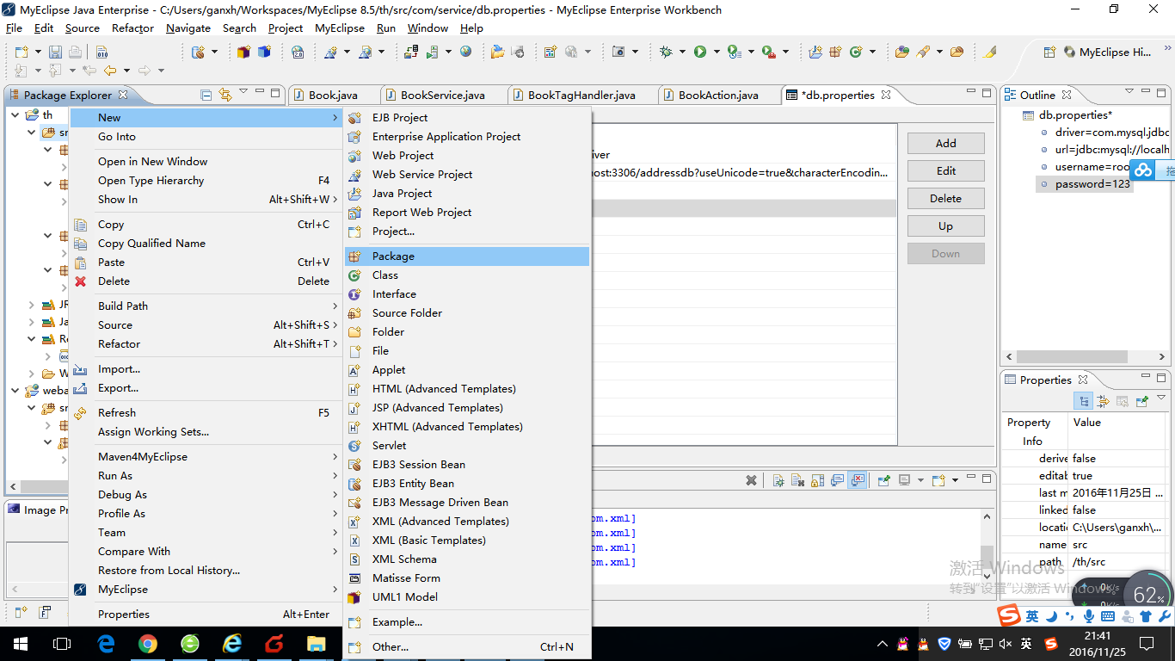

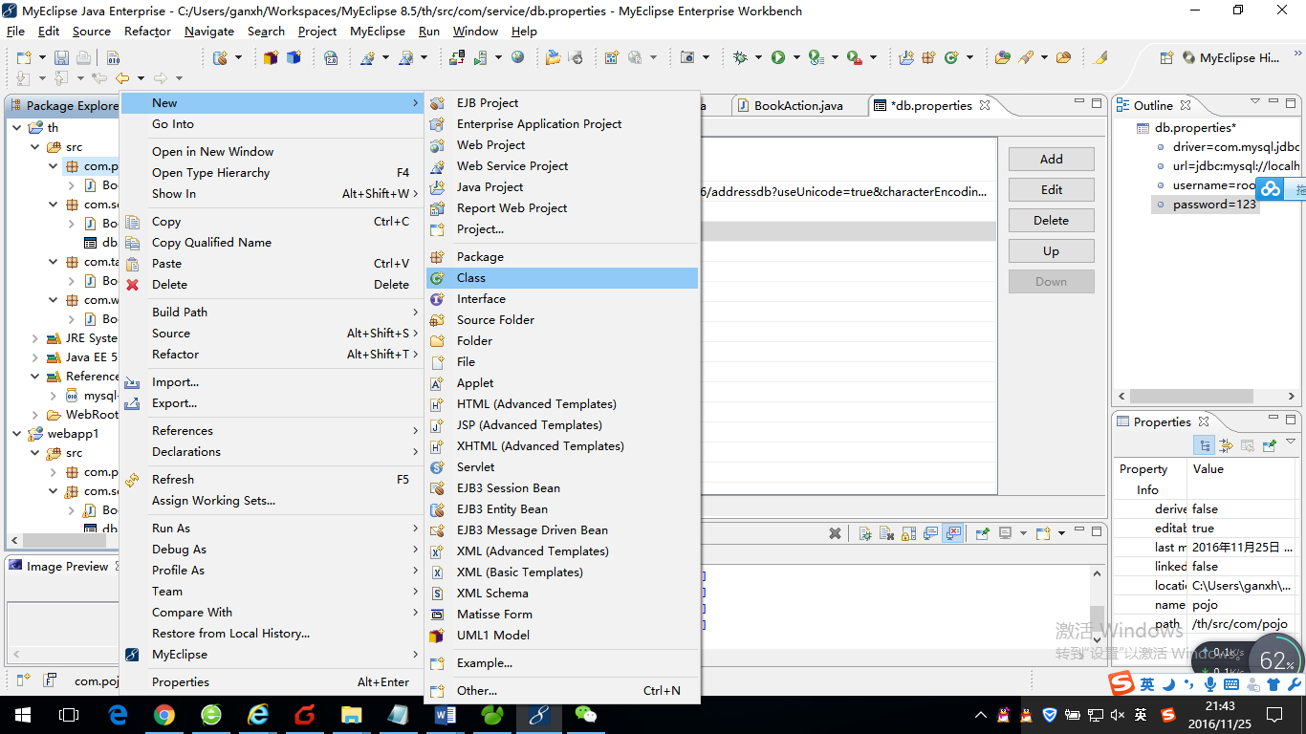

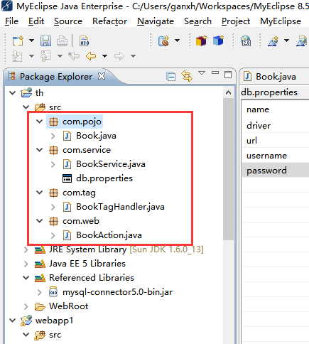

4个类的代码

## Book

**package** com.pojo;

**public** **class** Book {

**private** String isbn;

**private** String price;

**private** String title;

**public** String getIsbn() {

**return** isbn;

}

**public** **void** setIsbn(String isbn) {

**this**.isbn = isbn;

}

**public** String getPrice() {

**return** price;

}

**public** **void** setPrice(String price) {

**this**.price = price;

}

**public** String getTitle() {

**return** title;

}

**public** **void** setTitle(String title) {

**this**.title = title;

}

}

## Bookservice

package com.service;

import java.sql.Connection;

import java.sql.DriverManager;

import java.sql.ResultSet;

import java.sql.Statement;

import java.util.ArrayList;

import java.util.List;

import java.util.Properties;

import com.pojo.Book;

public class BookService {

static String driver;

static String url;

static String username;

static String password;

public BookService(){

try{

Properties prop = new Properties();

prop.load(this.getClass().getResourceAsStream("db.properties"));

driver = prop.getProperty("driver");

url = prop.getProperty("url");

username = prop.getProperty("username");

password = prop.getProperty("password");

}catch(Exception e){

e.printStackTrace();

}

}

public List getBookList(){

List list = new ArrayList();

try{

Class.forName(driver);

Connection conn = DriverManager.getConnection(url, username, password);

Statement stat = conn.createStatement();

ResultSet rs = stat.executeQuery("select * from tbl_books");

while(rs.next()){

Book book = new Book();

book.setIsbn(rs.getString("isbn"));

book.setTitle(rs.getString("title"));

book.setPrice(rs.getString("price"));

list.add(book);

}

}catch(Exception e){

e.printStackTrace();

}

return list;

}

}

## BookTagHandle

package com.tag;

import java.io.IOException;

import java.util.List;

import javax.servlet.jsp.JspException;

import javax.servlet.jsp.JspWriter;

import javax.servlet.jsp.tagext.SimpleTagSupport;

import com.pojo.Book;

public class BookTagHandler extends SimpleTagSupport {

@Override

public void doTag() throws JspException, IOException {

JspWriter out = this.getJspContext().getOut();

List<Book> list = (List<Book>)this.getJspContext().findAttribute("list");

for(Book o: list){

out.println(o.getIsbn() + "," + o.getTitle() + "," + o.getPrice() + "<br>");

}

}

}

## BookAction

package com.web;

import java.io.IOException;

import java.util.List;

import javax.servlet.ServletException;

import javax.servlet.http.HttpServlet;

import javax.servlet.http.HttpServletRequest;

import javax.servlet.http.HttpServletResponse;

import com.service.BookService;

public class BookAction extends HttpServlet {

/**

* The doGet method of the servlet. <br>

*

* This method is called when a form has its tag value method equals to get.

*

* @param request the request send by the client to the server

* @param response the response send by the server to the client

* @throws ServletException if an error occurred

* @throws IOException if an error occurred

*/

public void doGet(HttpServletRequest request, HttpServletResponse response)

throws ServletException, IOException {

doPost(request,response);

}

/**

* The doPost method of the servlet. <br>

*

* This method is called when a form has its tag value method equals to post.

*

* @param request the request send by the client to the server

* @param response the response send by the server to the client

* @throws ServletException if an error occurred

* @throws IOException if an error occurred

*/

public void doPost(HttpServletRequest request, HttpServletResponse response)

throws ServletException, IOException {

//call business code

BookService bookService = new BookService();

List list = bookService.getBookList();

request.getSession().setAttribute("list", list);

request.getRequestDispatcher("listbook.jsp").forward(request, response);

}

}

# 引用jar包

把素材中的jar包拷贝到项目目录下

例如图1拷贝到图2

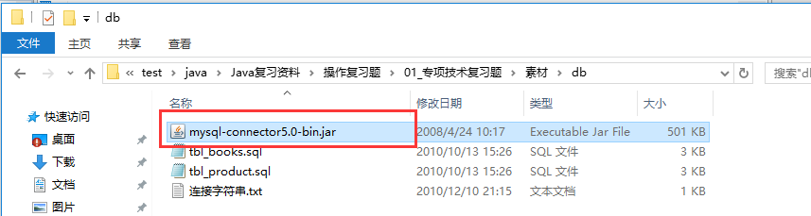

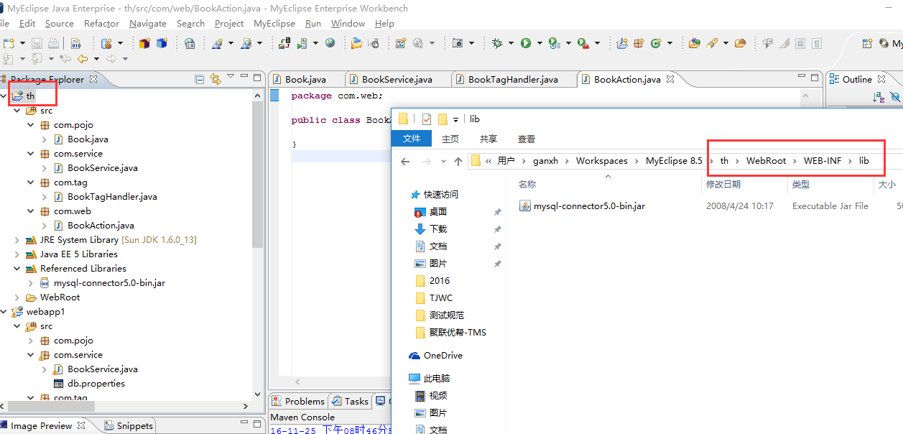

添加jar包（图三勾选后点击finish即可，已经选过了所以不能点了）

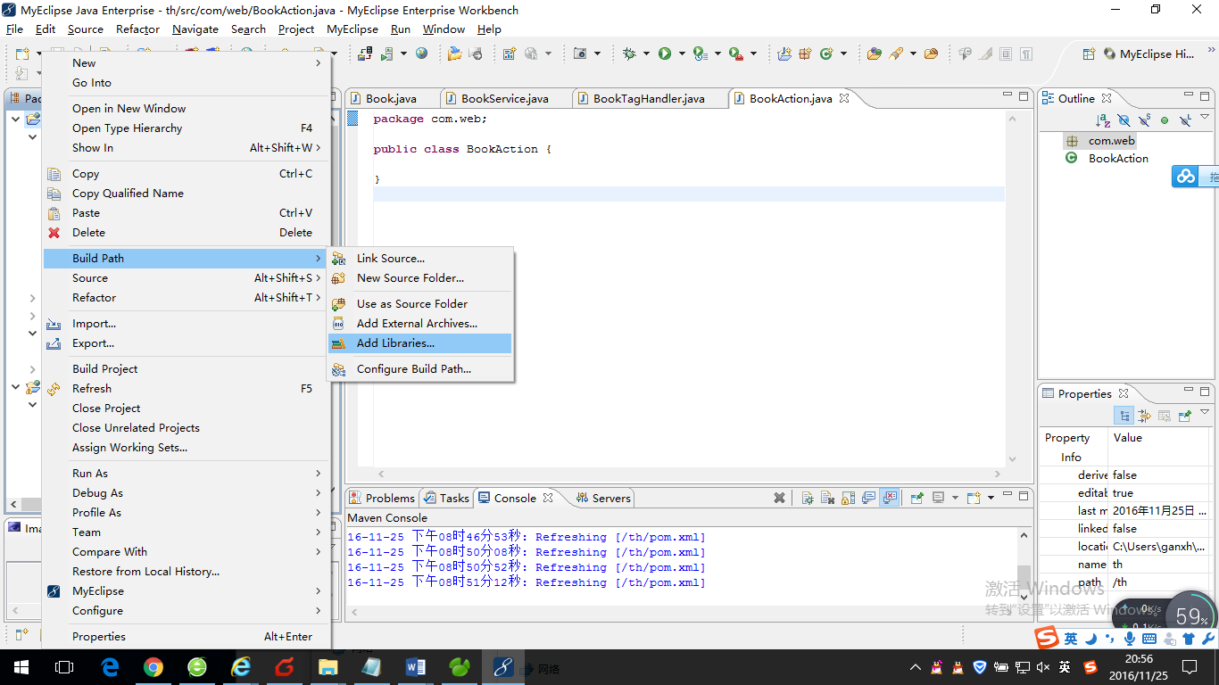

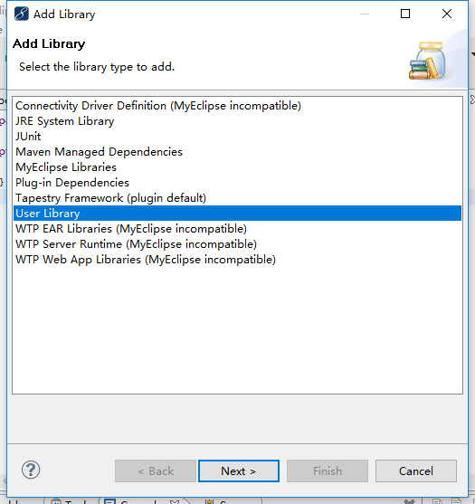

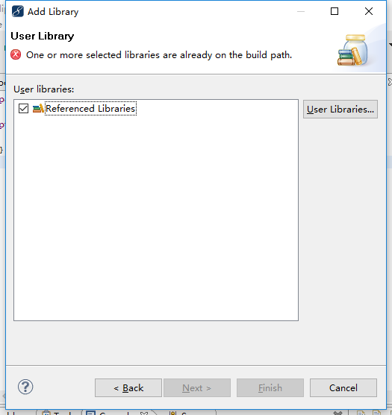

# 连接mysql数据库

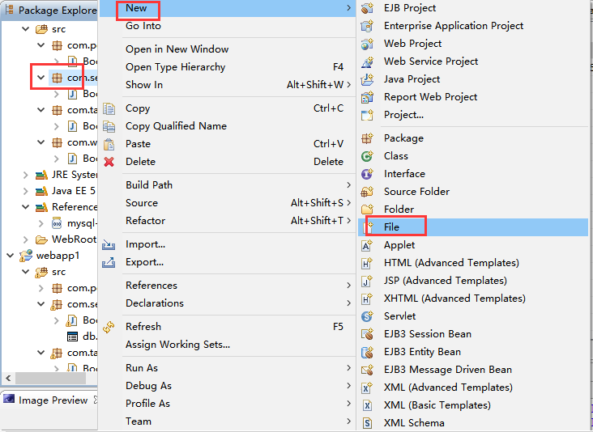

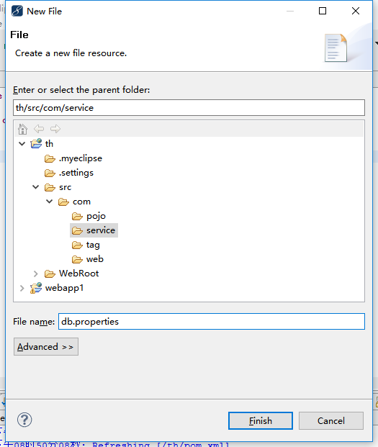

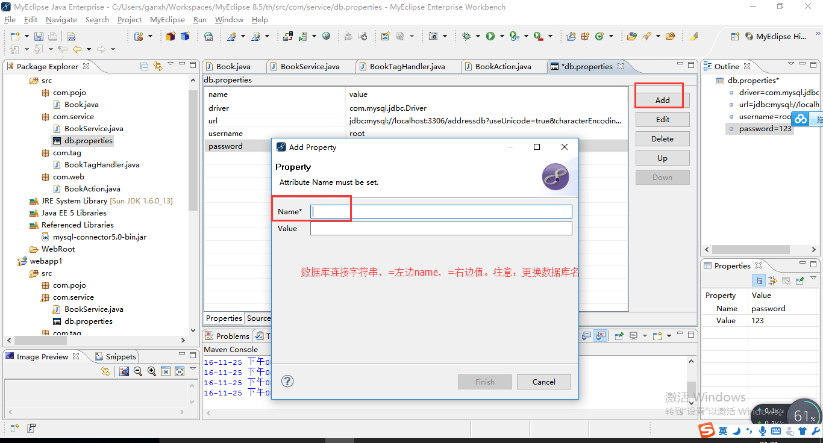

# 加界面

