Midterm report:

Just keeping growing a decision tree does not improve the model well.

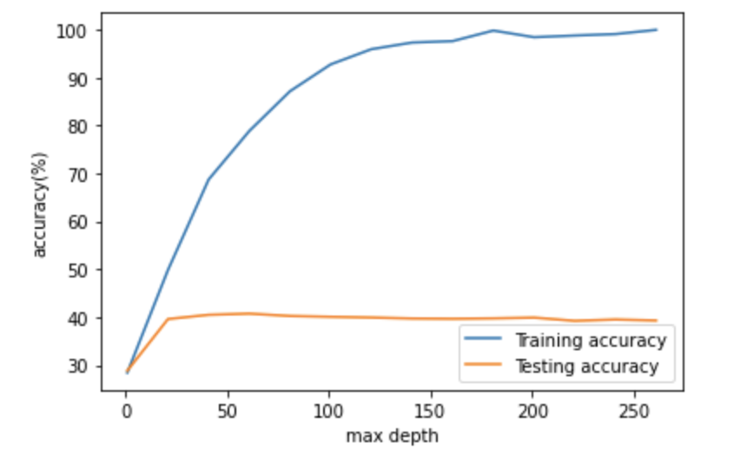

Final:

Worked on post pruning by looking for the most optimal value of cost complexity pruning alpha.

Cost_complexity_pruning_path -> list of