Jason, 1B, Feature analysis and Simple Classification Model.

Analysis:

Before starting on the Classification Model, we first had to do some analysis into the features in the dataset. Below are some graphs I used for analysis and their interpretations.

Here we visualize the top 5 teams based on Average Market Value. We can see here that the average Market Value of Liverpool is very high compared to the rest, followed is West Ham United with a Market Value which seems to be around 60% of Liverpool's.

Next we visualized the distribution of Positions between players. Here we can see again that CF is the most popular position by far.

I chose to only visualize the top 5, just so the graph will stay readable and won't overflow you with information. In this visual we can see that the country on first place is Italy, the amount of players from Italy heavily outweigh the other countries.

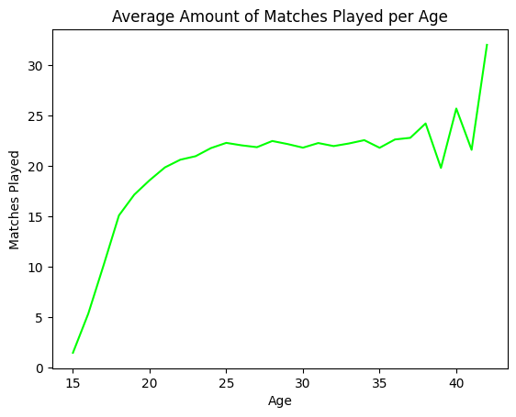

we can see that the younger a player is, the least matches they play, but this changes after around the age of 23: from this point onwards the line seems to be staying around the same value. There seems to be random peaks of data after the age of 35, but this is due to the lack of players in that age group in the dataset.

How do duels won and aerial duels won vary by position? Looking at the visual, we can keep the conclusion made earlier: the more defensive positions have the higher average amount of duels won and both datapoints have about the same distribution.

I can see that there is a really slight correlation to the two variables. There has to be a different variable which also has impact on this correlation, but it needs some extra future research.

Machine Learning:

First we started making a basic model without changing (preprocessing) the data too much, which gave the following results per type of model:

Linear Regression:

Logistic Regression:

Random Forest:

Gradient Boosting Trees:

To improve these models I applied Feature and Correlation Analysis per each position:

­Goalkeeper:

Attackers:

Defenders and MidFielders (combination)

Afterwards, I ended up scaling the data to make sure that they can be used along each other better, which often results into higher performances:

And afterwards, I applied parameter selection for certain models, below I will only show one example, since I did this using 2 methods for 2 models for each position.

After this, I trained the new models with updated data and better parameters, which ended up with the following performances: (Note: These performances were for goalkeepers, I had a different model for every type of position.)

These are the final performances for goalkeepers. We print out multiple types of scores, so we can decide which model is best fitted for the question based on multiple factors and performances.