**The Book in 3 Sentences**

* The secret to sales: Make people an offer so good they would feel stupid saying no.
* List potential objections and problems customers might have and address them.
* People pay for certainty, speed and ease.

**100M Offers Summary**

* The secret to sales: Make people an offer so good they would feel stupid saying no.”
* “Their discomfort compounds. And once the discomfort of staying the same surpasses the discomfort of change, they take the leap.” #motivation #change
* “Dr Burgelman, a famous Stanford business school professor said, it is far better to have understood why you failed than to be ignorant of why you succeeded”

**II. Pricing**

**3. Pricing: The Commodity Problem**

* Gross Profit: revenue - direct cost of servicing an ADDITIONAL customer (not net profit)
* Commoditized = Price Driven Purchases
* Differentiated = Value Driven Purchases

**4. Pricing Find The Right Market — A Starving Crowd**

* Starving Crowd (market) > Offer Strength > Persuasion Skills
* “I have coined the term “niche slap” to remind entrepreneurs in my communities to commit once they pick. All businesses and, all markets, have unpleasant characteristics. The grass is never greener once you get to the other side.”
* You’ll never become world class if you stop after a failed attempt.

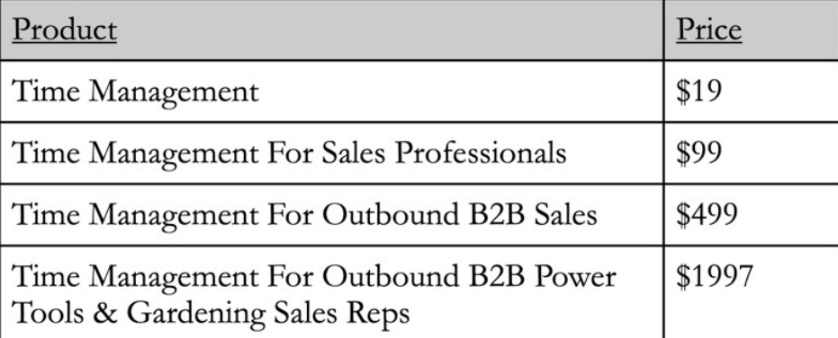

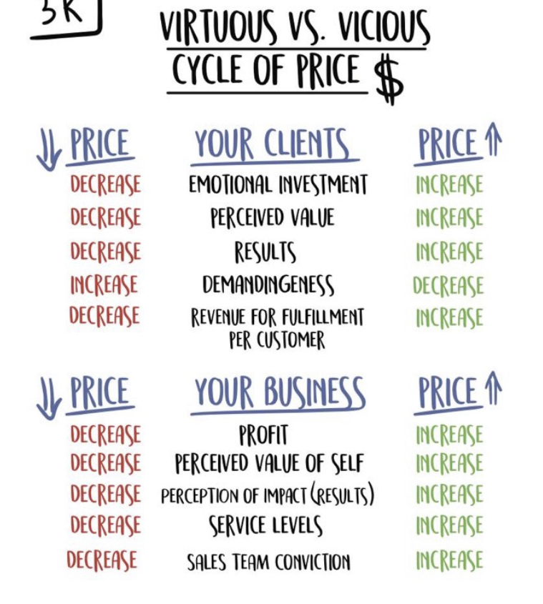

**III. Value - Create Your Offer**

**6. Value Offer: The Value Equation**

* What will I make? (Dream Outcome)
* How will I know it's going to happen? (Perceived Likelihood of Achievement)
* People pay for certainty
* How long will it take? (Time Delay)
* People who experience a victory early on are more likely to continue with something.
* What is expected of me? (Effort & Sacrifice)
* 10 minutes a day.
* The best companies in the world focus all their attention on the bottom side, making things immediate, seamless and effortless.
* If your able to make the bottom 0 = infinity
* It’s not about how much you increase your prospect’s likelihood of success, or decrease the time delay to achievement, or decrease their effort and sacrifice. That in itself is not valuable. Many times, they will have no idea. The Grand Slam Offer only becomes valuable once the prospect perceives the increase in likelihood of achievement, perceives the decrease in time delay, and perceives the decrease in effort and sacrifice.
* Example of London implementing tracking of train instead of making the trains actually faster. Customers perception of time decreased saved billions of dollars.
* This is why the supplement industry 123B is twice the size of the health club industry $62B.
* Knowing what people value versus what is good for them is key. It means you can find ways to monetize the things that people value in order to give them what they reallly need.

**8. Value Offer: The Thought Process**

* Life will pay you for your ability to solve using a divergent thought process. -> Think of many solutions to a single problem.
* Brick exercise:
* Use it as door stop.
* Put it inside a durable plastic IKEA bag and use it as a weight
* Use it as a paper weight
* Use it as a stand to elevate my monitor.
* Write a message on it with sharpie and leave it where I can see it

**9. Value Offer: Creating Your Grand Slam Offer PartI: Problems & Solutions**

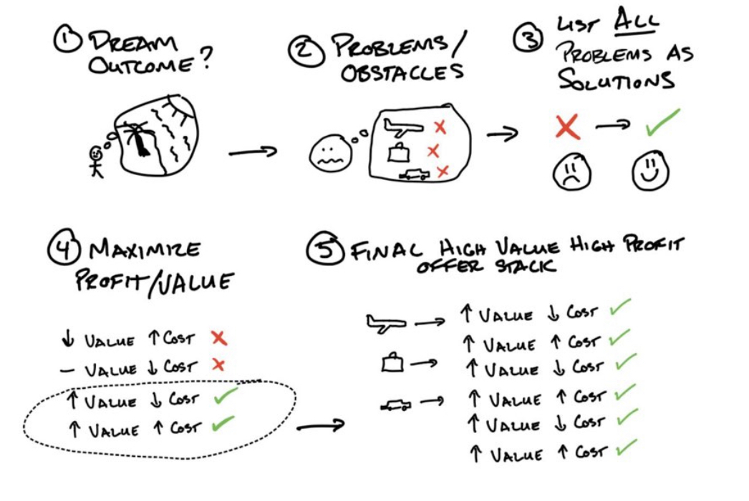

**1. Identify Dream Outcome**

* Don’t sell the plane flight, sell the vacation.

**2. List Problems**

* I don’t have time for meditation
* I’m going to quit after of a couple of days why pay?
* Does meditation even work? Will it solve the problems I’m facing?

**3. Solutions List**

* “How to” then reversing the problem using solution-oriented language is copywriting 101
* Too much time -> become more focused, clear and less anxious with just 5 minutes of meditation everyday.
* Going to quit -> Make meditation fun and effortless.
* Does meditation even work? -> Here’s a list of 1000,

**Value Offer: Creating Your Grand Slam Offer Part II Trim & Stack**

**4. Create Your Solutions Delivery Vehicles (The How)**

* What could you do that someone would immediately say, “All that? Seriously? Yes, I’m in.”
* “Remember, it’s important that you solve every problem. I can’t tell you the amount of times one single item becomes the reason someone doesn't buy.”

**5. Trim & Stack**

* When thinking about whether or not to add a feature consider:
* 1. Financially value
* 2. Cause them to believe they be likely to succeed
* 3. Make them feel like they can do it with much less effort and sacrifice
* 4. Help them accomplish their goal & see the result they want with far less time investment.

**IV: Enhancing Your Offer**

**Enhancing the Offer Scarcity, Urgency, Bonuses, Guarantees, and Naming**

* “People want what they can’t have. People want what other people want. People want things only a select few have access to.”
* *Desire comes from not getting what you want*

**Scarcity**

* Fear of loss is stronger than desire for gain.

**Urgency**

* Scarcity is a function of quantity. Urgency is a function of time.

**Bonuses**

* A Single offer is less valuable than the same offer broken into its component parts and stacked as bonuses
* The value of the bonuses should eclipse the value of the core offer.
* Get happier by using our app, for just 5 minutes everyday.
* Faster, easier or less effort/sacrifice
* Bonus should address a specific concerns customer might have.

**Guarantees**

* Unconditional -> No questions asked.
* Conditional -> If you don’t achieve X by Y.

**Naming**

* M: Make a magnetic reason
* Black Friday, Summer Sale
* A: Announce the avatar
* G: Give them a goal
* I indicate a time interval
* C: complete with a container word
* Challenge, Blueprint, Bootcamp, Cheat code, Experience, Solution.