**Macroeconomic Policy Should Focus On Maximising Happiness, Not Real GDP. Comment**

In the past GDP has been widely used to compare the development and success of countries, yet recently the movement to measure happiness and use this as a measure of success is growing. The following quote by David Cameron is indicative of this rising trend:

*"It's time we admitted that there's more to life than money and it's time we focused not just on GDP but on GWB – general wellbeing.”*

*~* David Cameron at the Zeitgeist Conference, 2006

In order to assess the plausibility of using “happiness economics” instead of GDP, this essay begins by defining exactly what real GDP and happiness are. Subsequently, it considers the benefits and shortcomings of real GDP as a measure, and also evaluates the validity of measuring and using data regarding happiness as a tool for policymakers.

Happiness is closely linked to quality of life. It is the subjective positive feeling that is good in itself. Thus, as happiness increases, the quality of the individual’s life must increase, regardless of the change in income. Although there are other measures of quality of life, for example income or physical health, these aspects of life are only good in so far as they create satisfaction for the individual. However, for the purpose of this essay, happiness will refer to long-term wellbeing rather than the short term bursts of endorphins that can be referred to as happiness. For example, when an addict takes a drug they feel happier for a short period of time, but this is not a sustainable way of living. For the purpose of this essay when referring to happiness, wellbeing, or satisfaction, I will be referring to a long-term feeling rather than the experience of the addict in this example.

Simon Kuznets initially developed the modern concept of GDP in a 1934 report for the US Congress, and he forewarned that is should not be used to measure welfare. Yet today, real GDP is widely used to measure success and development of a nation. This is because increasing GDP is an indicator of increasing output, which means that the population can consume more goods and services. Standard economic theory suggests that utility is a function of consumption such that as consumption increases so does the individual’s wellbeing. This has resulted in a consensus that by maximising GDP per capita, the quality of life of the population is maximised[1].

However, economists such as Richard Layard argue that an increasing income and standard of living stop being directly proportional to the happiness of an individual once the individual’s income has exceeded a subsistence level.

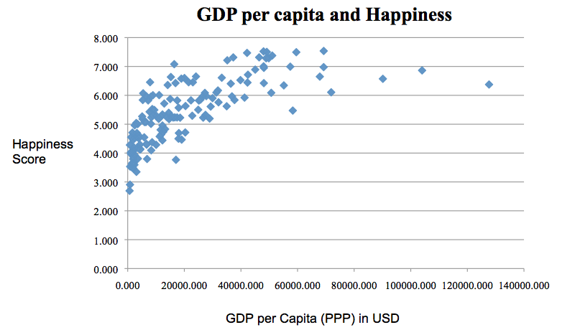To test this hypothesis championed initially by economists such as Easterlin in the 1970s, I collected data and analysed the relationship between GDP per capita and happiness, which can be shown by the graph below[2].

Overall, across all 150 data points the correlation co-efficient (r) was 0.705, which indicated that there was a positive relationship. According to Layard and Easterlin, once the top earners were removed from the data the relationship should be stronger, and they are correct. After removing countries with a GDP per capita of over $50,000, r equalled 0.787. Furthermore, the relationship between the countries with a GDP per capita over $50,000 was negative. However, this only applies to 13 countries, so there is insufficient evidence to claim there is a negative correlation between GDP per capita above $50,000 and happiness due to the low number of data points.

The data analysis suggests that GDP per capita serves as an appropriate proxy for happiness when the majority of a population’s income is below a subsistence level. By increasing aggregate demand or aggregate supply gradually and sustainably (e.g. by reducing international trade tariffs and thus allowing the free market equilibrium to be reached), the total value of output in a nation would increase. When a newly industrialising country (NIC) can benefit from this, workers and their families are pulled out of poverty, i.e. by providing more income that can be used to purchase essentials such as food, water, shelter and electricity. This has a direct benefit to the health and happiness of the impoverished public.

However, in a more economically developed country, such as the US, over 99.5% of the population has access to the bare essentials. In this scenario an increase in income would increase the purchasing power of a worker, but it would not provide a proportional increase in happiness. This is further evidenced by studies showing that in the US average incomes have more than doubled; yet people are no happier than they were 50 years ago. This paradox has also been shown to be true in Japan and Britain[3].

There are several key weaknesses of using GDP. It suggests that events that have a negative impact on society, such as car crashes, have positive outcomes, as it results in money being spent on repairs where it otherwise may not have been. This increase of trade of goods and services would then boost the figures for GDP, whilst having a negative impact on society due to increased driving delays to third parties and potential emotional and physical damage to the people involved in the crash. In addition, GDP does not include non-pecuniary work, for example an individual that takes care of their own garden produces the same service as if he were hiring a gardener, yet GDP figures only include the added benefit if he paid the gardener. In spite of all of its flaws, GDP has still been widely used to measure a country’s development because the consensus is that no better alternative has been developed yet

One of the reasons income stops resulting in more happiness is because of a psychological phenomenon called the hedonic treadmill. This is when humans quickly return to their base level of happiness after a major positive or negative event takes place, e.g. someone could be working longer hours in order to increase their income and save up enough money to buy an Aston Martin. Once the car has been purchased, the individual is overjoyed, but soon they return to their initial level of happiness. In spite of their improved standard of living, they have not become happier, yet if they were to lose the Aston Martin their happiness would drop below the level it initially was.

A large criticism of measuring happiness is that it cannot be measured easily, as a survey must be used. Happiness is a subjective feeling, therefore people could have different ideas about what happiness means. Furthermore, there is doubt that policymakers could be sure that if two individuals gave an identical score out of 10 for their happiness, that they were actually equally happy. However, recent studies have shown that there can be an objective reality to a subjective experience. Brain scans show that there is a correlation between how individuals answer to happiness survey questions, how their close friends perceive their happiness and the level of activity in different parts of the brain. Although this science is still in its infancy, there is growing evidence to support the theory that happiness can be objectively measured and quantified, and that surveys are an accurate method to measure this.

One could also argue that even after a reliable and accurate measure of happiness has been produced; it would still be difficult for policymakers to use this data when making decisions. For example, policymakers would have to choose between maximising society for everyone as a whole, or equalising it. This decision would be controversial, but no more than the current debate over whether the government should maximise efficiently in society or redistribute it equally. The consensus in Western countries is that income should be redistributed fairly, but with minimal change to the incentives that encourage the top earners to work for their wage. However, for happiness in most scenarios there would be very few real zero-sum games – i.e. there is no fixed limitation on the amount of satisfaction possible within a society. This means that implementing policies to increase happiness do not necessarily need to reduce the joy in the lives of the happiest.

The largest problem with basing policies solely on maximising happiness is that there is a potential for weakness. If two societies exist, with one (called A) maximising happiness and the other (called B) focusing on the free market and also national security, the latter would be able to produce more, and thus be more powerful. If these two societies go on to oppose each other in a war or political conflict, society A would have less power and therefore would be subservient to society B.

In spite of strong opposition, supporters of happiness economics still advocate that policies can, and more importantly should, be used to improve happiness, particularly for the most unhappy. As previously mentioned, consumers in developed countries think that buying new cars and goods makes us happier, which is irrational as people revert to their initial level of happiness, yet it exists due to a desire to consume and accumulate more wealth (largely due to advertising) and the aspiration to be wealthier than the people that we surround ourselves with. Some countries have attempted to reduce the impact of advertising on our desire to consume by banning companies from advertising to certain age groups, e.g. in Sweden advertising to children under 12 is illegal.

Another policy change would be to remove government incentives that improve geographical mobility. Standard economic theory suggests that a market failure exists in the labour market, as workers cannot be moved around to wherever the best jobs for them are. This geographical immobility is not a flaw in the labour market, but an indicator that labour should not be treated exactly the same as other factors of production. By encouraging workers to move, incomes are increased, but other sources of happiness have been cut off. The workers, although wealthier, are less happy after moving because they have lost friendships and a sense of community, which also leads to the trust the workers have in the people in their neighbourhood, which reduces their happiness.

In conclusion, there are strong arguments both for and against basing policies on happiness measure rather than GDP. However, there are very few reasons to only base policies on one. In order to benefit from the advantages of raising GDP – namely increasing output, purchasing power and the region’s influence as a whole, it must be used. Similarly, happiness measures should also be a tool for the policymaker as it can indicate the current state of the population’s quality of life, and can be used to let politicians assess the success of their policies in improving the lives of the people. These policies could range from banning advertising to certain members of society, e.g. smokers, to reducing government incentives that encourage uprooting families in a quest for more money. Conversely, by using both measures the disadvantages would be largely irrelevant. Using GDP in tandem with happiness economics to guide policymakers would prevent societies from falling into a trap of becoming weaker. Although developing countries can still rely on GDP much more heavily to judge happiness in a nation, it is not time for countries such as Britain to realise that peak economic performance is a means to an end. Once the essentials have been obtained, it is time to also focus on wellbeing directly.

1. Footnote: this assumes that the extra income is distributed to the majority of the population, in order for the majority of the population to be able to consume more and thus increase their standard of living.
2. The data for GDP per capita (PPP-adjusted) was from the IMF from 2016, and the Happiness Score had been calculated by the UN in their 2017 Happiness Report. I attached my data and calculations from my analysis in an excel spreadsheet in the email I sent this essay. I chose the compare the happiness data to the purchasing power parity adjusted figures for GDP per capita because it is a better indication of the standard of living of the average individual in a particular region.
3. In Britain, this has been evidence by comparing Gallup polls from the 1950s to Gallup polls from 2010 onwards - http://news.bbc.co.uk/1/hi/programmes/happiness_formula/4771908.stm